Circular Motion
November 19, 2025
Table of Contents
1
Introduction to Circular Motion 2
Centripetal Force 2
The Combined Centripetal Force Formula 4
Examples and Applications 4

Introduction to Circular Motion
Circular motion, as its name implies, involves an object moving in a circular trajectory. It is caused by a centripetal force and is directed toward the center of rotation, the point at which the object revolves around. An example of a centripetal force is the gravitational force Earth exerts on the Moon (idealistically).

Centripetal Force
Centripetal force is any force that causes an object to turn. Examples of forces that can act as centripetal force include:
- Gravity
- Tension
- Friction
Remember that centripetal force is not an additional force that acts on an object, but rather any inward force that causes an object to move in a circular path. For example, the centripetal force of a car turning is the frictional force.
The formula to calculate centripetal force is defined as follows:
,
where is the centripetal force, is the mass of the object, and is the radial acceleration during circular motion, which has its own, more prominent formula:
,
where is the velocity of the object and is the radius of the object’s circular path.
The formula used to determine the centripetal force experienced by an object is derived directly from Newton’s second law of motion (). However, the radial acceleration () in the centripetal force formula more often represents a change in direction rather than a change in speed.
Suppose you drive a car in a perfect circle at a constant speed. Although your speed is not changing, your direction is. Hence, your velocity is also changing, thus producing an acceleration. Recall that acceleration is the rate of change of velocity, not just speed alone. The velocity vector of an object in circular motion is always tangent to the path of motion.
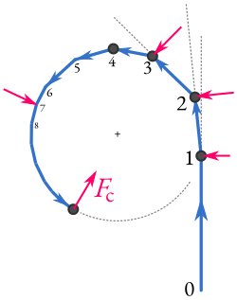Figure 1: A particle is disturbed from its uniform linear motion by a series of short kicks (1, 2, ...), giving its trajectory a nearly circular shape. The force is referred to as a centripetal force in the limit of a continuously acting force directed towards the center of curvature of the path. (By Ponor - Own work, CC BY-SA 4.0, https://commons.wikimedia.org/w/index.php?curid=129957104)
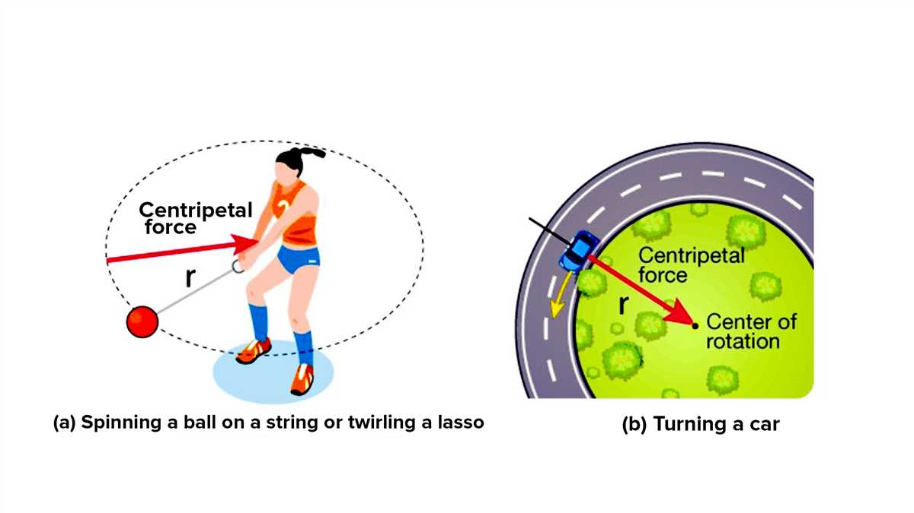Figure 2: Examples of circular motion and centripetal force.

The Combined Centripetal Force Formula
The combined centripetal force formula can be ultimately written as:
.
If a body is turning, you can calculate the net force by finding the sum of all the forces acting on it with their directions considered. The component of the net force that acts toward the center of curvature (perpendicular to the body’s tangential velocity) is the centripetal force.

Examples and Applications
- A -kilogram car moving counterclockwise at a constant speed of around a circular track with a radius of . determine the magnitude of the centripetal force acting on the car.

- A -kilogram roller coaster travels around a circular loop with a radius of in . Find the magnitude and direction of the centripetal force of the roller coaster. Approximate as .

