Waves**
(This idea or topic is a major aspect of the new Physical Science: Physics course.)
January 29, 2026 (cont’d. April 13, 2026)
Table of Contents
1
What Are Waves? 2
Mechanical Waves 2
Electromagnetic Waves 2
Classifying Waves 2
Periodic Waves 2
Transverse Waves 3
Longitudinal Waves 3
Wave Vocabulary 4
Measuring Waves 4
Calculating the Velocity of a Wave 4
Given Frequency and Wavelength 4
Given Distance and Time 4
References 4
Calculating the Period of a Wave 4
Drawing Waves in Two Dimensions 5
Pulses 5

What Are Waves?
A wave is a moving disturbance that carries energy rather than matter. Waves are essentially energy transport phenomenons. A wave’s amplitude squared is proportional to the amount of energy in the system.

Mechanical Waves
Mechanical waves require a medium. Examples of mechanical waves include water, earthquakes, and sound.

Electromagnetic Waves
Electromagnetic waves (i.e., light) move through a vacuum. Examples of electromagnetic waves include radio, light, microwaves, and x-rays.

Classifying Waves
There are multiple categories of waves. Most waves in simplified physics are periodic, but, at the same time, they can also be either transverse or longitudinal.

Periodic Waves
Periodic waves are waves that repeat over intervals of time or distance. These waves repeat over intervals or periods.
Sinusodial waves in mathematics, for example, repeat over periods and have positive and negative half cycles that repeat indefinitely.
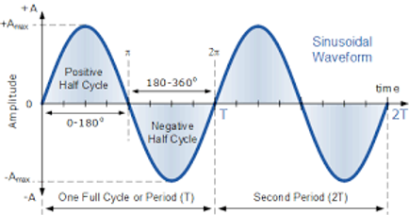Figure 1: A diagram of a sinusodial wave.

Transverse Waves
A transverse wave is a wave with a medium perpendicular to the motion of the wave. The particles through which the wave passes vibrate at right angles to the direction in which the wave is moving. The diagram below demonstrates how a transverse wave and its medium interact.
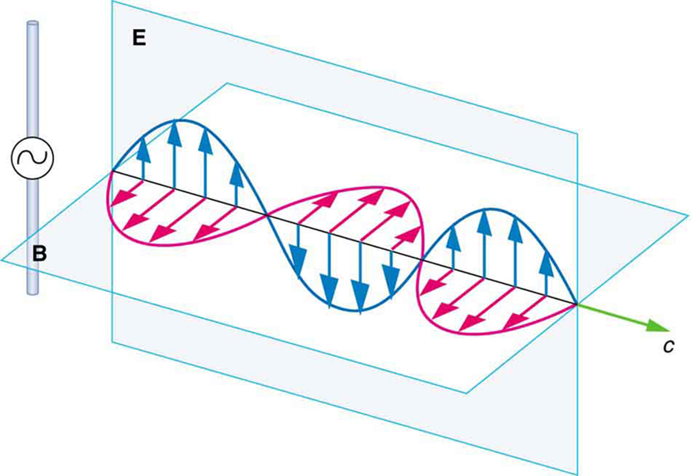Figure 2: A part of an electromagnetic wave moving perpendicularly to the motion of its medium.

Longitudinal Waves
A longitudinal wave is a wave with a medium parallel to the motion of the wave.
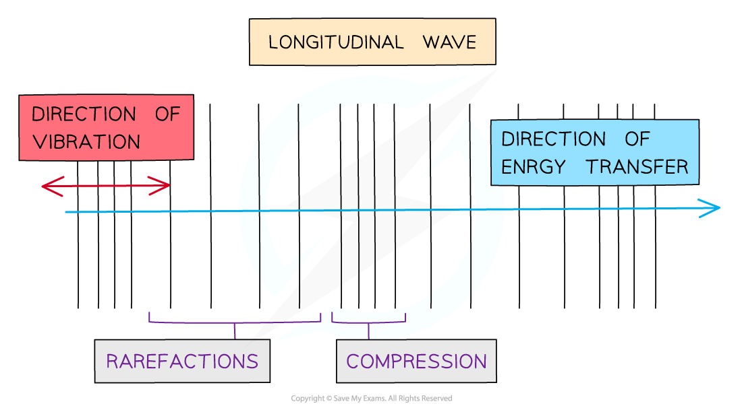Figure 3: A diagram representing a longitudinal wave and its properties.

Wave Vocabulary
- Crest: The highest point on the wave.
- Trough: The lowest point on the wave.
- Amplitude: The difference in height between the midline of the wave and its highest point.
- Wavelength (): The distance between consecutive points in phase (i.e., the period of a periodic wave).
- Frequency (): The number of vibrations per unit time.
- Period (): The time it takes a wave to complete one cycle.

Measuring Waves

Calculating the Velocity of a Wave

Given Frequency and Wavelength
To calculate the velocity of a wave given its frequency and wavelength, use the formula:
,
where is the velocity or speed of the wave, is its frequency (measured in hertz, , or cycles per second, ), and is its wavelength (in meters, ).

Given Distance and Time
To calculate the speed of a wave given its distance and time, simply use:
,
where is the wave’s velocity, is its distance traveled, and is the time it traveled for.

References
For reference, the speed of light is , while the speed of sound is .

Calculating the Period of a Wave
To calculate the period of a wave given its frequency, simply take the reciprocal of the frequency. Hence:
,
where is the period of the wave and is its frequency.

Drawing Waves in Two Dimensions
To draw a wave in two dimensions, you must represent specific elements using lines and symbols. Consider the following diagram:
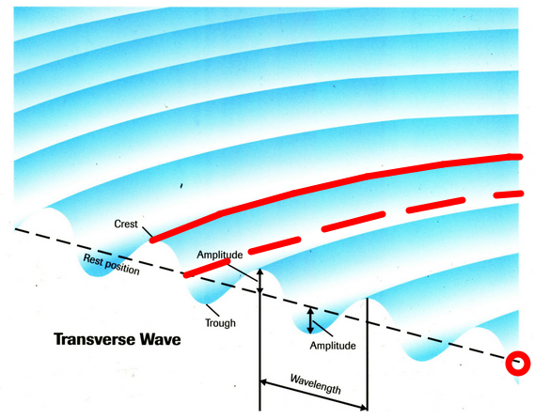Figure 4: A diagram of a transverse wave with elements labeled.
In a two-dimensional drawing of the wave above, the red solid line represents the wave front (crest), while the red dotted line represents the trough. The red circle represents the source of the wave.

Pulses
A pulse is a single vibratory disturbance. A continuous, periodic wave is the combination of several pulses generated at regular intervals.
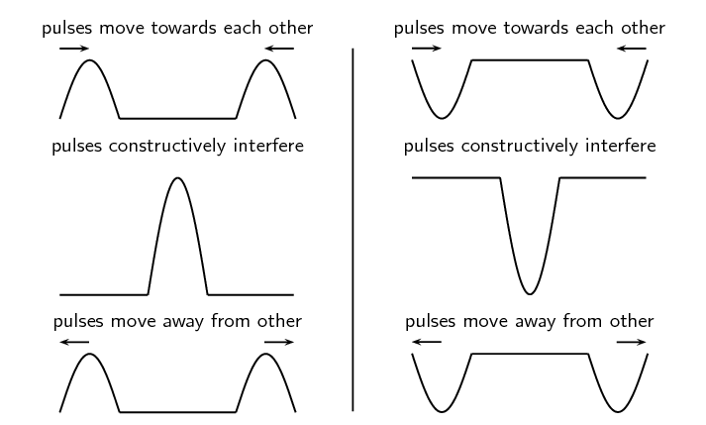Figure 5: Interference of pulses.

