Circuits and Electricity
February 26, 2026
Table of Contents
Circuits 2
Introductory Concepts 2
Drawing Circuits 2
Ohm’s Law 2
Series Circuits 3
Parallel Circuits 3
Electrical Work and Power 4
Analogy for Power 5
Kirchhoff’s Laws 5
Conservation of Charge 5
The Ammeter 5
Connecting Ammeters 5
The Voltmeter 5
Connecting Voltmeters 5
Gustav Robert Kirchhoff 6
Kirchhoff’s First Law 6
Kirchhoff’s Second Law 6
Current and Resistance 6
What is Current? 6
Types of Current 6
What is Resistance? 7
Factors Affecting Resistance 7
Resistors 7
Types of Resistors 7
Understanding Resistors 7
Examples and Applications 8

Circuits
Circuits are comprised of primarily three things: a source of potential difference (voltage) like a battery, conductive materials, and complete loops.

Introductory Concepts
- Voltage (Potential Difference): The difference in potential energy between two points in an electric field, measured in volts ()
- Current: The rate at which charge passes through a given point, measured in amperes ()
- Resistance: A measure of the opposition that a device offers to the flow of electric current, measured in ohms ().

Drawing Circuits
Circuits are drawn using schematic symbols representing physical parts:
To draw a circuit, pick the parts that must be used and connect the ends to complete the loop.
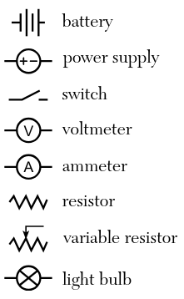Figure 1: Common schematic symbols for circuits.

Ohm’s Law
In the early nineteenth century, Georg Ohm defined the fundamental relationship between voltage (), current (), and resistance () in electric circuits. His experiments represent the beginning of circuit analysis. Today, the formula for Ohm’s Law is still used by engineers when designing circuits:
.
Because electricity is very predictable, circuit performance can be analyzed with mathematical formulas such as Ohm’s Law before circuits are even constructed.

Series Circuits
A series circuit is a circuit that only allows current to flow in one direction. Series circuits only consist of one loop. See the formulas:
There are four essential facts about series circuits:
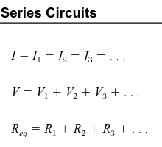Figure 2: Relationships between current, voltage, and resistance in series circuits.
- If one resistor fails, the other resistors also fail.
- Current remains constant.
- Voltage and resistance add up.
- The total resistance will be larger than the largest resistor in the loop.

Parallel Circuits
A parallel circuit is a circuit that allows current to flow in multiple directions. While series circuits only have one loop, parallel circuits have multiple loops. See the equations:
Below are four key facts about parallel circuits:
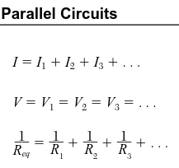Figure 3: Relationships between current, voltage, and resistance in parallel circuits.
- If one resistor goes out, the others can still stay on.
- Voltage remains constant.
- Current and the reciprocals of the resistors add up, as demonstrated by the formula:
.
- The total resistance will be smaller than the smallest resistor.

Electrical Work and Power
Electrical work is the amount of energy that is used by a circuit (measured in joules, ). Electrical power, on the other hand, is the rate of doing work or expending energy (measured in watts, ).
To calculate work given a charge and voltage, use the model:
,
where is the work done, is the charge (in coulombs, ), and is the voltage.
You can also use:
,
where is the power, is the time interval (in seconds), is the current, and is the resistance.
Although the above formula can be used to calculate work, its variables can be arranged to create a mathematical model for calculating power, . Thus, we can form the equation:
.

Analogy for Power
There are some restrictions on each circuit in your home. A fuse or circuit breaker protects each circuit. The protection is needed because too much current can heat or burn the wires in the walls of your home, potentially causing an electrical fire.
Most people think about the fuse or circuit breaker only when it turns off the electricity to a part of your home. The circuit is shut down when too much current is required. In most household circuits, the maximum current is usually or amperes. Each appliance in a typical house requires a certain amount of current to run properly.
The voltage of almost all of the circuits in a house is . If the fuse or circuit breaker can handle a maximum of , then the power limit is:
.

Kirchhoff’s Laws
Kirchhoff’s Laws relate to charge, voltage, and how they are conserved in a circuit.

Conservation of Charge
Conservation of charge means that the total amount of electrons and protons remains the same, resulting in a net charge of .

The Ammeter
The ammeter is a device used to measure current in amperes (). It is represented using the following symbol:

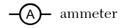
Connecting Ammeters
Ammeters are connected in series. Current is constant in a series circuit, so when an ammeter is connected in series, it reads the same current as the device being measured.

The Voltmeter
The voltmeter is a device used to measure voltage in volts (). It is drawn using the symbol:

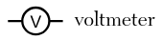
Connecting Voltmeters
Voltmeters are connected in parallel. Voltage is constant in a parallel circuit, so when a voltmeter is connected in parallel, it reads the same voltage as the device being measured.

Gustav Robert Kirchhoff
Gustav Robert Kirchhoff is a German physicist who studied how current flowed.

Kirchhoff’s First Law
Kirchhoff’s First Law, also known as the junction rule, states that total current entering a junction (node) is equal to the total current leaving it (conservation of charge).

Kirchhoff’s Second Law
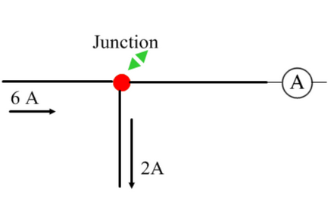Figure 4: Ammeter A reads because the total current entering the node () must equal the total current leaving the node.
Kirchhoff’s Second Law, also known as the loop rule, states in any complete circuit loop, the sum of the voltage gains (the battery) is equal to the sum of the voltage losses (the resistors).

Current and Resistance
Current and resistance are two essential topics for understanding electricity.

What is Current?
Current is the rate at which charge flows past a point in a circuit. It can be calculated using:
,
where is the current in amperes (), is the change in charge, and is the time elapsed.
One ampere is essentially one coulomb per second, as per the formula above.

Types of Current
There are two types of current: conventional current and electron flow. Conventional current is the flow of positive charges from a positive end to a negative end. Meanwhile, electron flow is the flow of electrons from a negative end to a positive end.

What is Resistance?
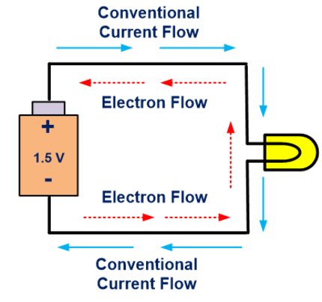Figure 5: The flow of charges in conventional current and electron flow.
Resistance, measured in ohms () is the opposition to the flow of electrons. Although resistance sounds like a negative aspect, it is very important in many circuits and is often used advantageously.

Factors Affecting Resistance
Resistance in a wire is primarily affected by the wire’s length, its cross-sectional area, and the temperature. The wire’s length simply represents how long it is, while its cross-sectional area describes how thick it is. The resistance in a metal conductor is directly proportional to the length and inversely proportional to the cross-sectional area. Temperature is also directly proportional to resistance.

Resistors
Resistors are devices that turn electrical current into heat energy. This is valuable in limiting current flow to another portion of a circuit.

Types of Resistors
There are two main types of resistors: fixed resistors and variable resistors (potentiometers). Their schematic symbols are different:

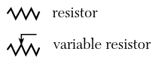
Understanding Resistors
There are two ways to determine the value of a resistor: measuring it with a meter or reading the color code. Resistors are labeled using bands, each having its own color.

Examples and Applications
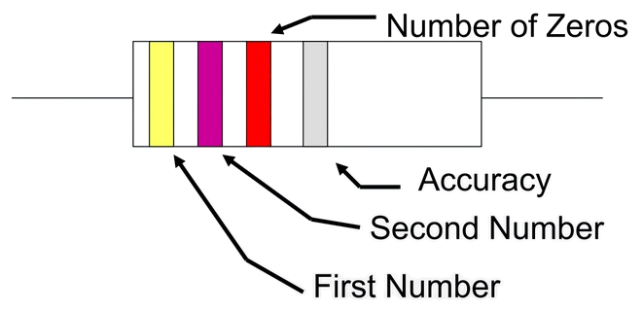Figure 6: The bands on a resistor labeled with colors.
- What is the current if elementary charges pass by a given point every ?

- An electric razor has a resistance of with a current of . What is the power developed by it?

- What is the power rating for a light bulb that is rated for and ?

- How much electrical energy is consumed by a light bulb that is used for two hours?

