Magnetism
March 26, 2026
Table of Contents
Introduction to Magnetism 2
Where Do You See Magnets? 2
Magnetic Force and Field 2
The Magnetic Field of an Atom 2
The ANTS Acronym 2
Magnetic Domains 2
Splitting a Magnet 3
Electromagnetism 3
Types of Current 3
Right-Hand Rules 3
The First Right-Hand Rule 3
The Second Right-Hand Rule 4
The Third Right-Hand Rule 4
Drawing Magnetic Fields in Two Dimensions 5
Electromagnetic Induction 5

Introduction to Magnetism
Magnetic and electric field lines look very similar. The north and south poles act like positive and negative sides of a battery. Both magnetic and electric fields are created by moving electrons.

Where Do You See Magnets?
Magnets are involved in many objects, including compasses, trains, the earth, the sun, and refrigerators. These are only several of the countless objects that function with magnetic fields.

Magnetic Force and Field
A magnetic field is the space around a magnet represented by continuous lines of force or magnetic flux that emerge from north-seeking magnetic poles and enter south-seeking magnetic poles.
The unit for measuring magnetic fields is called the tesla (). The unit for measuring magnetic flux is the weber ().
Magnetic force represents the attraction or repulsion that arises within a magnetic field. Fields are vector quantities, so they must be drawn with arrows. The strongest point in a field is located within the most dense region of field lines. Field lines never touch or cross.

The Magnetic Field of an Atom
Each electron in an atom behaves like a tiny magnet. Electrons in atoms tend to go in pairs, spinning in opposite directions and canceling each other out. Ferromagnetic materials, like iron, nickle, cobalt, and neodymium, have the ability to become strong permanent magnets.

The ANTS Acronym
Use the acronym ANTS when drawing magnetic field lines:
Away, North, Toward, South.
This acronym describes the behavior of magnetic field lines: the lines travel away from the north pole and toward the south pole.

Magnetic Domains
Magnetic domains are regions within a magnetic material in which the magnetization is in a uniform direction. In non-magnetic materials, however, domains are more arbitrary and do not point toward a common direction.

Splitting a Magnet
When a magnet is split into smaller pieces, each piece becomes a new magnet with its own north and south pole.

Electromagnetism
There are close relationships between magnetism and electricity. One such example of how they are related is in the case of a current-carrying wire; electricity flowing through a wire can create a magnetic field. This was discovered by Hans Christian Oersted in 1820.

Types of Current
Conventional current is the flow of positive charges from a positive terminal to a negative terminal. When considering magnetism, you must use the right-hand rules.
Electron flow is the flow of electrons from a negative terminal to a positive terminal. You can use the same rules, but using your left hand instead.

Right-Hand Rules

The First Right-Hand Rule
The first right-hand rule is used to solve for the direction of the magnetic field around a current-carrying wire. To use it:
- Point your thumb in the direction of the current (conventional current).
- Curl your fingers around the wire in the direction of the magnetic field.
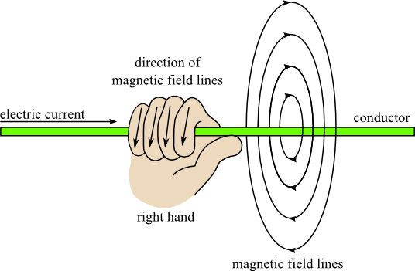Figure 1: A visual demonstration of the first right-hand rule.

The Second Right-Hand Rule
The second right-hand rule is used to solve for the direction of the magnetic field of a solenoid or a loop of wire. To use the rule:
- Curl your fingers around the solenoid or loop of wire in the direction of the current (conventional current).
- Point your thumb toward the north pole.

The Third Right-Hand Rule
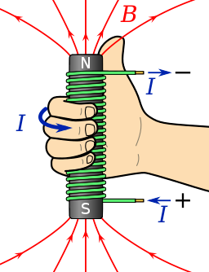Figure 2: A visual demonstration of the second right-hand rule (solenoid rule).
The third right-hand rule is used to solve for the direction of the magnetic force acting on a current-carrying wire (or charged particle) placed in a magnetic field. To use this rule:
- Point your fingers in the direction of the magnetic field (from north to south).
- Point your thumb in the direction of the current (or velocity of a positively charged particle).
- Face your open palm in the direction of the magnetic force on the wire or charged particle.
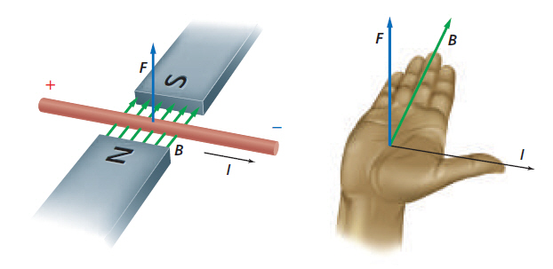Figure 3: A visual demonstration of the third right-hand rule.

Drawing Magnetic Fields in Two Dimensions
There are two symbols used to represent the direction of magnetic fields:
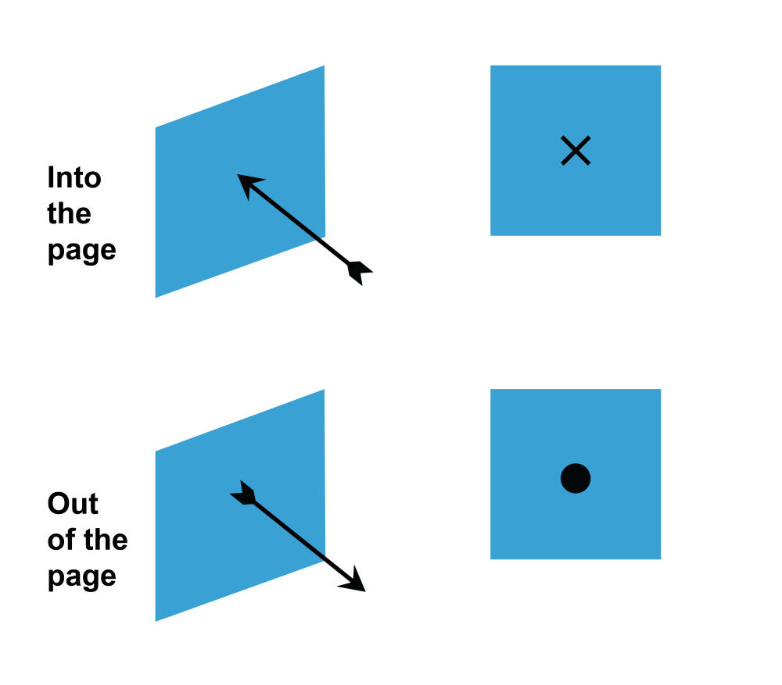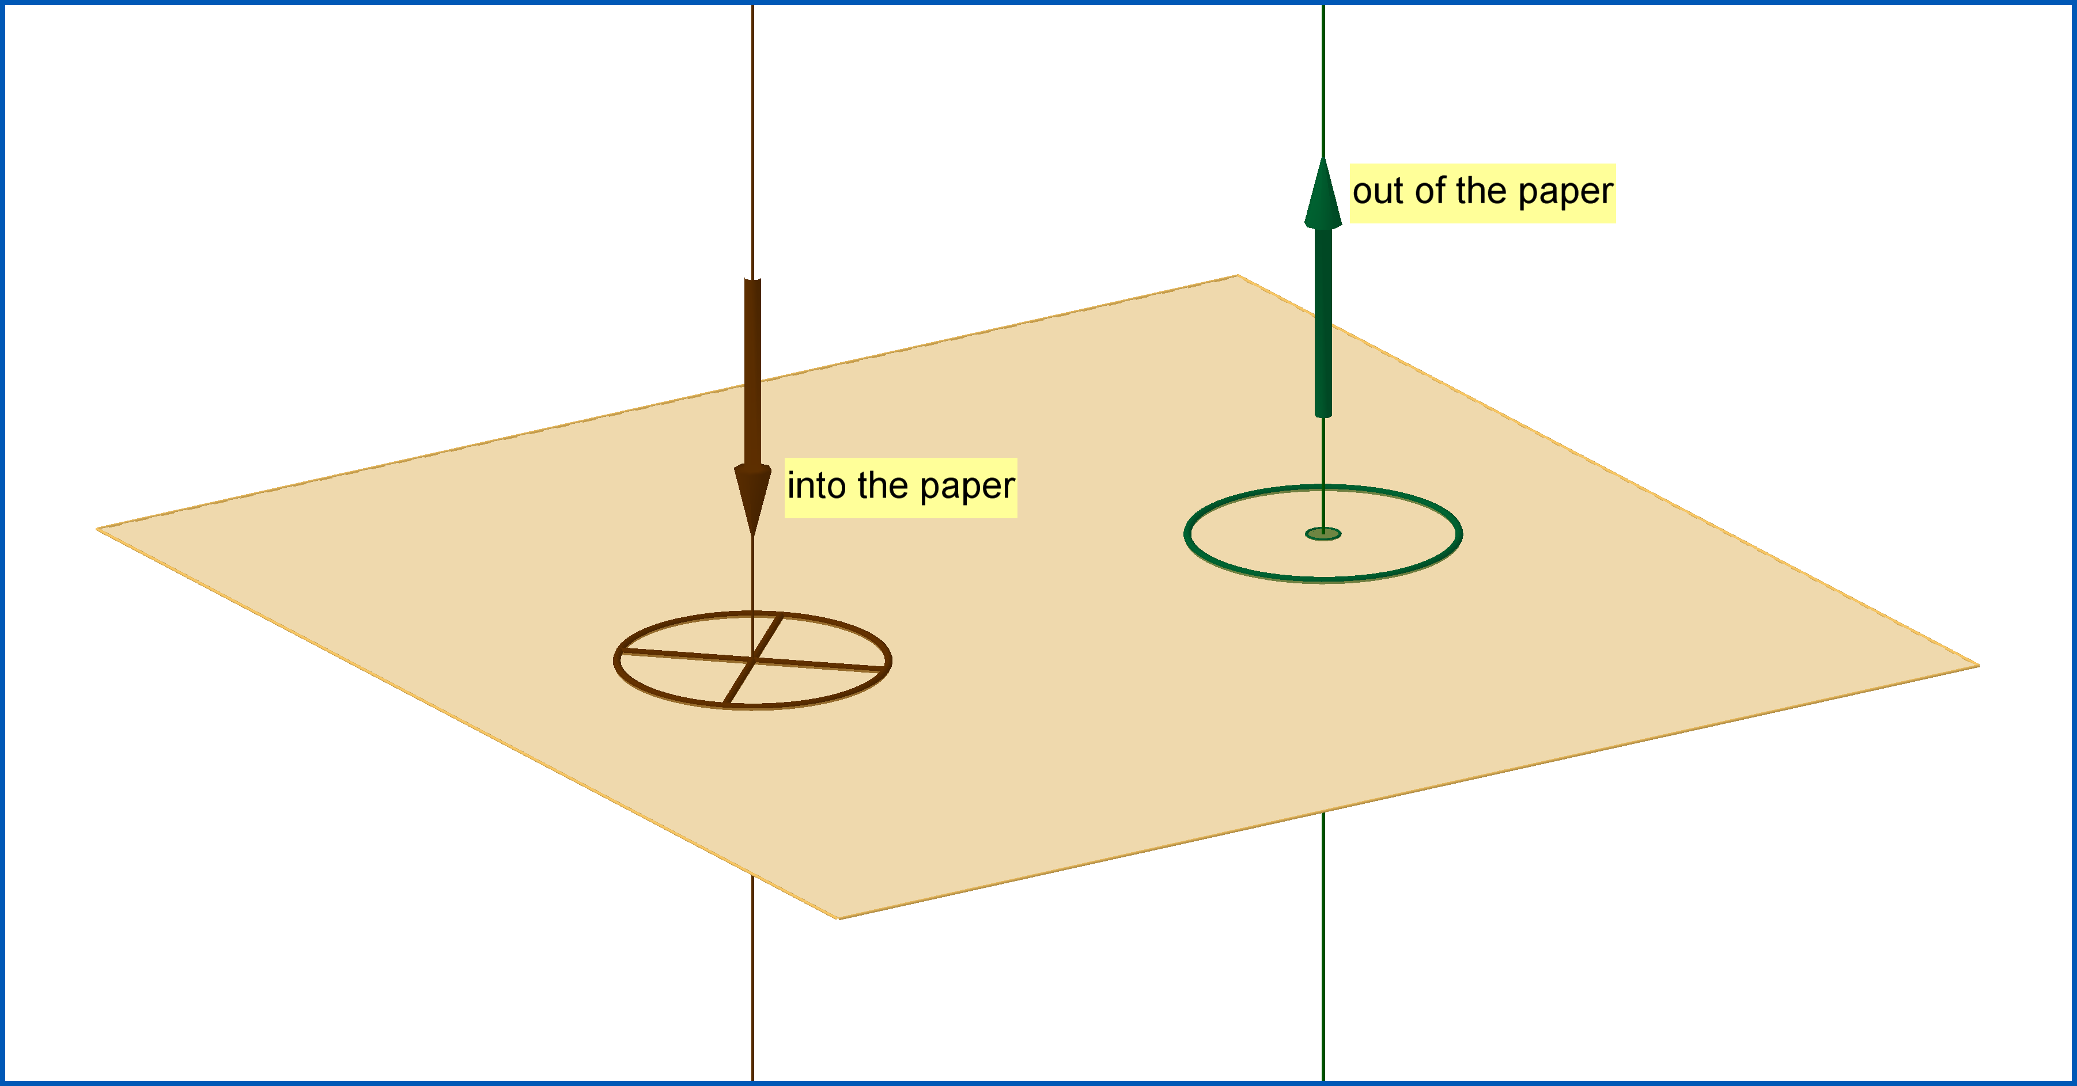

Electromagnetic Induction
Electromagnetic induction refers to the induction of an electric potential difference (voltage) when a wire is moved through a magnetic field. You must cut the magnetic field lines (flux lines) at a -degree angle to produce a maximum voltage. Moving the wire parallel to the field produces zero voltage.

