Phase and Interference
April 15, 2026
Table of Contents
1
What Is Phase? 2
What Is Interference? 3
Superposition 3
Constructive Interference 3
Destructive Interference 3
Standing Waves 4

What Is Phase?
When two points are in phase, they are located on the same level of the wave. In other words, the number of cycles between the two points is a whole number. Phase refers to the relative position of a point on a wave with respect to another point on the same wave.
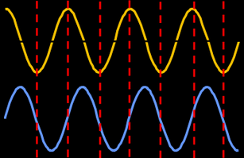Figure 1: The yellow wave and the blue wave are out of phase by 90 degrees because the point on the trough of the yellow wave is shifted 90 degrees (or one-fourth of a cycle/wavelength) away from the point on the principal axis of the blue wave.
The following diagram is an example of points that are in phase and out of phase on the same wave.
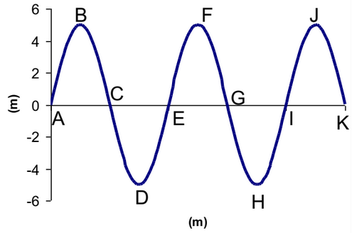Figure 2: Points A, E, and I; B, F, and J; and C, G, and K are in phase with each other, respectively. On the other hand, points C and E are out of phase by 180 degrees (one-half of a wavelength), while points G and H are out of phase by 90 degrees (one-fourth of a wavelength).

What Is Interference?
In waves, interference refers to adding or subtracting the amplitudes of two coherent waves.

Superposition
Superposition occurs when two or more waves travel through a medium simultaneously. The superposition principle states that the resultant displacement at any point is the sum of the individual waves. Interference is hence the effect of superposition; it can be either constructive or destructive.

Constructive Interference
The diagram below represents constructive interference. When two pulses undergo constructive interference, they add to produce a greater amplitude.
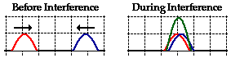Figure 3: The amplitudes of the pulse combine and form a new, larger pulse.

Destructive Interference
The figure below represents destructive interference. The term “destructive” is partially misleading; when the waves overlap, the effect of one of the pulses on the displacement of a particle of the medium is canceled by the effect of the other pulse. When two pulses undergo destructive interference, they subtract to produce a smaller amplitude.
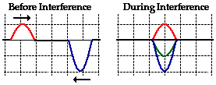Figure 4: The amplitudes of two approaching pulses combining, representing destructive interference.

Standing Waves
A standing wave, also known as a stationary wave, is a pattern of wave crests and troughs that remain stationary in a medium. A standing wave is a combination of two waves moving in opposite directions, each with the same amplitude and frequency. It occurs when waves are superimposed, leading to interference. Unlike traveling waves, which, as implied, travels through a medium in a certain direction, standing waves vibrate in place.
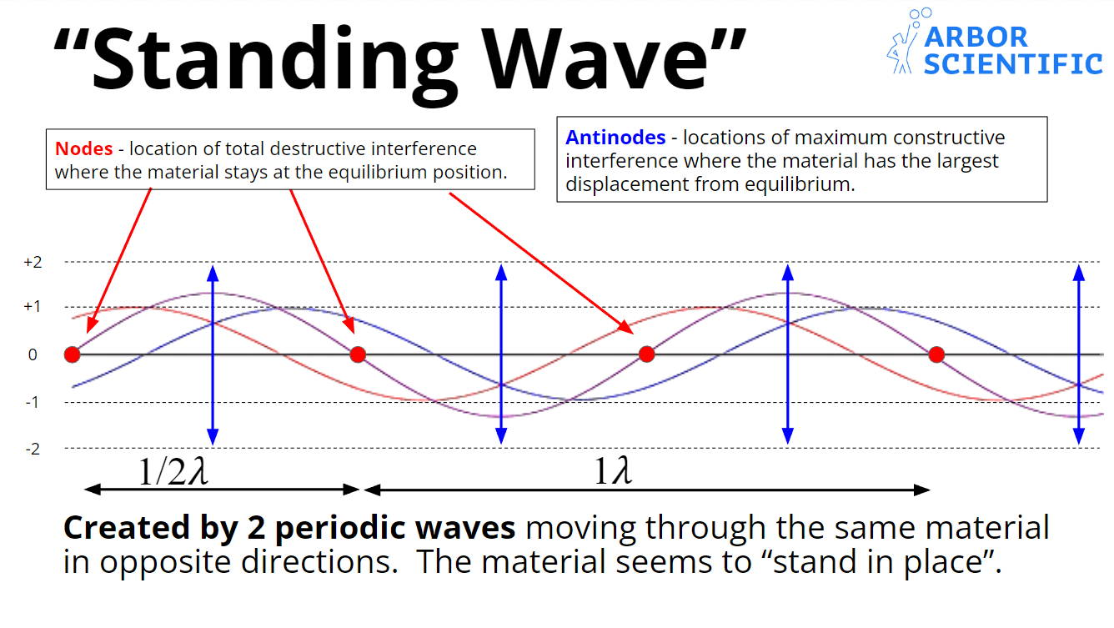Figure 5: A diagram representing standing waves and their properties.
Nodes are the stationary parts of a standing wave. Antinodes are the crest and trough of the wave.
When waves on a rope hit a fixed end, they are reflected and inverted. These reflected waves then combine with incoming incident waves. At certain frequencies the resulting superposition yields a standing wave, which has nodes, which never move at all, and antinodes, which have an amplitude twice as big as the original wave.
A rope of given length can support support standing waves of many different frequencies called harmonics, which are named based on the number of antinodes.
