Earthquakes*
(This idea or topic is excluded in the new Physical Science: Physics course.)
April 17, 2026
Table of Contents
1
What Are Earthquakes? 2
Seismic Waves 2
P-Waves 2
S-Waves 2
The Richter Scale 3

What Are Earthquakes?
An earthquake is the shaking of the surface of the Earth caused by a sudden release of energy in the lithosphere. They are measured by intensity; some are weak while others are very strong. The 2010 Haiti earthquake, for example, was a catastrophic magnitude earthquake that claimed between and lives.

Seismic Waves
Seismic waves are vibrations caused by movement inside Earth, later manifesting itself as an earthquake. There are two types of seismic waves: P-waves and S-waves.

P-Waves
P-waves (primary waves) are longitudinal waves that shake the ground in the direction in which the wave is traveling. Their speed depends on the nature of the rock through which they are traveling.
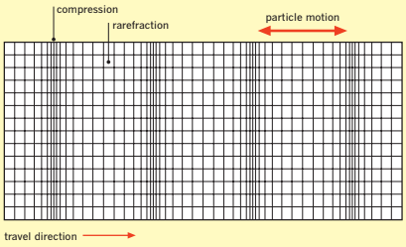Figure 1: A visualization of a P-wave traveling through a medium parallel to its motion.

S-Waves
S-waves (shear or secondary waves) are transverse waves that shake the ground in directions perpendicular to the direction of travel.
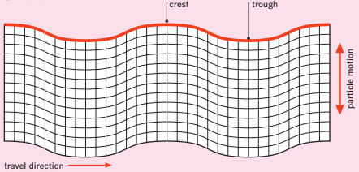Figure 2: A visualization of an S-wave traveling through a medium perpendicular to its motion.

The Richter Scale
Earthquake severity is measured on the logarithmic Richter scale. A magnitude earthquake is thus ten times more severe than a magnitude earthquake.

