Reflection**
(This idea or topic is a major aspect of the new Physical Science: Physics course.)
May 5, 2026
Table of Contents
1
Reflection of a Wave 2
Law of Reflection 2
Types of Reflection 2
Regular Reflection 2
Diffuse Reflection 3
Direction of Reflection 3

Reflection of a Wave
Reflection is the rebounding of a pulse or wave as it strikes a barrier. A light wave that reflects off an object cannot pass through. Hence, the material must be opaque. Objects that allow light to pass through are translucent.
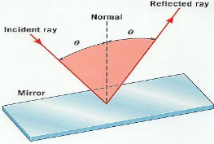Figure 1: A depiction of a reflected ray.

Law of Reflection
A ray that enters a mirror (i.e., the ray in the figure above) is called the incident ray, while the ray that is reflected off the mirror is called the reflected ray. The angle of incidence () and the angle of reflection () are equal.
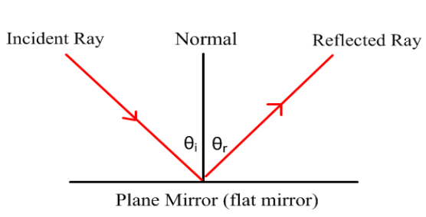Figure 2: The angle of incidence is equal to the angle of reflection on a plane mirror.

Types of Reflection

Regular Reflection
In regular reflection, a reflected image (picture) can be seen. This occurs most commonly on mirrors or objects with a smooth surface.
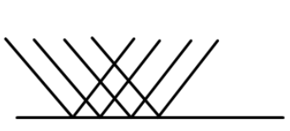Figure 3: Rays reflecting off a smooth surface (plane mirror).

Diffuse Reflection
In diffuse reflection, no reflected image can be seen because the surface is not smooth.
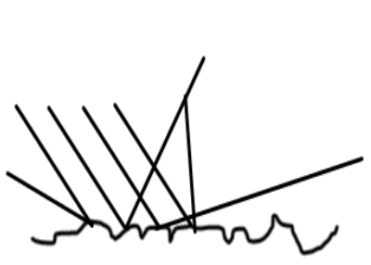Figure 4: Reflected rays scattered after reflecting off an irregular, rough surface.
The law of reflection is still obeyed because the normal is different at each point of reflection.

Direction of Reflection
When a wave is attached to a fixed end, the last particle of the medium is unable to move. The reflected wave is inverted at the boundary.
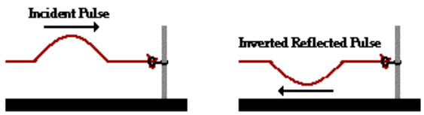Figure 5: A wave on a rope attached to a fixed end (a pole).

