Diffraction
May 12, 2026
Table of Contents
1
Diffraction of a Wave 2
Young’s Double-Slit Experiment 3
Polarization 3

Diffraction of a Wave
Diffraction refers to the spreading of wave fronts into a region behind a barrier in the path of a wave. This is a property that exists on all waves. Since light is also a wave, diffraction also occurs on it.
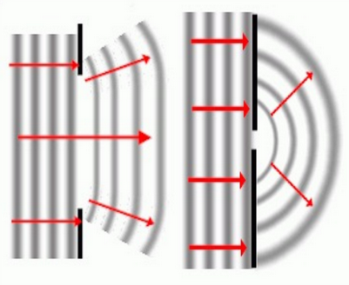Figure 1: The pattern that appears when diffraction occurs on a wave.
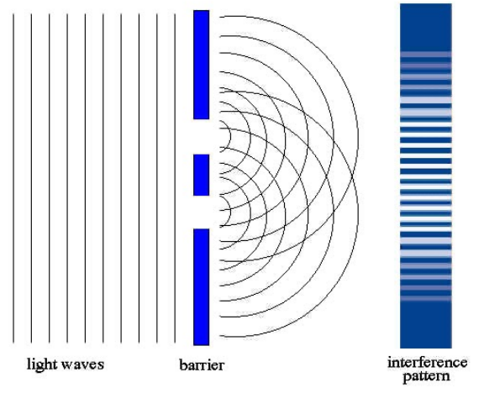Figure 2: Light waves diffracting over a barrier and engaging in interference.

Young’s Double-Slit Experiment*
(This idea or topic is excluded in the new Physical Science: Physics course.)
Young’s double-slit experiment proved that light behaves like a wave due to its properties of diffraction.

Polarization
Polarization is the phenomenon in which waves of light or other radiation are restricted in direction of vibration. It is essentially the filtering of light by direction. Recall that light is electromagnetic, so the oscillations of the medium particles are perpendicular to the direction of the wave.
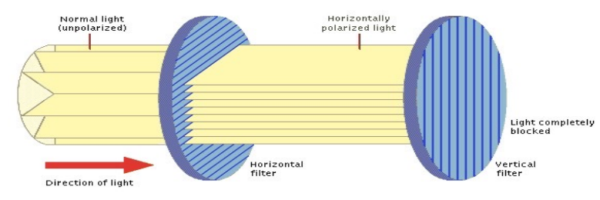Figure 3: A visualization of light polarization.
A common analogy is the picket fence analogy. When the pickets of two aligned fences are in the vertical direction, a vertical wave can make it through both fences. However, if the pickets of the second fence were horizontal, vertical vibrations will be unable to pass through the second fence.
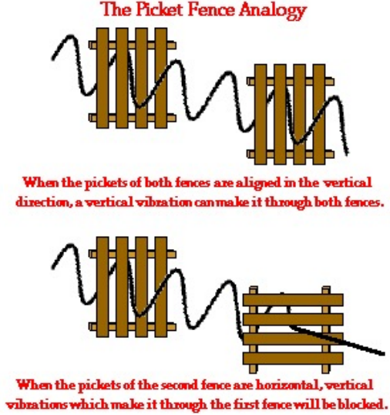Figure 4: An illustration of the picket fence analogy.

