Nuclear Power
May 29, 2026
Table of Contents
1
Nuclear Reactions* 2
Nuclear Fission 2
Nuclear Fusion 4
Radioactive Decay 4
The Mass Defect** 4

Nuclear Reactions*
(This idea or topic is excluded in the new Physical Science: Physics course.)
In all nuclear reactions, the sum of the atomic numbers of the reactants must equal the sum of the atomic numbers of the resultants. The total mass of the reactants must also equal the total mass of the resultants. There are multiple types of nuclear reactions: alpha decay, beta decay, positron decay, gamma decay, nuclear fission, and nuclear fusion.

Nuclear Fission
Unstable nuclei become more stable through a process known as nuclear fission, a process in which a nucleus breaks down into two or more smaller nuclei when bombarded with a neutron. Fission reactions lead to the emission of more neutrons, potentially causing a nuclear chain reaction in which nearby nuclei also break down due to the uncontrolled release of neutrons.
Humans have harnessed the power of nuclear fission reactions through the use of nuclear reactors, devices used to control and power fission nuclear chain reactions. They are often used to produce electricity, power production, and support research.
Fissile nuclei split after absorbing neutrons, releasing energy and (often two or three) more neutrons. The newly emitted neutrons can induce further fission of nearby nuclei. If left uncontrolled, these chain reactions can become detrimental. However, nuclear reactors mitigate this effect by meticulously controlling these reactions using control rods, which regulate the emission of neutrons by collecting them and preventing further fission reactions.
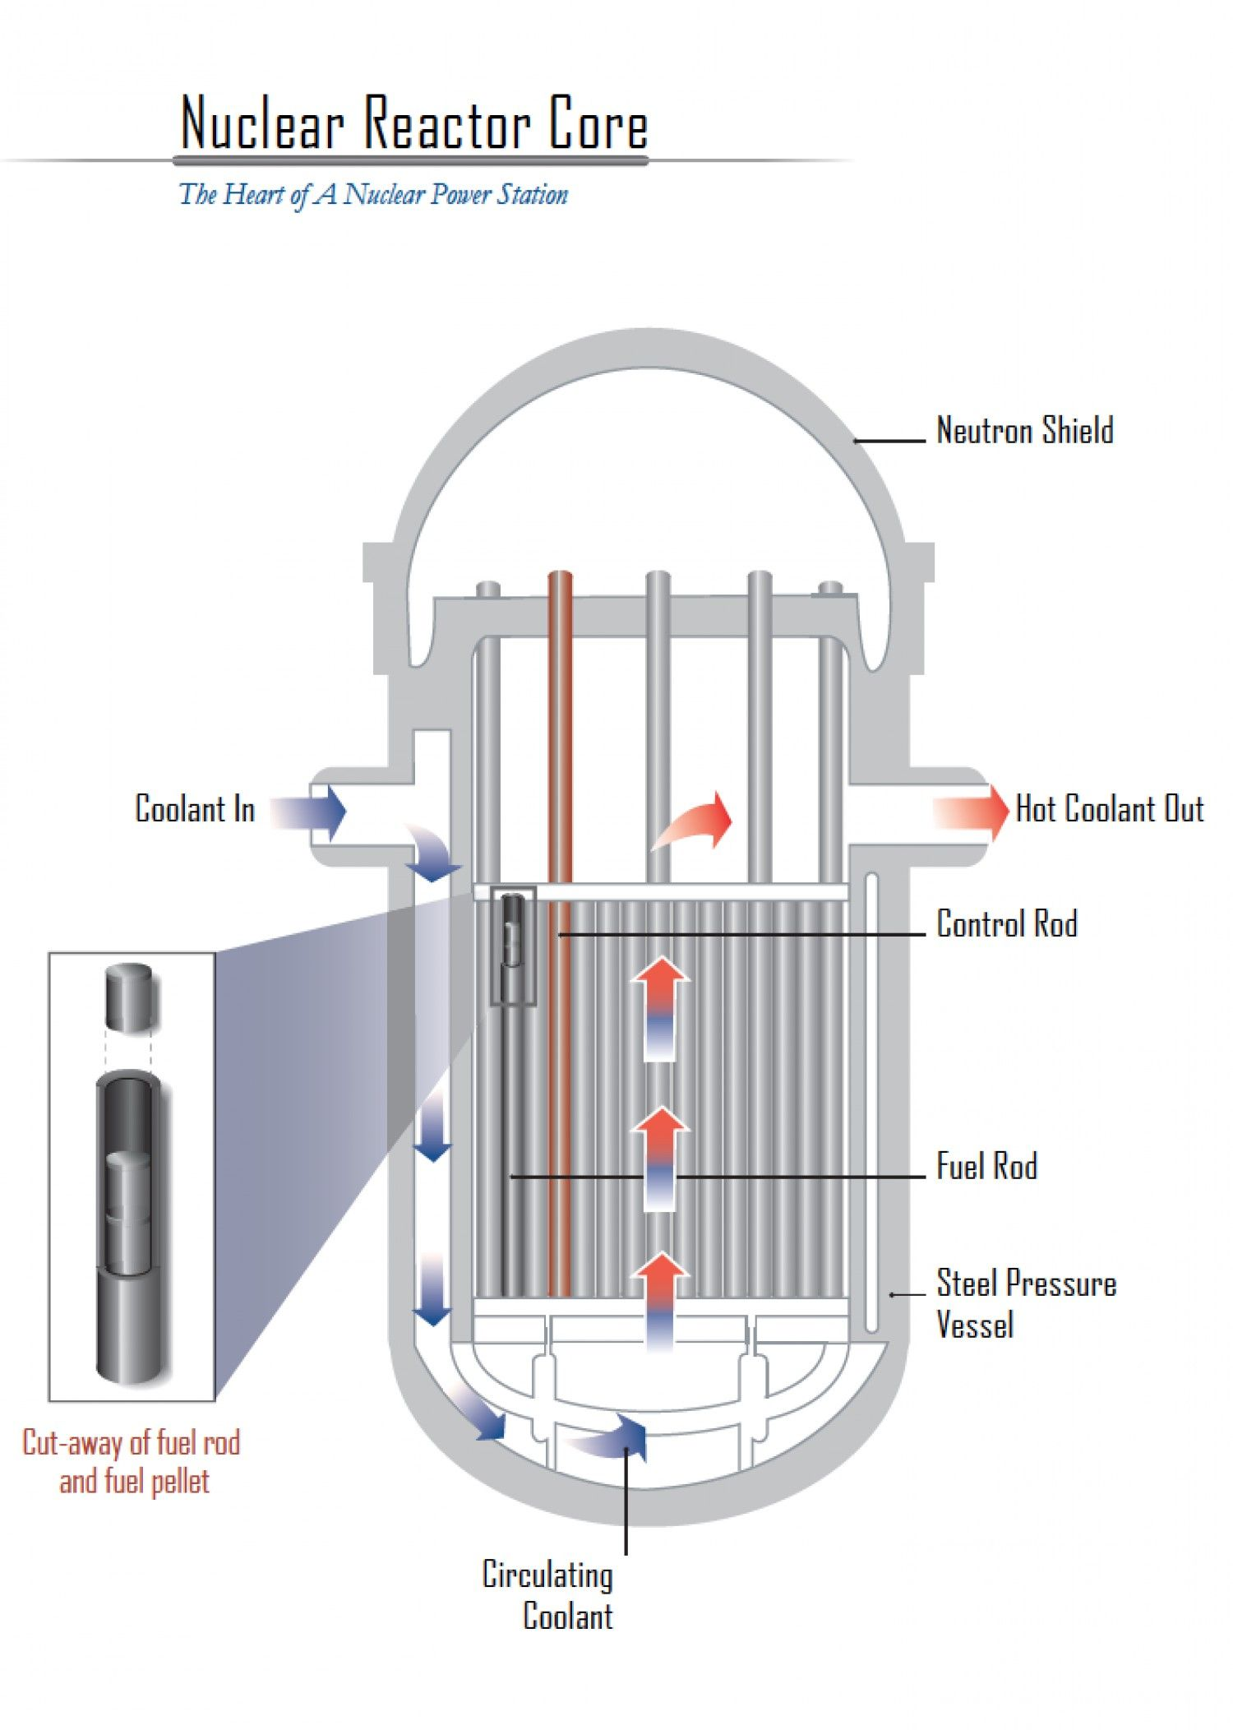Figure 1: A map of a nuclear reactor core.
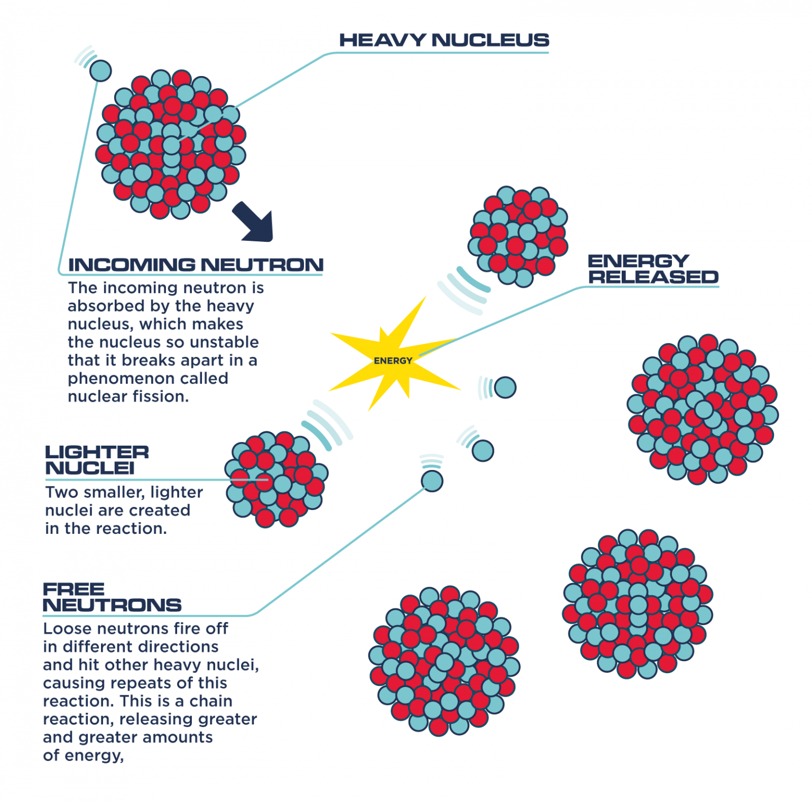Figure 2: The step-by-step process of nuclear fission.

Nuclear Fusion
Small nuclei become more stable by joining together to form larger nuclei, engaging in a process called nuclear fusion. The previously mentioned nuclear fusion reaction , for example, involves the joining of a hydrogen-2 atom and a hydrogen-3 atom.
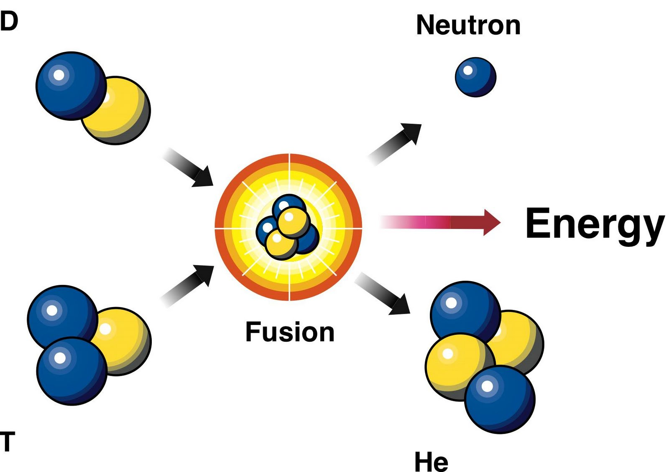Figure 3: A deuterium-tritium fusion reaction.

Radioactive Decay
Unstable nuclei spontaneously emit particles to become more stable. The three main types of radioactive decay are:
- Alpha Decay (): A helium nucleus () is emitted.
- Beta Decay (): A neutron turns into a proton and an electron, and the electron is ejected.
- Gamma Decay (): A high-energy photon is emitted, releasing only excess energy.

The Mass Defect**
(This idea or topic is a major aspect of the new Physical Science: Physics course.)
Protons, neutrons, and electrons are the main particles in an atom. However, when their masses are added up, you may notice that their sum is greater from the mass of the actual atom. This is because the “missing mass” was actually converted into energy. The mass defect is defined as the difference between the actual mass of an atom and the sum of its individual parts.
The binding energy is equivalent to the mass defect; it is the energy that holds the nucleus of an atom together (a strong force). This energy is released during nuclear fission and fusion.
Consider the following nuclear fusion reaction:
,
where has a mass of , has a mass of , has a mass of , and has a mass of . The mass defect of this equation is because it is the difference between the sum of the masses of the reactants (left side) and the sum of the masses of the resultants (right side).

