IN THE EXISTANCE OF SOUND WAVE: THE DEVELOPMENT OF BESSEL HORN WAVEGUIDE TO FOCUS SOUND WAVE ENERGY AND PRODUCE FIRE EXTINGUISHER EFFECT

Galang Persada Nurani Hakim

*Teknik Elektro, Universitas Mercu Buana, Jakarta*

Macross.galang.pes@gmail.com

Abstrak

Fire is a particularly feared hazard in confined enclosures such as in spacecraft and others. Therefore a fire extinguisher is very important equipment in spacecraft. Unfortunately existing fire extinguisher was using chemical compound which is dangerous. Therefore a new fire extinguisher method is needed to overcome this problem.

In this paper we proposed a new methods using sound wave to extinguisher fire. Our method was using a speaker and a Bessel horn waveguide to focus the sound wave to overcome the fire energy and thus put the fire down. Using Bessel horn waveguide we can focus the sound wave energy and amplify its energy at about 6.3 dB average at every frequency. Also using this method we can extinguish fire at 30 Hz and 40 Hz frequency with fire energy 2926 joule.

***Keywords****:* Bessel Horn Waveguide, Sound wave, fire extinguisher.

# **1. OVERVIEW**

Fire is a particularly feared hazard in confined enclosures such as in spacecraft. Therefore a fire extinguisher is very important equipment in spacecraft. A research in microgravity or none gravity combustion promises innovations and improvements in fire prevention and response for human-crew spacecraft [1]. Unfortunately the problem with existing fire extinguisher in space is, that it was using gaseous Halon 1301 (bromotri-fluoromethane). This gaseous has a high impact to the ozone depletion potential, which is now prohibited by international protocol [2]. Therefore a new fire extinguisher method is needed to overcome this problem, where a conventional fire extinguisher is hazardous [3].

Several researchers have developed new methods without chemical compounds such as using sound wave pulses [4] and electromagnetic pulses [5], [6]. But unfortunately an electromagnetic pulse sometimes can cause malfunctions in electronic equipment (such as power grid) [7]. Therefore an electromagnetic pulse fire extinguisher is out of question to be used near electronic devices.

Earlier researches showed that acoustic wave indeed can extinguish fire, but in order to extinguish fire more effectively D.A.R.P.A. researchers used a 46 cm speaker diameter and a sound wave tube that has same aperture diameter with the speaker diameter and 155cm length. D.A.R.P.A. researchers has manage to extinguish fire at 60Hz frequency [8] but the dimension of the equipment is very long hence it is not practical. Other researchers at SSeri Sound Engineering Research Institute used a sound lens to focus the sound wave [9] and managed to extinguish fire at frequency 100 Hz.

In this work, we combine D.A.R.P.A. study and SSeri Sound Engineering Research Institute study to extinguish fire using a speaker and a Bessel horn waveguide to focus the sound wave. Electronic equipment will be design to produce a sound wave within specific low frequency, also a Bessel horn waveguide is proposed to replace the sound wave lens and focus the sound wave energy. With this equipment we hope to produce a fire extinguisher effect application with no chemicals compound, low repulsion to the user, but also easy to use. We hope this research will become a part of a next generation of a portable electronic fire extinguisher in the future not only to be used in space but in land also.

# **2. Related Research**

Study of sound wave extinguisher is performed by researcher at D.A.R.P.A. [8], at SSERI researcher Ahn, I.S., Bae, M. J., et al [9] and Eryn B., Nathanial D. W., et al [4].

* 1. **Darpa Acoustic Instant Flame Suppression**

In 2012, DARPA, Defense Advanced Research Projects Agency of the United States, demonstrated that fire can be put out by surrounding it with two large sound speakers. The first sound fire extinguisher made by a Federal Defenses researcher was very huge and based on theory of initial principles, making it hard to be commercialized.

During the research the investigator found the extinction of a 15-cm non-premixed methane flame exposed to acoustic excitation ranging from 35-150 Hz with pressures ranging from 0.2 Pa (80 dB) to 112 Pa ( 135 dB). The sound source was a commercial speaker, and it ws measured its output with a high pressure decibel meter. Although the initial study described a frequency dependence of flame suppression (peak extinctions were observed near 60 Hz) when measuring acoustic pressures, later deduced that the observed peak in pressure at 60 Hz did not correspond to a peak in acoustic velocity at the location of the excited flame.

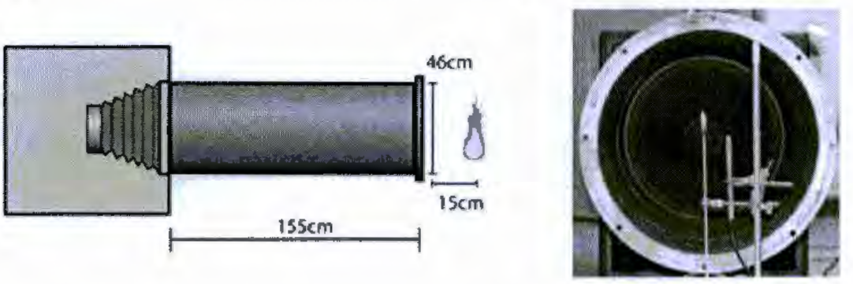

**Figure 1** Sound Fire extinguishers equipment use by DARPA [8]

The collimator provided an approximately planar wave front to interact with the flame. The observed several phenomena with the collimator within the collimator a 6 fold increase in pressure is measured at the speaker face compared to that of a bare speaker, measuring the flame 15 em in front of the collimator (170cm from the speaker face) has an increase of 144 Pa over the SPL measured 15 em from the open speaker (see figure 2.23). The majority of the experiments were performed with the flame source 15 em outside the collimator. The surveyed frequencies from 50-130 Hz, shows 50 Hz and 64 Hz are capable to extinguish fire with 2 meter range [8].

* 1. **Eryn Beisener, et al Acoustic Flame Suppression Microgravity Environment**

An Experiments and numerical simulations of acoustic effects on fire have shown that both frequency and sound velocity may affect the surface of a flame. An Eryn Beisener research applied this new method to extinguish fire in a microgravity environment. The measurements data was taken from an Arduino-based sensor system to validate the result. A Zippo lighter is ignited in microgravity and then displaced from the base of the flame and suppressed using surface interactions with single tone acoustic waves to extinguished the flame (see figure 2.24). The analysis of data collected shows that the acoustic flame suppression measurement techniques are effective to finding qualitative differences in extinguishing in microgravity and normal gravity. Further, the results suggest that the suppression may be more effective in a microgravity environment than in a normal (1g) environment and may be a viable method of extinguishing fires during space flight [4].

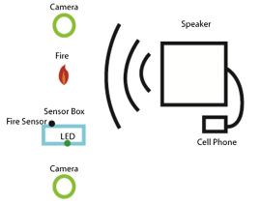

**Figure 2** Sound Fire extinguishers diagram in micro gravity [4]

According to the data collected in this research, acoustic flame suppression works in both regular gravity and microgravity and the Arduino-based sensor system is effective in gathering data for analysis. The raw accelerometer readings are adequate for reproducing the parabolic motions of the aircraft and the LED is adequate for aligning the data file with times tamps to the video. The fire sensor is able to read the fire with correlated digital and analog outputs, providing a 92 % accuracy in time comparison to the video when half-voltage is used as a baseline. In the microgravity environment, the flame suppression is qualitatively distinct and appears more effective, though further studies are recommended. The flame was suppressed with more efficiency at 74.0 Hz and was extinguished more quickly at the 30.6 Hz frequency, although a range of frequencies were effective with adequate acoustic pressure [4].

* 1. **Ahn, I.S., et al Sound Lens for Sound Fire Extinguisher**

The basic mechanism for every sound fire extinguisher is the low frequency. The sound fire extinguisher need produces low frequency sound less than 100 Hz, its vibration energy touches the flame, scatters its membrane, and then blocks the influx of oxygen, so the flame goes down. A Sound fire extinguisher is developed based on principle of quenching fire by blocking inflow of oxygen with contacting vibration energy from low frequency sound to fire and then, and thus lowering its temperature [9].

Ahn, I.S., et al a research team of SSERI, the Sori Sound Engineering Research Institute, introduced an improved device. The most important improvement to be found is the installation of a sound lens (see figure 2.25). The lens concentrates the sound generated (roughly 10 times stronger) from the speaker into one place and makes it possible to reach the fire more directly. In other words, it amplifies sound to maximize its efficiency without losing the power of sound which might be caused by the interference of the air. Figure 2.17 shows experiment for sound fire extinguisher.

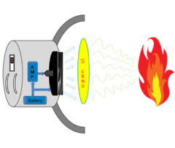

**Figure 3** Sound Fire extinguishers with sound lens [9]

* 1. **This Work**

Based on DARPA study, we will use an ordinary subwoofer to produce the sound wave energy [8]. In this work we propose the use of 10 Inch speaker which is less weight than DARPA (use 46cm speker diameter). Based on Eryn Beisner (he is using software generated sound pulse at android mobile phone ) [4] we are using sound pulse generated software at laptop. We are using laptop because it can generate sound pulse with high amplitude better from android mobile phone. Based on the Sori Sound Engineering Research Institute study we propose the use of Bessel horn waveguide to replace the sound lens. this replacement is made to avoid high cost in using an acoustic lens, where using Bessel horn waveguide it was cheaper because it can produce using 3D Printer. Also based on the Sori Sound Engineering Research Institute study we propose of using 2 stage amplifiers (which is pre-amplifier and power amplifier the sseri researcher using 1 stage amplifier) [9] to prevent clipping.

**3.** **HARDWARE DESIGN AND MEASUREMENT METHOD**

The system hardware that has been built generally consists of circuit blocks as shown in the figure 3.1 below:

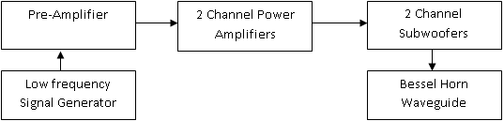

**Figure 4** System Block

In this research we only design low signal generator, pre-amplifier, 2 channel power amplifiers, Waveguide Bessel horn, and 10 inch subwoofer.

1. **Low Signal Generator**

In this experiment we are using audio generated software which is Dual Function Generator Version 1.10. This software is design by Grant Connel in 2011. It is a simple Windows interface program allowing your computer to Generate two audio waveforms simultaneously using the PC sound card. Figure 3.2 show the software that uses to generate audio signal. The program is a Windows soft panel operating as a dual channel function generator. The useful frequency of operation is from 2 Hz to 20000 Hz. The program uses computer sound card to generate the audio waveforms.

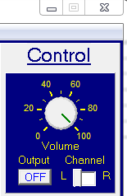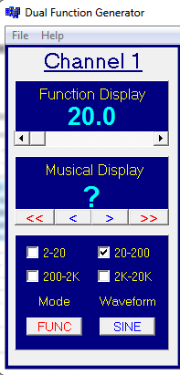

**Figure 5** Audio Signal Generated Software

1. **Audio Pre-Amplifier**

In this design we are using a low cost audio pre-amplifier which is LM386. The LM386 is a low audio amplifier designed for use in low voltage consumer applications. The gain is internally set to 20 to keep external part count low, but the addition of an external resistor and capacitor between pins 1 and 8 can increase the gain to any value from 20 to 200. Figure 3.3 show the schematic audio pre-amplifier with 200 dB gain. It has wide power supply operating, from 4 Volt to 18 Volt. It also has wide frequency response with bass boost from 20 Hz to 20 KHz.

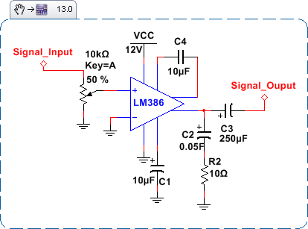

**Figure 6** LM386 Audio Amplifier schematic with 200 Gain [14]

1. **2 Channel Power Amplifier**

In this design we are using a low cost audio power amplifier which is STK465 from sony electronic coporation. The STK465 is a thick film hybrid IC stereo power amplifier module with two input channels and two output channels. It has minimum 30 watt output both on left-right audio channel with resistance load at about 8 Ohm loudspeaker. Figure 3.3 show the schematic audio power amplifier with STK465. STK465 also has wide frequency respon from 10 Hz to 100 KHz. STK465 require split power supply to be operated, but it has a wide power supply range from +/- 24 to +/- 41 Volt DC making it more interesting.

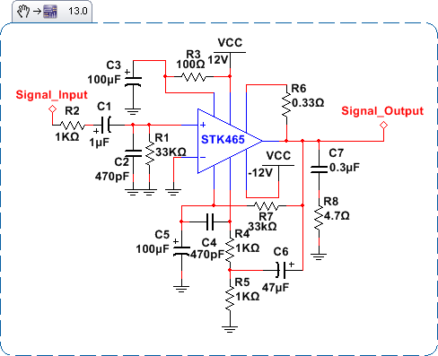

**Figure 7** STK456 Audio Power Amplifier Left-Right Channel schematic [15]

1. **LoudSpeaker – SubWoofer**

In this research we are using 10 inchi subwoofers with dual coil (dual channel) Hollywood HW10. With resistance load 4 Ohm for both channel (Right-left channel) Hollywood HW10 subwoofers has capabillieties of delivering 300 Watt RMS peak power handling. It has a wide frequency response from 24 Hz to 550 Hz with 91.20 dB sensitivity.

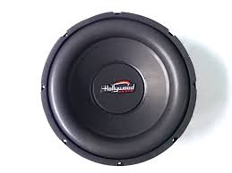

**Figure 8** Hollywood HW10 Subwoofers

1. **Bessel Horn Waveguide**

Bessel horn is a waveguide with wide entry horn (waveguide) and narrow exit. This particular horn has been design so that it’s capable to compress the sound wave, thus its gain and directivity will increase in logarithmic. Figure below show design of waveguide Bessel horn tht has been used in this experiment. An input aperture was design so that it can match the ordinary subwoofer (in this case 10 inch subwoofer diameter). An output aperture is design so we can change its exit diameter with easy, this is need to be done because we need to find the maximum exit aperture which can produce the maximum sound wave energy.

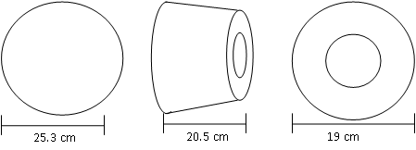

**Figure 9** Waveguide Bessel Horn design. Entry point of view (Left), Side pint of view (middle), and Exit point of view (Right)

1. **Bessel Horn Waveguide**

We design an experiment to show and measure effectiveness of this equipment in order to estinguish fire. Figure 3.8 show flowcharts of the measurement experiment.

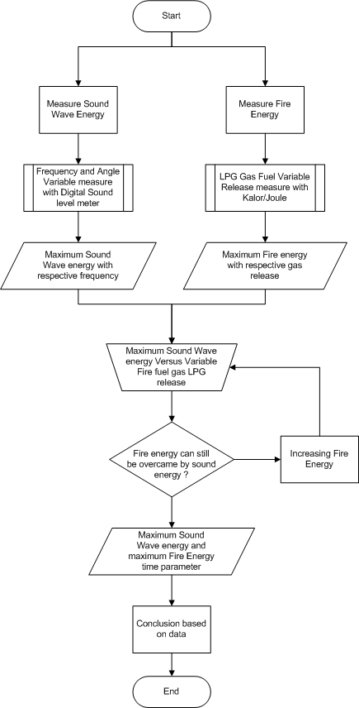

**Figure 10** Research Design flowcharts Method

**4.** **TESTING AND ANALYSIS**

We divide the experiment into 6 things which is sound wave energy frequency measurement with the effect of the sound wave guidance tube, sound wave energy frequency measurement with the effect of the respective angle, fire energy measurement, maximum sound wave energy frequency measurement versus maximum fire energy, effectiveness sound fire extinguisher with range variable, and sound fire extinguisher energy with Bessel horn exit aperture variable.

**4.1 Fire Extinguisher System Output Measurement**

This measurement is conduct to shown Fire Extinguisher system response when a sinusoidal signal is added as an input system. Using Digital clamp meter we measure the ampere and the voltage for each channel. Measurement is conduct using frequency variable from 10 Hz to 200 Hz. Figure 11 and table 1 shows fire Extinguisher system output measurement result.

**Table 1** Fire Extinguisher System Output Measurement

|  |  |  |  |  |
| --- | --- | --- | --- | --- |
| **No** | **Frequency (Hertz)** | **Amplifier Output (Ampere) x2 Channel** | **Amplifier Output (Volt) x2 Channel** | **Ouput in Watt** |
| 1 | 10 | 2.16 | 11.89 | 102.73 |
| 2 | 20 | 2.25 | 13.94 | 125.46 |
| 3 | 30 | 2.04 | 15.34 | 125.17 |
| 4 | 40 | 2.17 | 15.49 | 134.45 |
| 5 | 50 | 2.54 | 15.31 | 155.55 |
| 6 | 60 | 2.72 | 14.83 | 161.35 |
| 7 | 70 | 2.79 | 14.69 | 163.94 |
| 8 | 80 | 2.81 | 14.82 | 166.58 |
| 9 | 90 | 2.80 | 15.08 | 168.90 |
| 10 | 100 | 2.83 | 15.75 | 178.29 |
| 11 | 110 | 2.72 | 15.50 | 168.64 |
| 12 | 120 | 2.68 | 15.82 | 169.59 |
| 13 | 130 | 2.64 | 16.05 | 169.49 |
| 14 | 140 | 2.63 | 16.24 | 170.84 |
| 15 | 150 | 2.59 | 16.55 | 171.46 |
| 16 | 160 | 2.54 | 16.59 | 168.55 |
| 17 | 170 | 2.50 | 16.77 | 167.70 |
| 18 | 180 | 2.46 | 17.02 | 167.48 |
| 19 | 190 | 2.43 | 17.17 | 166.89 |
| 20 | 200 | 2.40 | 17.51 | 168.10 |

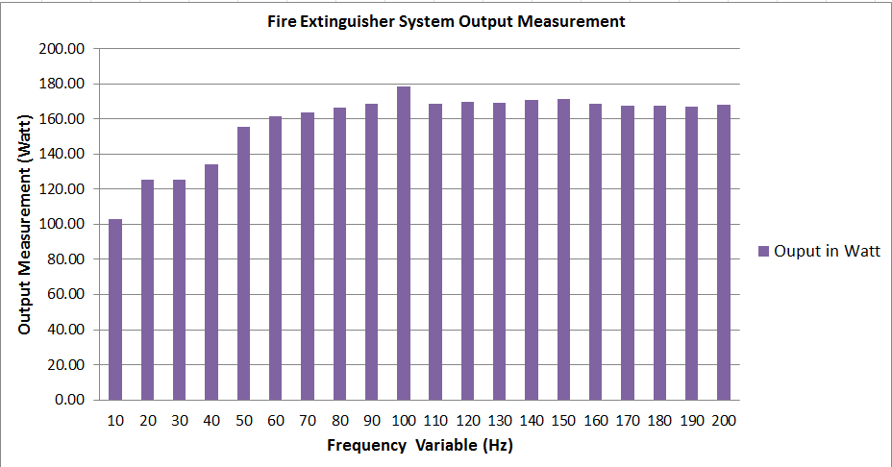

**Figure 11** Fire Extinguisher System Output Measurement

**4.2 Sound Wave Energy Measurement With & Without Waveguide Tube**

This measurement is conduct to shown system response when a waveguide is added to the audio system. Using digital sound level meter, measurement is conduct in front of speaker for less than 5 cm. On tables 2 we do sound wave measurement energy with frequency tuning at 10 Hz interval from 10 Hz until 200 Hz (see column frequency). Measurement is conduct using 2 different methods, which is using sound waveguide and other not using sound waveguide (see column measurement without tube and measurement with tube). Figure 12 shows measurement result using sound wave tube and without using sound wave tube. We can see that the sound wave energy varies respectably, as frequency higher and so the sound wave energy higher. Also we can see that the sound wave tube indeed can focus the sound wave energy, we can see the different in the measurement result when not using sound wave guide and after using sound wave guide the sound wave energy was higher at average 6.3 db.

**Table 2** Sound Wave Energy Measurement w/o Sound Wave Guidance Tube

|  |  |  |  |
| --- | --- | --- | --- |
| **No** | **Frequency (Hertz)** | **Measurement Without Tube (dBA)** | **Measurement With Tube (dBA)** |
|
| 1 | 10 | 104 | 108.6 |
| 2 | 20 | 100 | 101.4 |
| 3 | 30 | 98.6 | 103.9 |
| 4 | 40 | 99 | 106.8 |
| 5 | 50 | 100.9 | 108.7 |
| 6 | 60 | 102.8 | 109.2 |
| 7 | 70 | 103.6 | 109.2 |
| 8 | 80 | 106.1 | 110.8 |
| 9 | 90 | 106.1 | 112.1 |
| 10 | 100 | 108.2 | 113 |
| 11 | 110 | 109.2 | 114.4 |
| 12 | 120 | 108.2 | 115 |
| 13 | 130 | 108.4 | 115.4 |
| 14 | 140 | 109.4 | 117.3 |
| 15 | 150 | 110 | 118.2 |
| 16 | 160 | 111.1 | 119.4 |
| 17 | 170 | 111.2 | 120.2 |
| 18 | 180 | 111.3 | 120 |
| 19 | 190 | 111.4 | 118.9 |
| 20 | 200 | 112.4 | 115.4 |

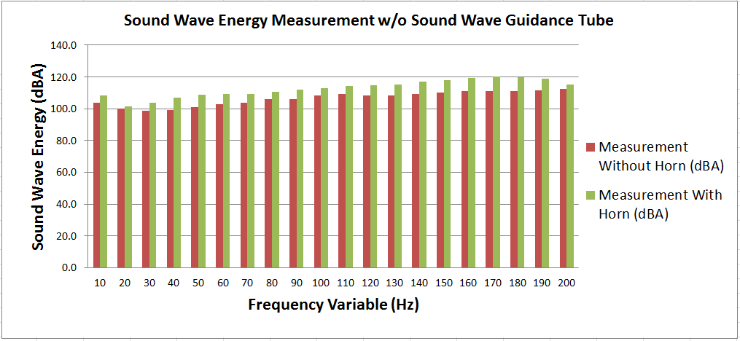

**Figure 12** Sound Wave Energy Measurements w/o Guidance Tube

**4.3 Fire Energy Measurement**

This measurement is conduct to shown maximum fire energy that can produce by LPG gas stove that using in this research. We are using 10 mL water with environment temperature (30o Celsius) until the water reach the boiling point (100o Celsius). Table 3 and figure 13 shows the measurement result. From figure 13 we can see that the fire energy increase as a function of LPG gas stove knob angle position. When gas stove knob reach 90o the fire energy has reach its full power.

**Table 3** Fire Energy Measurements

|  |  |  |  |
| --- | --- | --- | --- |
| **No** | **Angle Position Kenob (Degree)** | **Fire Energy (Joule)** | **Water time from 30 Celcius to 100 celcius (Second)** |
| 1 | 0 | 0.00 | 0.00 |
| 2 | 30 | 965.58 | 13.00 |
| 3 | 60 | 1931.16 | 26.00 |
| 4 | 90 | 2926.00 | 40.00 |

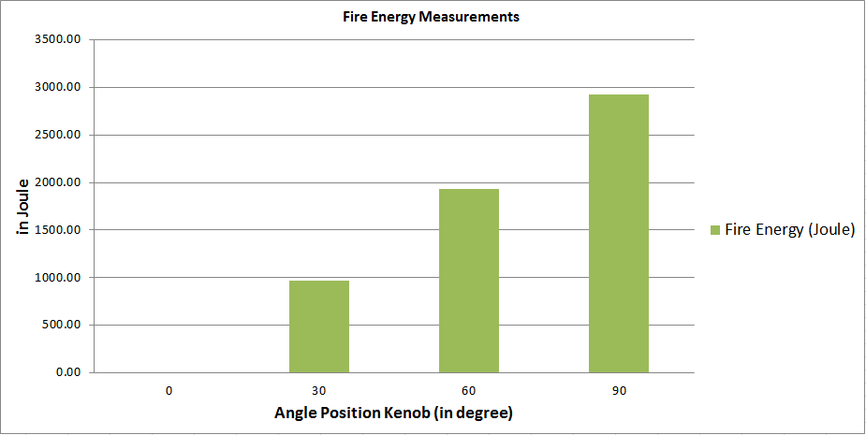

**Figure 13** Fire Energy Measurements

**4.4 Sound Wave Energy versus Fire Energy**

This measurement is conduct to shown maximum sound wave energy that produced by the audio system with additional sound wave guidance that can overcome the fire energy produce by the LPG gas Stove. This experiment is to show the effectiveness of this sound fire extinguisher. Based on fire extinguisher chemical agent, sodium bicarbonate acid liquid it has the longest period of time to put down fire compare with other chemical agents. It has maximum 180 second effectiveness to put down fire (where conventional fire extinguisher duration at about 180 Seconds) [18], therefore this design need more effective from existing fire extinguisher. Table 4 and figure 14 shows the measurement result. From figure 14 we can see that the most effective sound wave frequency to put the fire down is at 30 Hz – 40 Hz. Even though the most powerful sound wave occurs in 170 Hz but sound wave in this frequency cannot put the fire down at 3 minutes time, therefore frequency besides 30-40 Hz cannot effective against fire.

**Table 4** Sound Wave Energy versus Fire Energy

|  |  |  |  |  |
| --- | --- | --- | --- | --- |
| **No** | **Frequency (Hertz)** | **Measurement With Tube (dBA)** | **Maximum Fire Energy (Joule)** | **Time to Put Down Fire (Second)** |
| 1 | 10 | 108.60 | 2940.00 | > 180 |
| 2 | 20 | 101.40 | 2940.00 | > 180 |
| 3 | 30 | 103.90 | 2940.00 | 3 |
| 4 | 40 | 106.80 | 2940.00 | 3 |
| 5 | 50 | 108.70 | 2940.00 | > 180 |
| 6 | 60 | 109.20 | 2940.00 | > 180 |
| 7 | 70 | 109.20 | 2940.00 | > 180 |
| 8 | 80 | 110.80 | 2940.00 | > 180 |
| 9 | 90 | 112.10 | 2940.00 | > 180 |
| 10 | 100 | 113.00 | 2940.00 | > 180 |
| 11 | 110 | 114.40 | 2940.00 | > 180 |
| 12 | 120 | 115.00 | 2940.00 | > 180 |
| 13 | 130 | 115.40 | 2940.00 | > 180 |
| 14 | 140 | 117.30 | 2940.00 | > 180 |
| 15 | 150 | 118.20 | 2940.00 | > 180 |
| 16 | 160 | 119.40 | 2940.00 | > 180 |
| 17 | 170 | 120.20 | 2940.00 | > 180 |
| 18 | 180 | 120.00 | 2940.00 | > 180 |
| 19 | 190 | 118.90 | 2940.00 | > 180 |
| 20 | 200 | 115.40 | 2940.00 | > 180 |

**Figure 14** Fire Energy Measurements

**4.5 Sound Wave Energy and Fire Energy with Bessel Horn exit Aperture Variable**

In theory before the sound wave can be used to put the fire down as long as it focuses using a waveguide that can compress and release the sound wave energy. This measurement is to shown the correlation of the compressed sound wave versus its effectiveness to extinguisher fire with variable exit waveguide aperture of a Bessel horn. From table 5 and figure 15 we can see that the most effective diameter of sound wave energy to put the fire down is at about 7 cm until 11 cm, if the diameter was more than 11cm the sound wave energy cannot effective against fire energy.

**Table 5** Sound Wave Energy versus Fire Energy with Exit Aperture Variable

|  |  |  |
| --- | --- | --- |
| No | Exit Aperture Variation (in cm) | **Time to Put Down Fire (Second)** |
| 1 | 1 | > 180 |
| 2 | 2 | > 180 |
| 3 | 3 | > 180 |
| 4 | 4 | > 180 |
| 5 | 5 | > 180 |
| 6 | 6 | > 180 |
| 7 | 7 | 3 |
| 8 | 8 | 3 |
| 9 | 9 | 17 |
| 10 | 10 | 17 |
| 11 | 11 | 17 |
| 12 | 12 | > 180 |
| 13 | 13 | > 180 |
| 14 | 14 | > 180 |
| 15 | 15 | > 180 |
| 16 | 16 | > 180 |
| 17 | 17 | > 180 |
| 18 | 18 | > 180 |

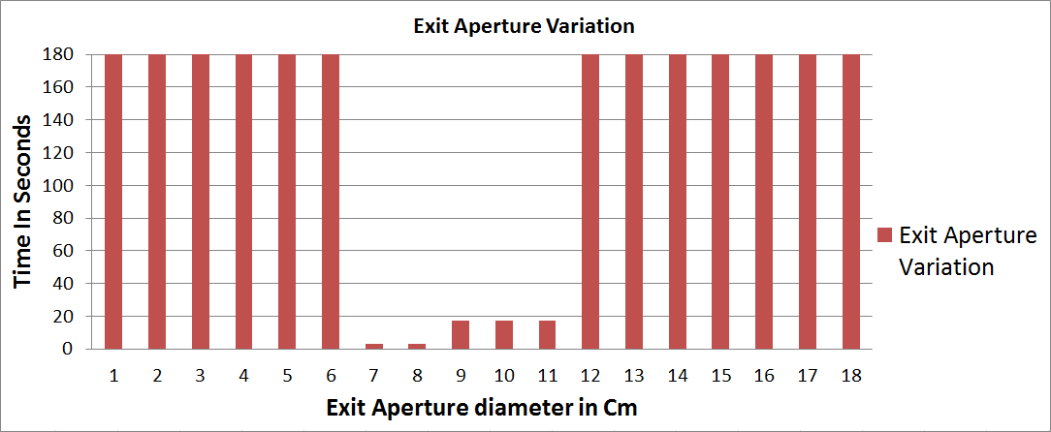

**Figure 15** Bessel Horn Exit Aperture Variations

# **5. Conclusion**

# After we do measurement, testing, and analysis based on respective measurement, we had a conclusion:

# 1. We see the maximum sound wave energy is produce by the audio system is happening when frequency is tuned at 170 Hz, but this frequency is only generate a sound pollution that high enough for human hearing, but not in the way to put fire down.

# 2. A receiver angle position doesn’t have any effect on the sound wave energy measurement, therefore we conclude that an angle to put the fire down it has the same effect whether it was 90o or 0o angle.

# 3. A tube that can increase (to focus) the sound wave energy acts as a frequency resonator and a sound lens, therefore it can increase the sound wave energy.

# 4. The optimum sound wave energy that can put the fire down is at 30 Hz – 40 Hz and not at 170 Hz.

# 5. The fire extinguisher using sound wave is effective equipment. It can put the fire with energy about 2926 Joule down in just 3 second using 30 Hz – 40 Hz frequency.

# 6. The fire extinguisher is effective when using at less than 1.3 meter range with the Fire Source, also it only effective when using using a bessel horn waveguide with exit aperture between 7 cm until 11 cm.

# References

[1] R. Friedman and D. L. Uietrich, “Fire Suppression In Human Crew Spacecraft,” Halon Altern. Tech. Work. Conf., 1991.

[2] R. Friedman, “Fire Safety in the Low-Gravity Spacecraft Environment,” NASA Glenn Res. Cent., vol. 01–1937, 1999.

[3] D. Plaks, E. Nelson, N. H. J. Espinosa, Z. Coley, C. Tran, and B. de Mayo, “Zero-g acoustic fire suppression system,” Acoust. Soc. Am. J., vol. 118, no. 3, p. 1945, 2005.

[4] E. Beisner, N. D. Wiggins, M. Rosales, K. Yue, J. Penny, J. Lockridge, R. Page, A. Smith, and L. Guerrero, “Acoustic Flame Suppression Mechanics in a Microgravity Environment,” Microgravity Sci. Technol., vol. 27, pp. 141–144, 2015.

[5] T. S. Call and D. B. Schwartz, “Electric Fields For Flame Extinguisher,” HQ AFCESA/RACF, no. ESL-TR-91-54, 1991.

[6] R. T. Schneider, R. J. Hirko, J. D. Cox, and N. H. Weinstein, “Phase II : Fire Extinguishment by Electro- Magnetic Fields,” ARFL, no. AFRL-ML-TY-TR-2002-4516, 2002.

[7] Oak Ridge National Laboratory, “Electromagnetic Pulse : Effects on the U . S . Power Grid,” 2008.

[8] D. A. R. P. A. Defense Advanced Research Projects Agency, “Instant Flame Suppression Phase TI - Final Report,” pp. 1–23.

[9] I.-S. Ahn, H.-W. Park, M.-J. Bae, and S.-G. Bae, “A Study on a Sound Extinguisher Using Sound Lens,” 171st ASA Meet., no. 516, pp. 2–7, 2016.

[10] G. M. Ballau, Handbook For Sound Engineers, 4th ed. Focal Press, Elsevier, 2008.

[11] S. N. Y. Gerges, G. A. Sehrndt, and W. Parthey, “Noise Sources,” W. H. O. World Health. Organization, 1992.

[12] Thomas D. Rossing and Neville H. Fletcher, Principles of Vibration and Sound Second Edition. Springer-Verlag New York, 2004.

[13] V. S. Bachtiar, Y. Dewilda, and B. Wemas, “USAHA PENGENDALIAN PADA UNIT PRODUKSI PADA SUATU INDUSTRI DI KOTA BATAM,” J. Tek. Lingkung. UNAND 10, vol. 2013), no. 51, pp. 85–93.

[14] Training Material K3 Bidang Penanggulangan Kebakaran. Kementrian Departemen Tenaga Kerja. Indonesia. 1996.

[15] National Semiconductor, “LM386 Low Voltage Audio Power Amplifier,” no. August, pp. 1–9, 2000.

[16] Sanyo Semiconductor Device, “Datasheet Thick Film Hybrid Stk-465, 2 Power 2 Channel 10-30 W min AF Power,” p. 9.