Deploying a web server in Windows instance

**Task 1 :** Create a windows instance using AMI : **Windows 2012 R2 base**

* Login to your AWS Account as a "**root user"**.
* Click on "**Services"** dropdown menu bar and select "**EC2**" ( Elastic Cloud Compute ) .

Machine generated alternative text:
aws 
History 
Console Home 
Billing 
EC2 
Services 
Step 1 
Resource Groups 
Compute 
EC2 
Lightsail 
Lambda 
Batch 
Elastic Beanstalk 
Blockchain 
Amazon Managed Blockchain 
Satellite 
Ground Station 
Analytics 
Athena 
EMR 
CloudSearch 
Elasticsearch Service 
Kinesis 
Harshitha 
Business 
Alexa for al 
Amazon Ch 
WorkMail 
Amazon HC 
Step 2 

* It will redirect to the below page and then click on **"Instances"**.

Machine generated alternative text:
aws 
Services 
Resource Groups 
(D Welcome to the new EC2 console! 
Harshitha 
N ew EC2 Expenence X 
EC2 0 ash rd 
E vents 
Instances 
Instances 
Instance Types 
Launch Temp 
Spot Requests 
Savings plans 
Reserved Instances 
Step 3 
Were redesigning the EC2 console to rn*e it easier to use and improve We'll new screens peiodicauy. We encourage you to try them and 
let us know whee we can make improvements. To switch between the old console and the new console, use the New EC2 Experience toggle. 
Resources 
You are using the following Amazon EC2 resources in the US East (Ohio) Region: 
Account attributes 
Supported platfoms 
• vpc 
Default VPC 
vpc-ce54f7a5 
Settings 
EBS encryption 
Zones 
Default credit specification 
Console experiments 
x 
Explore AWS 
Running instances 
Dedicated Hosts 
Volumes 
Key pa i rs 
placement groups 
Elastic IPS 
Snapshots 
Load balancers 
Sec—Tity groups 
Dedicated Hosts 
Capacity Reservations 
Images 
Elastic Bloc k Store 
Q Feed back 
English (US) 
Easily Size, and deploy MiUOSOft SQL Server Always On availability groups on AWS using 
the AWS Wizard for SQL Sewer. 

* It will redirect to the below page and click on "**Launch instance**".

Machine generated alternative text:
aws 
Services v 
Resource Groups 
Launch Instance 
Actions v 
Harshitha 
New EC2 Experience 
Teu 
EC2 Dashboard 
Events 
Tags 
Limits 
V Instances 
I "stances 
Instance Types 
Launch Templates 
Spot Requests 
Savings Plans 
You do not nave any running instances in tnis region. 
First time EC27 Check Out the Getting Started Guide _ 
Click the Launch Instance button to start your own server. 
Launch Instance 
Step 4 
Filler by tags and attributes or search by keyword 
Select an instance above 

* Check box the "**free tier only"** (Optional).

**Step 1:** Choose an Amazon Machine Image (AMI) " **Windows 2012 R2 base** ".

* Click on "**Select"** button.

Machine generated alternative text:
aws 
I. C noose AMI 
Services 
Resource Groups 
Cæf'gure Secunry 
Cancel and Exit 
select 
64-bit (x86) 
select 
64-bit (X86) 
select 
64-bit (X86) 
2 Cncose Instance Conngure Instance 
4 S AE lag S 
Step 1: Choose an Amazon Machine Image (AMI) 
W. ndows 
W. ndows 
SUSE Linux 
Microsoft Windows Server 2016 With SQL Server 2019 Enterprise - ami-063e4fffe50ceb235 
Microsoft WndOwS 2016 Datacenter edition, Microsoft SOL Server 201 g Enterprise. (EnglShl 
Rwt tym type ENA V" 
Microsoft Windows Server 2012 R2 Base - 
Microsoft WndOwS 2012 R2 Standard edition With 64-bitarchitectu@ (Engl*hl 
Step 5 
Rwt tym type ENA V" 
SUSE Linux Enterprise Server 12 SP5 (HVM), SSD Volume Type - ami-Of84a 134e8f9d527b 
SLISE Enterprise Server 12 Service Pack S (HVM). EBS General Purpose (SSD) Volume Type. Pub5C Cbud, Advanced Systems 
Management, Web and Scripting, and Legacy modules enabled 

**Step 2:** Choose an Instance Type

* Choose the "**free tier eligible t2 micro"** instance type and click on "**Next: Configure instance Details."**

Machine generated alternative text:
aws 
Groups 
Step 2: Choose an Instance Type 
Amazon EC2 prov&-s Selecticn Of instance to "t different use cases Instances are virtual servers that Can run They have Varying Of CPU, memory. 
capaco, and give tree to cncn* tne appropriate mix OT rescuces 'or your applications Learn nue about instance tvses anc tney can meet your computing needs 
F itter by: All types 
Colm ns 
E B S-opti,nited 
previous 
Performance . 
Low to Moderate 
Low to uoderate 
to Moderate 
to Woderate 
Low to Moderate 
Next Conngure Instance 
selecEC: t2miro Nana* ECL's, 1 'CPUs, 26 GHz. Intel Xeon Family, 1 men-or'. EBS 
amily 
General purpose 
Ge 
Ge 
t2.nano 
t2srrøll 
12 
"CPUs 
(GiB) . 
Instance Storage (GBI W) . 
Eas only 
Eas only 
Eas only 
Eas only 
Cancel 

**Step 3:** Configure Instance Details

* Modifications to be done :
  1. Choose "**Auto-assign Public IP**" as "**Enable**"
  2. "**Shutdown behavior**" to "**Stop**" from dropdown menu
  3. Enable the option "**Protect against accidental termination**"
* Click "**Next: Add Storage**".

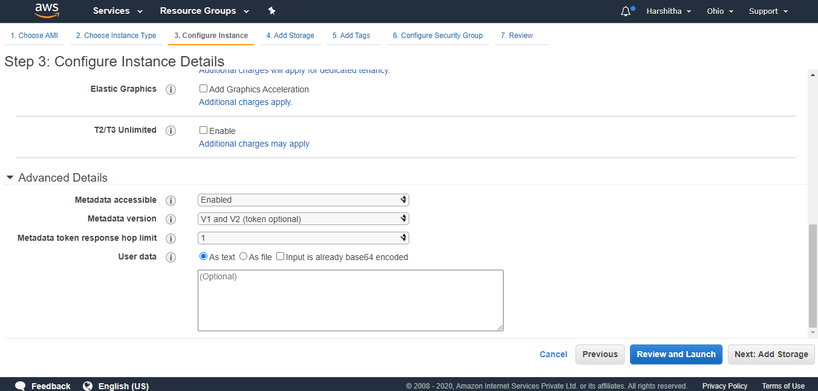

**Step 4:** Add Storage

* Enable "**Delete on Termination**"
* Click "**Next: Add Tags**".

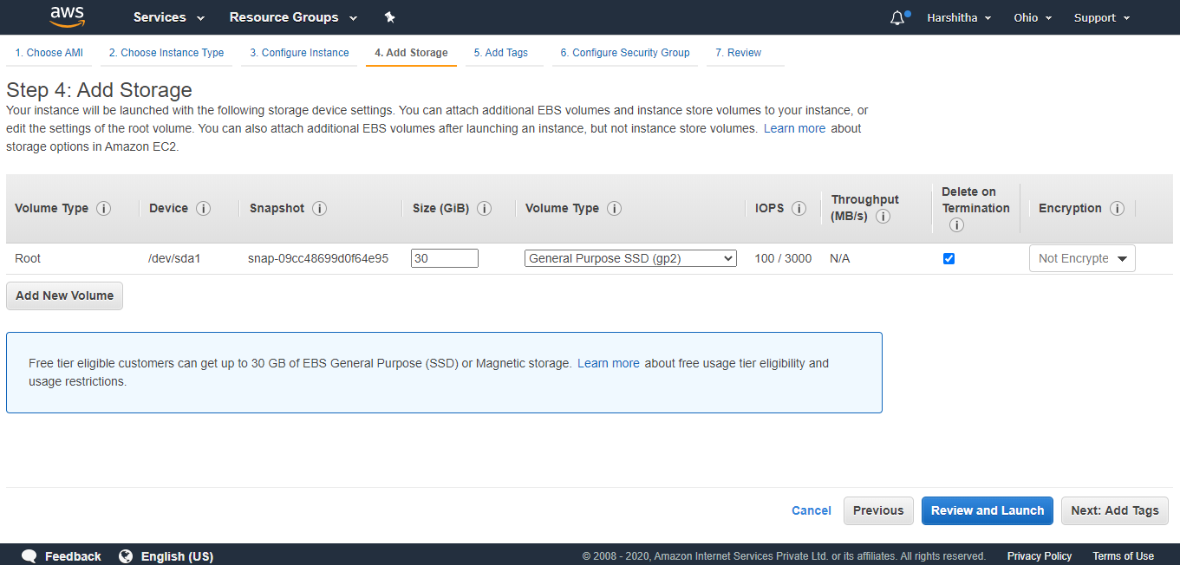

**Step 5:** Add Tags

* Click on "**Add Tag**" button enter the "**Key**" as "**Name**" and "**Value**" as "**Windows**".
* Click on "**Next: Configure Security Group**".

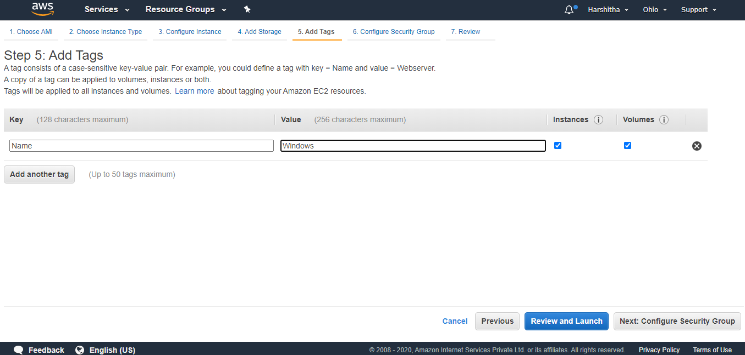

**Step 6:** Configure Security Group

* Select "**Create a new security group**"
* Choose "**Type**" as "**All traffic**" and "**Source**" as "**Anywhere**"
* Click on "**Review and Launch**".

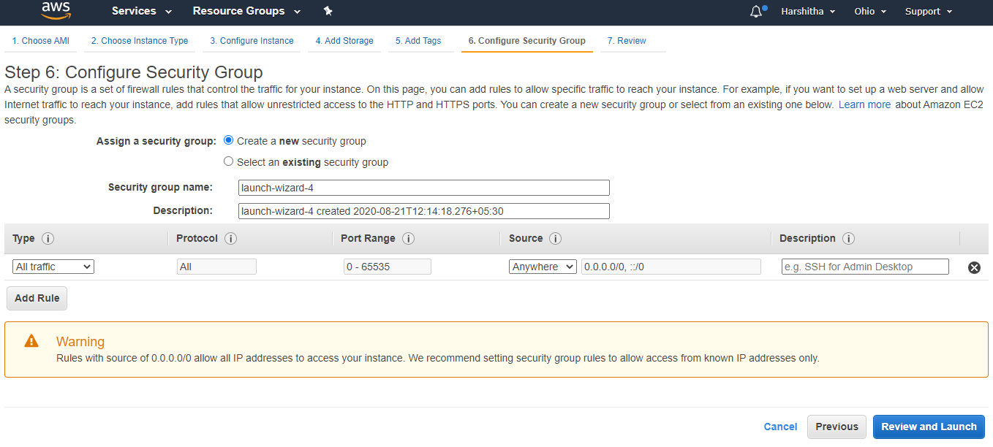

**Step 7:** Review Instance Launch

* Click on "**Launch**".

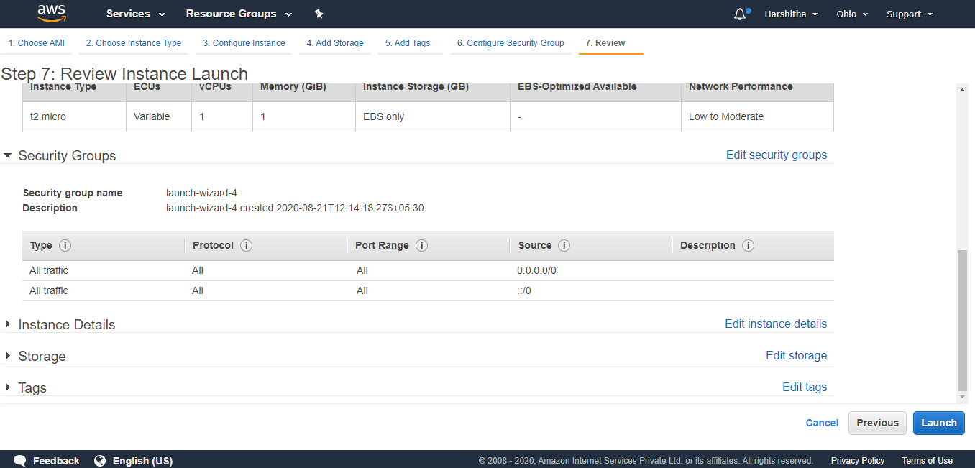

* A pop-up will appear as shown below.
* Choose "**Create a new key pair**" and enter "**Key pair name**" as "**LetsUpgrade**"
* Click on "**Download Key Pair**" and save the "**LetsUpgrade.pem**" file
* Click on "**Launch instances**".

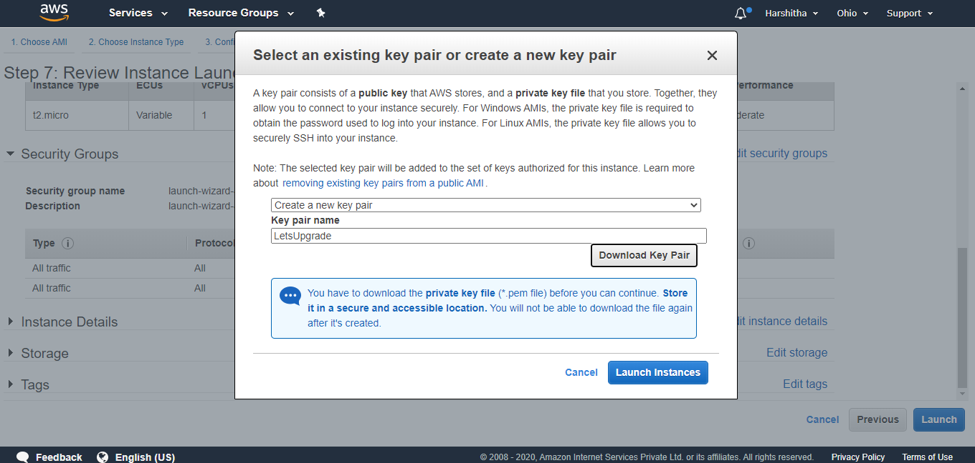

* Navigates to the below page and click on the **id link**.

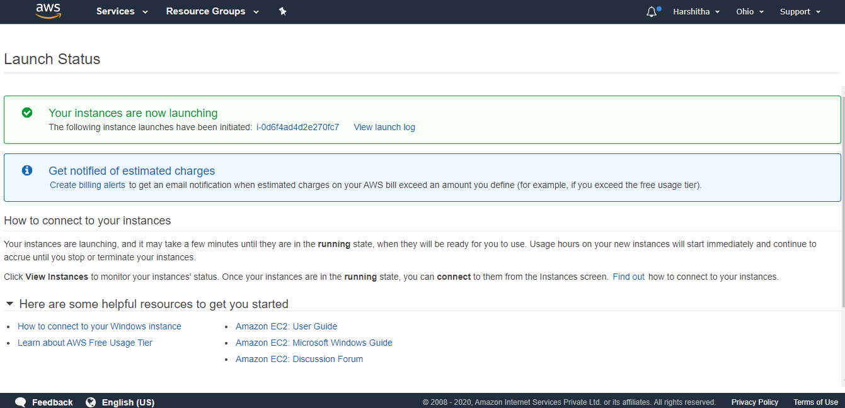

* Redirects to the page below and wait until the "**Instance State**" to be "**running**" and "**2/2 Status Checks**"

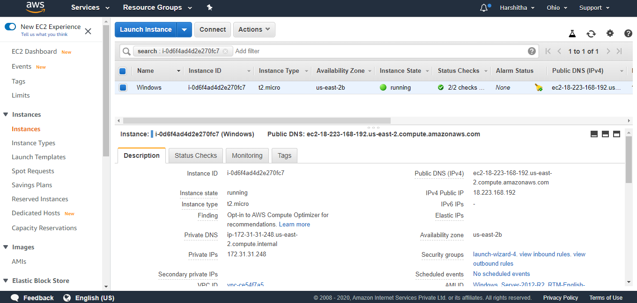

* Terminated the above instance and created and Launched new instance as shown below:

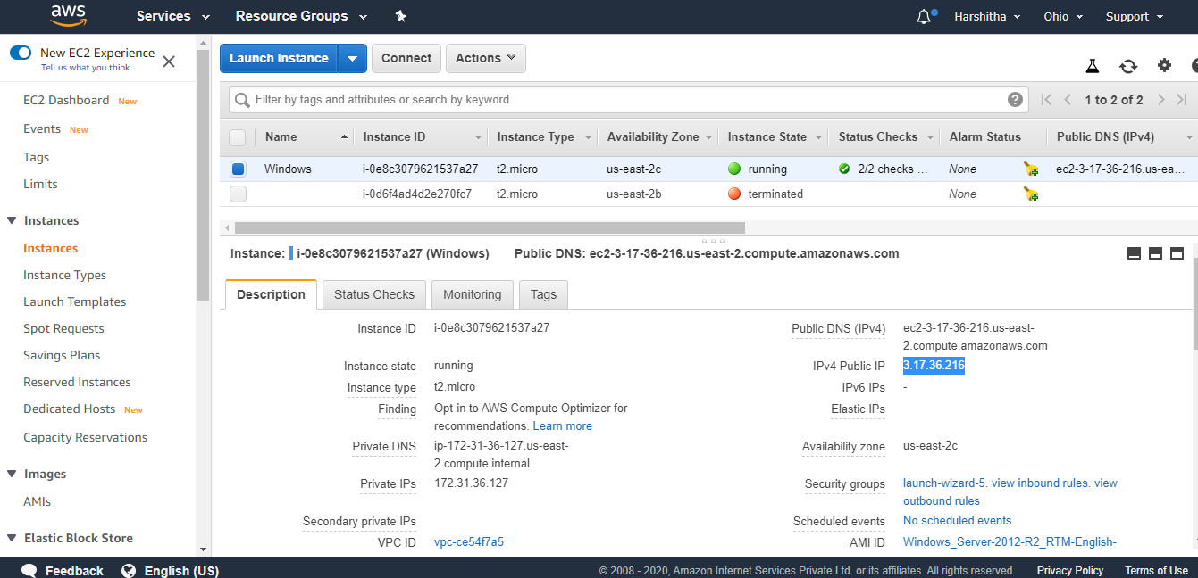

* Click on "**Connect**"
* A pop-up will appear and then click on "**Download Remote Desktop File**" and save the .rdp file
* Click on "**Get Password**"

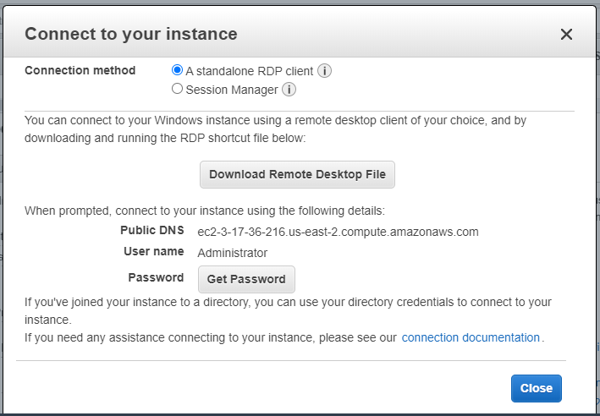

* Click on "**Choose File**" and select the "LetsUpgrade.pem" file.
* Click on "**Decrypt Password**" and copy the password.
* **"Close"** the pop-up.

**Task 2 :** Launch the Windows instance using RDP

* Open the downloaded .rdp file
* Click on "**Connect**" and enter the password which we copied in the above step and click "**ok**"
* Click "**Yes**"

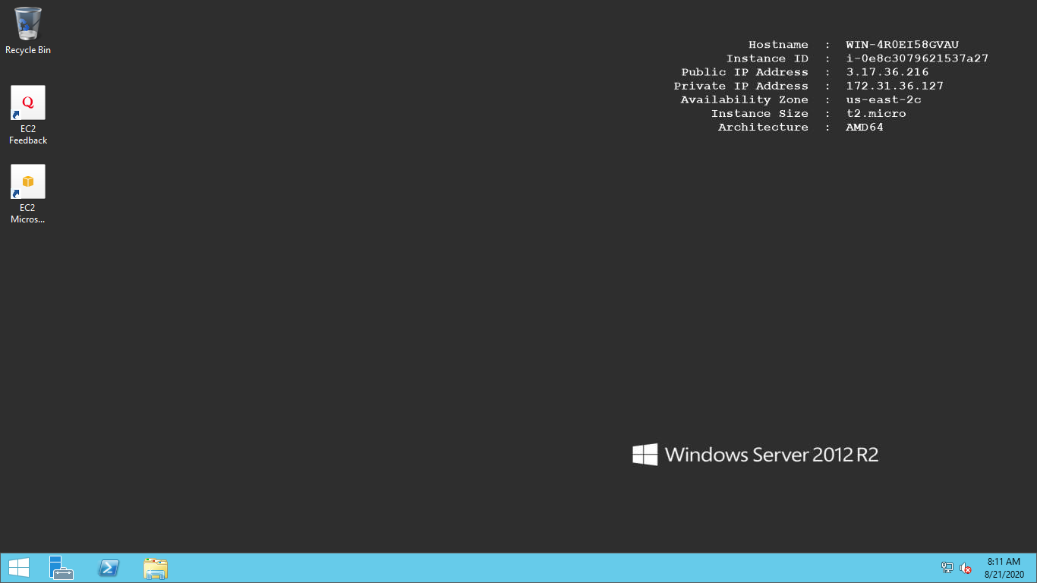

**Task 3 :** Install IIS web server using Powershell ISE

Note : Simply copy the command below and paste in the PowerShell ISE to install the IIS web server.

!!!! Powershell is case sensitive.

Install-WindowsFeature -name Web-Server -IncludeManagementTools

* In the RDP, go to start menu and select "**Windows PowerShell**"

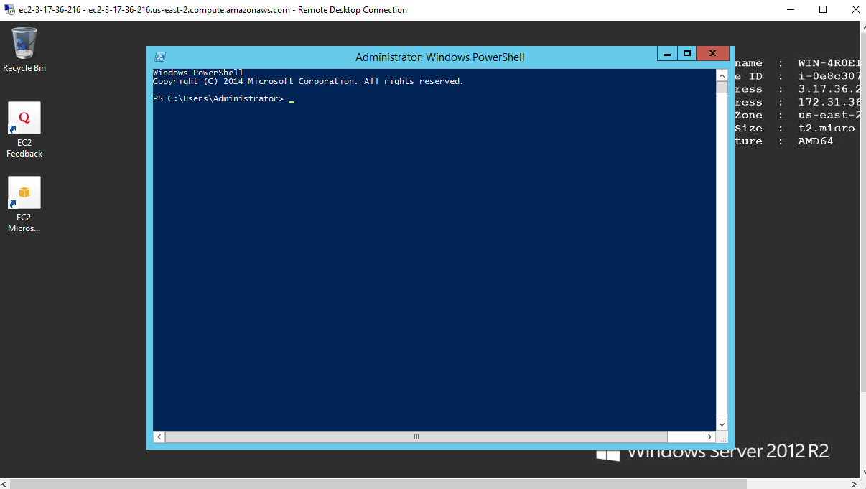

* Run this command : Install-WindowsFeature -name Web-Server -IncludeManagementTools

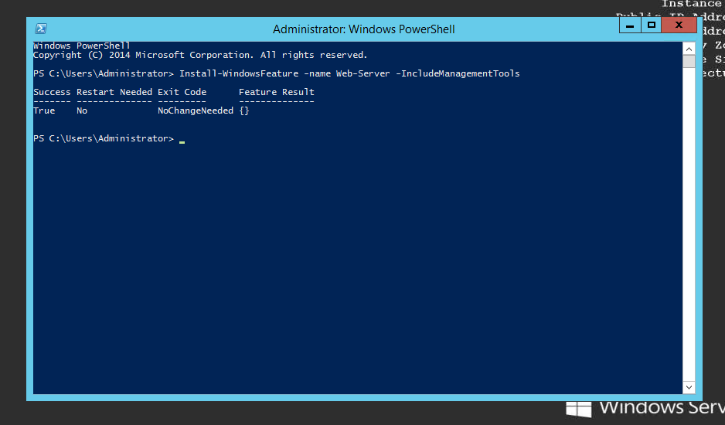

* Installed Successfully.

**Task 4 :** Verify successful installation of IIS Web Server

Note: You should be able to see the Internet Information Services Web page when you paste the public IP into the browser.

* Copy the Public IP and paste it into the browser for verification.

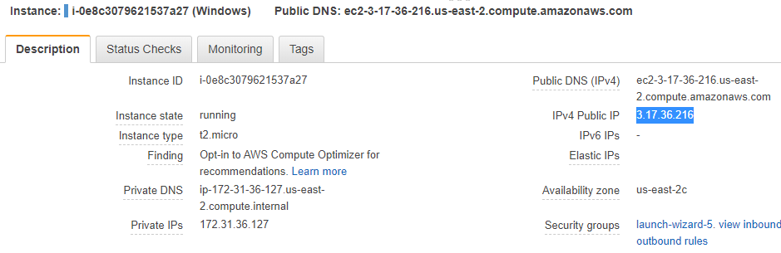

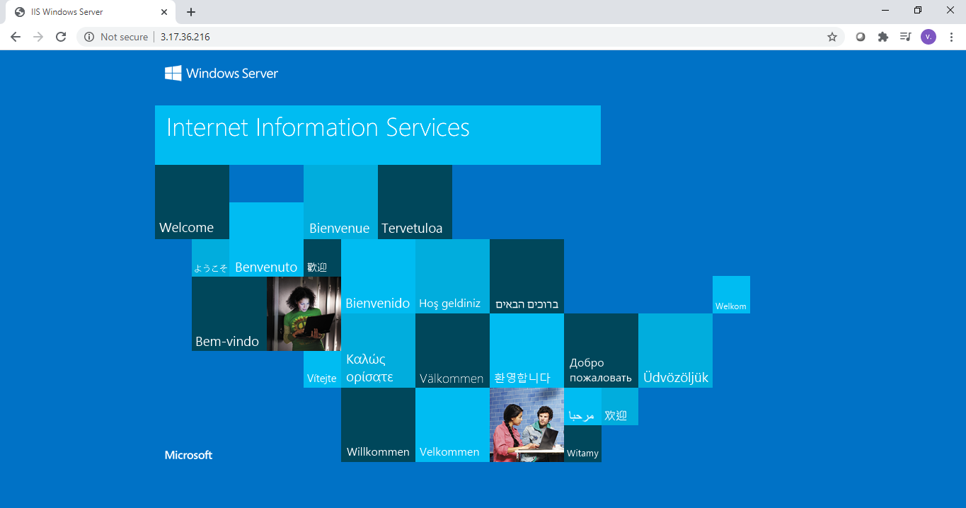

**\*\*\*\*\*\*\*\*\*\*\*\*\*\* END \*\*\*\*\*\*\*\*\*\*\*\*\*\***