Contents
Executive Summary: 2
Problem/Opportunity Statement 2
Project Objectives (Ideas that go along with problem/opportunity statement) 2
Potential Business Benefits 2
Timeline 3
Project Part 1 – Data Exploration: 3
Phase 1: Data review (discuss variables etc.) 3
Phase 2: Data cleaning and variable transformation 4
Phase 3: Analysis and visualization 4
Phase 4: Data mining algorithm selection 8
Project Part 2 – Data Algorithm and Evaluations: 8
Phase 1: Model testing 8
Phase 2: Results and Discussion 13
Conclusion: 14

Inc 5000 Companies Report
By Matthew Scott, Vichaka Houi, Jacob Thompson

Executive Summary:

Problem/Opportunity Statement
- GreenCorp is a new investment firm that wants to determine factors (‘industries/locations/etc’) that drive high-yield growth for companies listed on the Inc. 5000 to predict new companies that will generate similar results in the future.

Project Objectives (Ideas that go along with problem/opportunity statement)
1. Understand the drivers of companies continuing to represent themselves on the Inc. 5000 for an extended period of time.
2. Analyze revenue through company characteristics, such as company age, workforce size, and geographical location.
3. Find correlations that signal continuous growth to detect and predict drivers of success in industries or locations that have future potential.

Potential Business Benefits
1. Understanding growth drivers will help create predictions of future new company’s success.
2. Predicting success will allow GreenCorp to invest in new companies before significant growth has occurred, creating large returns on investment.

Timeline
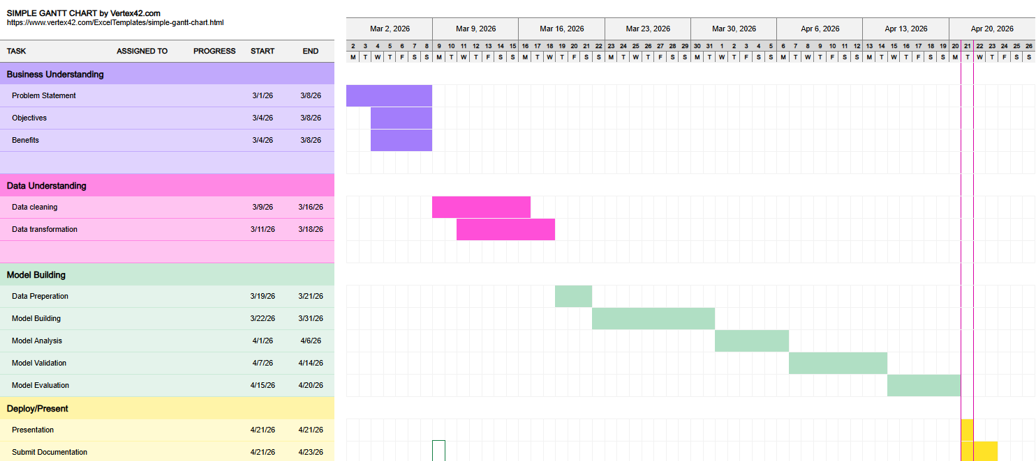

Project Part 1 – Data Exploration:

Phase 1: Data review (discuss variables etc.)
The dataset contains 14 variables describing companies ranked on the Inc. 5000 list based on their 3-year growth performance. The variable rank is numeric and represents each company’s relative growth position.
Several variables contain company identification information, including name, profile, and url. The profile and url variables are stored in web-link (string) format and may not be directly useful for quantitative analysis unless web scraping or external validation is required.
Location-related variables include state, city, and metro. The state variable is represented using two-letter abbreviations (categorical). Both city and metro are string variables, and in some cases may contain redundant or overlapping geographic information. These fields may require cleaning due to inconsistent formatting or missing entries.
The dataset also includes business performance variables such as revenue, growth_%, and industry. While revenue is numeric in nature, it may require preprocessing if stored with currency symbols or commas. Similarly, growth_% may contain percentage symbols and must be converted into numeric format for statistical analysis. The industry variable is categorical and may require encoding for modeling purposes.
Company timeline information includes founded and yrs_on_list. The founded variable is represented as a four-digit year, while yrs_on_list is an integer indicating how many years the company has appeared on the list.

Phase 2: Data cleaning and variable transformation
The first variable that was transformed was revenue, which was transformed to revenue_new, which created a numerical value for the revenue.
Next, we cleaned workers because one value was missing, and assumed the blank meant there were no employees, which we placed under workers_cleaned. We also created a new variable called worker change, which shows employee change from previous workers to current workers.
To categorize the workforce size, we also created a variable called workforce. Companies with less than 100 workers are considered small; those between 100 and 500 are medium, and greater than 500 are large.
We also created a variable called repeat, where we categorized companies as either being on the INC 5000 list for the first time, ‘first-time’, or multiple times, ‘repeat’. To remove blanks in metro, we created a new variable called metro cleaned, that removed all blanks with a – to represent that no metro exists in the area.
Lastly, we found duplicate ranks on the 5000 Inc. data where the duplicate ranks had several companies where the rank was the same but name was different and so was growth%. We decided that we will just create additional rankings from where they were at and placed them in spots based on their growth%.

Phase 3: Analysis and visualization
We have created 8 different visualizations. We measured Top 15 growth companies, Combined Growth by State, Growth by State Average, Revenue By State, Average Growth by Industry, Worker Change by State, Top Worker Change Tiers by Average Revenue. These visualizations give a portrayal of the characteristics that we believe will influence our algorithm to allow us to predict future companies with high revenue growth.
Top Growth Companies
The first graph created was top growth companies using a bar graph, which shows the top 15 companies and their respective growth rates. The top company, Freestar, has a growth rate of 36,680% and the 15th company has a growth rate of 10,176%, showing that all top 15 companies have at a growth rate of at least 10,000%.
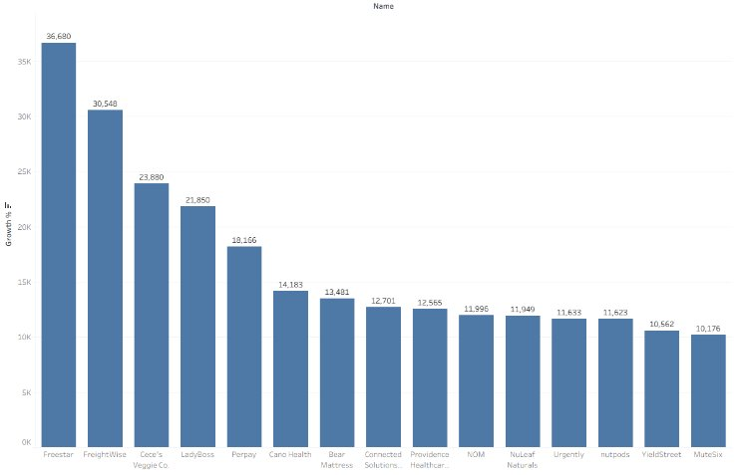
Figure 1: Top Growth Companies

Combined Growth by State
The second visualization created was combined growth by state using the map graph. This graph shows the combined growth for all companies within the state, which can help show geographical growth. California, Texas, Florida, New York and Virginia are the top 5 growth states, respectively. These 5 states all have a combined growth rate of at least 135,000%, with California leading at almost 350,000%.
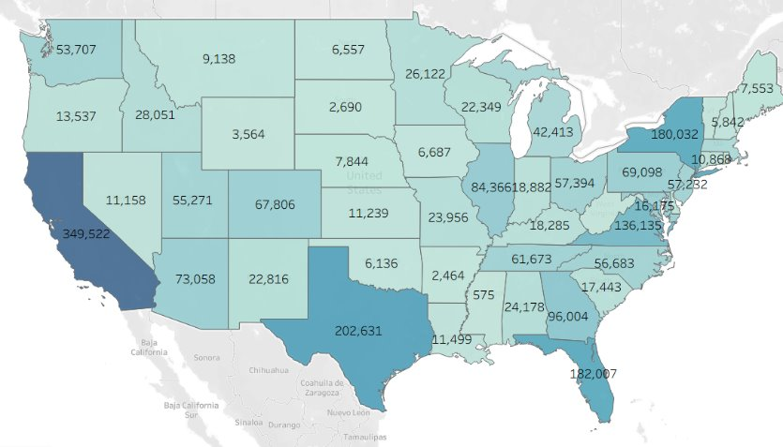
Figure 2: Combined Growth by State
Average Growth By State
The 3rd graph created was average growth by state using the map graph. New Mexico, Puerto Rico, and Idaho lead average growth due to the high growth rate of the companies listed and the low number of total companies on the list. When comparing the average growth to the total growth map, the results are different due to the number of companies listed in each state. This helps explain that in places that lead total growth, like California, there are a lot of listed companies that range in growth rates.
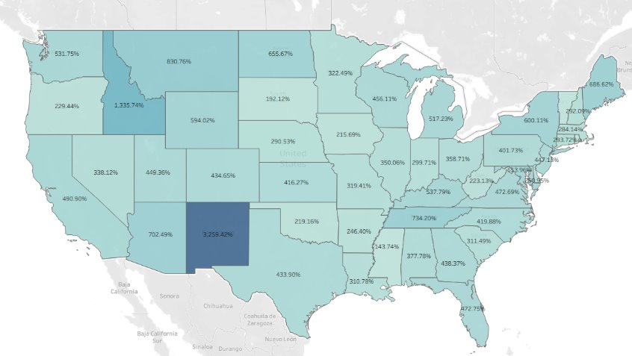
Figure 3: Average Growth by State
Revenue by State
The 4th visualization created was Revenue by State using the map graph. States like California, Texas and Florida have noticeably higher earnings than the rest. Their earnings set at 12 billion and above USD. States like Vermont, Montana and Wyoming have some of the lowest total earnings. They are roughly below 40 million USD.
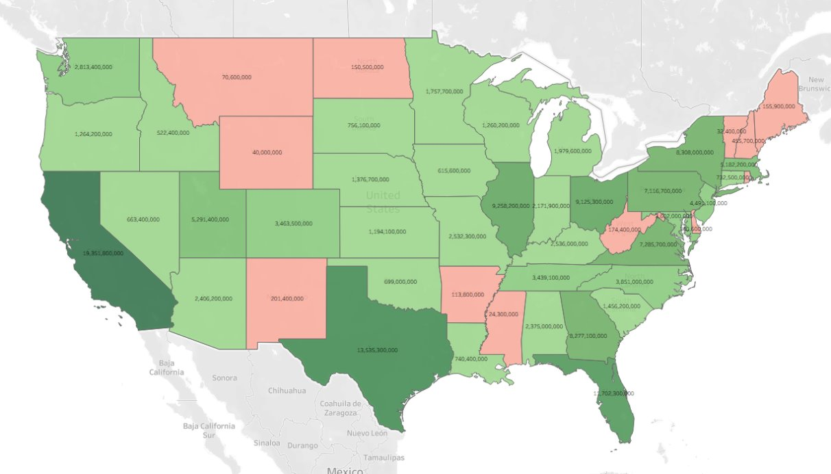
Figure 4: Revenue by State
Average Growth by Industry
The 5th graph created was Average Growth by Industry. We measured the top 10 industries that experienced the highest average growth %. Logistics and Transportation along with Consumer Products & Services sit above the 680% mark. Food & Beverages along with Computer Hardware are also relatively close in average growth %. Software, Telecommunications and Security are some of the lowest average growth % among the top 10. They sit below 525% growth % mark.
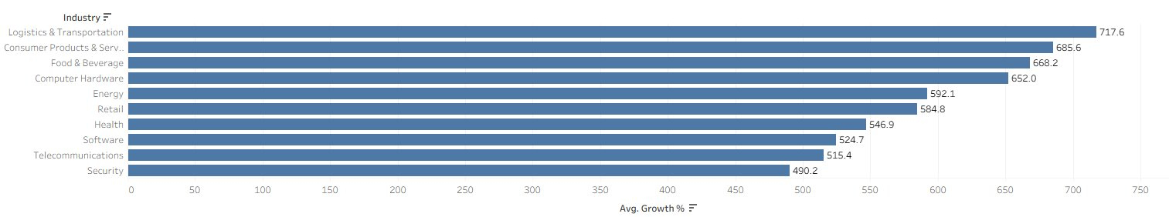Figure 5: Average Growth by Industry
Worker Change by State
The 6th visualization shows the total worker change by state. California is an outlier with the largest margin by worker change while other states are near the 100-20,000 range. Puerto Rico is the lowest number on the map with 23 worker change.
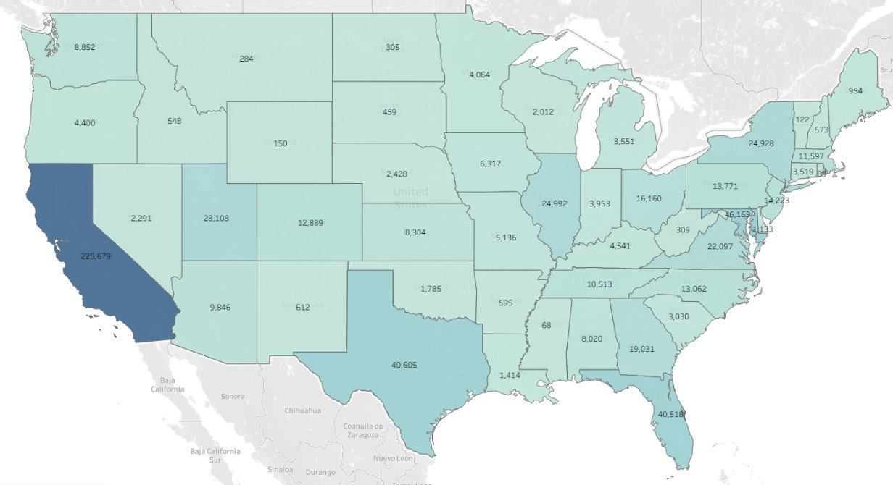
Figure 6: Worker Change by State
Top Worker Change by Industry
The 7th graph shows the top 10 total worker change by industry. This graph shows that the security industry has the most worker change by a significant amount compared to the other industries.
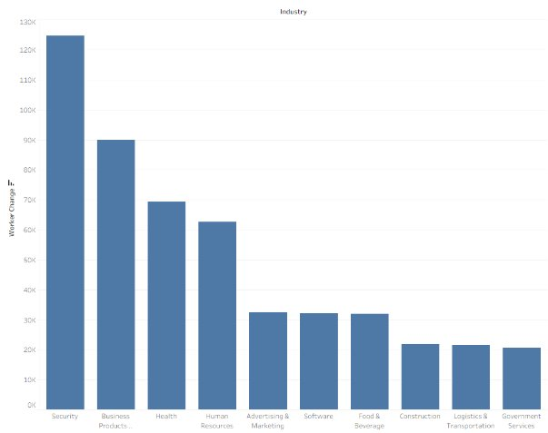
Figure 7: Top Worker Change by Industry
Tiers By Average Revenue
The last graph shows the average revenue according to the metric of tiers. Tiers represents how much time certain companies stay on the Inc. 5000 list. The very long term (Elite tier) companies have the highest average revenue per company while lots of the first timers on the list have less average revenue even though they have more companies on the list.
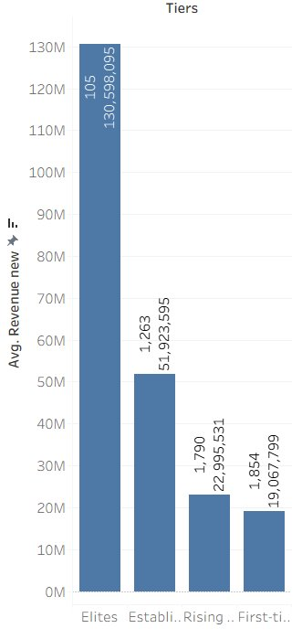
Figure 8: Tiers by Average Revenue

Phase 4: Data mining algorithm selection
Our data mining algorithm will be Linear Regression. We chose this because our goal is to predict factors that drive growth. As an investment company, we want to be able to invest in companies early to maximize our profits and predict these companies will reduce our investment risk.

Project Part 2 – Data Algorithm and Evaluations:

Phase 1: Model testing

Step 1: Model Building and Analysis:
For all model building, we used the same set of predictors. With this, we utilized linear regression, decision tree, and random forest models to help explain factors of growth. To normalize the data from being heavily skewed by outliers, we performed log scale on the growth percentages.

We used Python MinMaxScaler to normalize all predictors. We then performed log scale on Growth_% to normalize the difference between 50% and 300,000%.
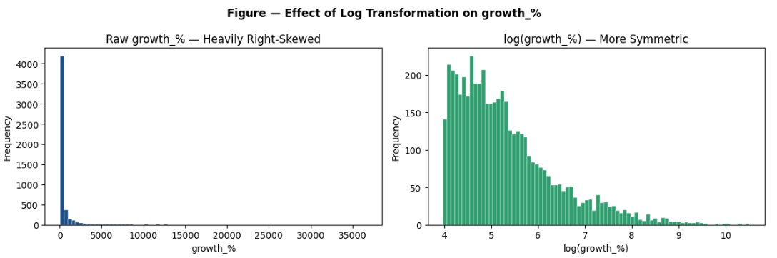
Figure 9: Log Scale on Growth_%
First, linear regression was utilized to find the top predictors of growth. This helps explain how the predictors influence growth, either positively or negatively. Since we are trying to find the maximum potential growth, we want to find the coefficients that are most positive, or how we can minimize the negatives, such as with yrs_on_list. The results of the regression are shown below.
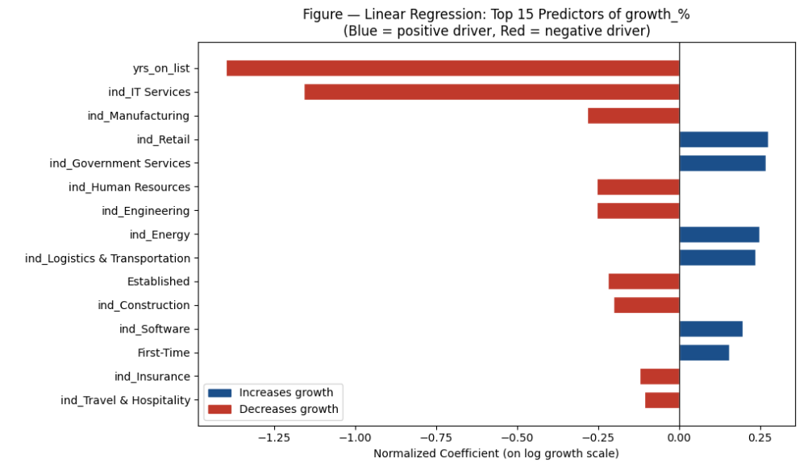
Figure 10: Growth Predictions

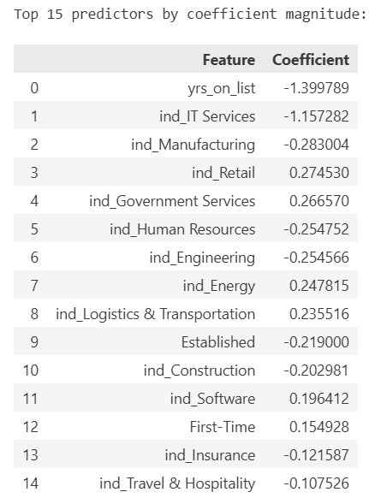
Table 1: Top 15 Predictors by coefficient magnitude
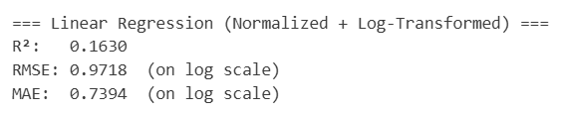
The results show that the top average growth industries are retail, government services, energy, and software, based on their positive coefficients. With years on list being most influential, it will be important to only select newer companies, which aligns with reason. This will have to be analyzed further to see if there are certain aspects beyond brand new companies that reflect large-scale growth.

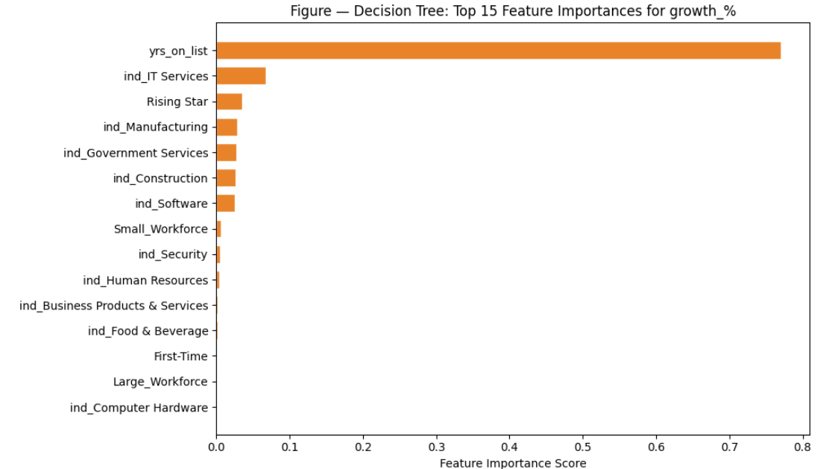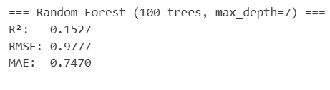
Figure 11: Top 15 Feature importances for growth_% (Decision Tree)

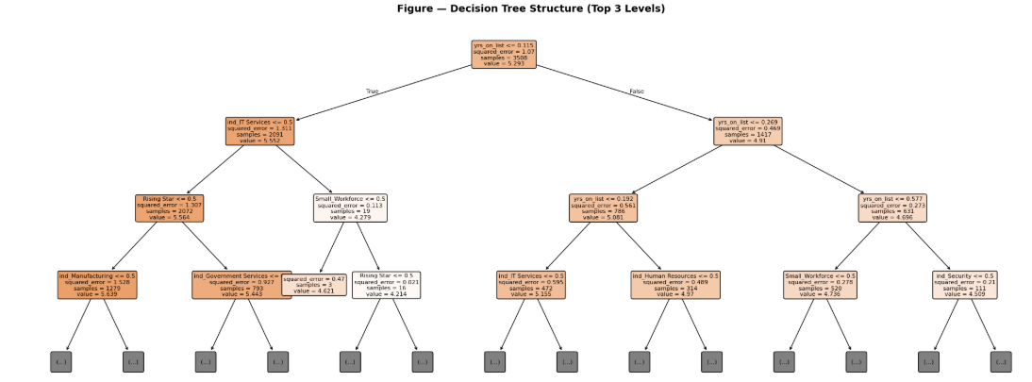
Figure 12: Decision Tree Structure

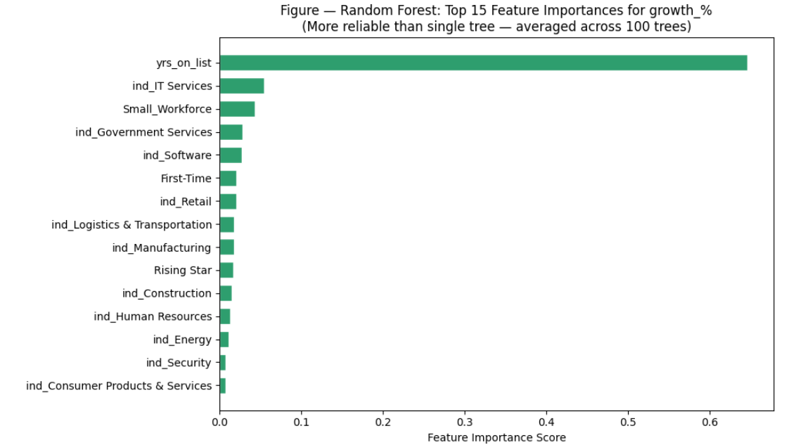
Figure 13: Top 15 Feature Importances for growth_% (Random Forest)
The decision tree and random forest models both validate what was found in the linear regression. Most important growth factors are maintained, with the new findings including the dummy variables first-time and rising star being included, as well as small workforce. This helps provide more insight that early-stage companies maintain the most growth, for at least the first 4 years.

Then we compared the model split of 70%/30% (Training/Testing) and 80%/20% (Training/Testing).
70%/30%:
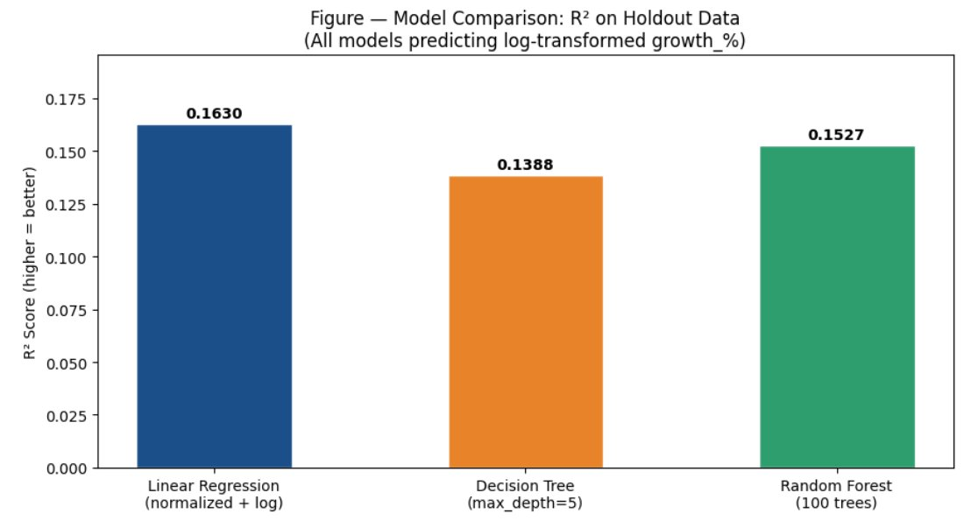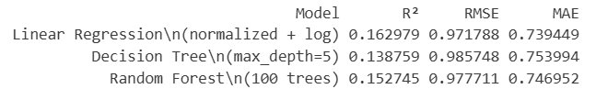
Figure 14: Model Comparison 70%/30%
80%/20%:
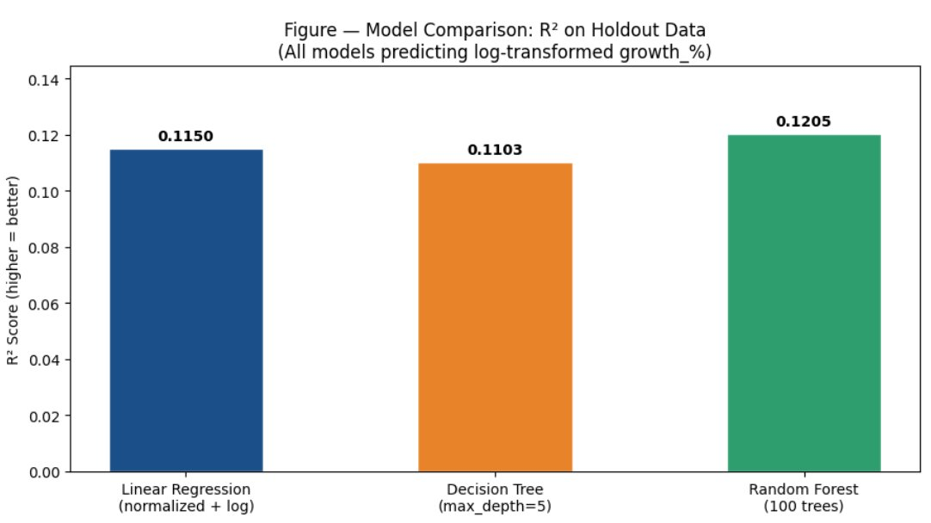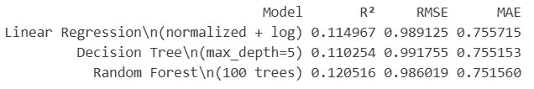
Figure 15: Model Comparison 80%/20%

Step 2: Model Validation and Evaluation:
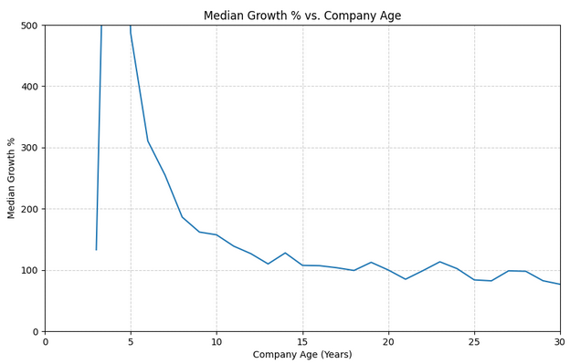Figure 16: Median Growth % vs. Company Age
With years on list being the highest coefficient, it is important to find where the most growth occurs, and when it begins to decline. The decision tree model found that rising star, (2-3 years old), was a top indicator for growth. After removing outliers and finding the median growth percentages defined by company age, from founded to 2019, it is apparent that companies between 2 to 7 years old maintain the highest median growth.
The linear regression model also shows that the top industries for increased growth include retail, government services, energy, and software. The median growth rate for these industries is between 180% to 260%, which shows consistent growth that can be capitalized upon. Other industries are heavily skewed to the right due to a small number of companies scaling rapidly.
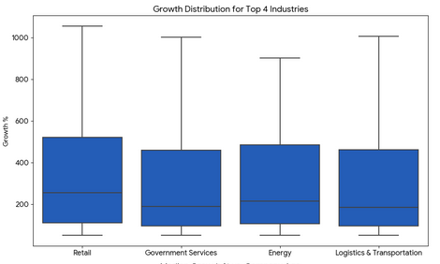
Figure 17: Growth Distribution for Top 4 Industries
Small workforce also was shown to be a major factor in growth in the decision tree and random forest. This categorizes companies with a workforce of less than 100 workers. When these companies are shown on a box and whisker plot, the highest potential for growth is from a lean workforce, declining at approximately 100 workers.
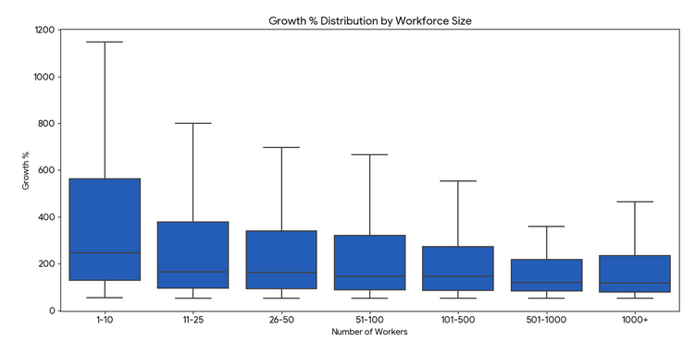
Figure 18: Growth % Distribution by Workforce Size

Phase 2: Results and Discussion
With these results, GreenCorp could maximize its potential future profit, and minimize its risk, by investing in companies that are less than 7 years old. It would also be best to inquire about the number of workers and focus on lean operations that maintain less than 100 workers. To diversify, it would be best to invest in companies in the top four industries, as they are all above the average growth rate of 157%.

Conclusion:
This data gave great insight into factors that can be manipulated for analysis, as well as various ways that data can be manipulated. It is important to ensure that the data is cleaned and transformed if needed to gather accurate results. It is important to find outliers that may skew the data, because the results were insignificant until the outliers were removed. Normalizing the data, by transforming growth through log, also helped remove skewed data, and gave better results. Training and testing the data also helped validate that the results were accurate enough to base a conclusion for our investment company.

