INVENTION DISCLOSURE FORM

Details of Invention for better understanding:

1. TITLE: Memory Preservation & Digital Afterlife

2. INTERNAL INVENTOR(S)/ STUDENT(S): All fields in this column are mandatory to be filled
A. Full name | _{Sahil}
Mobile Number | 9350707382
Email (personal) | Sahildhakau211@gmail.com
UID/Registration number | 12322937
Address of Internal Inventors | Lovely Professional University, Punjab-144411, India
Signature (Mandatory) | 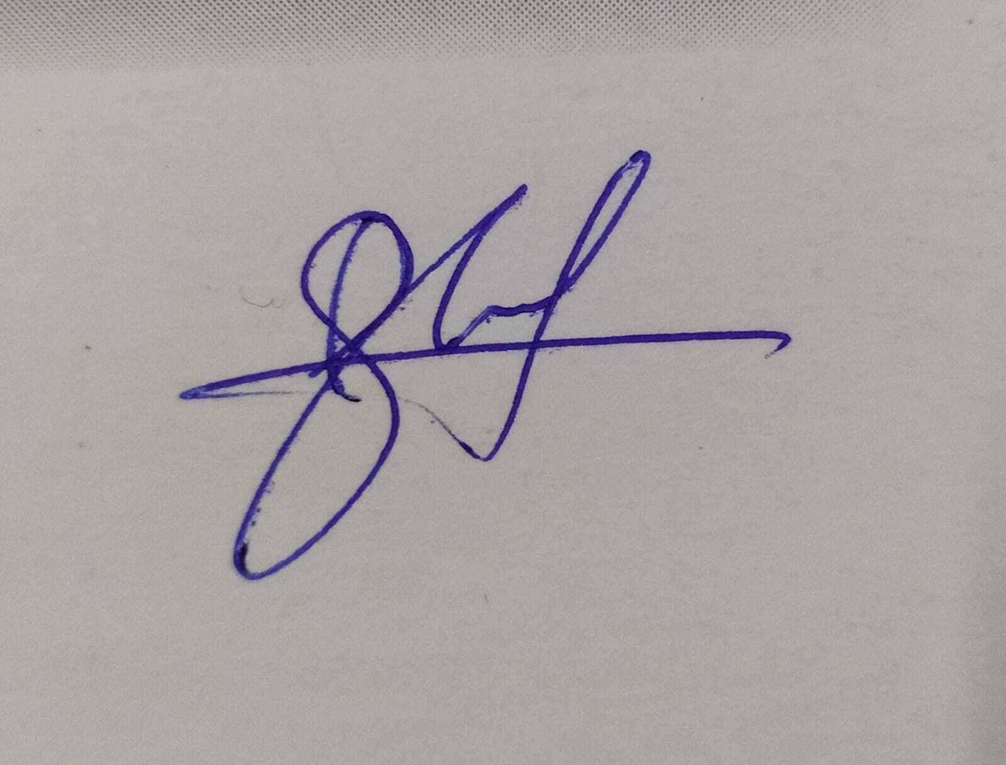

B. Full name | _{Vishal Kumar Shukla}
Mobile Number | 91420 55765
Email (personal) | vsbettiah@gmail.com
UID/Registration number | 12306876
Address of Internal Inventors | Lovely Professional University, Punjab-144411, India
Signature (Mandatory) | 

C. Full name | Dr. Ishan Kumar
Mobile Number | 734 700 0919
Email | ishan.23347@lpu.in
Address of External Affiliations | UID: 23347
Signature (Mandatory)

DESCRIPTION OF THE INVENTION

- PROBLEM ADDRESSED BY THE INVENTION

In today's rapidly moving digital world, the preservation of human thoughts, emotions and heritage is a concern. Traditional methods such as written diaries, recorded videos, and photographs are valuable, but have limitations. Documents in these forms remain static and lack the ability to truly grasp a person's developing thoughts, feelings, and personality. Many people want to leave more than just words or pictures. They want to preserve their essence, wisdom and experience in a way that future generations can use. The present invention provides innovative solutions by creating Ai-Chat Bots that repeat a person's personality after death, and devices that convert thoughts into digital diary entries. When a loved one is visible, families often have to deal with unanswered questions, emotional stress, and deep longing for interaction. Traditional monuments and recorded news can provide some comfort, but there is no real-time interaction. An AI chatbot, run by machine learning and processing of natural languages, allows individuals to continue their discussion with the digital version of the deceased. This provides a sense of emotional relief, closure, and a continuous presence, allowing people to navigate their sadness more effectively. As they age, their memories gradually fade away, making it difficult for them to maintain important life experiences and personal knowledge. Digital diary devices from the roof play an important role in recording and storing these memories before they are lost. By using advanced neuronal interfaces or linguistic text technology, the device records thoughts, emotions and reflexes in real time, ensuring that they are stored in both individual and generational continuity. Many people want to seek advice from their deceased loved ones, rethink their past conversations, or simply hear their voices again. KI Chatbot enables this by creating very realistic digital personalities using historical data, personal writing and audio recordings. In contrast to traditional archives, this interactive system allows users to ask questions, get answers, experience individuals' unique conversation styles, and promote stronger emotional connections. In modern times, people leave behind a large amount of digital content, including social media contributions, emails, audio recordings, and videos. However, these digital footprints are passive and often difficult to access or organize. By converting this data into interactive AI units, the present invention ensures that human heritage is not only preserved, but also wise. Future generations can learn from their ancestors, gain insights, and gain family continuity in ways they have never before seen before. It provides people with profound and transformative ways to maintain connections beyond life, support mourners, and protect their thoughts from time and loss of memory. This is more than just technology. It is a bridge between the past, present and future to ensure that the story is truly unforgettable.
- STATE OF THE ART/ RESEARCH GAP:
SN | Patent number | Title | Abstract | Difference
1 | US11681763B2​ | Systems of Apps Using AI Bots for One Family Member to Share Memories and Life Experiences with Other Family Members | This patent outlines a system where an AI bot interacts with a registered user to collect personal information across various life stages. The AI compiles this information into a biography, which can be shared online with family members and others. The system includes features for user authentication, payment processing, and data integration with other platforms. | The system employs an AI bot to guide users through a series of predefined questions, gathering personal information related to different life stages. This data is then used to create a comprehensive biography that can be shared with family members and others, facilitating the preservation and sharing of personal histories.  - vs -  Your system aims to preserve an individual's memories and personality by capturing real-time thoughts and experiences, potentially through advanced technologies like Brain-Computer Interfaces (BCI). Unlike the structured interview approach of the referenced patent, your system would allow for spontaneous and continuous data collection, creating a dynamic and evolving digital representation of the individual.
2 | US20220068462A1 | Artificial Memory for Use in Cognitive Behavioral Therapy Chatbot | This patent describes a chatbot system designed for cognitive behavioral therapy (CBT) that utilizes artificial memory to enhance patient interactions. The system extracts and stores information from patient conversations, enabling personalized responses and therapeutic interventions based on the patient's history and relationships. | The system focuses on therapeutic applications, using a chatbot to engage patients in CBT. It builds an artificial memory by extracting details from patient conversations, allowing for personalized and contextually relevant therapeutic interactions.  - vs -  While also utilizing AI-driven chatbots, your system is designed for memory preservation and creating a digital legacy, rather than therapeutic interventions. It aims to capture and store an individual's thoughts and experiences to facilitate posthumous interactions with loved ones.
3 | US20240414108 | Chatbot Long-Term Memory | This patent presents a chatbot system capable of maintaining persistent, personalized memories from past interactions. By summarizing and storing user information, the chatbot can generate contextually relevant responses, creating a more natural and engaging conversation flow. Features include controlled memory moderation, user data privacy, and scalability for long conversations. ​ | The system enhances chatbot interactions by implementing long-term memory, allowing the chatbot to remember user facts, interests, and preferences across multiple sessions. This results in more personalized and contextually appropriate responses during interactions.​  - vs -  Your system also emphasizes personalized interactions but focuses on preserving an individual's identity and experiences for future interactions, potentially after the individual's death. It aims to create a digital legacy that embodies the person's personality and memories.

DETAILED DESCRIPTION (Technical as well as non-Technical)

Technical :
- AI-Powered Chatbot for Personality Replication
This invention leverages Artificial Intelligence (AI), Natural Language Processing (NLP), and Machine Learning (ML) to analyze and simulate human speech, thought processes, and conversational style. The chatbot is trained using personal data sources such as emails, text messages, social media posts, voice recordings, and videos, allowing it to build an accurate representation of an individual's personality. Additionally, voice cloning technology is incorporated to replicate the user’s original voice, making interactions feel more natural and lifelike. Structured interviews or pre-recorded responses further enhance personality accuracy and ensure dynamic, engaging conversations. The AI system continuously refines its responses based on stored data and past interactions, allowing it to adapt over time and provide a more personalized experience.
- Thought-to-Digital Diary Device
The present invention uses BRCI sensors (brain computer interfaces) to identify neural signals and convert them into digital text. Advanced techniques such as EEG (EEG) and functional near-infrared spectroscopy (FNIRS) are used to capture and interpret thoughts in relation to brain activity. Alternatively, AI-based speech recognition systems can transfer spoken words into text format for simple use. Natural Language Processing (NLP) plays an important role in structuring and organizing diary entries in coherent and easy-to-read formats. Additionally, cloud store integration ensures secure access to diary entries, and AI-based summarization tools contribute to highlighting important ideas and recurring topics, making digital diaries clearer and easier to use.
- Integration and Accessibility
This invention is designed for multi-platform accessibility, seamlessly integrating with mobile apps, web platforms, smart home assistants, and VR/AR devices. To ensure privacy and ethical usage, it employs secure encryption and user authentication, protecting personal data from unauthorized access. Additionally, users have the flexibility to customize their digital presence, allowing them to control how their digital legacy is stored, accessed, and interacted with. This level of customization ensures a personalized and secure digital afterlife experience.
Non-Technical :
- Purpose and Concept
The purpose of this invention is to maintain human memory, emotions and personality traits beyond the individual's life. It provides an interactive experience that allows users to communicate with AI-controlled chatbots that repeat the language, knowledge and personality of the deceased's loved one. Additionally, digital diary devices Digital diary devices ensure that no memory is lost. This is especially valuable for people with cognitive decline or those who want to easily document their thoughts. This technology continues to be relevant and provides a reasonable way to receive personal heritage for future generations.

- Emotional and Psychological Benefits
This invention helps families stay in touch with their loved ones even after their family die. Through interaction with the digital version of a deceased relative, people can find comfort and express their emotions and experiences again. It conveys a sense of continuity, allowing individuals to search for leadership again and experience past moments again. Additionally, it acts as a lifeline for people suffering from Alzheimer's disease, dementia, or memory loss, storing thoughts and memories before fading. The present invention is more than just technology, and serves as a therapeutic device that ensures that personal connections and legacy remain intact for future generations.
- Applications and Ethical Considerations
The present invention includes a variety of applications, including mourning advice and emotional therapy. This application supports individuals in handling losses and maintaining emotional connections. It also plays an important role in historical archives and inheritance, allowing individuals to document their lives for future generations in an interactive form. Data protection and ethical considerations are prioritized to provide full control over your digital heritage by determining permissions to determine who can interact with AI representations. Furthermore, technology technology offers and provides insight into the psychological impacts of memory services, digital immortality, and AI human interactions.

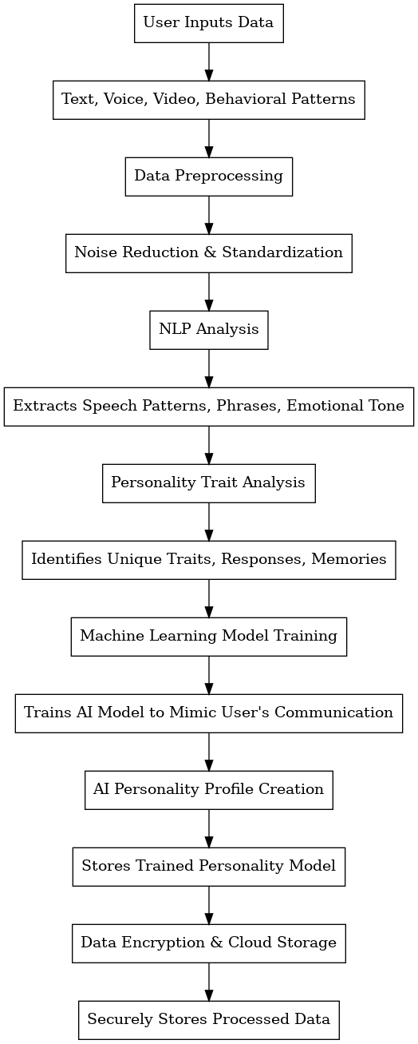

Figure 1. This process involves gathering data from a user while they are alive, which is later used to replicate their personality in an AI-powered chatbot.
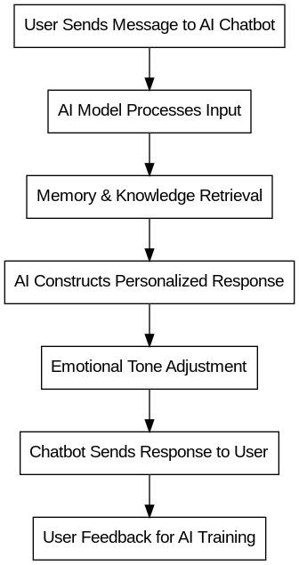

Figure 2. This process enables users (family/friends) to interact with an AI chatbot that simulates the deceased person’s personality and memories.
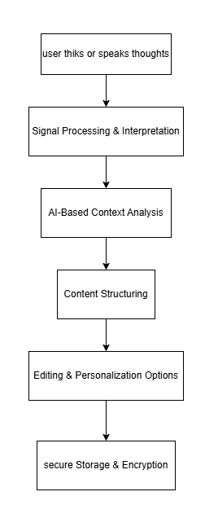

Figure 3. This process captures and digitizes a person’s thoughts, converting them into structured diary entries for memory preservation.
- RESULTS AND ADVANTAGES OF THE INVENTION:

This invention offers a revolutionary way to preserve memories and personalities for future generations. By utilizing an AI-powered chatbot and digital diary, individuals can leave behind their thoughts, emotions, and experiences, ensuring their wisdom remains accessible to loved ones even after they are gone. It provides much-needed emotional support by allowing grieving friends and family to interact with a chatbot that replicates the deceased’s personality, offering comfort during difficult times. Additionally, it serves as a cognitive aid for individuals suffering from Alzheimer’s or dementia, helping them capture and store their memories before they fade.
Unlike traditional diaries or recorded messages, this technology enables AI-driven personalized interactions, dynamically responding to queries for a more engaging experience rather than static recollections. Security is a key focus, with encrypted data storage ensuring the privacy of personal thoughts and conversations. The chatbot continuously learns and refines its responses based on user feedback, improving over time to create more accurate and emotionally resonant interactions.
Designed for accessibility, the system integrates across multiple platforms, allowing users to communicate through text, voice, or video-based mediums. This adaptability ensures a personalized experience suited to different communication preferences. Moreover, the invention plays a crucial role in bridging the gap between generations, allowing future family members to interact with digital representations of their ancestors, fostering a deeper connection with their heritage and legacy.

- WORKING DESIGN/COMPOSITION

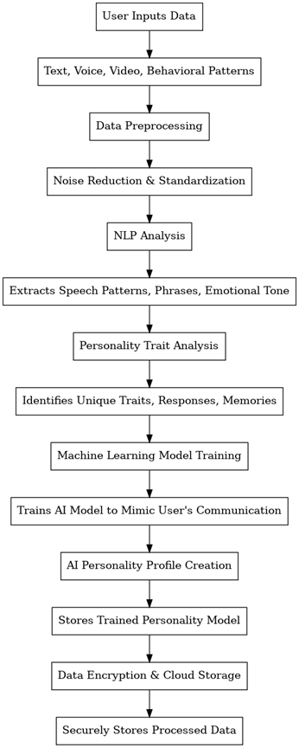
- EXISTING DATA REPORTS

Existing technology for storing memories and digital life after death simulates conversations, but without deep personalization. The brain computer interface (BCI) of companies such as NeuralInk can be considered for conversion, but remains experimental. Platforms like Storyworth and Myheritage Deep Nostalgia help to store memories, but AI interactions are missing in real time.
Our invention combines AI-controlled personality replication with Nachdenker-Diabuch technology, providing an interactive, personalized, secure approach to conservation and post-mortem communication.

- USE AND DISCLOSURE :

- Have you described or shown your invention/ design to anyone or in any conference? | YES ( ) | NO (✔)
- Have you made any attempts to commercialize your invention (for example, have you approached any companies about purchasing or manufacturing your invention)? | YES ( ) | NO (✔)
- Has your invention been described in any printed publication, or any other form of media, such as the Internet? | YES ( ) | NO (✔)
- Do you have any collaboration with any other institute or organization on the same? Provide name and other details. | YES ( ) | NO (✔)
- Name of Regulatory body or any other approvals if required. | YES ( ) | NO (✔)

- KEYWORDS:
Memory Preservation, Digital Afterlife, AI Chatbot, Personality Replication, Natural Language Processing (NLP), Machine Learning, Brain-Computer Interface (BCI), Thought-to-Digital Conversion, Emotional AI, Secure Data Storage, Posthumous Communication, Cognitive Legacy, AI-Powered Diary, Deep Learning, Virtual Presence
- POTENTIAL CLAIMS:

- AI-Powered Personality Simulation
- Natural Language Processing for Memory-Based Responses
- Thought-to-Digital Diary Conversion
- Secure Data Storage & Encryption
- Adaptive Emotional Tone Adjustment

