1. Write a program in Python to allow the error of syntax to be handled using exception handling.

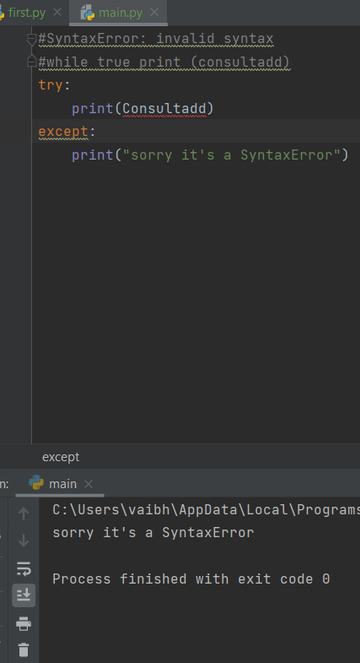

1. Write a program in Python to allow the user to open a file by using the argv module. If the entered name is incorrect throw an exception and ask them to enter the name again. Make sure to use read only mode.

input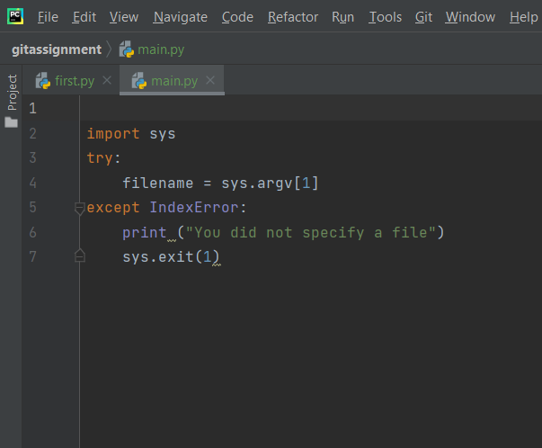

output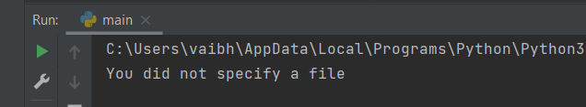

1. Write a program to handle an error if the user entered a number more than four digits it should

return “The length is too short/long!!! Please provide only four digits”

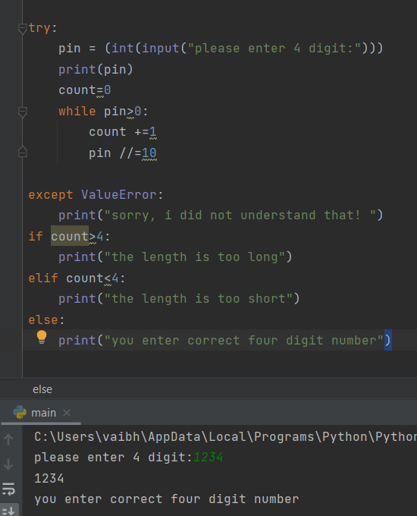

1. Create a login page backend to ask users to enter the username and password. Make sure to

ask for a Re-Type Password and if the password is incorrect give chance to enter it again but it

should not be more than 3 times.

input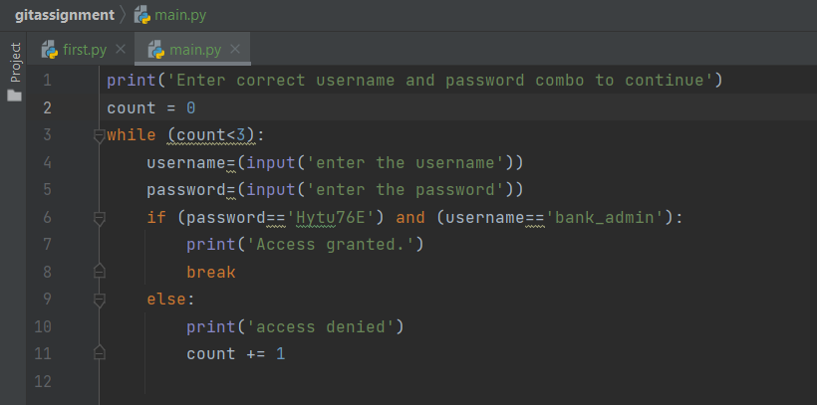

output

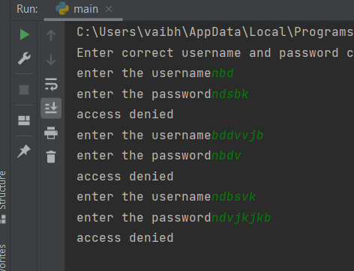

1. Read doc.txt file using Python File handling concept and return only the even length string from the file. Consider the content of doc.txt as given below:

Hello I am a file

Where you need to return the data string

Which is of even length

Make sure you return the content in The same link as it is present.

