实验十四、用户管理菜单实验

1 实验目的
掌握智能锁中使用菜单的方式管理用户。

2 实验内容
1、基于用户管理工程。
2、编写代码，实现新增用户、编辑用户和删除用户菜单，在菜单中管理用户
3、编译工程，验证菜单功能是否正确运行。

3 实验原理
在“用户管理”实验中，已经实现了用户管理的基本功能，但是该实验仅仅验证了用户管理模块的功能，还达不到用户可用的程度。本实验中设计一个用户管理菜单，在实验平台上直接操作，完成用户管理。
设计用户管理菜单如下图所示。主菜单中有四个选项，分别是“添加普通用户”、“添加管理员”、“编辑用户”和“删除用户”，其中“添加普通用户”和“添加管理员用户”都跳转到“用户编辑”菜单；“编辑用户”和“删除用户”都先跳转到用户列表，由用户选择一个id，然后分别跳转到“用户编辑”和“确认删除”菜单。

4 实验步骤
- 使用Clion切换代码到“用户管理框架”节点。
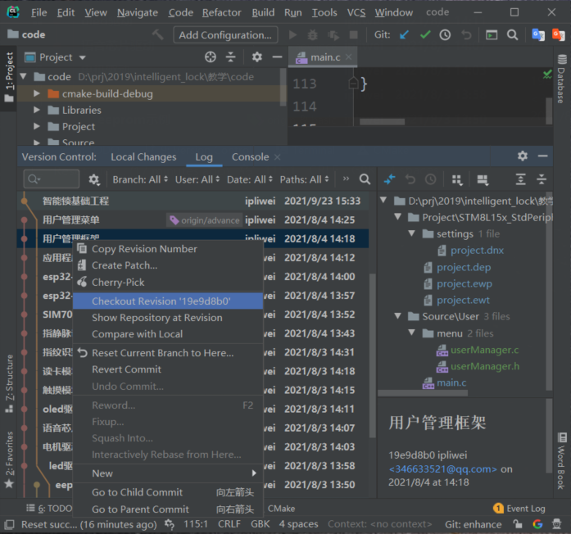
- 启动IAR集成开发环境，选择【File】->【Open Workspace】，打开该工程，如下图：
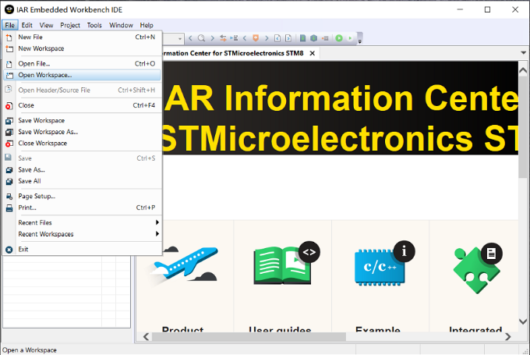
- 在User/menu目录下创建addUser、deleteUser、editUser、userManageMenu和userList，如下图所示。
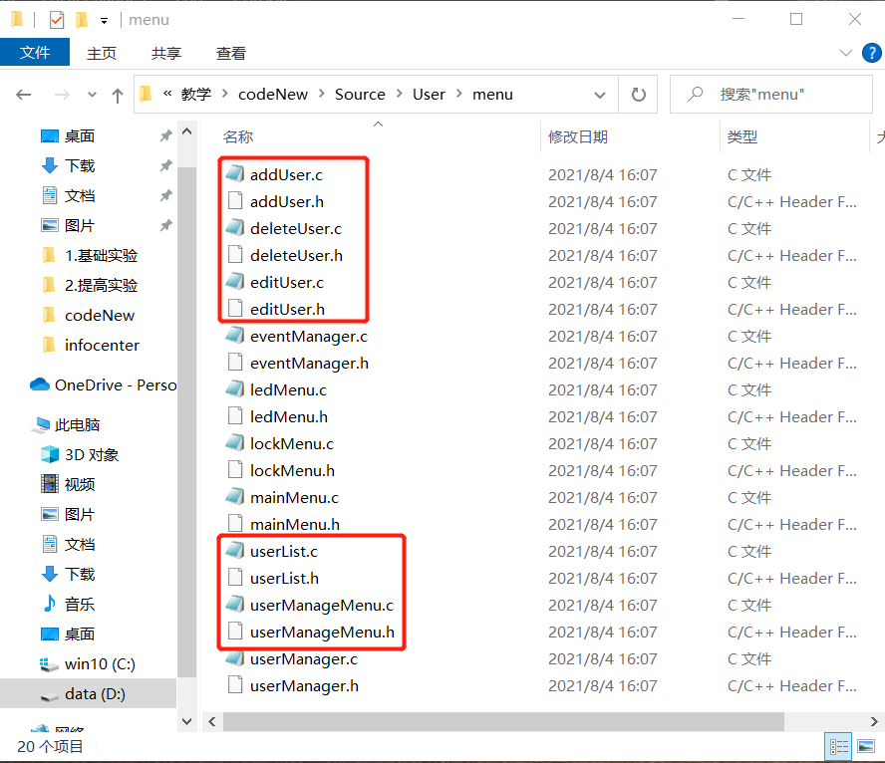
- 在iar工程中的menu目录下添加以上文件，如下图所示：
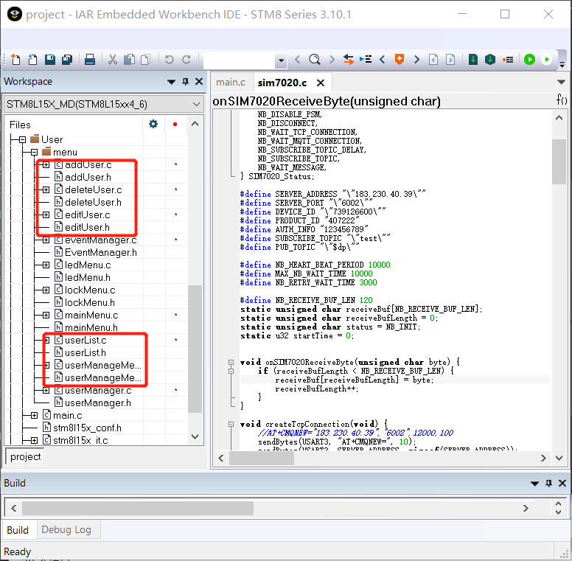
- 在addUser.c中实现添加用户。
#include "stdio.h"
#include "string.h"
#include "stm8l15x.h"
#include "userManager.h"
#include "oled.h"
#include "eventManager.h"
#include "userManageMenu.h"

UserT userToEdit;

static void eventCallback(unsigned char event, unsigned char *pData, unsigned char length);

static void onInputChar(unsigned char c);

static void onInputConfirm(void);

static void showMenu(unsigned char userType) {
userToEdit.id = getAvailableUserId();
clear_screen();
if (userType == USER_ADMIN) {
display_GB2312_string(0, 0, "添加管理员用户", 0);
} else if (userType == USER_GENERAL) {
display_GB2312_string(0, 0, "添加普通用户", 0);
} else {
return;
}
char strBuf[20];
sprintf(strBuf, "用户ID:%d", userToEdit.id);
display_GB2312_string(0, 2, strBuf, 0);
display_GB2312_string(0, 4, "密码类型:", 0);
oledLineInit(40, 6);
display_GB2312_string(0, 6, "密码:", 0);
}

void onAddUserMenuCreate(unsigned char type) {
initNewUser(&userToEdit);
userToEdit.type = type;
showMenu(type);
registerEventCallback(eventCallback);
}

static void finish(void) {
unRegisterEventCallback();
}

static void onInputStart(void) {
userToEdit.passWord.type = TYPE_KEY;
userToEdit.passWord.length = 0;
memset(userToEdit.passWord.text, 0, PASSWORD_LENGTH);
OLED_Clear_line(4);
display_GB2312_string(0, 4, "密码类型:", 0);
display_GB2312_string(72, 4, passwordTypeMap[userToEdit.passWord.type], 0);
OLED_Clear_line(6);
oledLineInit(40, 6);
display_GB2312_string(0, 6, "密码:", 0);
}

static void onInputChar(unsigned char c) {
if (userToEdit.passWord.length > (PASSWORD_LENGTH - 1))return;
userToEdit.passWord.text[userToEdit.passWord.length] = c;
userToEdit.passWord.length++;
oledLineAppendChar(c);
}

static void onInputConfirm(void) {
saveUser(&userToEdit);
finish();
onUserManageMenuCreate();
}

static void eventCallback(unsigned char event, unsigned char *pData, unsigned char length) {
switch (event) {
case KEY_INPUT_START_EVENT:
onInputStart();
break;

case KEY_INPUT_CHARS_EVENT:
onInputChar(*pData);
break;

case KEY_INPUT_CANCEL_EVENT:
finish();
onUserManageMenuCreate();
break;

case KEY_CONFIRM_EVENT:
onInputConfirm();
break;
}
}
- 在addUser.h中定义声明函数API。
#ifndef LOCK_ADDUSER_H
#define LOCK_ADDUSER_H
void onAddUserMenuCreate(unsigned char userType);
#endif //LOCK_ADDUSER_H
- 在deleteUser.c中实现删除用户。
#include "stdio.h"
#include "string.h"
#include "stm8l15x.h"
#include "userManager.h"
#include "oled.h"
#include "eventManager.h"
#include "userManageMenu.h"
static unsigned char userId = 0;
static unsigned char userSelect = 0;//0:取消；1：删除
static void eventCallback(unsigned char event, unsigned char *pData, unsigned char length);
static void onInputChar(unsigned char c);
static void onInputConfirm(void);
static void showMenu(unsigned char select) {
clear_screen();
display_GB2312_string(0, 0, "删除用户", 0);
unsigned char strBuf[10];
sprintf(strBuf, "用户ID：%d", userId);
display_GB2312_string(0, 2, strBuf, 0);
display_GB2312_string(0, 6, "取消", !select);
display_GB2312_string(95, 6, "删除", select);
}
void onDeleteUserCreate(unsigned char id) {
userId = id;
showMenu(0);
registerEventCallback(eventCallback);
}
static void finish(void) {
unRegisterEventCallback();
}
static void onInputStart(void) {
}
static void onInputConfirm(void) {
if(userSelect != 0){
deleteUserById(userId);
}
finish();
onUserManageMenuCreate();
}
static void onInputChar(unsigned char c) {
switch (c) {
case '2'://向上
break;
case '4'://向左
userSelect = 0;
showMenu(userSelect);
break;
case '6'://向右
userSelect = 1;
showMenu(userSelect);
break;
case '8'://向下
break;
}
}
static void eventCallback(unsigned char event, unsigned char *pData, unsigned char length) {
switch (event) {
case KEY_INPUT_START_EVENT:
onInputStart();
break;
case KEY_INPUT_CHARS_EVENT:
onInputChar(*pData);
break;
case KEY_INPUT_CANCEL_EVENT:
finish();
onUserManageMenuCreate();
break;
case KEY_CONFIRM_EVENT:
onInputConfirm();
break;
}
}
- 在deleteUser.h中声明函数API。
#ifndef LOCK_DELETEUSER_H
#define LOCK_DELETEUSER_H
void onDeleteUserCreate(unsigned char id);
#endif //LOCK_DELETEUSER_H
- 在editUser.c中实现用户编辑。
#include "stdio.h"
#include "string.h"
#include "stm8l15x.h"
#include "userManager.h"
#include "oled.h"
#include "eventManager.h"
#include "userManageMenu.h"
static UserT userToEdit;
static void eventCallback(unsigned char event, unsigned char *pData, unsigned char length);
static void onInputChar(unsigned char c);
static void onInputConfirm(void);
void displayPassword(unsigned char y, unsigned char type, unsigned char *password, unsigned char length) {
unsigned char i, strBuf[5];
OLED_Clear_line(y);
display_GB2312_string(0, y, "密码:", 0);
oledLineInit(40, y);
switch (type) {
case TYPE_KEY:
case TYPE_NB:
case TYPE_WIFI:
case TYPE_BLE:
oledLineAppendStr(password);
break;
case TYPE_CARD:
for (i = 0; i < length; i++) {
sprintf(strBuf, "%x", password[i]);
oledLineAppendStr(strBuf);
}
break;
}
}
static void showMenu(void) {
clear_screen();
char strBuf[20];
display_GB2312_string(0, 0, "编辑用户", 0);
sprintf(strBuf, "用户ID:%d", userToEdit.id);
display_GB2312_string(0, 2, strBuf, 0);
display_GB2312_string(0, 4, "密码类型:", 0);
display_GB2312_string(72, 4, passwordTypeMap[userToEdit.passWord.type], 0);
displayPassword(6, userToEdit.passWord.type, userToEdit.passWord.text, userToEdit.passWord.length);
}
void onEditUserCreate(unsigned char id) {
memcpy(&userToEdit, getUserById(id), sizeof(UserT));
showMenu();
registerEventCallback(eventCallback);
}
static void finish(void) {
unRegisterEventCallback();
}
static void onInputStart(void) {
userToEdit.passWord.type = TYPE_KEY;
userToEdit.passWord.length = 0;
memset(userToEdit.passWord.text, 0, PASSWORD_LENGTH);
OLED_Clear_line(4);
display_GB2312_string(0, 4, "密码类型:", 0);
display_GB2312_string(72, 4, passwordTypeMap[userToEdit.passWord.type], 0);
OLED_Clear_line(6);
display_GB2312_string(0, 6, "密码:", 0);
oledLineInit(40, 6);
}
static void onInputChar(unsigned char c) {
if (userToEdit.passWord.length > (PASSWORD_LENGTH - 1))return;
userToEdit.passWord.text[userToEdit.passWord.length] = c;
userToEdit.passWord.length++;
oledLineAppendChar(c);
}
static void onInputConfirm(void) {
saveUser(&userToEdit);
finish();
onUserManageMenuCreate();
}
static void eventCallback(unsigned char event, unsigned char *pData, unsigned char length) {
switch (event) {
case KEY_INPUT_START_EVENT:
onInputStart();
break;
case KEY_INPUT_CHARS_EVENT:
onInputChar(*pData);
break;
case KEY_INPUT_CANCEL_EVENT:
finish();
onUserManageMenuCreate();
break;
case KEY_CONFIRM_EVENT:
onInputConfirm();
break;
}
}
- 在editUser.h中声明函数API。
#ifndef LOCK_EDITUSER_H
#define LOCK_EDITUSER_H
void onEditUserCreate(unsigned char c);
#endif //LOCK_EDITUSER_H
- 在userList.c中实现展示用户列表。
#include "stdio.h"
#include "string.h"
#include "stm8l15x.h"
#include "userManager.h"
#include "oled.h"
#include "eventManager.h"
#include "userManageMenu.h"
static unsigned char userIdList[MAX_USER_COUNT] = {0};
static unsigned char usersCount = 0;
static unsigned char userSelect = 0;
void (*onNextMenuCreate)(unsigned char c);
static void eventCallback(unsigned char event, unsigned char *pData, unsigned char length);
static void onInputChar(unsigned char c);
static void onInputConfirm(void);
static void showMenu(unsigned char id) {
if (usersCount == 0) {
clear_screen();
display_GB2312_string(0, 0, "用户列表为空", 0);
return;
}
clear_screen();
displayChar('>', 0, (id % 4) * 2, 0);
unsigned char i, start = id / 4 * 4, end = usersCount - 1, strBuf[20];
if ((end - start) >= 4) {
end = start + 3;
}
for (i = start; i <= end; i++) {
sprintf(strBuf, "ID:%d %s", userIdList[i], getUserById(userIdList[i])->type == USER_ADMIN ? "管理员":"");
display_GB2312_string(16, (i - start) * 2, strBuf, 0);
}
}
void onUserListCreate(void (*nextMenu)(unsigned char c)) {
onNextMenuCreate = nextMenu;
userSelect = 0;
getUsersIndexList(userIdList, &usersCount);
showMenu(0);
registerEventCallback(eventCallback);
}
static void finish(void) {
unRegisterEventCallback();
}
static void onInputStart(void) {
}
static void onInputConfirm(void) {
if (usersCount == 0) {
return;
}
finish();
onNextMenuCreate(userIdList[userSelect]);
}
static void onInputChar(unsigned char c) {
switch (c) {
case '2'://向上
if (userSelect > 0)userSelect--;
showMenu(userSelect);
break;
case '4'://返回
finish();
onUserManageMenuCreate();
break;
case '6'://确认
onInputConfirm();
break;
case '8'://向下
if (usersCount == 0)return;
if (userSelect < (usersCount - 1))userSelect++;
showMenu(userSelect);
break;
}
}
static void eventCallback(unsigned char event, unsigned char *pData, unsigned char length) {
switch (event) {
case KEY_INPUT_START_EVENT:
onInputStart();
break;
case KEY_INPUT_CHARS_EVENT:
onInputChar(*pData);
break;
case KEY_INPUT_CANCEL_EVENT:
finish();
onUserManageMenuCreate();
break;
case KEY_CONFIRM_EVENT:
onInputConfirm();
break;
}
}
- 在userList.h中声明函数API。
#ifndef LOCK_USERLIST_H
#define LOCK_USERLIST_H
void onUserListCreate(void (*nextMenu)(unsigned char c));
#endif //LOCK_USERLIST_H
- 在userManageMenu.c中实现用户管理菜单功能选择。
#include "stdio.h"
#include "string.h"
#include "stm8l15x.h"
#include "userManager.h"
#include "oled.h"
#include "eventManager.h"
#include "userManageMenu.h"
#include "addUser.h"
#include "editUser.h"
#include "deleteUser.h"
#include "userList.h"
static unsigned char userSelect = 0;
static void eventCallback(unsigned char event, unsigned char *pData, unsigned char length);
static void onInputChar(unsigned char c);
static void onInputConfirm(void);
static void showMenu(unsigned char selected) {
clear_screen();
displayChar('>', 0, selected * 2, 0);
display_GB2312_string(16, 0, "添加普通用户", 0);
display_GB2312_string(16, 2, "添加管理员", 0);
display_GB2312_string(16, 4, "编辑用户", 0);
display_GB2312_string(16, 6, "删除用户", 0);
}
void onUserManageMenuCreate(void) {
userSelect = 0;
showMenu(0);
registerEventCallback(eventCallback);
}
static void finish(void) {
unRegisterEventCallback();
}
static void onInputStart(void) {
}
static void onInputConfirm(void) {
switch (userSelect) {
case 0://添加普通用户
onAddUserMenuCreate(USER_GENERAL);
break;
case 1://添加管理员用户
onAddUserMenuCreate(USER_ADMIN);
break;
case 2://编辑用户
onUserListCreate(onEditUserCreate);
break;
case 3://删除用户
onUserListCreate(onDeleteUserCreate);
break;
}
}
static void onInputChar(unsigned char c) {
switch (c) {
case '2'://向上
if (userSelect > 0)userSelect--;
showMenu(userSelect);
break;
case '4'://返回
break;
case '6'://确认
onInputConfirm();
break;
case '8'://向下
if (userSelect < 3)userSelect++;
showMenu(userSelect);
break;
}
}
static void eventCallback(unsigned char event, unsigned char *pData, unsigned char length) {
switch (event) {
case KEY_INPUT_START_EVENT:
onInputStart();
break;
case KEY_INPUT_CHARS_EVENT:
onInputChar(*pData);
break;
case KEY_INPUT_CANCEL_EVENT:
break;
case KEY_CONFIRM_EVENT:
onInputConfirm();
break;
}
}
- 在userManageMenu.h中声明函数API。
#ifndef LOCK_MANAGEUSERMENU_H
#define LOCK_MANAGEUSERMENU_H
void onUserManageMenuCreate(void);
#endif //LOCK_MANAGEUSERMENU_H
- 在userManager.c中定义密码类型到文字的映射。
unsigned char passwordTypeMap[][10] = {"键盘", "卡号", "指纹", "指静脉", "NB", "WIFI", "蓝牙"};
- 在userManager.h中声明passwordTypeMap。
extern unsigned char passwordTypeMap[][10];
- 修改main函数，在main函数中调用onUserManageMenuCreate函数，并循环调用keysProcess，实现按键操作菜单。
#include <stdio.h>
#include "stm8l15x.h"
#include "stm8_eval.h"
#include "board.h"
#include "led.h"
#include "door.h"
#include "sound.h"
#include "oled.h"
#include "tsm12.h"
#include "card.h"
#include "fingerPrint.h"
#include "fingerVein.h"
#include "sim7020.h"
#include "esp32.h"
#include "userManager.h"
#include "userManageMenu.h"
void main(void) {
CLK_SYSCLKDivConfig(CLK_SYSCLKDiv_1);
boardInit();
initUserManager();
/*请在此调用onUserManageMenuCreate函数*/
while (1) {
/*请在此调用keysProcess()函数*/
}
}
- 编译并烧写程序到实验平台。

5 实验结果
重启单片机，OLED屏幕将显示用户管理菜单，如下图所示。按“2”和“8”键上下选择管理功能，按“#”键进入管理功能，按“*”键可以返回上一级菜单。
