实验六、读卡模块驱动实验

1 实验目的
设计读卡模块驱动，实现读取IC卡功能。

2 实验内容
1、打开“触摸模块驱动”工程。
2、添加card模块到工程中。
3、编写代码，在board中实现rc523芯片初始化。
4、编写代码，实现从rc523芯片读取卡号，并把卡号显示在屏幕上。
5、编译工程，验证读卡模块驱动是否完成。

3 实验原理
MFRC523是高度集成的非接触式(13.56MHz)读写卡芯片，内部发送器可驱动读写器天线与ISO14443A、MIFARE卡和应答机的通信，无需其它电路。接收器提供一个功能强大和高效的解调和译码电路，用来处理兼容ISO14443A/MIFARE卡和应答机的信号。数字电路部分处理完整的ISO14443A帧和错误检测（奇偶&CRC）。MFRC523引脚封装如下图所示：
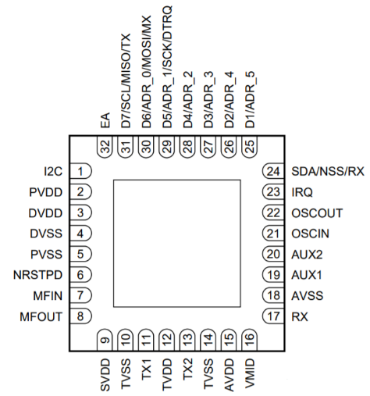
读卡模块电路如下图所示。更多相关资料请参考《6.MFRC523.pdf》。
读卡过程大致如下：MCU通过对读卡器芯片内寄存器的读写来控制读卡器芯片，读卡器芯片收到MCU发来的命令后，按照非接触式射频卡协议格式，通过天线及其匹配电路向附近发出一组固定频率的调制信号(13.56MHz)进行寻卡，若此范围内有卡片存在，卡片内部的LC谐振电路(谐振频率与读卡器发送的电磁波频率相同)在电磁波的激励下，产生共振，在卡片内部电压泵的作用下不断为其另一端的电容充电，获得能量，当该电容电压达到2V时，即可作为电源为卡片的其他电路提供工作电压。当有卡片处在读卡器的有效工作范围内时，MCU向卡片发出寻卡命令，卡片将回复卡片类型，建立卡片与读卡器的第一步联系，若同时有多张卡片在天线的工作范围内，读卡器通过启动防冲撞机制，根据卡片序列号来选定一张卡片，被选中的卡片再与读卡器进行密码校验,确保读卡器对卡片有操作权限以及卡片的合法性，而未被选中的则仍然处在闲置状态，等待下一次寻卡命令。密码验证通过之后，就可以对卡片进行读写等应用操作。

4 实验步骤
- 使用Clion切换代码到“触摸模块驱动”版本。
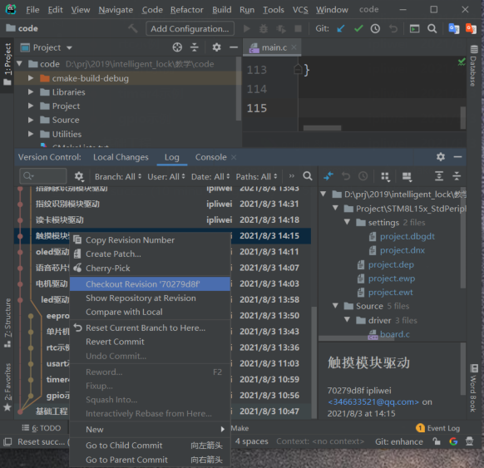
- 启动IAR集成开发环境，选择【File】->【Open Workspace】，打开该工程，如下图：
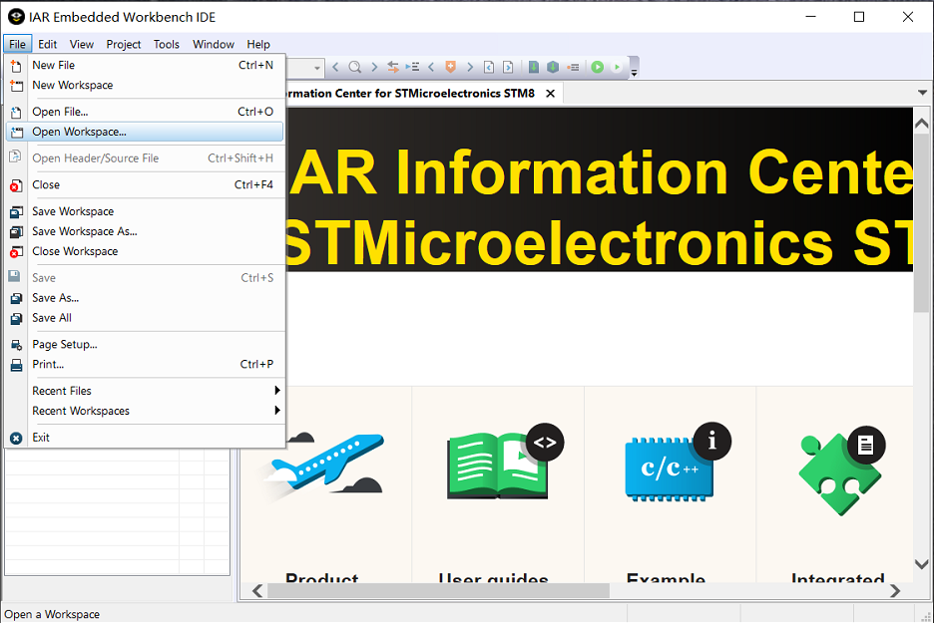
- 在driver目录下添加card.c和card.h，如下图所示：
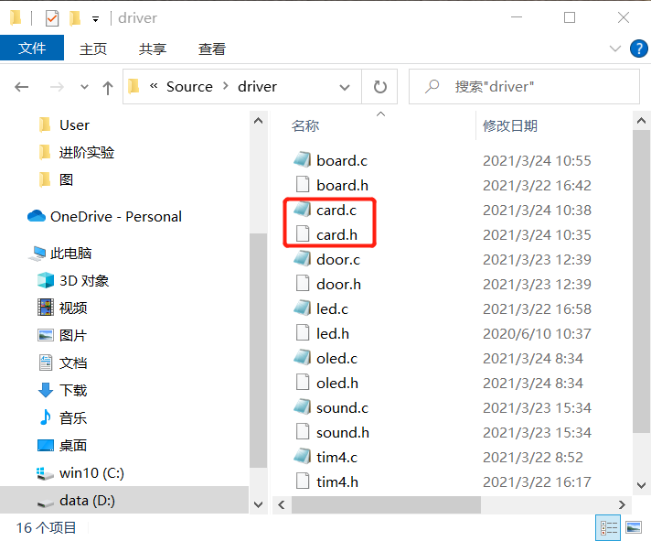
- 右键【driver】->【Add】->【Add Files..】，添加card.c和card.h到工程中，如下图：
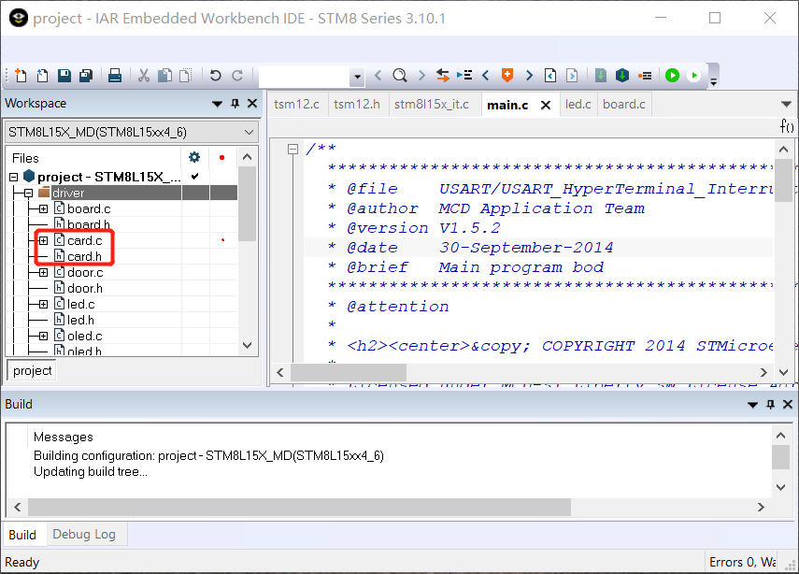
- 在card.c中加入读卡代码：
#include "stdio.h"
#include "string.h"
#include "stm8l15x.h"
#include "card.h"
#include "timer4.h"
#define RC523_PORT GPIOF
#define SCK GPIO_Pin_6
#define MISO GPIO_Pin_4
#define MOSI GPIO_Pin_5
#define NSS GPIO_Pin_7
#define CLR_NSS GPIO_ResetBits(RC523_PORT,NSS)
#define SET_NSS GPIO_SetBits(RC523_PORT,NSS)
#define CLR_SCK GPIO_ResetBits(RC523_PORT,SCK)
#define SET_SCK GPIO_SetBits(RC523_PORT,SCK)
#define CLR_MOSI GPIO_ResetBits(RC523_PORT,MOSI)
#define SET_MOSI GPIO_SetBits(RC523_PORT,MOSI)
#define GET_MISO GPIO_ReadInputDataBit(RC523_PORT,MISO)
#define MAXRLEN 18
void rcDelay(int dly) {
int i;
for (i = 0; i < dly; i++);
}
void WriteRawRC(u8 Address, u8 value) {
u8 i, ucAddr;
CLR_SCK;
CLR_NSS;
rcDelay(5);
ucAddr = ((Address << 1) & 0x7E);
for (i = 8; i > 0; i--) {
if ((ucAddr & 0x80) == 0x80) { SET_MOSI; }
else { CLR_MOSI; }
SET_SCK;
rcDelay(5);
ucAddr <<= 1;
CLR_SCK;
rcDelay(5);
}
for (i = 8; i > 0; i--) {
if ((value & 0x80) == 0x80) {SET_MOSI;}
else {CLR_MOSI;}
SET_SCK;
rcDelay(5);
value <<= 1;
CLR_SCK;
rcDelay(5);
}
SET_NSS;
SET_SCK;
}

u8 ReadRawRC(u8 Address) {
u8 i, ucAddr;
u8 ucResult = 0;
CLR_SCK;
CLR_NSS;
rcDelay(5);
ucAddr = ((Address << 1) & 0x7E) | 0x80;
for (i = 8; i > 0; i--) {
if ((ucAddr & 0x80) == 0x80) {SET_MOSI;}
else {CLR_MOSI;}
SET_SCK;
rcDelay(5);
ucAddr <<= 1;
CLR_SCK;
rcDelay(5);
}
for (i = 8; i > 0; i--) {
SET_SCK;
rcDelay(5);
ucResult <<= 1;
if (GET_MISO) {ucResult |= 1;}
CLR_SCK;
rcDelay(5);
}
SET_NSS;
SET_SCK;
return ucResult;
}
void PcdReset(void) {
WriteRawRC(ModeReg, 0x3D);
WriteRawRC(TReloadRegL, 30);
WriteRawRC(TReloadRegH, 0);
WriteRawRC(TModeReg, 0x8D);
WriteRawRC(TPrescalerReg, 0x40);
WriteRawRC(TxAutoReg, 0x40);
}
void SetBitMask(unsigned char reg, unsigned char mask) {
char tmp = 0x0;
tmp = ReadRawRC(reg);
WriteRawRC(reg, tmp | mask);
}
void ClearBitMask(unsigned char reg, unsigned char mask) {
char tmp = 0x0;
tmp = ReadRawRC(reg);
WriteRawRC(reg, tmp & ~mask);
}

void PcdAntennaOn(void) {
unsigned char i;
i = ReadRawRC(TxControlReg);
if (!(i & 0x03)) {
SetBitMask(TxControlReg, 0x03);
}
}
void PcdAntennaOff() {
ClearBitMask(TxControlReg, 0x03);
}
void CalulateCRC(unsigned char *pIndata, unsigned char len, unsigned char *pOutData) {
unsigned char i, n;
ClearBitMask(DivIrqReg, 0x04);
WriteRawRC(CommandReg, PCD_IDLE);
SetBitMask(FIFOLevelReg, 0x80);
for (i = 0; i < len; i++) { WriteRawRC(FIFODataReg, *(pIndata + i)); }
WriteRawRC(CommandReg, PCD_CALCCRC);
i = 0xFF;
do {
n = ReadRawRC(DivIrqReg);
i--;
} while ((i != 0) && !(n & 0x04));
pOutData[0] = ReadRawRC(CRCResultRegL);
pOutData[1] = ReadRawRC(CRCResultRegM);
}
char PcdComMF522(unsigned char Command,
unsigned char *pInData,
unsigned char InLenByte,
unsigned char *pOutData,
unsigned int *pOutLenBit) {
int status = MI_ERR;
unsigned char irqEn = 0x00;
unsigned char waitFor = 0x00;
unsigned char lastBits;
unsigned char n;
unsigned int i;
switch (Command) {
case PCD_AUTHENT:
irqEn = 0x12;
waitFor = 0x10;
break;
case PCD_TRANSCEIVE:
irqEn = 0x77;
waitFor = 0x30;
break;
default:
break;
}
WriteRawRC(ComIEnReg, irqEn | 0x80);
ClearBitMask(ComIrqReg, 0x80);
WriteRawRC(CommandReg, PCD_IDLE);
SetBitMask(FIFOLevelReg, 0x80);
for (i = 0; i < InLenByte; i++) { WriteRawRC(FIFODataReg, pInData[i]); }
WriteRawRC(CommandReg, Command);
if (Command == PCD_TRANSCEIVE) { SetBitMask(BitFramingReg, 0x80); }
i = 1000;
do {
n = ReadRawRC(ComIrqReg);
i--;
} while ((i != 0) && !(n & 0x01) && !(n & waitFor));
ClearBitMask(BitFramingReg, 0x80);
if (i != 0) {
if (!(ReadRawRC(ErrorReg) & 0x1B)) {
status = MI_OK;
if (n & irqEn & 0x01) { status = MI_NOTAGERR; }
if (Command == PCD_TRANSCEIVE) {
n = ReadRawRC(FIFOLevelReg);
lastBits = ReadRawRC(ControlReg) & 0x07;
if (lastBits) { *pOutLenBit = (n - 1) * 8 + lastBits; }
else { *pOutLenBit = n * 8; }
if (n == 0) { n = 1; }
if (n > MAXRLEN) { n = MAXRLEN; }
for (i = 0; i < n; i++) { pOutData[i] = ReadRawRC(FIFODataReg); }
}
} else { status = MI_ERR; }

}
SetBitMask(ControlReg, 0x80);
WriteRawRC(CommandReg, PCD_IDLE);
return status;
}
char PcdRequest(unsigned char req_code, unsigned char *pTagType) {
int status;
unsigned int unLen;
unsigned char ucComMF522Buf[MAXRLEN];
ClearBitMask(Status2Reg, 0x08);
WriteRawRC(BitFramingReg, 0x07);
SetBitMask(TxControlReg, 0x03);
ucComMF522Buf[0] = req_code;
status = PcdComMF522(PCD_TRANSCEIVE, ucComMF522Buf, 1, ucComMF522Buf, &unLen);
if ((status == MI_OK) && (unLen == 0x10)) {
*pTagType = ucComMF522Buf[0];
*(pTagType + 1) = ucComMF522Buf[1];
} else {
status = MI_ERR;
}
return status;
}
char PcdAnticoll(unsigned char *pSnr) {
int status;
unsigned char i, snr_check = 0;
unsigned int unLen;
unsigned char ucComMF522Buf[MAXRLEN];
ClearBitMask(Status2Reg, 0x08);
WriteRawRC(BitFramingReg, 0x00);
ClearBitMask(CollReg, 0x80);
ucComMF522Buf[0] = PICC_ANTICOLL1;
ucComMF522Buf[1] = 0x20;
status = PcdComMF522(PCD_TRANSCEIVE, ucComMF522Buf, 2, ucComMF522Buf, &unLen);
if (status == MI_OK) {
for (i = 0; i < 4; i++) {
*(pSnr + i) = ucComMF522Buf[i];
snr_check ^= ucComMF522Buf[i];
}
if (snr_check != ucComMF522Buf[i]) { status = MI_ERR; }
}
SetBitMask(CollReg, 0x80);
return status;
}
char PcdSelect(unsigned char *pSnr) {
int status;
unsigned char i;
unsigned int unLen;
unsigned char ucComMF522Buf[MAXRLEN];
ucComMF522Buf[0] = PICC_ANTICOLL1;
ucComMF522Buf[1] = 0x70;
ucComMF522Buf[6] = 0;
for (i = 0; i < 4; i++) {
ucComMF522Buf[i + 2] = *(pSnr + i);
ucComMF522Buf[6] ^= *(pSnr + i);
}
CalulateCRC(ucComMF522Buf, 7, &ucComMF522Buf[7]);
ClearBitMask(Status2Reg, 0x08);
status = PcdComMF522(PCD_TRANSCEIVE, ucComMF522Buf, 9, ucComMF522Buf, &unLen);
if ((status == MI_OK) && (unLen == 0x18)) { status = MI_OK; }
else { status = MI_ERR; }
return status;
}
char PcdRead(unsigned char addr, unsigned char *pData) {
int status;
unsigned int unLen;
unsigned char i, ucComMF522Buf[MAXRLEN];
ucComMF522Buf[0] = PICC_READ;
ucComMF522Buf[1] = addr;
CalulateCRC(ucComMF522Buf, 2, &ucComMF522Buf[2]);
status = PcdComMF522(PCD_TRANSCEIVE, ucComMF522Buf, 4, ucComMF522Buf, &unLen);
if ((status == MI_OK) && (unLen == 0x90))
{
for (i = 0; i < 16; i++) { *(pData + i) = ucComMF522Buf[i]; }
} else { status = MI_ERR; }

return status;
}
char PcdWrite(unsigned char addr, unsigned char *pData) {
int status;
unsigned int unLen;
unsigned char i, ucComMF522Buf[MAXRLEN];

ucComMF522Buf[0] = PICC_WRITE;
ucComMF522Buf[1] = addr;
CalulateCRC(ucComMF522Buf, 2, &ucComMF522Buf[2]);
status = PcdComMF522(PCD_TRANSCEIVE, ucComMF522Buf, 4, ucComMF522Buf, &unLen);
if ((status != MI_OK) || (unLen != 4) || ((ucComMF522Buf[0] & 0x0F) != 0x0A)) { status = MI_ERR; }
if (status == MI_OK) {
for (i = 0; i < 16; i++) { ucComMF522Buf[i] = *(pData + i); }
CalulateCRC(ucComMF522Buf, 16, &ucComMF522Buf[16]);
status = PcdComMF522(PCD_TRANSCEIVE, ucComMF522Buf, 18, ucComMF522Buf, &unLen);
if ((status != MI_OK) || (unLen != 4) || ((ucComMF522Buf[0] & 0x0F) != 0x0A)) { status = MI_ERR; }
}
return status;
}
char PcdHalt(void) {
int status;
unsigned int unLen;
unsigned char ucComMF522Buf[MAXRLEN];
ucComMF522Buf[0] = PICC_HALT;
ucComMF522Buf[1] = 0;
CalulateCRC(ucComMF522Buf, 2, &ucComMF522Buf[2]);
status = PcdComMF522(PCD_TRANSCEIVE, ucComMF522Buf, 4, ucComMF522Buf, &unLen);
return status;
}

unsigned char cardLeave(void) {
unsigned char card_status = 0;
unsigned char status;
static unsigned char put_card_flag = 0;
static unsigned char take_card_flag = 0;
unsigned char buf[20];
status = PcdRequest(PICC_REQALL, buf);
if (status != MI_OK) {
card_status = 2;
}
status = PcdAnticoll(buf);
if (status != MI_OK) {
card_status = 2;
} else card_status = 1;
PcdHalt();
switch (card_status) {
case 1:
put_card_flag = 1;
return 0;
case 2:
take_card_flag = 1;
if ((1 == put_card_flag) && (1 == take_card_flag)) {
put_card_flag = 0;
take_card_flag = 0;
return 1;
}
break;
}
return 0;
}
unsigned char *readCard(unsigned char *length) {
unsigned char status, card_leave;
static unsigned char strp[20];
static unsigned char strb[20];
static unsigned char cardidbuf[20];
*length = 0;
char *p = NULL;
card_leave = cardLeave();
if (1 == card_leave) memset(cardidbuf, 0, 20);
sprintf(strb, "%x %x %x %x", cardidbuf[0], cardidbuf[1], cardidbuf[2], cardidbuf[3]);
status = PcdRequest(PICC_REQALL, cardidbuf);
if (status != MI_OK) {
return p;
}
status = PcdAnticoll(cardidbuf);
if (status != MI_OK) {
return p;
}
PcdHalt();
sprintf(strp, "%x %x %x %x", cardidbuf[0], cardidbuf[1], cardidbuf[2], cardidbuf[3]);
*length = 4;
if (strcmp(strb, strp) == 0) return p;
else return strp;
}

void rc523Init(void) {
PcdReset();
Delay_ms(250);
PcdAntennaOff();
PcdAntennaOn();
}
- 在card.h中加入芯片寄存器定义及API声明：
#ifndef CODE_RC523_H
#define CODE_RC523_H

// PAGE 0
#define RFU00 0x00
#define CommandReg 0x01
#define ComIEnReg 0x02
#define DivlEnReg 0x03
#define ComIrqReg 0x04
#define DivIrqReg 0x05
#define ErrorReg 0x06
#define Status1Reg 0x07
#define Status2Reg 0x08
#define FIFODataReg 0x09
#define FIFOLevelReg 0x0A
#define WaterLevelReg 0x0B
#define ControlReg 0x0C
#define BitFramingReg 0x0D
#define CollReg 0x0E
#define RFU0F 0x0F
// PAGE 1
#define RFU10 0x10
#define ModeReg 0x11
#define TxModeReg 0x12
#define RxModeReg 0x13
#define TxControlReg 0x14
#define TxAutoReg 0x15
#define TxSelReg 0x16
#define RxSelReg 0x17
#define RxThresholdReg 0x18
#define DemodReg 0x19
#define RFU1A 0x1A
#define RFU1B 0x1B
#define MifareReg 0x1C
#define RFU1D 0x1D
#define RFU1E 0x1E
#define SerialSpeedReg 0x1F
// PAGE 2
#define RFU20 0x20
#define CRCResultRegM 0x21
#define CRCResultRegL 0x22
#define RFU23 0x23
#define ModWidthReg 0x24
#define RFU25 0x25
#define RFCfgReg 0x26
#define GsNReg 0x27
#define CWGsCfgReg 0x28
#define ModGsCfgReg 0x29
#define TModeReg 0x2A
#define TPrescalerReg 0x2B
#define TReloadRegH 0x2C
#define TReloadRegL 0x2D
#define TCounterValueRegH 0x2E
#define TCounterValueRegL 0x2F
// PAGE 3
#define RFU30 0x30
#define TestSel1Reg 0x31
#define TestSel2Reg 0x32
#define TestPinEnReg 0x33
#define TestPinValueReg 0x34
#define TestBusReg 0x35
#define AutoTestReg 0x36
#define VersionReg 0x37
#define AnalogTestReg 0x38
#define TestDAC1Reg 0x39
#define TestDAC2Reg 0x3A
#define TestADCReg 0x3B
#define RFU3C 0x3C
#define RFU3D 0x3D
#define RFU3E 0x3E
#define RFU3F 0x3F
#define PCD_IDLE 0x00 //取消当前命令
#define PCD_AUTHENT 0x0E //验证密钥
#define PCD_RECEIVE 0x08 //接收数据
#define PCD_TRANSMIT 0x04 //发送数据
#define PCD_TRANSCEIVE 0x0C //发送并接收数据
#define PCD_RESETPHASE 0x0F //复位
#define PCD_CALCCRC 0x03 //CRC计算
#define PICC_REQIDL 0x26 //寻天线区内未进入休眠状态
#define PICC_REQALL 0x52 //寻天线区内全部卡
#define PICC_ANTICOLL1 0x93 //防冲撞
#define PICC_ANTICOLL2 0x95 //防冲撞
#define PICC_AUTHENT1A 0x60 //验证A密钥
#define PICC_AUTHENT1B 0x61 //验证B密钥
#define PICC_READ 0x30 //读块
#define PICC_WRITE 0xA0 //写块
#define PICC_DECREMENT 0xC0 //扣款
#define PICC_INCREMENT 0xC1 //充值
#define PICC_RESTORE 0xC2 //调块数据到缓冲区
#define PICC_TRANSFER 0xB0 //保存缓冲区中数据
#define PICC_HALT 0x50 //休眠

#define MI_OK 0
#define MI_NOTAGERR (-1)
#define MI_ERR (-2)
#define DEF_FIFO_LENGTH 64 //FIFO size=64byte
#define RC523_PORT GPIOF

void rc523Init(void);
unsigned char* readCard(unsigned char *length);

#endif
- 修改board.c，在boardInit函数中增加读卡模块初始化代码。
#include "stm8l15x.h"
#include "led.h"
#include "timer4.h"
#include "oled.h"
#include "tsm12.h"
#include "card.h"
void boardInit(void){
…
//card
GPIO_Init(GPIOF,GPIO_Pin_5|GPIO_Pin_6|GPIO_Pin_7,
GPIO_Mode_Out_PP_High_Fast);
GPIO_Init(GPIOF, GPIO_Pin_4, GPIO_Mode_In_PU_No_IT);
rc523Init();
}
- 修改main函数，在main函数中循环读卡，读到卡号后，把卡号显示到屏幕上。
#include <stdio.h>
#include "stm8l15x.h"
#include "stm8_eval.h"
#include "board.h"
#include "led.h"
#include "door.h"
#include "sound.h"
#include "oled.h"
#include "tsm12.h"
#include "card.h"
void main(void) {
unsigned char length;
unsigned char* cardId;
CLK_SYSCLKDivConfig(CLK_SYSCLKDiv_1);
boardInit();
display_GB2312_string(0,0,"智能锁实践", 0);
while (1) {
/*请在此调用readCard 函数，读到卡号时把卡号显示到屏幕上，并执行一次开锁*/
/*注意，当没有卡片时，readCard 函数的返回值是NULL*/
}
}
- 编译并烧写程序到实验平台。

5 实验结果
重启单片机，把IC卡放到读卡模块上，单片机将读到该卡的卡号并显示在OLED屏幕上。
