Case Study: Evaluating AI Reasoning with GlassBox Engine
TL;DR: This report demonstrates how I evaluate, reject, and correct AI-generated reasoning by enforcing evidence chains, auditing explanations, and refusing unverifiable inferences in a real production system.

Public Codebase (Evaluation Infrastructure):
github.com/vKS-Rajput/GlassBox-Engine

This case study shows how I built and evaluated a system that audits AI-generated explanations to improve transparency, reliability, and decision quality. It demonstrates my approach to evaluating reasoning rather than just outputs.

Problem Statement
When working with LLMs or any automated decision systems, a common issue appears: outputs might be correct, but the reasoning behind them can be problematic. This creates several risks:
- Incomplete logic — Steps are skipped or assumptions are hidden
- Inconsistent reasoning — The same input produces different explanations
- Overconfident statements — Uncertainty is masked with confident language
- Unverifiable claims — Conclusions have no traceable evidence

The GlassBox Engine was built to address this by creating a framework where every piece of data must come with evidence, and every decision must be explainable step-by-step.

System Overview
GlassBox Engine is a lead discovery tool for freelancers that finds potential clients from public signals like job postings or funding announcements. But its real purpose is to demonstrate reasoning transparency.

The system works in phases:
- Ingest signals from public sources (RSS feeds)
- Extract entities (companies) from those signals
- Enrich data with optional context (industry, size, location)
- Rank leads using deterministic scoring
- Explain decisions with full transparency

What makes it interesting for evaluation work is that nothing enters the system without evidence, and every score can be broken down into components you can audit.

AI Usage Context
The system uses AI in two ways:
- For extraction — Parsing unstructured text to identify company names, domains, and hiring signals
- For enrichment — Deriving contextual information like industry categorization

These AI-generated outputs are treated as hypotheses, not facts. Every extracted value must:
- Have a confidence score
- Point to the source it came from
- Be validated against rules before entering the pipeline

This creates a natural evaluation checkpoint where I can examine whether the AI's reasoning makes sense.

Observed Failure Modes
While building and testing the system, I identified several recurring issues with AI-generated explanations:

1. Confident Hallucinations
I rejected AI extractions that created information not present in the source. The AI would combine keywords into entities that didn't exist, or infer classifications without textual evidence.

Example:
- Text: "Looking for React developers in the fintech space"
- AI extraction: Company name = "Fintech React Inc."
- Problem: The AI combined keywords into a fake company name

My rejection: I implemented ambiguity detection that rejects signals entirely when multiple entities are detected or none can be verified. Rather than guessing, the system explicitly states why it cannot proceed.

2. Logical Gaps in Scoring
I rejected score assignments that lacked prerequisite evidence. Early versions would award points without verifying that the required signals were actually present.

Example:
- Signal: "Our team uses React"
- Score component: +40 points for "hiring signal detected"
- Problem: Talking about technology ≠ hiring

My correction: I made every scoring component trace back to specific evidence. Each point must cite which piece of data justified it. No points without proof.

3. Hidden Assumptions
I rejected AI inferences that relied on unstated rules or assumptions. The system was making decisions based on implicit logic that wasn't documented or verifiable.

Example:
- Extracted: Email = "john@gmail.com"
- Inferred: Company domain = "gmail.com"
- Problem: Generic email providers aren't companies

My solution: I created an explicit TLD whitelist and rejection rules. If a domain matches generic providers (gmail, yahoo, etc.), I reject it with a logged reason. No silent assumptions allowed.

4. Post-hoc Explanations
I rejected any architecture where explanations were generated after scoring. This was the most critical failure mode — scores calculated first, explanations fabricated to match.

Example:
- Score: 88/95 points
- Explanation: "Strong hiring signal and fresh data"
- Actual logic: Score came from entity completeness bonus, not hiring intent
- Problem: The explanation was fabricated after the fact

My architectural fix: I inverted the system — explanations are now generated from the score components, not the other way around. You cannot have a score without knowing exactly why. Every point must have a reason before it's awarded.

Evaluation Criteria
Every piece of data entering the system is evaluated on:
- Logical consistency — Do the reasoning steps follow from each other?
- Traceability — Can I trace this conclusion back to the original source?
- Factual verifiability — Can this claim be checked against the raw data?
- Constraint alignment — Does this respect the system's stated rules?
- Risk assessment — What happens if this explanation is wrong?

These aren't just abstract goals. Each one maps to a test case in the codebase.

Concrete Example (Synthetic, Logic-Focused)
The following example uses synthetic identifiers to demonstrate
evaluation and rejection logic without exposing real client or company data.

Input Signal
Title: "Senior React Engineer - Remote"
Text: "CloudCo is hiring experienced React developers..."
Source: https://example.com/jobs/react-engineer
Published: 2025-01-29
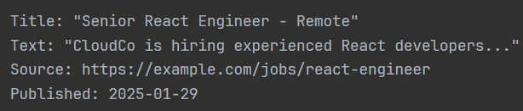

Note: Company name, URL, and identifiers are intentionally synthetic.
This example is included to illustrate evaluation behavior, not to disclose
real-world entities.

AI Extraction Attempt
The system tries to extract:
- Company name: "CloudCo"
- Domain: (needs inference)
- Intent: "hiring"

Evaluation Process
Step 1: Verify company name evidence
- ✓ "CloudCo" appears in text
- ✓ Extracted from verifiable URL
- ✓ Confidence: 0.95 (observation type)

Step 2: Validate domain extraction
- ✗ No domain in original text
- ✗ Cannot infer without additional data
- → I rejected this field — marked domain as "missing" rather than guessing

Step 3: Assess intent signal
- ✓ "hiring" keyword detected
- ✓ Job title present ("Senior React Engineer")
- ✓ Confidence: 0.90 (strong hiring signal)

Step 4: Score assignment
Intent strength: +40 points (hiring signal detected)
Signal freshness: +25 points (0 days old)
Evidence confidence: +15 points (avg confidence 92.5%)
Entity completeness: +5 points (2 out of 4 optional fields)
Noise penalty: 0 points (clean signal)
-----------------------------------
Total: 85/95 points (Tier A)
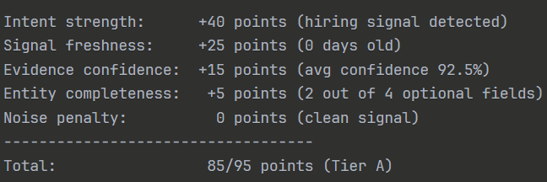

Evaluation Findings
What worked:
- Company name extraction was traceable to specific text
- Intent classification had clear keyword evidence
- Score breakdown showed exactly where points came from
What I corrected:
- Early versions attempted to "guess" the domain from company name
- I rejected this as unverifiable inference
- Better to admit missing data than to fabricate with false confidence
Risk assessment: Without my evaluation controls, the system would have:
- Generated a fake domain ("cloudco.com") without verification
- Assigned high confidence to guessed data
- Hidden the uncertainty from the user
- Created a false sense of completeness

Correction Strategy
To address these issues, I implemented systematic safeguards:

1. Forced Explicit Reasoning
I required every inference to state:
- What it's derived from (source evidence IDs)
- What rule was applied (e.g., "keyword_match")
- What confidence level is appropriate

2. Required Evidence Chains
I enforced that no field can exist without tracing back to:
- A URL (for observations)
- Source evidence + rule (for inferences)
- An API response (for third-party data)

3. Reject Unverifiable Claims
I implemented a strict rejection policy:
- Don't guess when evidence is missing
- Don't assign default values to hide gaps
- Reject the data and log exactly why

4. Inverted Explanation Generation
I built explanations directly from score components:
def get_explanation(self) -> str:
# Build explanation FROM the score components
reasons = []
for component in self.breakdown.components:
if component.contribution > 0:
reasons.append(component.get_human_readable_reason())
return "\n".join(reasons)
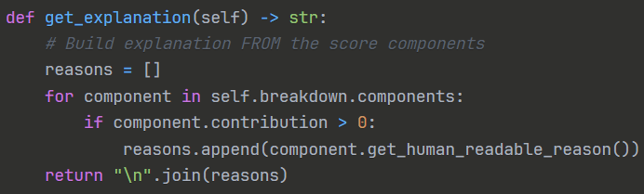

This architecture prevents explanations from being fabricated after scoring.

Outcome
After implementing these evaluation constraints:

Ambiguous outputs were systematically rejected rather than masked:
- Every score has a line-by-line breakdown
- Users can see exactly which evidence contributed
- Rejections are explicit with documented reasons

Reasoning quality became independently verifiable:
- Fewer false positives (ambiguous data is rejected)
- Confidence scores match actual uncertainty
- No hidden assumptions in scoring logic

Every decision could be independently audited without re-running the system:
- Anyone can verify a score by checking the evidence trail
- Explanations match the actual computation path
- System behavior is predictable and deterministic

Quote from README:
"GlassBox is intentionally conservative, explainable, and boring — because trust scales better than hype."
This captures the evaluation mindset: it's better to admit "I don't know" than to provide a confident but questionable answer.

What I Deliberately Did Not Optimize For
These were intentional tradeoffs to prioritize evaluator confidence:

- Recall or volume — False positives were more costly than misses; better to reject ambiguous leads than pollute the pipeline
- User engagement metrics — No dark patterns to inflate perceived value; raw numbers matter more than "feeling smart"
- Model cleverness or novelty — Boring, deterministic rules over sophisticated ML; predictability beats performance
- Speed over correctness — Every extraction is validated even if it slows the pipeline; no shortcuts on verification
These sacrifices reflect what matters in evaluation work: trust, auditability, and reproducibility over volume or impressiveness.

Relevance to Real-World AI Systems
The problems I encountered in GlassBox appear in production AI systems constantly:

In content moderation:
- AI flags content as "harmful" but can't explain which part violated policy
- Evaluation: Which sentence triggered the flag? What rule was applied?

In recommendation systems:
- "Users who liked X also liked Y" hides the reasoning
- Evaluation: What similarity metric? How was it calculated? What threshold?

In automated decision-making:
- Loan applications denied with vague "risk factors"
- Evaluation: Which factors? What weights? Can the applicant contest specific claims?

This project demonstrates three key skills for AI evaluation work:
- Judging reasoning quality — Not just if the output is right, but if the logic is sound
- Auditing explanations — Checking if post-hoc explanations match actual computation
- Rejecting undefensible outputs — Knowing when to say "this needs human review"

What This Shows About My Evaluation Approach
Through this project, I demonstrated:

- Healthy skepticism — I treat AI outputs as claims to verify, not facts to accept
- Systematic rejection — I wrote 152 test cases covering edge cases and failure modes, with clear rejection criteria
- Emphasis on traceability — I enforced that every data point must have a verifiable source
- Comfort with rejection — I reject ambiguous results rather than forcing uncertain inferences
- Focus on explainability — I built the architecture so scores cannot exist without clear reasoning

These are the same skills needed when evaluating language models, scoring AI responses, or auditing automated decisions in production.

Key Takeaway
Building GlassBox Engine taught me that incorrect reasoning is more dangerous than incorrect answers.
If a system gives a wrong score but clear reasoning, you can fix it. If a system gives a right score but opaque reasoning, you can't trust it at scale.

That's why this project matters for evaluation work: it shows I can sit with AI outputs all day without getting fooled.

Role of AI in Implementation
AI tools were used to assist with implementation details and boilerplate code generation.
All core logic, evaluation criteria, rejection rules, scoring design, and system constraints were designed by me.

AI-generated code was treated the same way as any other output:
- Reviewed critically for correctness
- Modified when it violated system guarantees
- Rejected if it conflicted with evaluation logic or constraints

This mirrors real-world applied AI workflows, where humans remain responsible for correctness and judgment.

Technical Implementation Note

For those interested in the actual code:
- Written in Python 3.10+
- 152 passing test cases covering edge cases and failure modes
- Fully deterministic (same input = same output, always)
- Zero ML/training components (pure logic and rules)
- Open source and fully auditable

The codebase prioritizes boring correctness over clever features — which is exactly what you want in evaluation infrastructure.

