What I Did:
Create a code to guess the magnitude of an earthquake based on: ["Latitude", "Longitude", "Depth", "Year", "Month", "Num_Stations"]
I put 4 models to the comparison:
Dummy: just the mean value of the magnitude on the dataset
Random Forest Regression
XGBoost Regression
Deep Learning (MLP Regression)

Those models are then evaluated and compared to each other on 4 different criteria:
RMSE: Root Mean Squared Error, it’s the average error on the prediction
R²: Coefficient of Determination, in % how accurate is the model compared to a prediction of the mean (so the Dummy model)
Training time: how long did it took to train the model
Prediction time: how long did it take to predict a result

Current result:
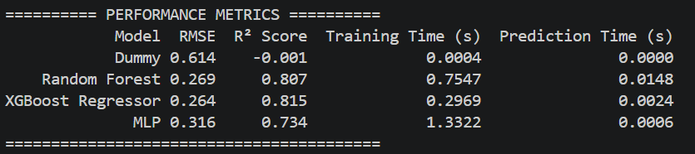

Next step:

