Work:
Made a lot of data viz to understand how each feature has impact on the earthquake magnitude to have a more complete and professional work on:
- Year, month and hour number of earthquake and magnitude difference
- Evolution of magnitude based of number of station detection
- evolution of magnitude based of depth of the earthquake
Then I downloaded the full list of earthquakes (20k) to make some comparisons
So, I build the full csv with the 11 extracts from: https://www.kyoshin.bosai.go.jp/en/eqdownload/
Result to a 20k earthquake csv
Currently doing the comparison between the two of them

Result of analysis:
As expected, Depth and Number of stations is a valuable feature to get predict de magnitude
Hours and years don’t seem to have any impact.
Months need more analysis as it may seem like summer has stronger earthquake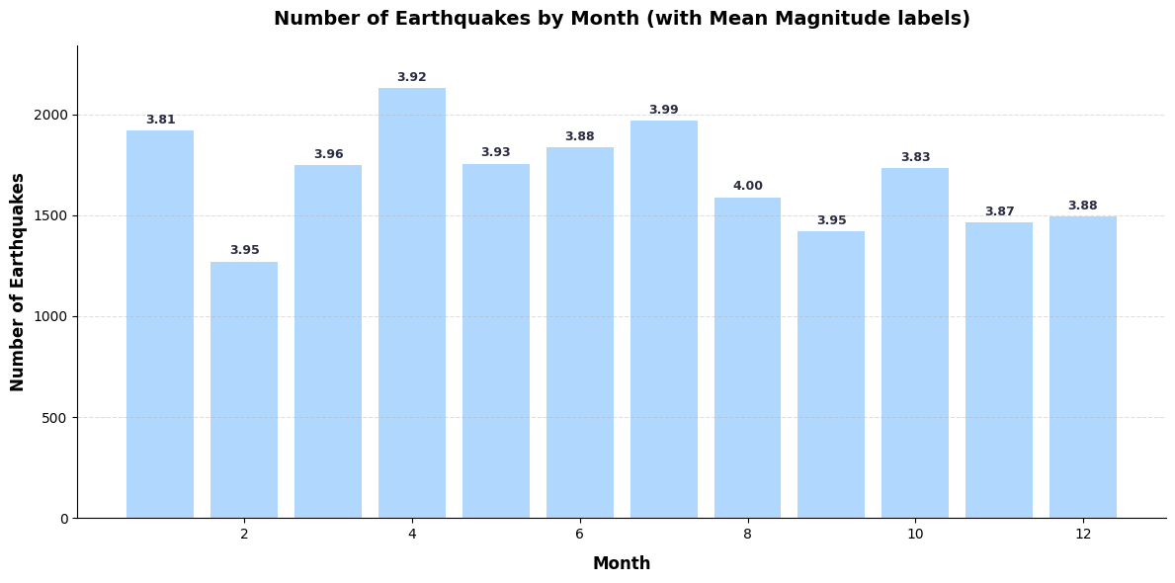
Currently doing the Comparative analysis which is on the way on the way.

Once again sorry for last week lack of report but I was Really sick and stuck home for 3 days straight

