NATIONAL JUNIOR COLLEGE
Mathematics Department

General Certificate of Education Advanced Level
Higher 2

COMPUTING  Written |  |  |  | 9569/01  16 Aug 2024  1 hour
Additional Materials: |  |  | Pre-printed A4 Answer Booklet
READ THESE INSTRUCTIONS FIRST

An answer booklet will be provided with the question paper. You should follow the instructions on the front cover of the answer booklet. If you need additional answer paper ask the invigilator for a continuation booklet.

There is 2 questions totalling 35 marks.

Answer all questions.
Approved calculators are allowed.

The number of marks is given in the brackets [ ] at the end of each question or part question.

Q1 [23]
Q2 [7]

This document consists of 4 printed pages

1 | A sub-contractor company assigns its employees to work on projects for its clients. The duration of the projects usually last more than two days. Each of its employee has a specific skill. The following information needs to be maintain by the company:  - Each project has an unique ID number and a title.  - Each employee has a unique ID number, a name and a SINGLE skill  - Each employee can work on a number of projects at the same time.  - Each skill has an ID number, name and a cost per hour.  - The cost to a client for each employee is the employee’s cost per hour multiplied by the number of hours worked on the project.  The company currently keeps a spreadsheet shown below to keep track of its projects so that its’ clients can be billed when a project has completed.  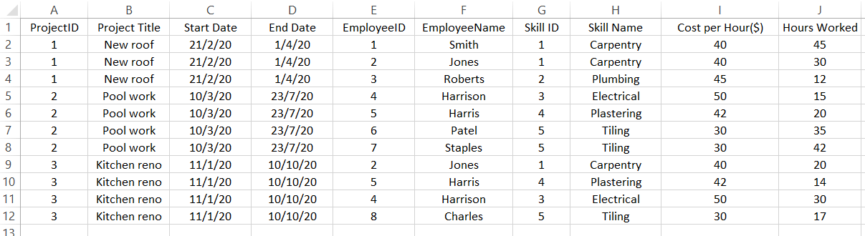  The company wants to construct a relational database to store the data shown above. The spreadsheet data was imported into a single data table in the relational database.
 | (a) | Identify the primary key that can be used for this table. | [1]
 | (b) | Explain, giving an example, whether the above table is in third normal form (3NF). | [2]
 | (c) | A new carpenter, John, is hired by the company but has not being assigned to any project yet. Explain how data anomaly can occur when the company needs to store the data for this new employee in the table. | [2]
 | (d) | Design a ERD (Entity Relationship Diagram) to model the data in third normal form (3NF). | [5]
 | (e) | Describe the relations in the data model, indicating the primary key by underlining the attribute/s and the foreign key with an asterisk *. | [4]
At the end of a project, the client will receive an invoice, showing the hours work and total charges for each skill used in the project and the total cost for the project.
An example of an invoice billed to a customer, Joe Kong, may look like this:
INVOICE
Joe Kong
13 Hillcrest Road
288913

Project ref: 1
Project title: New Roof
Project Start Date: 21 Feb 2020 End Date: 1 Apr 2020

 | (f) | Explain the change/s that need/s to be made to the existing data model in order to produce the invoice shown above. You do not need to modify the answers in (d) and (e) to reflect the change/s. | [3]
 | The hourly cost of hiring a carpenter (a person who has carpentry skill) increases from $40 to $45.
 | (g) | Explain how a problem may arise, if the Cost Per Hour ($) field for the Carpentry skill is updated in the fully normalised (3NF) relational data base that you described in (d) and | [2]
 | (h) | What are the change/s that need/s to be made on the data model in order to fix the problem that you explained in (g). Explain the reason for the change/s that you made. You do not need to modify the answers in (d) and (e) to reflect the change. | [2]
 | For the next question, use the data model that you defined in (d) and (e)
 | (i) | Write the SQL statement to query for all employees that can do Carpentry work. | [2]

2 | The pseudocode for a recursive function is given as follows:  FUNCTION calc(number: INTEGER)RETURNS INTEGER  IF number = 0 THEN  RETURN 10  ELSE  RETURN 2 + calc(number – 1)  END FUNCTION
 | (a) | Use a trace tree to trace the execution of the pseudocode above when the function is called as followed:  calc(3)  Show the return values of each recursive calls and the final return value clearly in the trace tree. | [3]
 | (b) | Re-write the function in pseudocode using an iterative solution. | [4]

END OF PAPER

