To hide OR not to hide attributes in a class?_{- Shuban}
2022
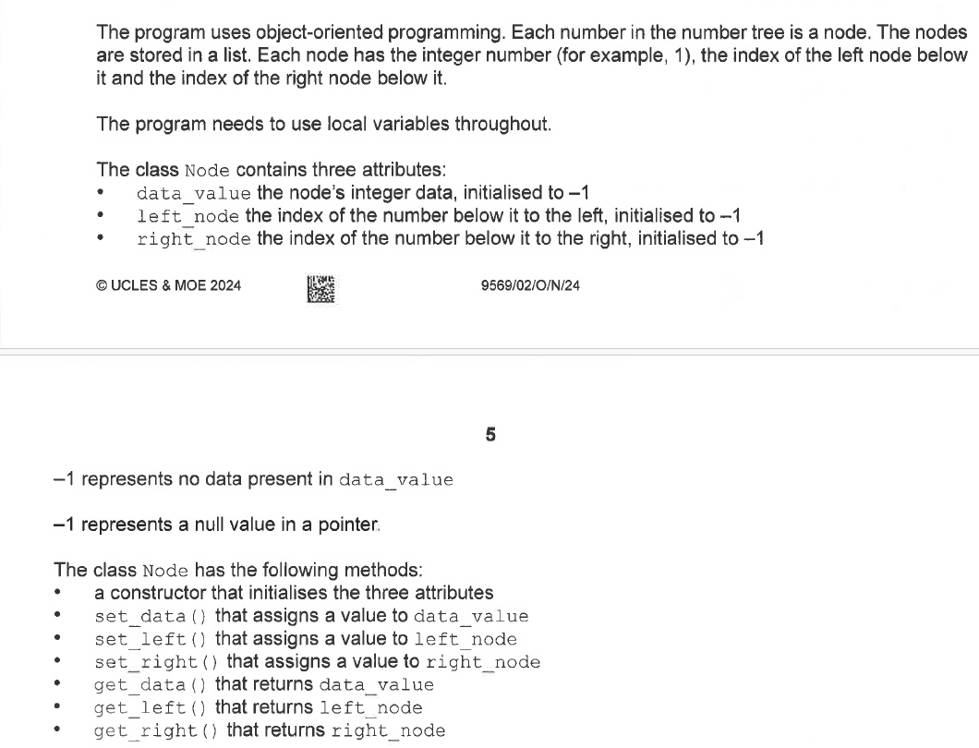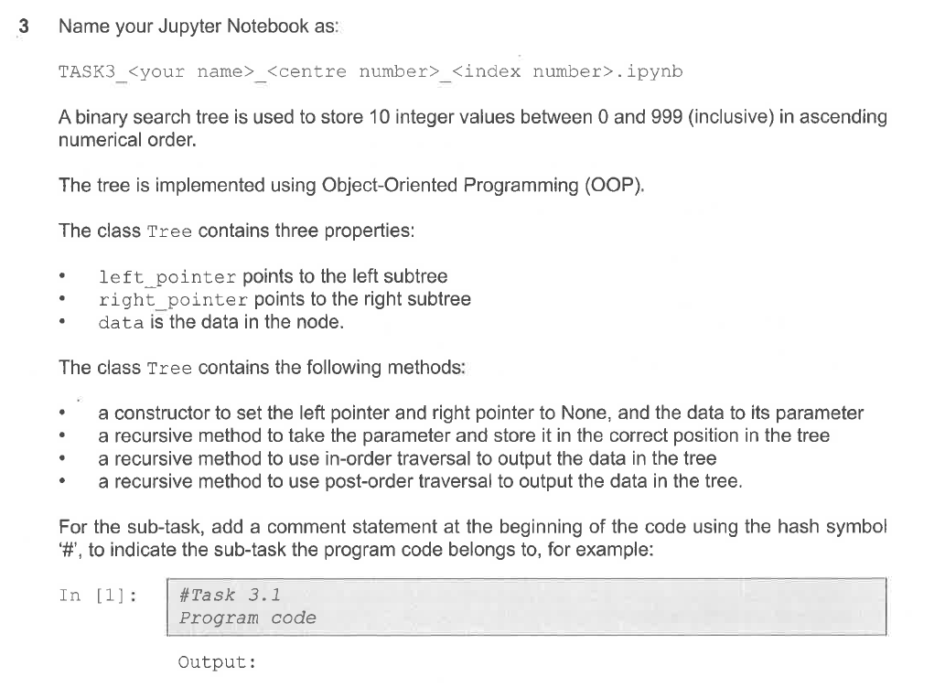
[4]

2024
[4]

