Exercise 4.4

References:
https://developer.mozilla.org/en-US/docs/Learn/CSS/CSS_layout/Flexbox

Code Pen demo:
https://codepen.io/khar-woh-leong/pen/KKYjmwq

The flex layout settings on a container element allows all the child elements that have a width property defined to fill all the space of the container and the empty spaces distributed . The following properties are used to make a flexbox container .
display: flex; /* This will by default layout the child elements in rows */
flex-wrap: wrap /* When there is not sufficient space in a row, flow over to next row */
justify-content: flex-start | flex-end | center | space-even | space-between | space-around
1 |  | Modify your products.html using flexbox layout by creating a container box to contain all the boxes that you have created previously.
Your product catalogue should look similar to this:

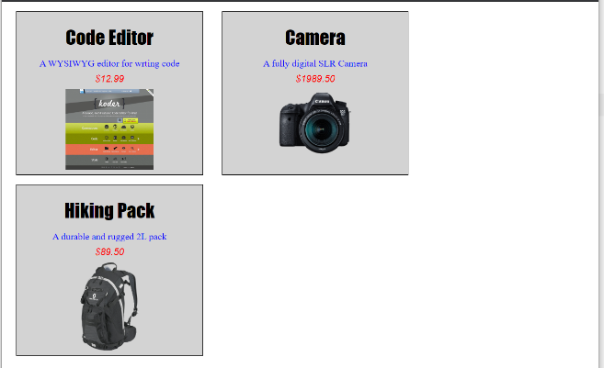

or
 |  | 