**Computer Networks – Theory Worksheet**

***2013 A-Level – Paper 2 – Question 1***

**1** A dental practice currently uses a computer system to store details of its patients, staff and appointments in separate files.

The practice manager and the receptionist have their own computers for accessing and updating the files.

The system produces a small number of reports.

An updated system is to be produced by a software company. The updated system will use a database. In the updated system the dentists will be given a hand-held device to use in their rooms for accessing and updating the patient records. The new system will also be capable of producing additional reports.

The software company has software engineers who have expert skills in specific areas of software development. A number of the engineers will be involved in the development of the updated system.

The hand-held devices the dentists use in their practice rooms will be networked. Both client-side scripting and server-side scripting will be used in the new software which is produced. An intranet with a web server will be created. Web browsers will be used on the hand-held devices.

**(g)** Describe three possible uses of the device. [6]

**(h)** For each scripting method, client-side scripting and server-side scripting, give an appropriate example. Justify your response. [4]

***2013 A-Level – Paper 2 – Question 4***

**4** A software development company currently hosts its own email server. The company is considering a replacement webmail service, using cloud computing.

1. State two advantages of this change. [2]
2. State one disadvantage of this change. [1]
3. Describe an example of how employees of the company may use the cloud to work collaboratively. [3]

**(d)** Describe how the cloud can be beneficial to the company when developing new software for a client. [4]

***2014 A-Level – Paper 2 – Question 1***

**1** A supermarket chain wants to encourage customers to return to its store. They operate a scheme of rewards for customers based on how much they spend over a period of time.

Customers are issued with a card that is readable by a Point of Sale (POS) terminal. When a customer provides their card at the checkout, the system identifies them and stores the products they purchased and how much they spent.

Currently the only use of this data is to issue the customer with vouchers every three months. Vouchers have a value based on the total amount the customer has spent during the previous three months. The vouchers can only be used in part payment for goods bought the supermarket.

The supermarket managers want to make more use of the customer purchase data. They hire a software development company to produce software that will implement new uses of data.

Software developers have skills in developing software. The supermarket managers have in depth knowledge of their business. At first, software developers will have little knowledge of the business.

Management staff can already access the company network remotely for other software applications. Management are to be given the facility to access, and interact with, the customer data Via the company LAN. However, a decision is made not to allow access to the customer data remotely for this updated system.

**(f)** Describe **two** methods which can be used to ensure that there is no remote access to customer data by management staff. [4]

ln the new system, customers will have access to information through a web browser. Each customer will be able to see some information about their purchase history.

**(g)** Explain what software needs to be developed to provide this customer facility. [5]

**(h)** One of the software developers has the task of ensuring that social issues are considered.

This developer has to document these issues.

Describe **two** issues that might be in the document with regard to customers accessing their data. [4]

***2014 A-Level – Paper 2 – Question 4***

**4** A small local area network (LAN) in a school consists of one switch, one file server and ten computers.

1. Explain why circuit switching could be used in this LAN. [2]

The network has a connection to the lnternet added.

1. Explain how packet switching is used when a web page is downloaded from the Internet. [3]

A packet from the web server consists of 256 bytes. One of the bytes is the checksum byte.

In each byte one bit is the parity bit.

1. If the byte 0 0 1 1 0 1 0 1 results in a parity error, state the type of parity being used. [1]
2. The receiving computer uses the checksum byte to check whether the packet contains an error. Explain how it does this. [4]

***2015 A-Level – Paper 2 – Question 1***

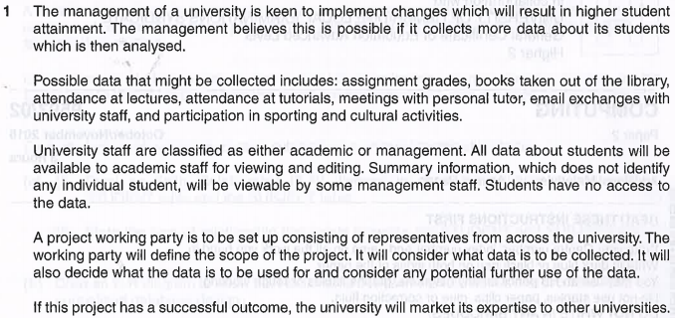

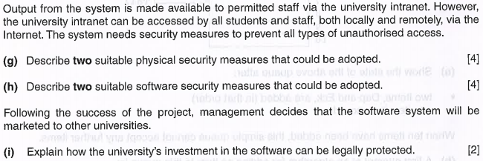

***2016 A-Level – Paper 2 – Question 1***

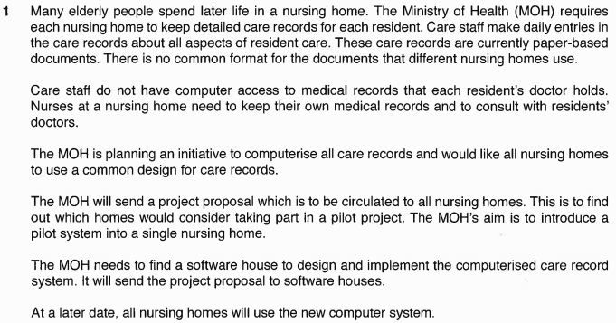

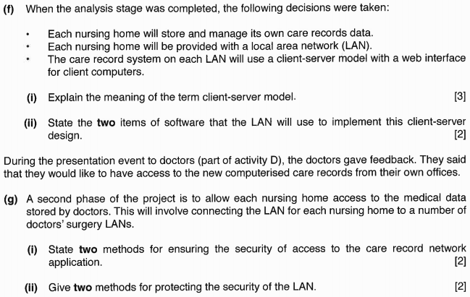

***2017 A-Level – Paper 2 – Question 2***

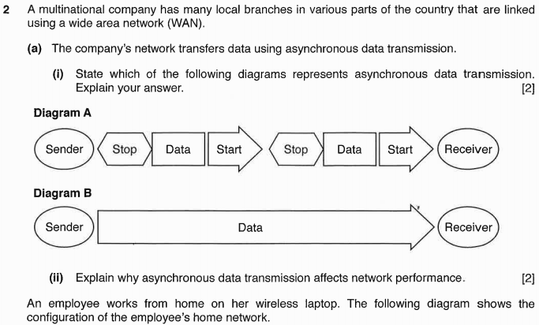

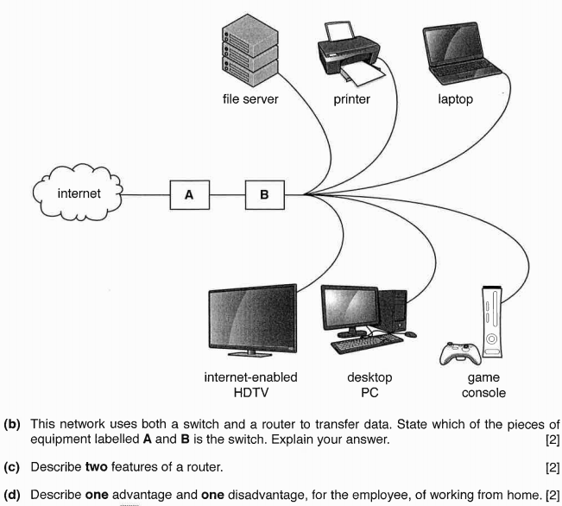

***2017 A-Level – Paper 2 – Question 4***

