# Web Worksheet 7: Render Products from file

## References:

* <https://www.tutorialspoint.com/flask/index.htm>.
* <http://jinja.pocoo.org/docs/2.10/templates/>
* Miguel Grinberg (2014). *Flask Web Development(1st Ed.)*.O’Reilly.

**Populate the ProductsApp folders**

1. Make sure that you have a folder hierarchy that you have created according to the last worksheet. Your static images folder should contain the images that you have uploaded using the web form from the last exercise and a file products.txt that contains the records of the products. The products.html file should be the one with the grid or table layout.

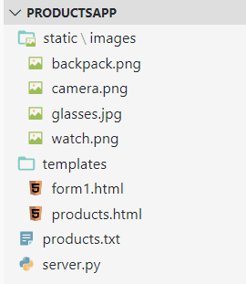

1. You should have at least 4 products in the products.txt file.

Example:

Baby Rockie,Outdoor Backpack,42.00,backpack.png

Zenon EOS6D,SLR Pro Camera,1392.00,camera.png

Zenva glasses,A classical design,342.00,glasses.jpg

Smart Band,4/7 heart rate monitoring,365.00,watch.png

1. In the python file named server.py rename your root function which return the form1.html to show_form and modify the decorator to map "/form" to the show_form function:
2. Add a new function named root with the decorator @app.route("/"). This is your new home or landing page.
3. The code in the function should read the contents of the file products.txt and store the data in a 2D list named **products_list** as follows

[["Baby Rockie","Outdoor Backpack","42.00", "backpack.png"],

["Zenon EOS6D","Zenon EOS6D","1392.00","camera.png"]

:

]



1. After creating the 2D list, invoke the render_template function as follows

render_template("products.html",products=products_list)

1. Use the html document that you have created in Worksheet 4. Name the html file products.html. Modify the products.html by adding jinja expressions as follows:

| <table>  **{% for product in products %}**  <tr>  <td>  ~~Code Editor~~ **{{product[0]}}**  </td>  <td>  ~~A WYSIWYG editor for wrting code~~ **{{product[1]}}**  </td>  <td>  ~~$12.99~~ **{{product[2]}}**  </td>  <td>  <img src**="static/images/{{product[3]}}"** />  </td>  </tr>  **{% endfor %}**  </table> |
| --- |

You can remove the rest of the <tr></tr> blocks.

When flask jinja parse the code above, for every product in products it will produce a <tr> block and the jinja expression will be replaced by the values in their respective columns.

1. Test your web app by using the the web form you created in the last exercise to add new products to be display. Now you have to access your form using the url localhost:5000/form or you may add a hyperlink in the products.html to link to http://localhost:5000/form
2. In the function form_submit,instead of returning a string, use:

return redirect("/"), which will redirec the reponse to fetch the contents from "/".

This will re-direct your web rowser to request for the / resource.

1. Make sure you add a line to import redirect from flask.