## About assignment:

**This project was designed to make an GUI application with Django.**

### My Directory structure:

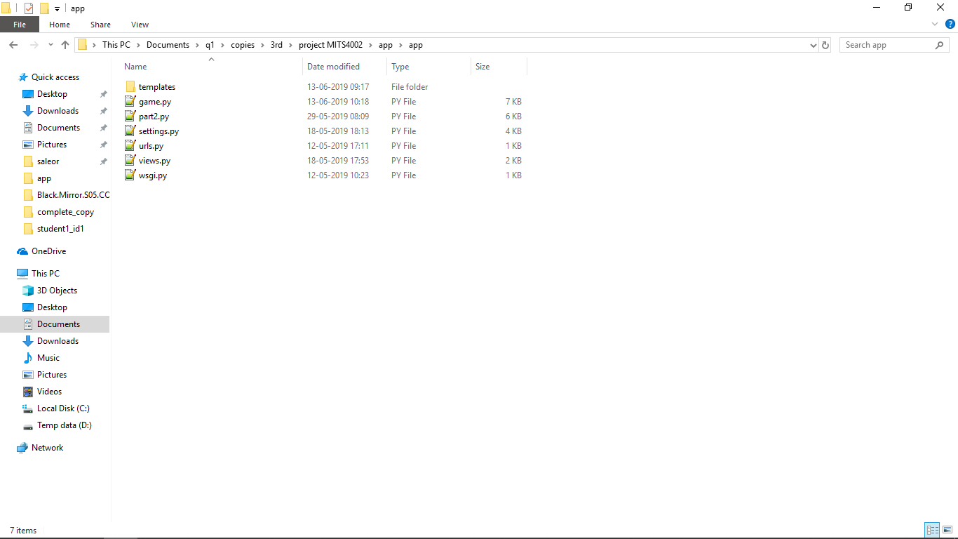

## Requirements:

1. **Python**
2. **Django**
3. **Requests**

# Installations:

If you don’t have following, install it by typing,

1. ***“apt-get install python3.6”***
2. ***“Python3 -m pip install Django”***
3. ***“Python3 -m pip install Requests”***

## Instructions:

1. Navigate to /app folder.
2. Run following command in terminal:

***Python3 manage.py makemigrations***

***Python3 manage.py migrate***

***Python3 manage.py runserver***

1. Now browse 127.0.0.1:8000 in your favorite browser.