**Attention SPOILERS, for better game experience I advise you read this document after at least one game session.**

||

||

||

||

||

||

||

|||||||||

||||||

||

Doodle Game

Vladyslav Kubyshkin

My game was created as a clone of world-famous game title “Doodle Jump”. I will describe which elements exist in game and what they do. Game was tested in Debug, and Release x64. I don’t recommend place project with path which contains not ASCII symbols. You can run game in debug mode to see where exactly colliders starts and end.  
 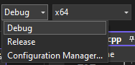  
 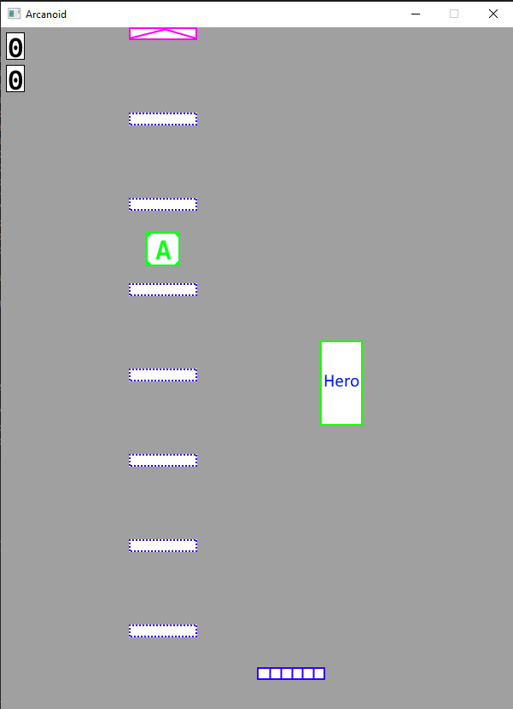

To play normal game set Release configuration.

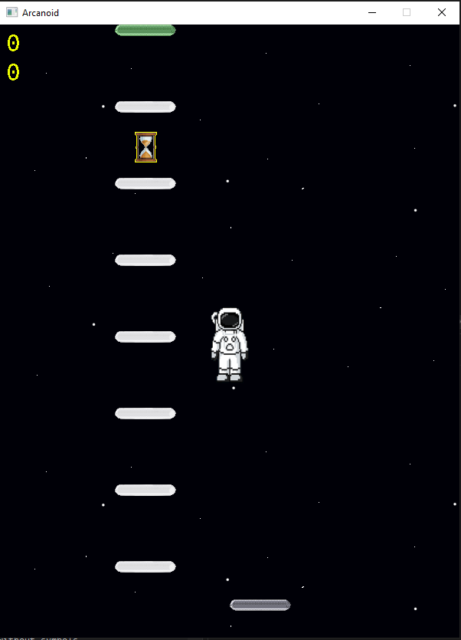  
On game start you can set your own window width and height. I recommend 600 and 800, because world generator works on them in a best way. 

1. Main Hero – or just a doodle.   
    or   
     
   Behave in very similar way as a hero from doodle jump. Use Left and Right arrow to move him left and right. No worry’s, input system is not reverted.   
     
   You can shoot by clicking left mouse button in the game window area.   
    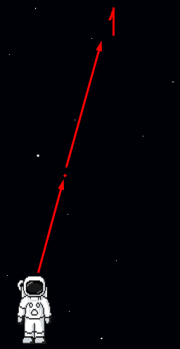

Figure 1 - “1” place where was clicked. Little red dot is your projectiles.  
  
If player or projectiles disappear from game screen by intersection left or right side, they will be teleported to opposite site.

1. Scoreboards

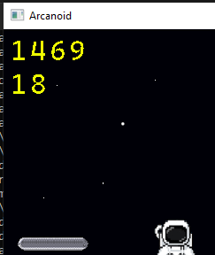

First one it’s you traveled distance, second one count how many platforms you have pass.

1. Platforms
   1. Regular platform  or . Nothing special, just a static platform.
   2. Boost platform  or . If player jump from this platform, he will be boosted nearly 300% higher than from regular one.
   3. One touch  or . Player can jump from this platform once, after that platform will be deleted.
   4. Enemy platform  or . Like regular platform but with enemy on them.
   5. Hole platform  or . Like regular platform but with white or black hole on them.
   6. Move platform  or . Like regular platform, but moves from the left to the right screen sides.
2. Abilities. They can be picked up by player with regular intersection. After picking up you will see your active ability in the bottom right screen corner. Random ability spawn on the random platform after any 50 player jumps (can be changed in file “Hero.h -> int jumpsToSpawnAbility = 50;”). Game currently has 5 available abilities:  
    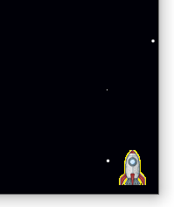

Figure 2 - Ability indicator in the right bottom corner

* 1. Auto shoot  or. For 20 seconds your hero automatically shoots projectile to the enemy on a screen.  
     Hero state when ability is active:  or 
  2. Jetpack  or. For 5 seconds your hero flies upper and kill any monster on collision.   
     Hero state when ability is active:  or 
  3. Rocket  or. For 10 seconds your hero flies upper and kill any monster on collision.   
     Hero state when ability is active:  or 
  4. Shield  or . For 20 seconds make your hero invincible for the enemy. You kill enemy on any collision. Be careful, you still can fall out from the world.   
     Hero state when ability is active:  or 
  5. Slow motion  or . For 10 seconds make times two times slower.   
     Hero state when ability is active:  or 

1. Holes. This object is not GIT, but they can pull or push player from themselves. They only change hero direction in space and can’t kill him.
   1. Whitehole  
       or . Push player away from them.
   2. Blackhole  
      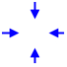or . Pull hero to them.
2. Enemy  or . Can kill player on intersection. Player can kill them by shooting or jumping on them. Jump from them gives same boost as boost platform.

**Remark. Graphics was copied from web and modified by me, I’m not author. Code wasn’t copied, I’m author.**