创建src文件夹并在文件夹下创建主文件main.js
创建public文件夹，在文件夹下创建index.html
npm init -y 初始化
安装开发环境
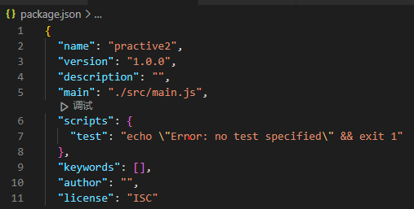
npm install webpack webpack-cli -D
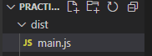
webpack默认打包文件到dist目录下，webpack本身只能处理js资源
创建webpack.config.js
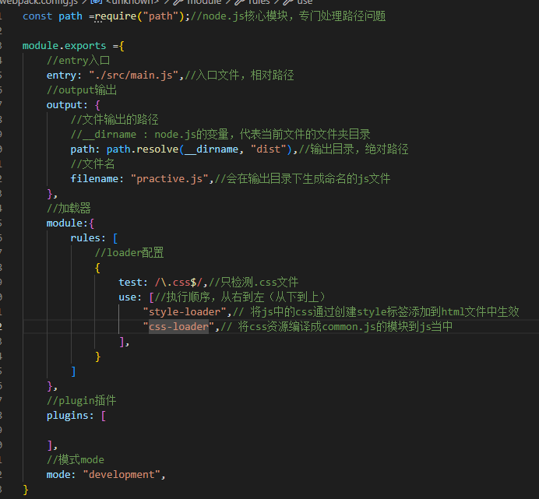

问题:出现Module parse failed: Unexpected token (1:0)
You may need an appropriate loader to handle this file type, currently no loaders are configured to process this file. See https://webpack.js.org/concepts#loaders报错
解决：loader和npm i css-loader 保存未被识别，删除重新操作解决该问题。

