

**UNIVERSITY OF GREENWICH**  
COMP1640 – Enterprise web

Software Development

Individual

|  |  |
| --- | --- |
| Student name | Nguyen Nhat Khang |
| ID number (00xxxxxxx) | 001353323 |
| Lecturer/Tutor name | Doan Dinh Ho |
| Student submission date | April 25, 2024 |

**Group name:** Cyber

|  |  |  |
| --- | --- | --- |
| Member’s name | Banner ID | Roles |
| Nguyen Nhat Khang | 001353323 | Technical leader, Database designer, Developer |
| Huynh Thanh Nhan | 001353384 | Tester, Developer |
| Nguyen Ngoc Duy Chuong | 001353256 | Tester, Developer |
| Nguyen Van Lap | 001353336 | Scrum Master, Product Owner |
| Huynh Phan Thai | 001353466 | Tester, Developer |

Table ò content

1. Introduction

The coursework project involved collaborating within a Scrum team to develop UMagazine website a role-based system for collecting student contributions at a university. Led by the Cyber team, the system's development was well-organized, documented, and aimed for high-quality results. This report will detail my role, describe UMagazine's features with screenshots, assess the final product, and evaluate the effectiveness of the Scrum methodology and team communication. Individual team members' performances will be evaluated, including my contributions to the team effort and final product presentation.



Figure 1: Home page

1. Evaluation
   1. The product
      1. Database

* **Flexibility and extensibility:** MongoDB is a NoSQL database system, allowing data to be stored in a flexible document format (document-oriented). This allows for easy extension and changes to the data structure without changing the schema.
* **High performance:** MongoDB is designed to handle high loads and fast query speeds, suitable for applications with high performance and scalability requirements.
* **Compatibility with programming languages:** the project uses nodejs to deploy code, and MongoDB supports many popular programming languages such as JavaScript, Python, Java, and Node.js, making application development easier and more flexible.
  + 1. User interface
* **Easy to use:** The interface is easy to understand; it doesn't take too many steps to complete a function. It will not take too many steps for students to be able to upload articles. all with just one pop-up modal. In addition, the website also provides a navigation bar on the left side for users to conveniently move between pages.

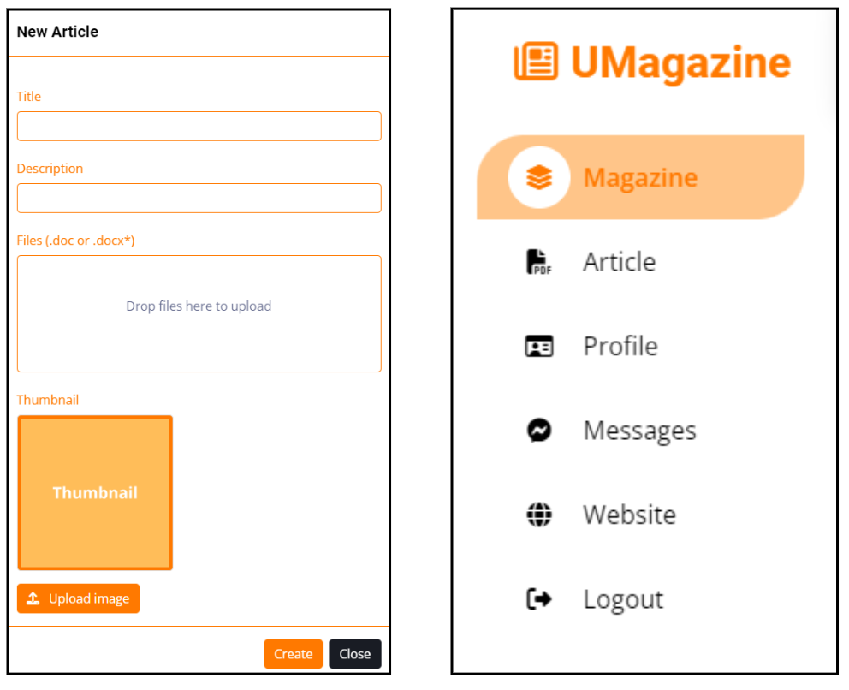

Figure 2: UI’s Easy to use

* **Aesthetics:** The website uses consistent colors and fonts. In addition, the website also uses icons to help users quickly identify functions. Furthermore, the statistical analysis function uses charts to represent data instead of simply text.
* **User Interaction:** When the user performs actions and sends requests to the server, the website will display the loading animation, and when there is a response from the server, the website will display the results of the action the user just performed.

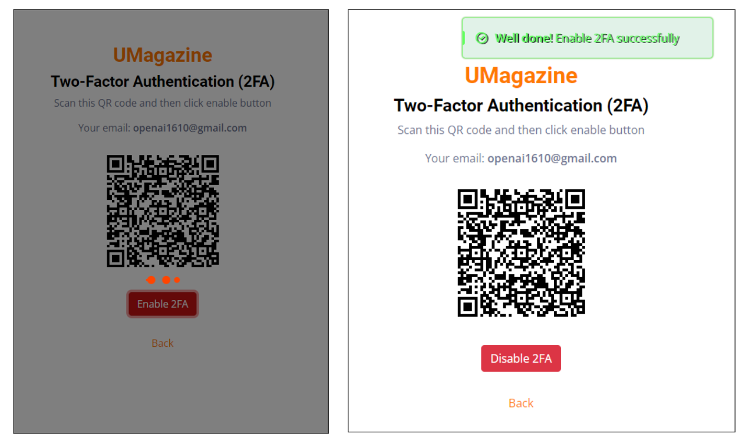

Figure 3: UI’s User Interaction

* **Consistency:** Pages are consistent in layout and color, avoiding users having to remember too much information.

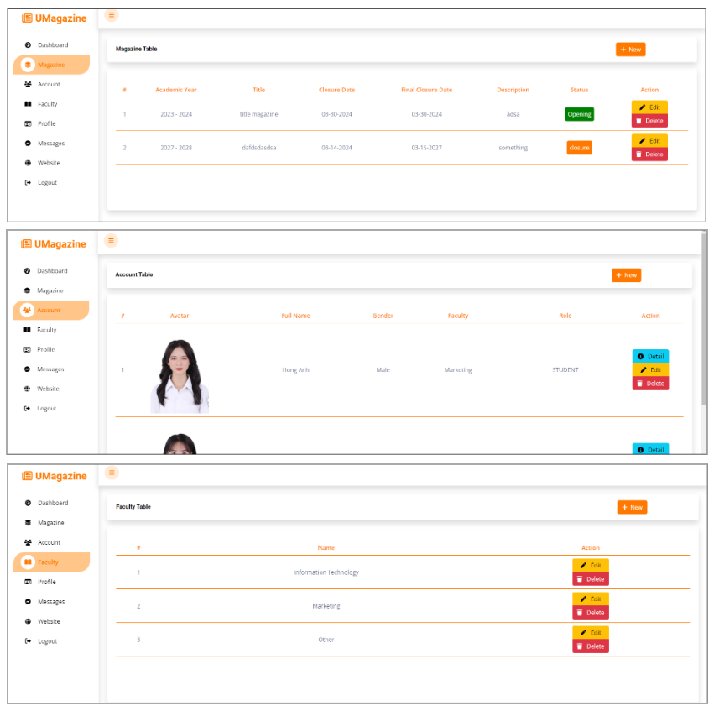

Figure 4: UI's Consistency

* **Safety and Confidentiality:** Sensitive data will be hidden, such as passwords

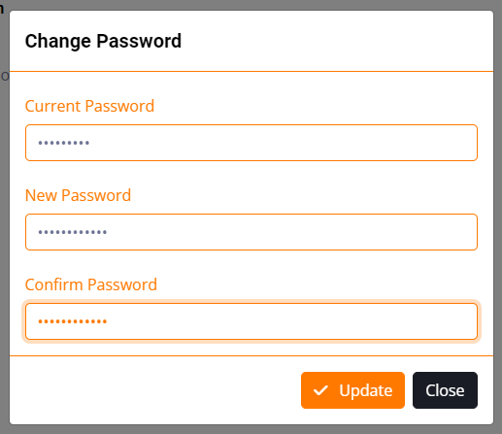

* **Compatibility:** To meet a variety of user devices, the website can be responsive according to the user's screen size and support well on three ratios: desktop, tablet, and mobile.

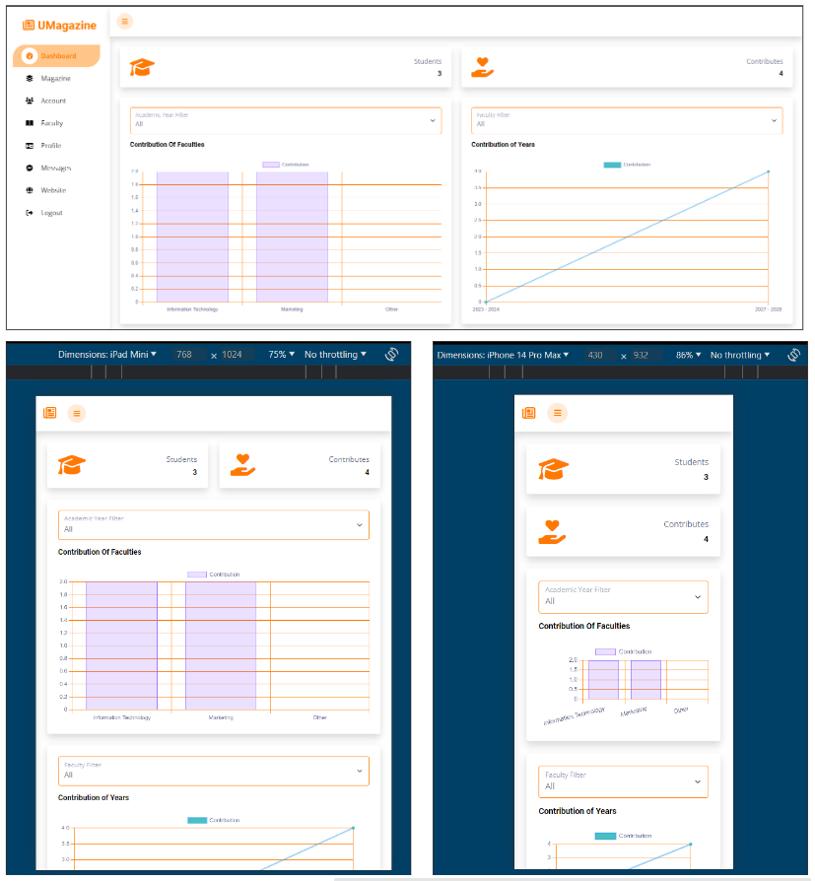

Figure 5: Dashboard responsive

* + 1. Functionality
    2. Performance

The speed of loading and displaying the website to users is also very important. Below are the performance scores of some estimated high-traffic pages calculated by Lighthouse (a website scoring tool available in Google Chrome development tools).

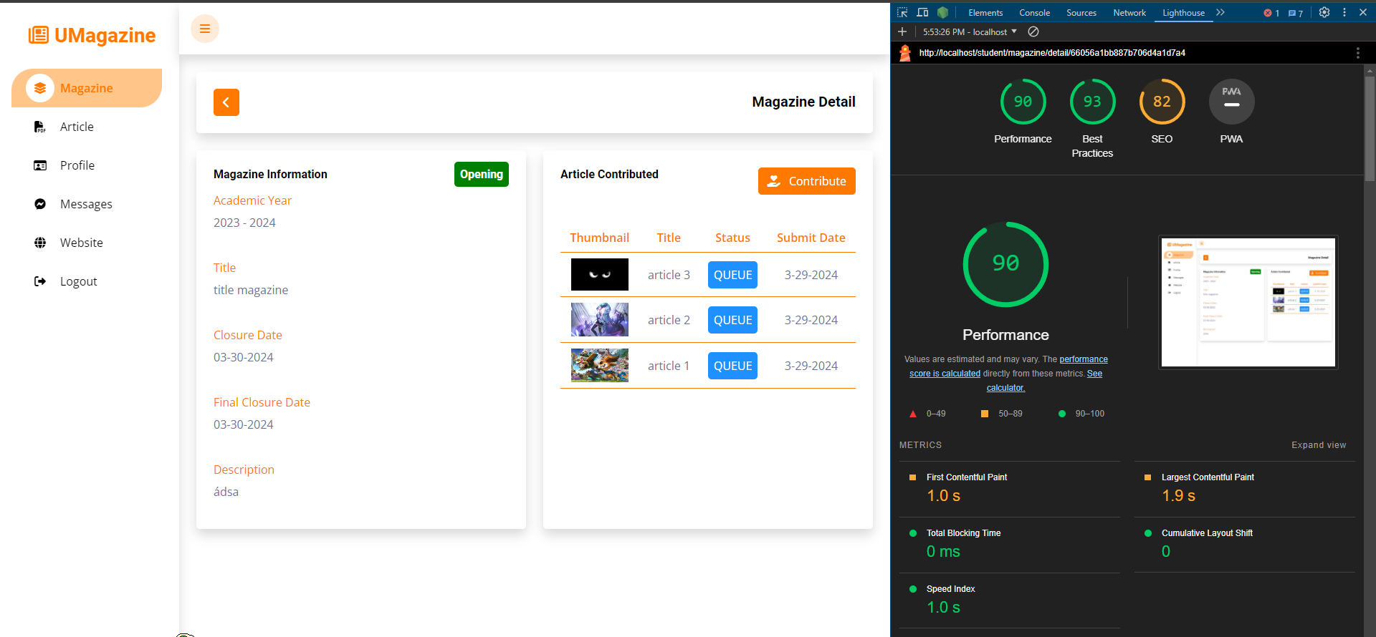

Figure 6: magazine detail page (student role)

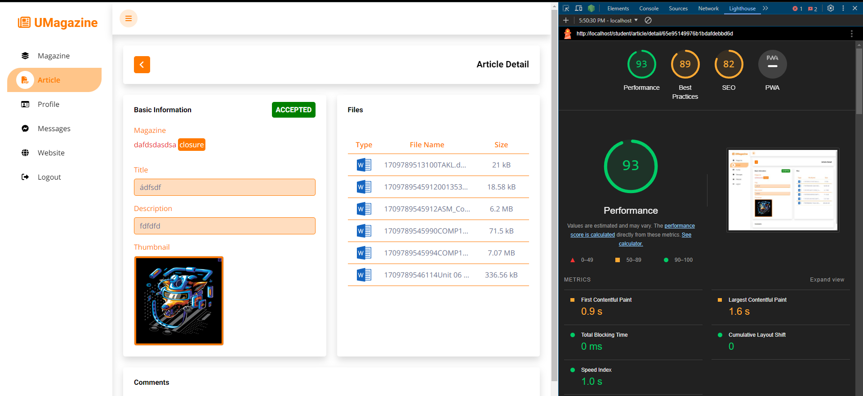

Figure 7: article detail page (student role)

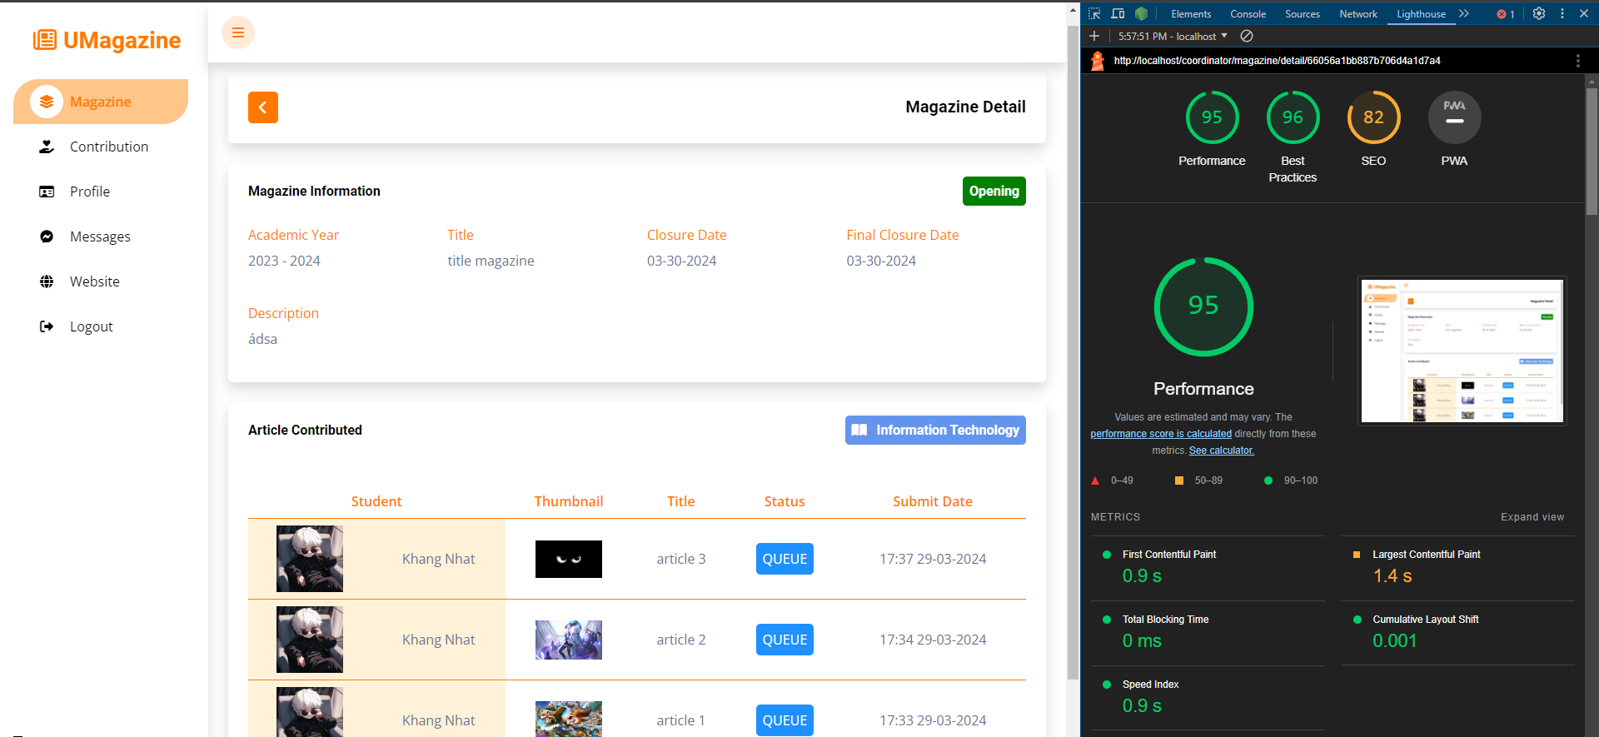

Figure 8: magazine detail page (marketing coordinator role)

* 1. The process