## TesorFlow.js

A JavaScript Library for

### Training and Deploying Machine Learning Models In the Browser

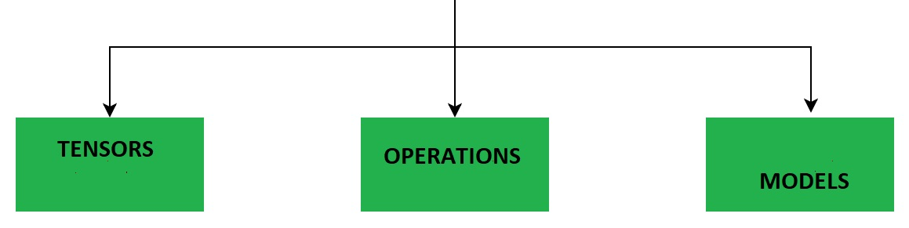

## Tensorflow Models

**Models** and **Layers** are important building blocks in **Machine Learning**.

For different Machine Learning tasks you must combine different types of Layers into a Model that can be trained with data to predict future values.

TensorFlow.js is supporting different types of **Models** and different types of **Layers.**

A TensorFlow **Model** is a **Neural Network** with one or more **Layers**.

## A Tensorflow Project

A Tensorflow project has this typical workflow:

* Collecting Data
* Creating a Model
* Adding Layers to the Model
* Compiling the Model
* Training the Model
* Using the Model

## Example

Suppose you knew a function that defined a strait line:

*Y = 1.2X + 5*

Then you could calculate any y value with the JavaScript formula:

y = 1.2 * x + 5;

To demonstrate Tensorflow.js, we could train a Tensorflow.js model to predict Y values based on X inputs.