**Footer**



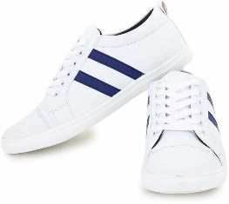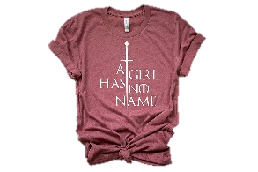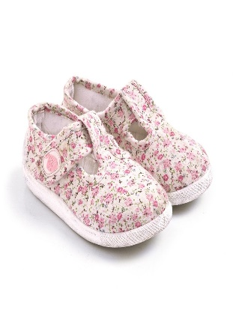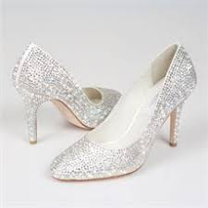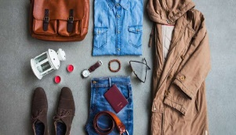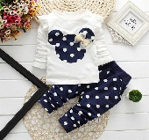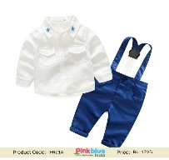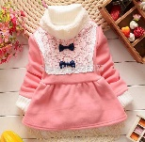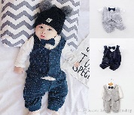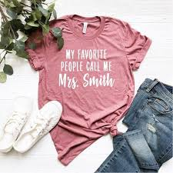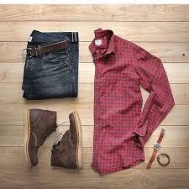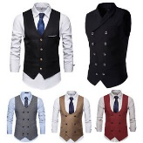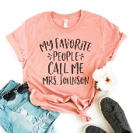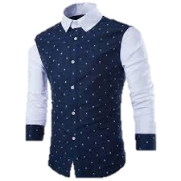

US $2.22

US $2.22

US $2.22

US $2.22

US $2.22

US $2.22

US $2.22

US $2.22

US $2.22

US $2.22

US $2.22

US $2.22

US $2.22

US $2.22

US $2.22

US $3.22

**Logo**

|  |  |  |  |  |  |  |  |  |
| --- | --- | --- | --- | --- | --- | --- | --- | --- |
| Category See All | Super Deal | Best Buy | | Promo | | Home | |  |
| Men |  | | | | | | | |
| Women |
| kids |  | |  | |  | |  | |
| Shoes |
| Accessories |
| Phone |  | |  | |  | |  | |
| Men |
| Women |
| kids |  | |  | |  | |  | |
| Shoes |
| Accessories |
|  |  | |  | |  | |  | |
|  |  | |  | |  | |  | |

Footer1

**Banner images**

Search



All Category

**Cart**

**Sign In | Join**



tabs

**Footer**



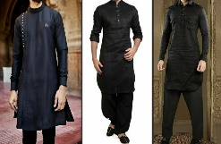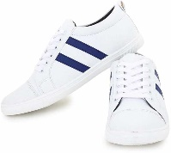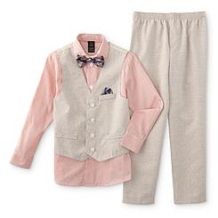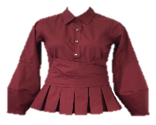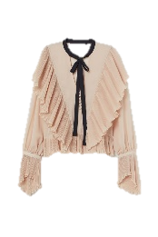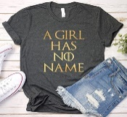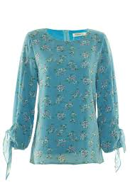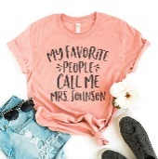

**Logo**

US $2.22

US $2.22

|  |  |  |  |  |  |  |  |  |  |  |
| --- | --- | --- | --- | --- | --- | --- | --- | --- | --- | --- |
| Category See All | Super Deal | Best Buy | | | Promo | | | Home | |  |
| Men |  | | | | | | | | |
| Women |
| Kids |
| Phone |  | | |  | | |  | | |
| Laptop |
| Shoes |
| Men |  | |  | | |  | | |  | |
| Women |
| Kids |
| Phone |  | |  | | |  | | |  | |
| Laptop |
| Shoes |
| Men |  | |  | | |  | | |  | |
| Men |
| Women |
| Kids |  | |  | | |  | | |  | |
| Phone |
| Laptop |
|  |  | |  | | |  | | |  | |

Footer1

US $3.22

US $2.22

US $2.22

US $2.22

US $2.22

US $2.22

US $2.22

US $2.22

US $2.22

US $2.22

US $2.22

US $2.22

US $2.22

US $2.22

US $2.22

US $2.22

US $2.22

**Banner images**

Search



All Category

**Cart**

**Sign In | Join**



tabs

