**Login Page**

**Member Login**

Username

Password



**Login**

**Sign Up**

**Forgot Password?**

**Forgot Password**

**Forgot Password**

Enter your email address

**Reset Password**

**Back to Login**



**Enter your email address and we will send you the reset code.**

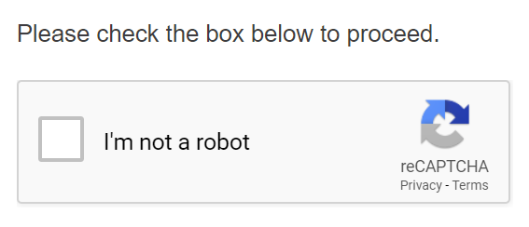

**Forgot Password verification code**

**Account recovery**

Enter code

**Next**

**An email with a verification code was just send vth……….@gmail.com**

**Reset Password**

**Password Reset**

New password

**Reset Password**

**Enter your new password for your account.**

Confirm new password