Helen Dougherty

13 November 2017

Project 3 Textures

1. (and technically 2)

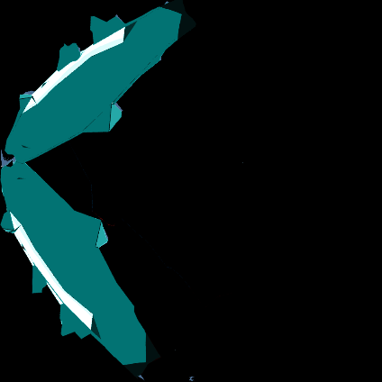 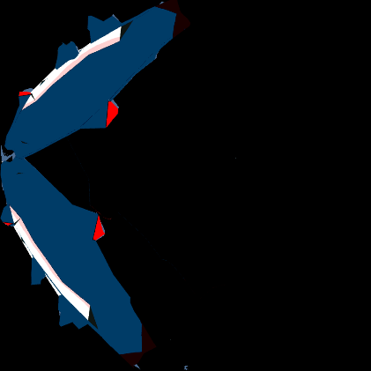

My fish paint textures, made in Blender and modified with Photoshop.

1. The normal map made by this picture does a remarkable job of looking like bark, it turns out.

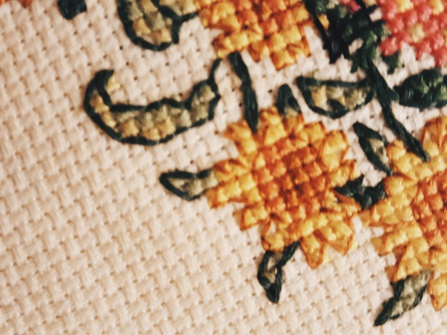

1. The normal map this image made was used on the cliff faces/bare rock to give the terrain a rougher/more rocky texture without going overboard.

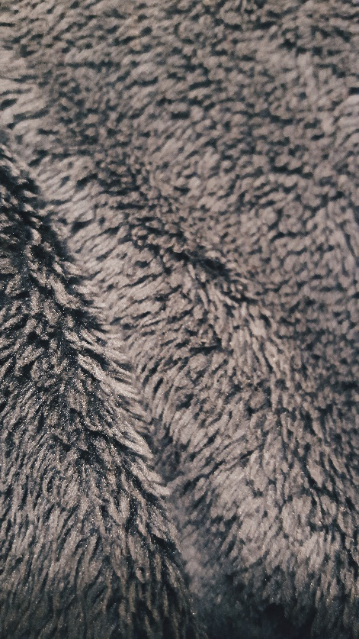

An additional note about my scene: I did try to combine the flocking scripts and the predator scripts, to likely less-than-stellar results. The smaller fish does appear to avoid the larger predator, but I haven’t seen a predator successfully nab a smaller fish.

And as a side note, it turns out if you have two disparate schools of fish in a small environment, turning out of the way of an oncoming fish can result in some sort of corkscrew/death spiral thing I haven’t been able to fix. The results are mitigated if I remove the two sphere colliders at the end of the predator’s noses, so that is probably something to do with why I haven’t seen any actual prey/predator deaths. (The prey is pretty good at avoiding the predators, however. That part of my prey/predator set-up is working nicely.)

I did use a third-party script to turn my Blender-made “terrain” into an actual Unity terrain object. The script may be found here: <https://wiki.unity3d.com/index.php/Object2Terrain>. (This is actually a really useful script; I like making terrains and such from planes in Blender instead of directly in Unity, so this gives me the best of both worlds.) All credit goes to Eric5h5, the Unity forum member who made the script (and used a fairly terrifying example of a robot mesh turned into a terrain in their post).

Icon picture source: <https://www.theonlinefisherman.com/images/00_reel_news/2016/02/27/Underwater-Forests.jpg>