Feshchenko Aleksandr, P3117

My photo
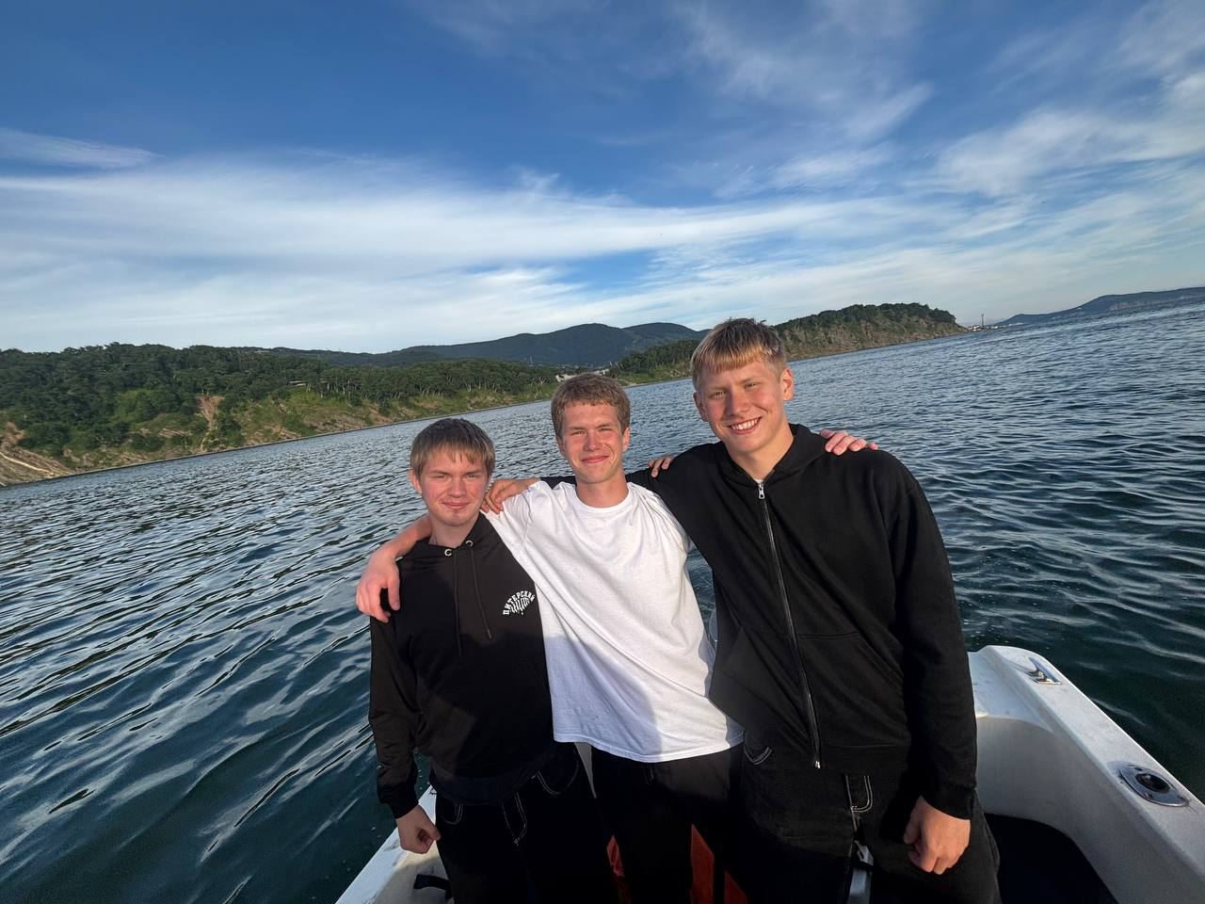
This photo was taken last summer in Petropavlovsk-Kamchatsky. My two friends and I were walking along the shore of the bay when we saw a man who was renting out his boat. We didn't plan it, but we decided to rent it for an hour. In the picture, we are standing at the front of the boat. The sun was shining, a light wind was blowing and the water was very calm. While we were sailing across the bay, we were smiling and joking all the time, so we asked the captain to take a photo of us. Behind us you can see green hills and a forest near the water. After the boat trip, we went to one of my friends' house and relaxed there for the rest of the evening. I like this photo very much because it reminds me of a spontaneous and happy day with my friends.

