Efrain JacoboJr
06/15/2026
CI345 ML

Abstract
This paper will discuss how we used a dataset of the passengers on the Titanic and how we transformed said data to be more descriptive and see if the algorithms could accurately predict whether the passenger survived or not and how the formulas work.

Introduction
In data processing, especially in the sense of a dataset that focuses on the tragic story of the Titanic, we wanted to find a way to display how many people survived and see what class they were in. As well as checking what gender they were as well as their age, luckily we were able to find a dataset that had all of that. This paper will explain and discuss the program and explain how each input works.

Dataset Description
As the introduction mentioned we choose a database that was about the passenger of the Titanic and the data that it includes is whether the passenger survived the accident, how old where they what was their gender and class were they riding on as well as their names

DA and Visualization
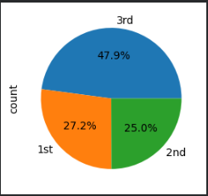
The first Visualization that we have is a pie chart and it shows the percentage of how many people were in each class, In first class the percentage was 27.2% which is equal to 323 passenger that rode in first class as for second class the percentage is 25% and that equal to 277 passenger in second class and lastly for third class with the majority at a 47.97% which equals to a total of 709 passengers. The total number of passengers in all classes is 1,309 which is not that far off from the official record which tells us that the actual number of passengers was 1,317 according to Titanic Facts.
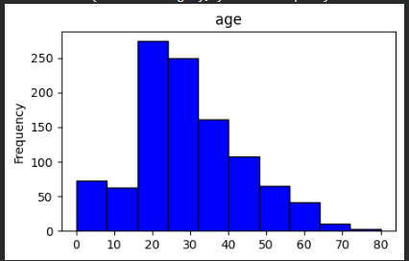
The second Visualization we have is a bar chart in which we present the number of passengers and what class they correspond to, the same data as the previous one just in a different style and a little bit easier to understand/visualize. As for the third chart, we’re showing you the amount of people in which age group the corresponded or the frequency of how many people were in each age group, with the highest numbers belonging to the ages 15 through 25 and the lowest between 70 through 80 years olds interestingly enough the amount of children below the age of 10 is close to the 70’s.
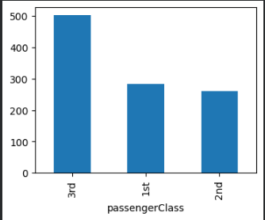
And lastly we used a box plot to show the range of age between each class and age group was more common in each class and we’ll discuss some outliers that appeared in the chart.
In first class we age groups that range from babies all the way to 80 year olds but the most common age groups in first class were from the ages 30 to 50 years olds which makes perfect sense for the time period were ticket for first class at that time coil range from 247 pounds to 512 pounds which for the time period makes sense that the older people could afford it due to social standings businesses or etc… .
While second class had age groups between the ages of 0 to 60 being the most common but it have a few outlier such 8 people being older than the average age group and each of those 8 passenger were part of their own age group with maybe a few overlapping but back to the main point the most common age group was 27 to 35 if we want to be specific or 20 to 40 year olds.
As for third class the age groups ranged from 0 to 55 year olds with also a few outlier who ages ages range from 55 to 75 year olds and only three of those outliers overlap as for the most common age groups they ranged from 20 to 35 year olds or to simplify 20 to 30 year olds.
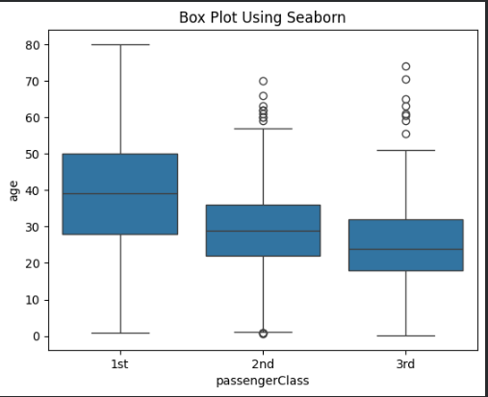

Preprocessing/Models
For preprocessing we simplified the values meaning we changed them to something more easier for example we change from yes and no to 1 and 0 so for example we could ask to display a certain passenger and where it would show if she survived instead of displaying a yes there would be a 1 in its place, the reason for this decision was to make the information much more easy to understand for the mode and for us as well.
As for models we used, we went with KNN, Learning Tree and LDA(Linear Discrimination Analysis), and what we were checking was how accurate the system is in predicting whether the passenger survived or not. As for KNN works the formula will be supplied down below.
d(P,Q)=$\sqrt{\sum_{i=1}^{n}{}(p_{i}-q_{i})^{2}}$
“The algorithm calculates the distance between a new, unclassified data point and all the existing data points in the training set. The most common distance metric used is the Euclidean distance, which measures the straight-line distance between two points.” Once all the distances have been calculated the algorithm sorts them in ascending order and chooses the K data point that is closer to the new point. And after isolating K, KNN will make its final prediction based on what it's been instructed to calculate.
For Learning Tree it refers to “refers to the mathematical equations and impurity metrics used in Machine Learning(Decision Trees) to split data.”
Gini=$1-\sum_{i=1}^{n}{}(p_{i}{)^{2}}_{}$
“It measures the probability that a randomly chosen element would be incorrectly classified if it was randomly labeled based on the distribution in the node. The algorithm seeks to minimize this value.”
ENTROPY=-$\sum_{i=1}^{n}{}p_{i}$lo$g_{2}(p_{i})$
It also measures the entropy, the amount of uncertainty and randomness in a dataset. A perfect set has an entropy of 0, while an equal split has entropy of 1.

And LDA is a supervised machine learning algorithm that is used for classification and dimensionality reduction, it projects a higher dimension data into lower-dimensional space while maximizing the separation between different classes and minimizing the variance within each class.
Results/Discussion
The results for the KNN had a precision of 74% for not surviving and a 75% for surviving as for Learning Tree we got a 73% of not surviving and a 74% for surviving and for LDA we got a 74% for not surviving and a 69% for surviving. KNN and Learning Tree had some close numbers in terms of result both being in the 70s while LDA had 70s in not surviving and 69% for surviving it seem that although they go about it in different ways they’re all in range for whether it checks on how the system is in predicting whether the passenger survived or not.
Conclusion
Although each algorithm system is different they both achieve the same even though they go about it in a different way, in terms of complexity it’s somewhat complex but the fact that the data set that we used for it made it somewhat palpable for us to understand it.

Resources.
“The Gilded Age.” PBS, Public Broadcasting Service, www.pbs.org/wgbh/americanexperience/features/carnegie-gilded/. Accessed 17 June 2026.
RMS Titanic: How Much Did First Class Cost?, www.worldofcruising.co.uk/editors-corner/titanic-first-class-cabin-ticket-cost. Accessed 17 June 2026.

“K-Nearest Neighbor(KNN) Algorithm.” GeeksforGeeks, GeeksforGeeks, 2 May 2026, www.geeksforgeeks.org/machine-learning/k-nearest-neighbours/.

“Decision Tree in Machine Learning.” GeeksforGeeks, GeeksforGeeks, 2 May 2026, www.geeksforgeeks.org/machine-learning/decision-tree-introduction-example/.

“Titanic Passengers • Titanic Facts.” Titanic Facts, 26 Jan. 2026, titanicfacts.net/titanic-passengers/.

