LAB PROGRAMS

1.DDL Commands using CREATE, ALTER , TRUNCATE and DROP

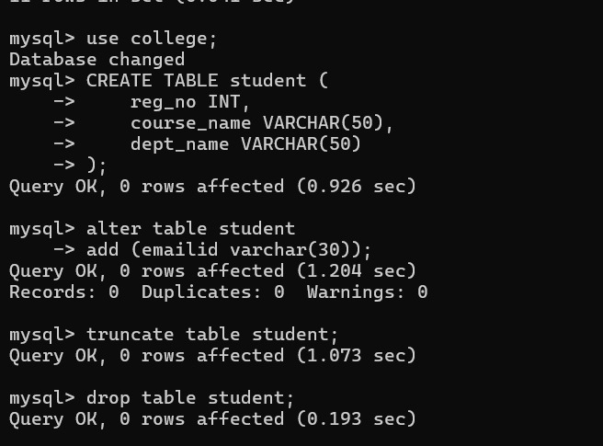

Output :
Table Student created successfully.
Table altered successfully.

2.DDL Commands with Constraints – PRIMARY, FOREIGN KEY, UNIQUE,CHECK, DEFAULT, NOT NULL
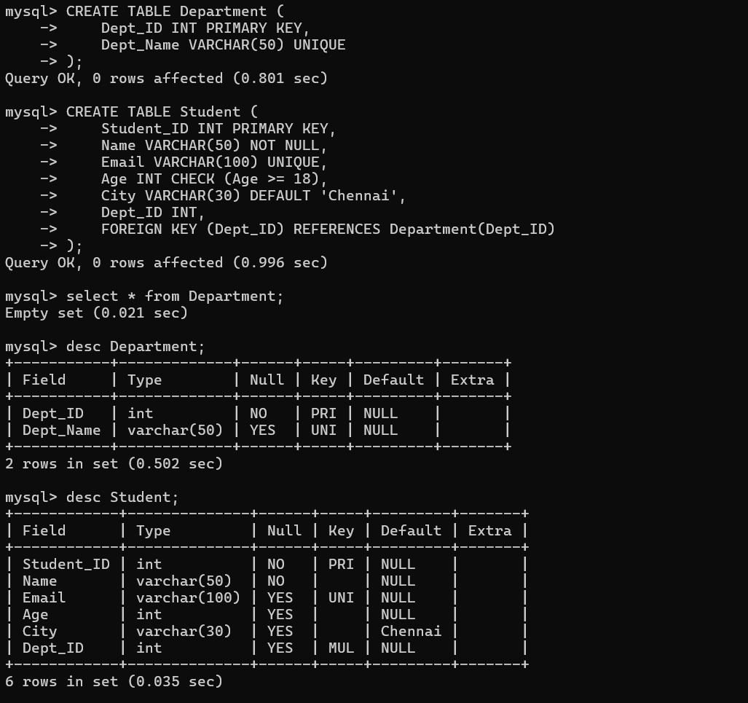
Output:
Table desc Department created successfully.
Table desc Student created successfully.

3.DML Commands using INSERT, SELECT

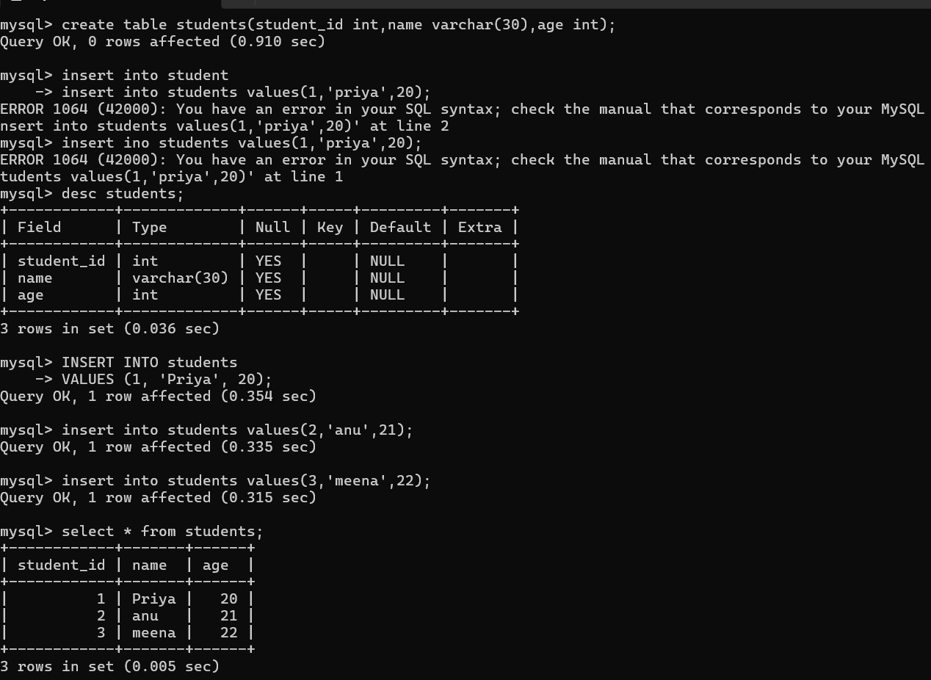
Output:
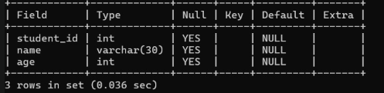

4.DML Commands using UPDATE, DELETE

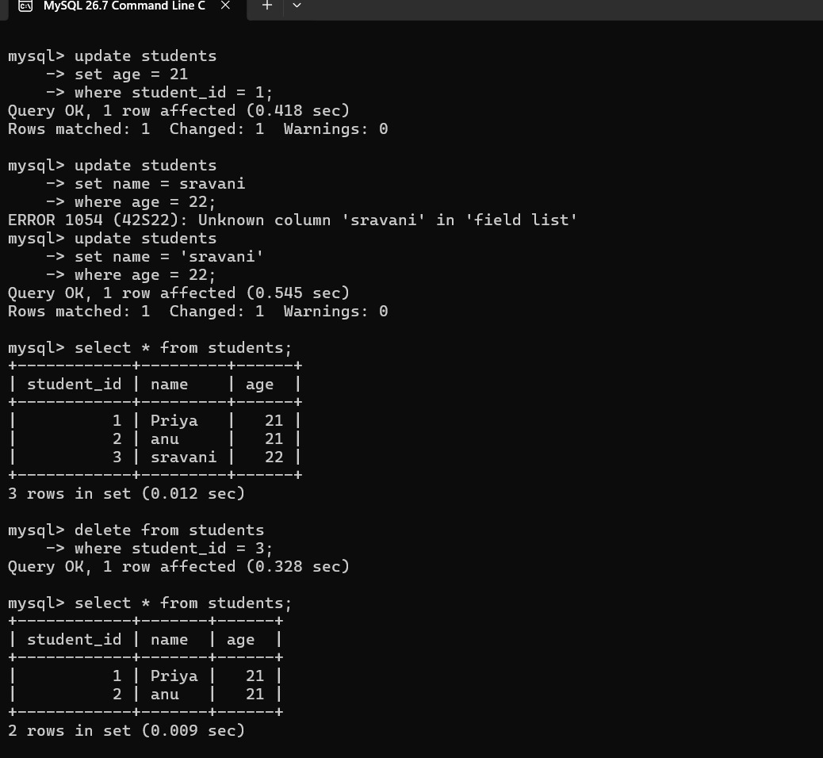

Output:
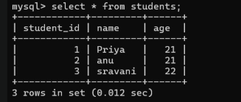
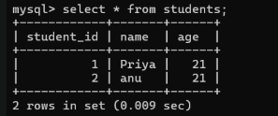
5.TCL Commands – COMMIT, SAVEPOINT, ROLLBACK
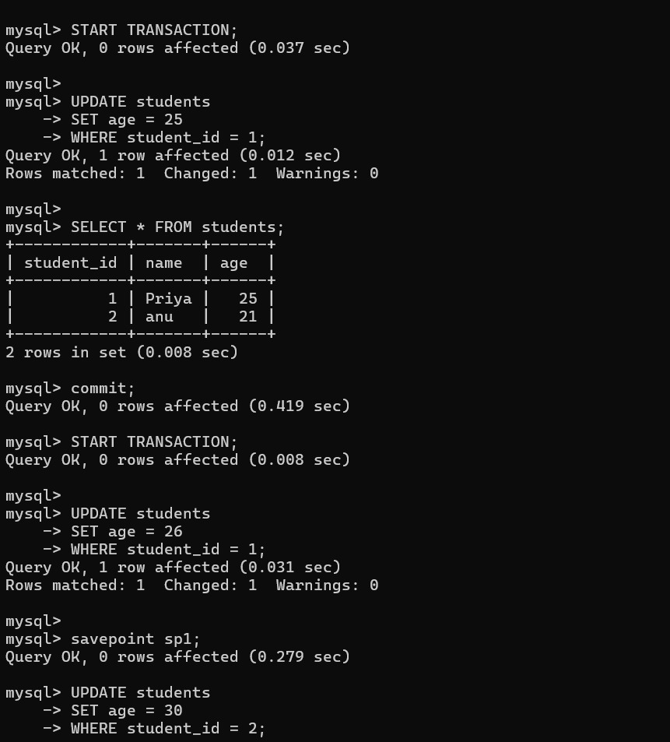

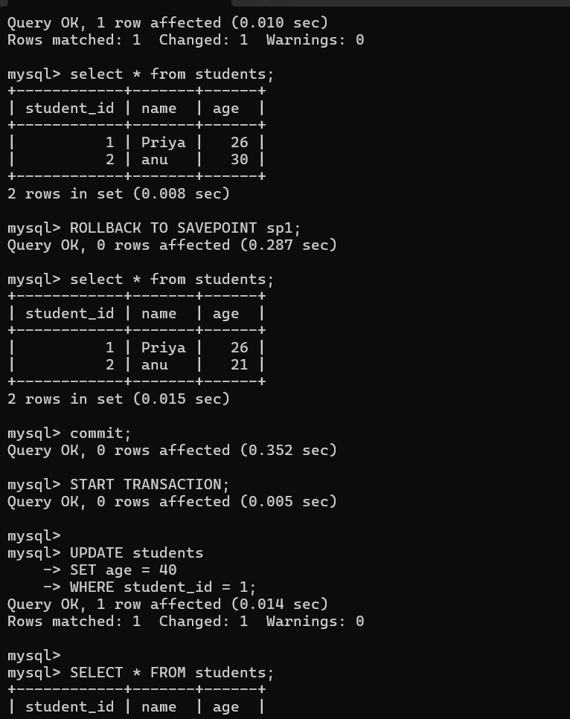
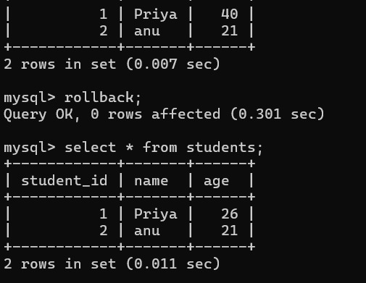

Output:
