Twipi Pushbutton Functions

Layout:

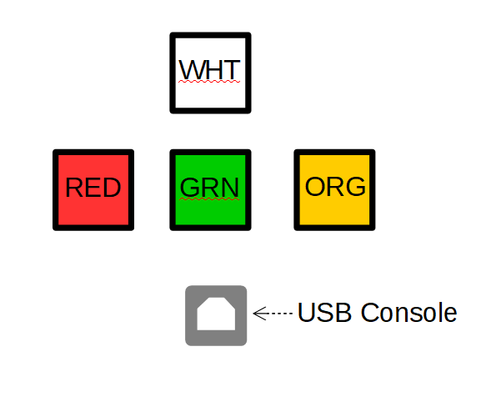

Functions

Button Colour | Pushed In | Out Position | Illuminated | Extinguished
White | Battery Power CONNECTED | Battery power DISCONNECTED | 12 V power IS available | 12 V power IS NOT available
Red | 5 v power comes from BATTERY | 5 v power comes from USB Console | 5 V battery power IS available | 5 V battery power is NOT available
Green | ESP32 is being RESET | ESP32 is NOT being RESET | Selected 5 V power is going to ESP32 | Selected 5 V power is NOT going to ESP32
Orange | S/W readable pin is HIGH | S/W readable pin is LOW | S/W has turned ON the light | S/W has turned OFF the light

