Examination of Etch Widths In Eagle > FlatCAM > G-CodeFiles

Test files:

etch-fun.sch, etch-fun.brd
-Eagle files for minimal circuiit to simplify analysis

tst1-trace-by-wiki.nc, tst1-drill-by-wiki.nc
-G-Code files produced from etch-fun files by following procedure and parameter settings in our wiki.
- parameter settings are documented in the cad-conversions.ods file as well

chart-data.ods
- import of trace file G-Code corners into a spreadsheet
- charted using a scatter graph to allow examination of data points from the shapes

The bottom right corner of the circuit has a trace running between the larger of the pads which seems like a good case to examine. The scatter graph for that part looks like this:

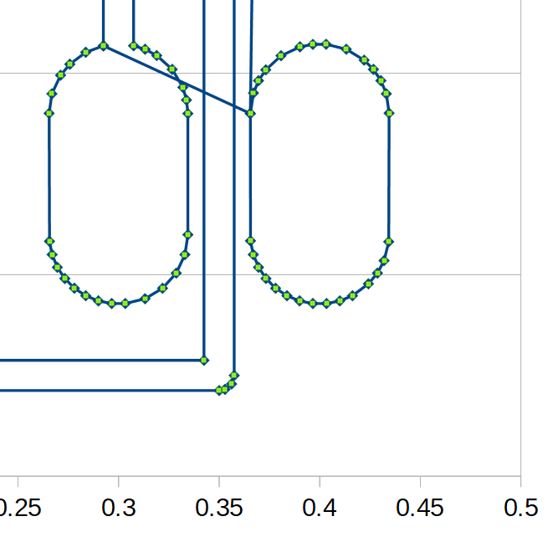

The cross section of the vertical trace looks like this:

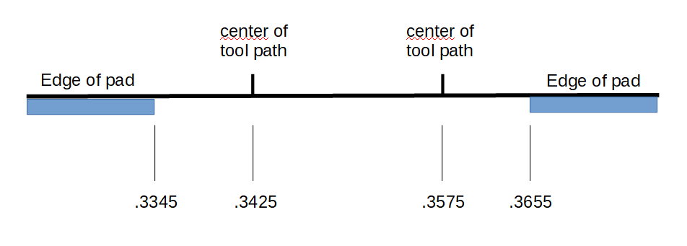

Adding the 0.009 inch width of the V bit to the diagram, we get:

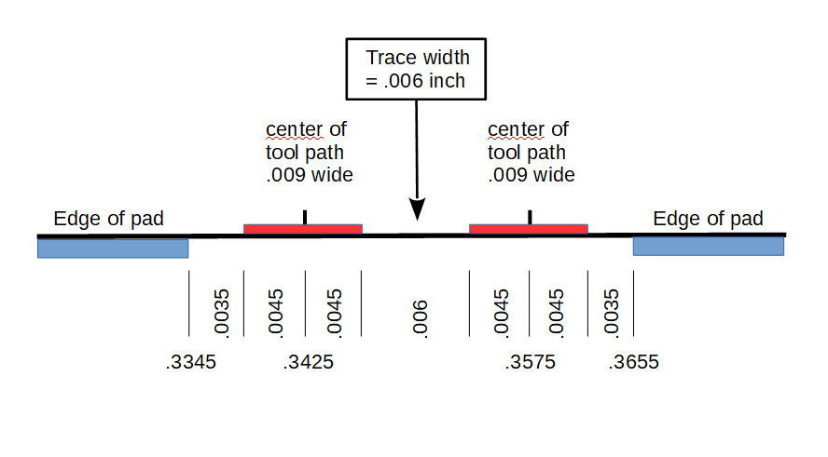

In this case, we could double the trace width to .012 inches in EagleCAD and there would be enough room between the pads. There would be a .005 space between the pads and the edge of the toolpath. This change seems to work through EagleCAD, and FlatCAM, and produces the expected G-Codes.

