HexaFloorRide high level design

This document explains how the dimensions used for the HexaFloorRide robot were derived.

Design philosophy
The design philosophy behind the new HexaFloorRide robot chassis is simply to preserve the cartesian coordinate system dimensions used to calculate the robot’s toe position as much as possible. That said a few fundamental things are different with this new design.

Differences in the new design
The first difference between the old and new design plans are in metric not imperial units. In some cases this may slightly change dimensions resulting from rounding measurement. The reason for this change is two fold. First, using metric aligns the units that are used to design the chassis with the units used to calculate toe position. Second, metric units are favoured by the OEM data sheets for most of the components that make up the robot, including the servo motors. This change makes the units through out the entire design process for the robot consistent.

The second difference between the old and new design is that we have moved the toe from being outside of the ankle joint in the neutral position to being directly under the ankle joint when in the neutral position. This will change the trigonometry of the leg movements but only affects the toe offset term of the equation from its current value of 3.245 to 0 (defined as toeOffset in the flows.h file). The reason for this change is change is to reduce the torque demands of the ankle servo, which testing shows improves when this change in geometry is made.

The third difference between the old and new design is that we have switched from using generic MG996R hobby servo motors to HiTec HS-485HB hobby servo motors. These motors have slightly different physical dimensions. The reason for this change is to improve the precision of movement and too reduce the rate of failure of the motors. The new motors are also three times the cost (up front) but may end up cheaper in the long run if the failure rate of motors improves.

The fourth difference between the old and new design is that we have switched from using 1/4” to 3.175mm (1/8”) 6061 aluminum. The reason for this change is to reduce the weight of the robot to require less torque from the motors.

The fifth and final difference is that the old design used direct modelling and the new design uses parametric modelling. Time will tell if this change is for the better as both approaches have pros and cons.

The robot’s anatomy
To describe the different parts of the HexaFloorRide robot we use the following anatomical terms:

- The body. This is the main chassis of the robot. Please refer to figure 1.
- The hip. This is the servo that connects to the thigh to the body.
- The thigh connects to the horn of the hip servo as well as to the body of the knee servo.
- The knee servo connects the thigh to the shin.
- The shin connect the horn of the thigh servo to the horn of the ankle servo.
- The ankle servo connect the shin to the foot.
- The foot ends at the toe which is the primary reference point used to calculate servo angles for the robot’s leg movements.

Figure 1: Leg terminology - picture TBD

The robot’s joints
The robot has three joints on each of its six legs for a total of 18 joint. The joints on each leg are the hip, knee and ankle. Each joint is a Hitech HS-485B hobby servo motor (shown in Figure 2).

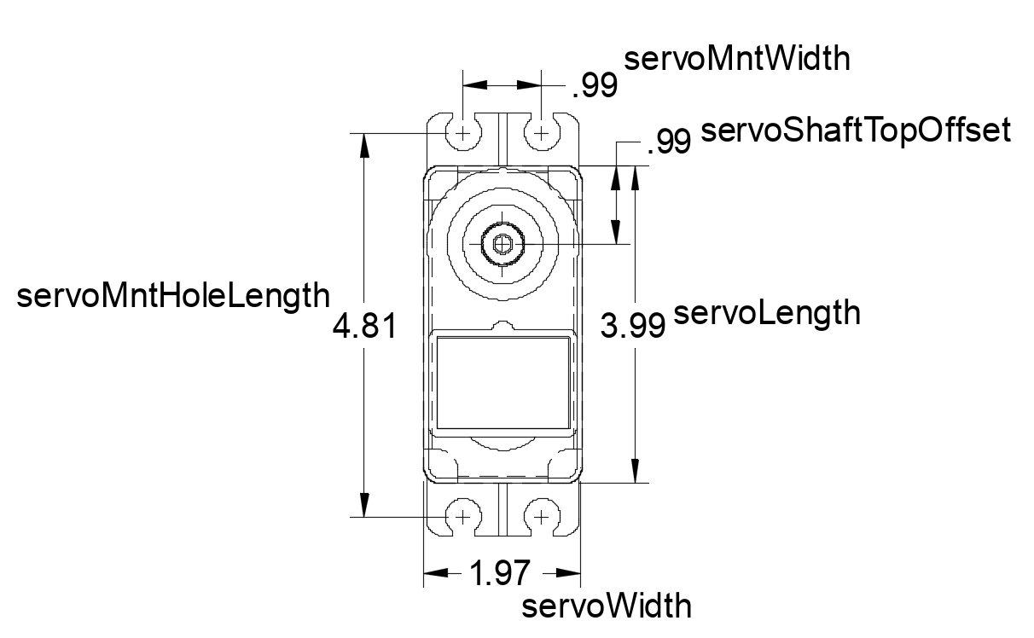
Figure 2: Hitech HS-485HB servo motor dimensions

Each joint also uses an aluminium horn that has a 24 tooth spline and an SES V1 mounting pattern (shown in figure 3). The key parameters are listed below.

- hornCenterHole is the diameter of the centre hole that the mounting screw passes through to affix the horn to the servo shaft which equals 0.8cm.
- hornMntGuideDiam is the diameter of guidance circle used to place four equally spaced holes around the horn. These holes are used for mounting the robot’s leg parts to the joints. This circle has a diameter of 1.66624 cm (0.656”).
- hornThreadHoles s the drill hole size to accommodate threading a #2-56 screw which equals 0.86” (3/32”) or 0.238125 cm.
- hornOuterDiam is the outer diameter of the horn which is 2.54 cm (1”).
- hornSplineGreaterDiam is the grater diameter of the 24T spline used to mount onto the servo shaft which is 0.56 cm.
- hornScrewHole is the drill hole size to accommodate passing a #2-56 screw without engaging the threads. This diameter is 0.238125 cm hole that can be drilled with a 3/32” drill bit.

See Figure 5. You can read about the different variations of the SES specification here: https://wiki.lynxmotion.com/info/wiki/lynxmotion/view/servo-erector-set-robots-kits/servo-erector-set-system-info/ses-mounting-pattern-information/

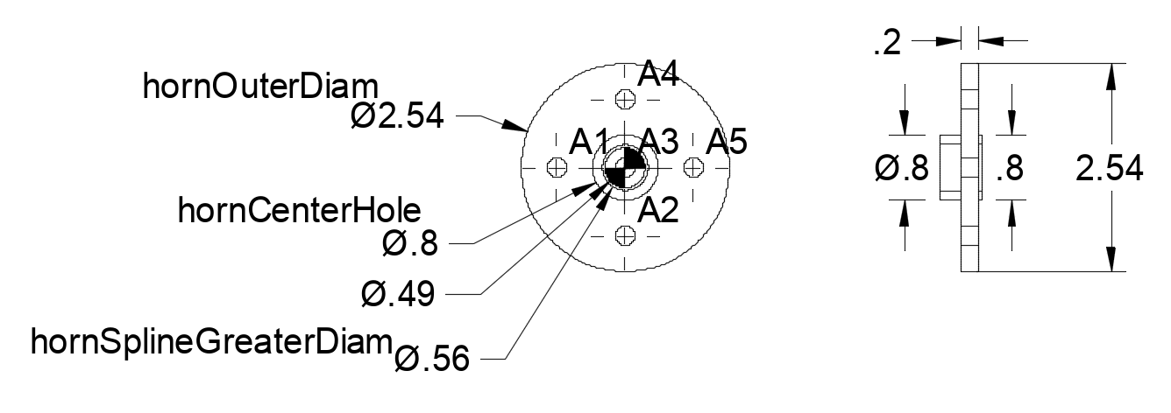

Figure 3: Servo horn dimensions.

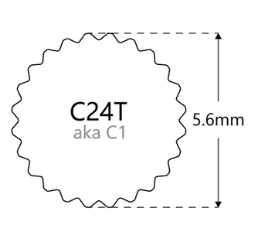Figure 4: HiTec 24T spline

The robot’s foot
The key parameters used for the design of the foot are listed below.

- clearanceTolerance is the gap allowance used to ensure that parts such as the servo motors fit inside the spaces in the robot chassis created for them to fit inside. The formula used to calculate the clearance tolerance is material thickness (3.175) * die punch material factor for aluminium (0.15) which equals 0.4763 cm. This calculation came from the web site https://www.unipunch.com/support/calculators/die-clearance-calculator/.
- servoShaftTopOffset is the distance from the flat top of the ankle servo’s main chassis to the shaft of the ankle servo that acts as the centre of rotation for the robot’s foot which equals 9.82 cm. (see figure 1)
- ankleToToeDistance is the distance from the centre of the ankle servo shaft to the tip of the toe on the foot which equals 11.059 cm defined as footLength in the flows.h file. (see figure 5)
- servoLength is the length of the main part of the servo motor chassis that seats inside the foot. This is calculated as the published dimension for the length of the servo motor which equals 3.99 cm. (see figure 1)
- servoWidth is the width of the main part of the servo motor chassis that seats inside the foot which equals 1.97 cm. (see figure 1)
- servoMntHoleLength is the distance lengthwise between the two sets of mounting holes for the servo motor which equals 4.81 cm. (see figure 1)
- servoMntWidth is the distance widthwise between the mounting holes on one end of the servo motor which equals 0.99 cm. (see figure 1)
- servoMntHoleDiam is the drill hole size to accommodate threading a #2-56 screw which equals 0.86” (3/32”) or 0.238125 cm.
- shoeHole is the drill hole size to accommodate passing a #2-56 screw without engaging the threads. This diameter is 0.238125 cm hole that can be drilled with a 3/32” drill bit.
- shoeOffset is the thickness of the shoe on the foot which equals 0.3175 cm. (see figure 5)
- thickness defines both the minimum material thickness around cavities as well as defining how thick the material used to make the part is. This value is 0.3175 cm (1/8”).

Figure 5: foo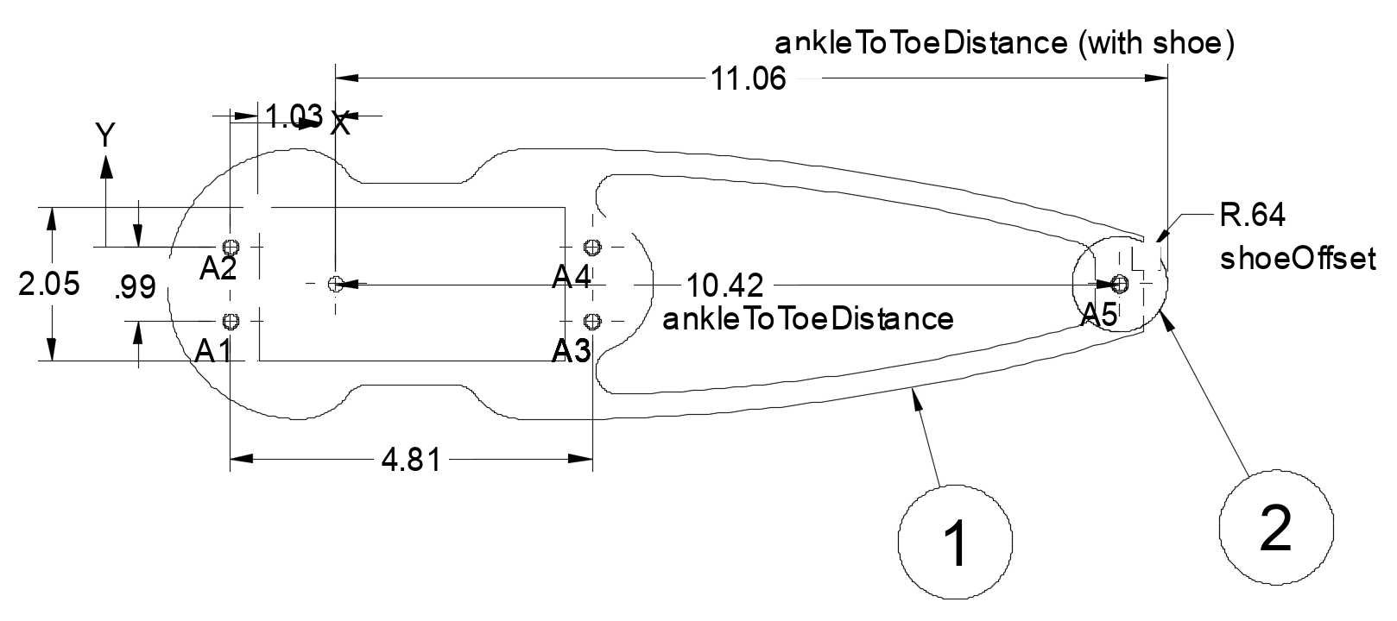t dimensions. 1 = foot, 2 = shoe.

The robot’s shoe
With this new design we will be able to experiment with different “shoes” that can be made of (or coated with) different materials. The shoe is a simple disk with a radius of 0.64 cm and a 3/32” canter hole that ill allow a #2-56 screw to pass through and screw into the foot at the toe. You can see the shoe placement in figure 5.

