CS 340 Project Two README

About the Project/Project Title
This project allows the client, Grazioso Salvare, to more easily access and view their database of animals that are present at the Austin Animal Shelter via a web-based dashboard.

This project has three layers working alongside each other to ensure its functionality:
- A database layer that uses MongoDB to store the database of animals.
- A Python layer that acts as a controller for the web-based dashboard. This done using a custom class that handles Create-Read-Update-Delete (CRUD) actions that work within the database layer via the PyMongo library.
- A Dash layer that uses HTML to display the necessary information.

Why this specific structure?
For the database operations, MongoDB was chosen over something more widely-used like SQL because of its ease of use and flexibility. Mongo uses a more dynamic schema than its counterparts, which helps prevent certain, common errors that can occur during a create or update operation, such as information of the wrong data type being input. On top of this, Mongo works in a JSON format, which is much better suited to a web-based set up. While it doesn’t have the same level of ACID properties as SQL, the database is only for displaying and interpreting data, and is not designed to handle transactions, so this can be disregarded.

Python was chosen for, largely, the same reasons as MongoDB. Python’s many libraries allow for an easier and more seamless connection between the front end and the backend; As an example, PyMongo is used to interact with MongoDB on the backend, and Dash is used to create a visual representation of the backend data on the front end.

Dash, more specifically Plotly-Dash and Dash Leaflet, is a JavaScript-based tool that interacts with Python through its API. These libraries allow developers to create graphical representations of data with charts, maps, or raw HTML that allows the rendering of tables.

Installation
This project has quite a few dependencies it relies on to ensure it functions properly:
- An up-to-date version of Python3 to run both the .py files and the .ipynb files.
- An up-to-date version of MongoDB to access the database itself.
- The PyMongo library so the Python files can control the database.
- Plotly Dash and Dash Leaflet for the web application to display.

Getting Started (should probably get some extra screenshots for this)
In the event the project needs to be replicated or restarted, that can be done by:
- Make sure all of the necessary dependencies are accounted for and downloaded. All dependencies are listed in the Installation section above.
- With an admin account, use MongoDB to import the needed data into a usable database.
- Within MongoDB, create the necessary accounts to access the CRUD Python module. Since the admin account already exists, a secondary user with only read and write permissions is needed.
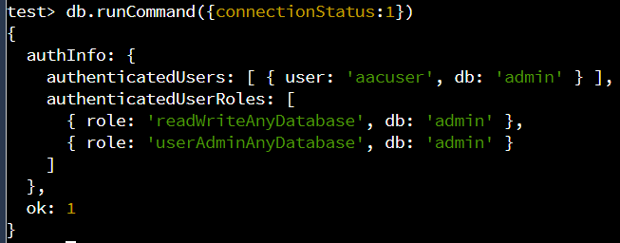
- Make sure the CRUD Python Module is instantiated within the host server.
- Within the CRUD Python Module, there is a section that holds a username and password. Make sure to update these with the user account details you created for the secondary account in Step 3.
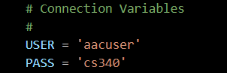
- Add the Dash components and their necessary callbacks as needed.
  - Creating the Data Table
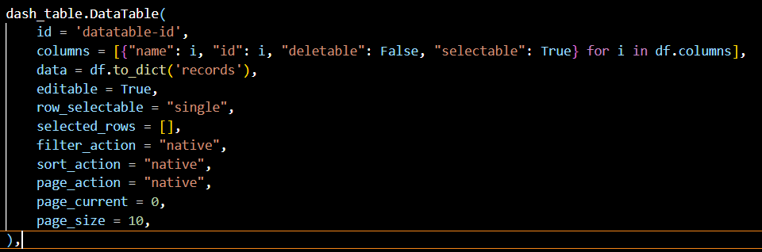
  - HTML Div that holds individual widgets
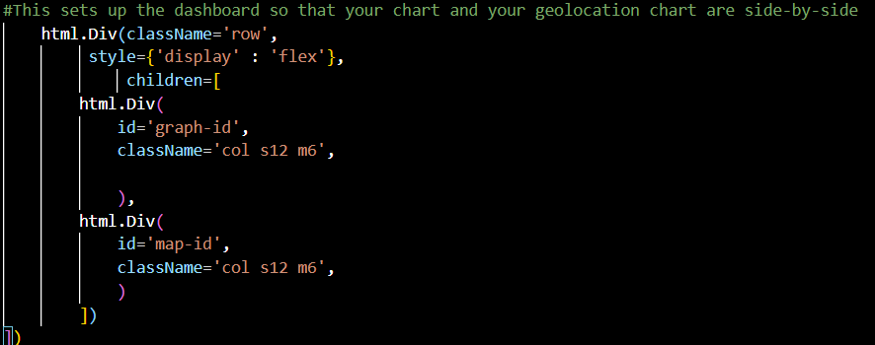
  - Radio Buttons that are used for Filtering
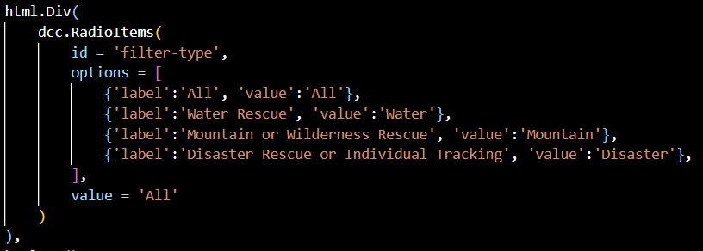
- Update the regular expressions that are used for filtering in the event they’ve changed.
  - Water Rescue RegEx, as an example
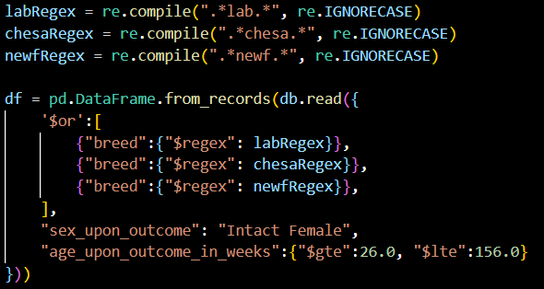
- Start MongoDB.
- Start the Dashboard.

Usage
Below is a slightly-zoomed-out look at the Grazioso Salvare dashboard. (Zooming out on the page was the only way I could fit every necessary component onto the screen at once)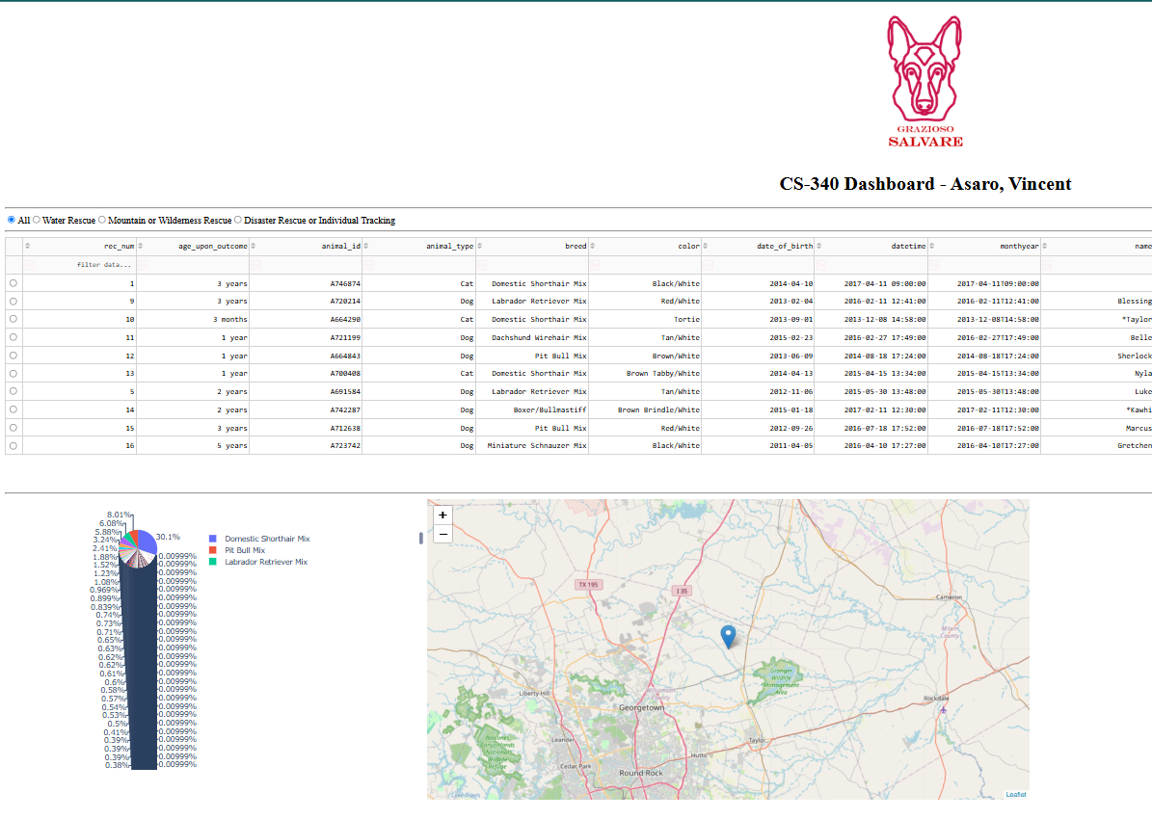
Pie Chart showing available breeds
Table that updates with user input
Company logo and link to homepage
Inline Filters and Sorting
Buttons that act as Quick Filters
Map control toggles
Map showing location of selected animal

The filters were defined by the client and are as follows:

Rescue Type | Preferred Breeds | Preferred Sex | Training Age
Water | Labrador Retriever Mix, Chesapeake Bay Retriever, Newfoundland | Intact Female | 26 to 156 weeks
Mountain or Wilderness | German Shepherd, Alaskan Malamute, Old English Sheepdog, Siberian Husky, Rottweiler | Intact Male | 26 to 156 weeks
Disaster or Individual Tracking | Doberman Pinscher, German Shepherd, Golden Retriever, Bloodhound, Rottweiler | Intact Male | 20 to 300 weeks

Is a user chooses a new filter, the graph and table will update accordingly.

Water Rescue:
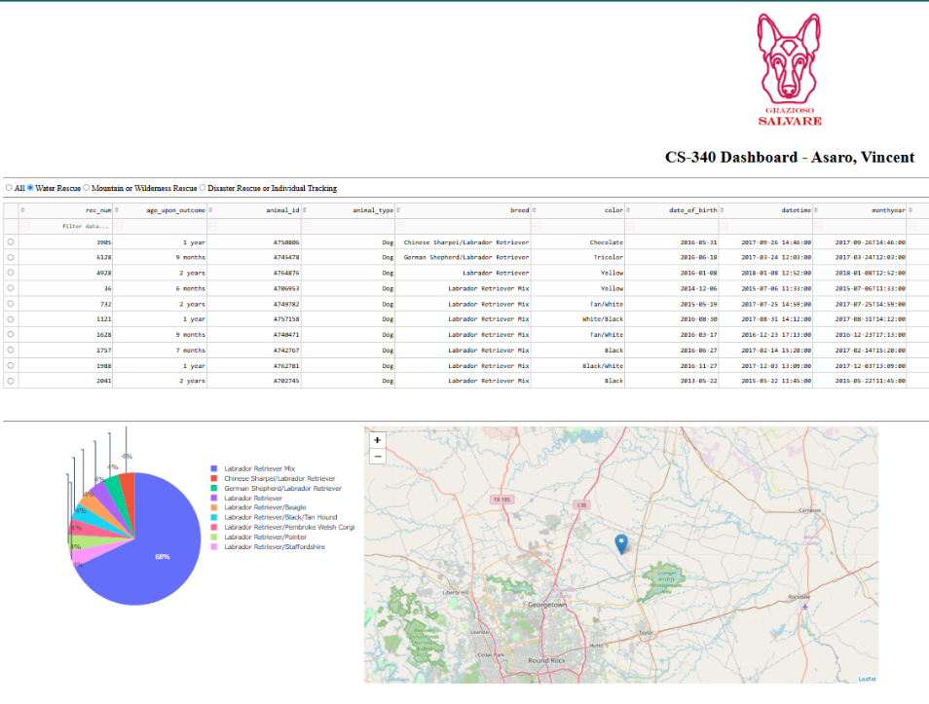
Mountain and Wilderness Rescue:
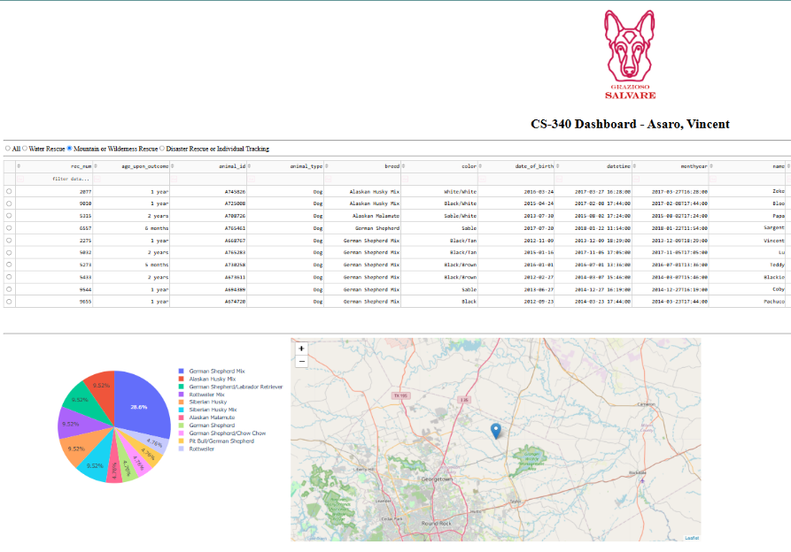

Disaster Rescue or Individual Tracking:
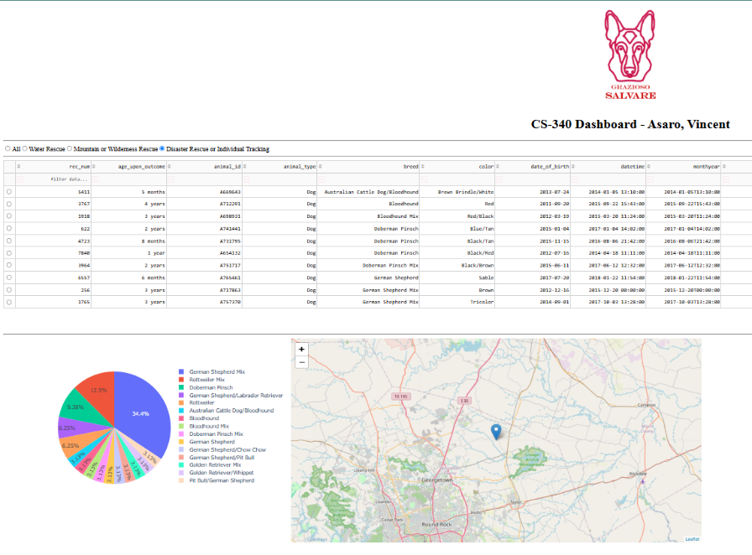
If an animal is selected in the table, the map will update to show its location.
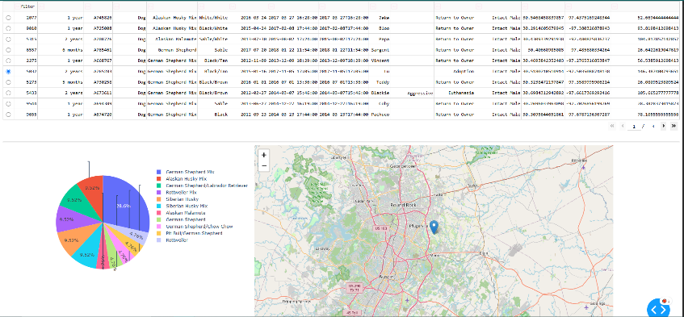

Contact
Your name: Vincent Asaro, vincent.asaro@snhu.edu

