

Vaadin
TestBench
User's Manual
Vaadin TestBench 2.0

Vaadin TestBench is an environment used for automated user interface regression testing of Vaadin applications on multiple platforms and browsers.

Vaadin TestBench allows you to run tests on the UI after a build and catch problems created by changes to the business logic. This helps you catch problems that affect the UI functionality early on, before they become a real problem.

Introduction to Vaadin TestBench

Overview
Quality assurance is one of the cornerstones of modern software development. Extending throughout the entire development process, quality assurance is what binds the end product to the requirements. In iterative development processes, with ever shorter release cycles and continuous integration, the role of regression testing is central. The special nature of web applications creates many unique requirements for regression testing.
Vaadin TestBench makes it possible to automate the regression testing of web applications that use Vaadin. You record test cases by interacting with your application. After recording, the tool can run the tests for as many times as you want, on multiple platforms and browsers. Test results are stored in a centralized test server for later analysis and quality assurance.
The main features are:
- Recording and playing back test cases using a recorder in browser
- Validating UI state by assertion points and screen capture comparison
- Screen capture comparison with difference highlighting
- Distributed test grid for running tests
- Integration with unit testing
Execution of tests are distributed over a grid of test nodes, which speeds up testing. The grid nodes can run different operating systems and have different browsers installed. In a minimal setup, such as for recording the tests, you can use Vaadin TestBench on just a single computer.

Installation Architecture

Figure 1: Vaadin TestBench Architecture
The test cases and results are stored in Vaadin TestBench Server, which allows you to manage, edit, and execute test cases, view the results from test runs, and manage users.
The main components of Vaadin TestBench are:
- Vaadin TestBench Recorder
- Vaadin TestBench Library
- Vaadin TestBench Grid Hub
- Vaadin TestBench Grid Node Controller
Recording test cases requires Vaadin TestBench Recorder, which is a Firefox extension that you install in your browser. It provides a control panel to record test cases and play them back. You can play test cases right in the recorder and later automatically by the Grid Node Controller, which opens a browser and starts the recorder in playback mode.
Vaadin TestBench Library...
Vaadin TestBench Grid Hub is a service that distributes test tasks to nodes in the testing grid. It contacts the Grid Node Controller in a node and asks it to open a specific browser and run specific tests in it. The Grid Hub runs in a server which can be dedicated or serves also as one of the grid nodes.
Vaadin TestBench Grid Node Controller is a service that runs in every grid node. It is able to open any of the browsers installed in a grid node and start the Vaadin TestBench recorder in the playback mode to execute the tests. It receives requests to execute tests from the grid hub and reports any reports back to it.
Vaadin TestBench is based on the Selenium testing framework

Vaadin TestBench Setup
The basic setup for a Vaadin TestBench environment consists of:
- A workstation with Firefox and the TestBench Recorder for recording tests
- A build/test server used to build, launch, and test the web application
- A server running the Grid Hub
- One or more servers running Grid Remote Controls
The workstation and servers can be separate computers or one computer can work in multiple roles.
Machines for Hub, Remote Controls and test creation may be the same machine.

Requirements
For recording and playback with Vaadin TestBench Recorder:
- Firefox 3 or newer
For running tests:
- Java JDK 1.5 or newer
- Browsers installed on test nodes
- Apache Ant or some other way to run Ant scripts (recommended)

Installing Vaadin TestBench

Overview
The installation of Vaadin TestBench covers the following tasks:
- Download and unpack the Vaadin TestBench installation package
- Install Vaadin TestBench Recorder
- Install Vaadin TestBench Library and launch scripts
- Install Vaadin TestBench Grid Hub
- Install Vaadin TestBench Grid Node Controllers
In a typical small test development setup, you will install all the components in a single workstation. In a full distributed setup, you will install the components in separate hosts.

Downloading and Unpacking the Installation Package
Download the Zip-packaged installation package Vaadin-TestBench-<version>.zip and extract it to an installation directory.

Simple setup for recording
After extracting the files from the installation package, enter the testbench-ide/ directory under the installation directory. Open Firefox and either drag and drop the Vaadin-TestBench-ide-<version>.xpi to an open Firefox window or open it from the File menu. Firefox will ask if you want to install the TestBench Recorder extension.
Note that because TestBench Recorder is based on the Selenium IDE, the installation of the extension will overwrite a previously installed Selenium IDE extension. The installation of a new version of Vaadin TestBench Recorder will also overwrite a previous version.
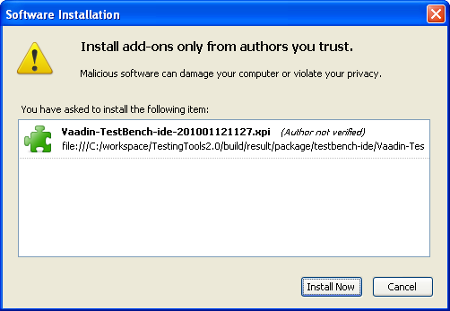
After the installation of the add-on is finished, Firefox offers to restart. Please restart it. Once Firefox has restarted, navigate to a Vaadin application for which you want to record test cases, such as http://demo.vaadin.com/colorpicker.
Open Vaadin TestBench Recorder from the Tools menu and record a small test.
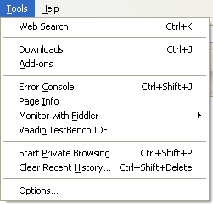
Figure 2: Starting Vaadin TestBench Recorder
After recording a test case, open a new browser window or tab and press to see that the test works.
Save the test as an .html file by selecting Save Test from the File menu. to example/testscripts/
Vaadin TestBench stores the test cases as HTML files. This makes it easy to review saved test cases.

Simple setup for playback on local machine
(see also Running tests with only a Remote Control p.14)
The hub and remote control are set up so that they can be run on the local machine just by first starting the hub with /grid/hub/hub.bat and then the remote control with /grid/remote-control/rc.bat (hub.sh and rc.sh under Linux).
Navigate to grid/hub/ and run hub.bat to start the hub on port 4444.
Then go to grid/remote-control/ and run rc.bat to start the remote control on the local machine and have it connect to the hub.
Check that the remote control registered correctly by opening http://localhost:4444/console

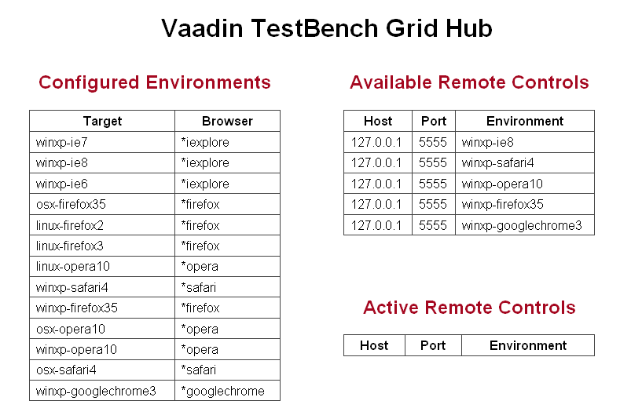
Next run the ant script in the example/ directory. The script will convert, compile, run the recorded test and give a brief output on test success or failure.

Setting Up the Grid
A Vaadin TestBench grid consists of 2 parts:
- The Hub
- A number of remote controls
The hub handles communication between the JUnit test runner and the remote controls. The remote controls launch a browser and perform the actual execution of test commands in the browsers.

Configuring the hub
For the Hub, port and environments can be easily defined in grid_configuration.yml
- name: “” represents the Target value in the console and
browser: “” is the browser run by this target.
The name can be defined as anything, but may not contain a [,] as the remote control environment string is parsed by [,].

The supported browser strings are defined at the end of this document.
Configuring the remote control

The remote control values are defined in the file rc_configuration.xml. Values given in the xml will override the values given in the run scripts.
<port> - is the port this remote control listens to
<hubURL> - is the address to the hub
<environment> - defines one environment that this rc supports
<host> - defines the host address for this rc. If not defined hub takes it from the
registration request.

The remote control can also be configured from the run scripts (rc.sh or rc.bat) by defining
ENVIRONMENT - defines environments/browsers supported by this remote control
USEREXTENSIONS - defines where user-extensions.js is located

and adding following after SelfRegisteringRemoteControlLauncher
-hubUrl [hubUrl] - is the address to the hub
-port [PORT] - is the port that this remote control listens to

The ENVIRONMENT variable(s) should match one or more of the ones defined in the hub console.

How to record tests

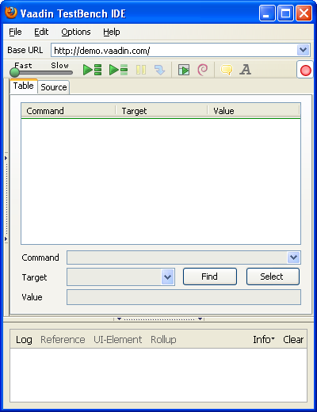
Tests are recorded using the TestBench IDE.

Open the page with the application that you want to test and launch the IDE from the [Tools] menu.

Recording will be automatically enabled when the program launches. This is marked by the button.

Recording:

TestBench will record appropriate commands as the user navigates the application.
(note. Passwords are recorded in plain text as they do not differ from normal text input)
Changing tabs or open windows is not recomended while recoding is enabled, as any clicks and other actions will be recorded.

After the test has been recorded, it is advisable to playback the test using to see that it works as planned and no faulty/wrong commands are found (test runs without errors).

When the test works correctly it should be saved as a .html file with [Save Test] from the [File] menu. HTML file format is used because the IDE saves the test in XHTML format. (Also the default files that are searched when running tests as JUnit tests with the ant script is *.html)

Special commands

Comparing screenshot images: [screenCapture]

From the right click menu, screenCapture will record an event that takes a screenshot of the desktop, crops out the canvas and compares the result against a reference image (if one is available). If no referense image is available it will save this screenshot and fail the test at the end.
(note that screenshots are not taken and compared with the IDE, only when using a remote control)

For the screenCapture command the Value field can be used to define a identifier string for the screenshot. If left empty the identifier will be a running number starting from 1 for each test. Using an ID for the screenshot is more reliable than the numbers if the test changes and screenshots are added or removed.

The naming convention of screenshots is automated and has the following format.
NameOfTest_OperatingSystem_BrowserName_BrowserMajorNumber_Identifier.png

Recording ToolTips: [showTooltip]
Clicking will enable recording of a tooltip. Recording is done by hovering over the target element until a tooltip appears and then moving the mouse away from the element. This will record a showTooltip command and disable the tooltip button.

Recording AssertText: [assertText]
Clicking will enable recording of an assertText command on elements where context menu doesn't show. When assertText button is active the IDE will record an assertText on element command for the next mouse click. Assert stops bubbling of events for most Vaadin components.

Connecting tests together: [includeTest]

Vaadin TestBench has the capability to connect tests together. This is done by adding the command includeTest where Value is the path to the test to insert (from where the TestConverter is run or full path). Target test will be added in full at the position with includeTest. Inclusion only works when converting to JUnit tests with com.vaadin.testbench.util.TestConverter.

IDE buttons:

The Find button will highlight the target element on the page where as the Select button will allow changing the target for the currently selected command. Select will change the target according to the next element that is clicked. Select will stop bubbling of events for most Vaadin components, so selection of new target will not cause an actual click for most Vaadin components.

Editing tests

To edit a test open the test in the IDE.

Command fields can be changed by selecting target command and then changing the wanted field. (Command, Target or Value)

New commands can be inserted by right clicking and selecting [Insert New Command] and comments with [Insert New Comment].

Note that new command and new comment will be added on the place that is selected and move the selected command down.

Faulty tests:

tests may become faulty due to intentional changes to the application. Normally it involves changes in elements so that the Vaadin TestBench element locator can't find the correct element. (refer to known problems)

If the problem is that an element can't be found press to playback the test and find the problem position and check with the Find button that the element can't be found (eg. It's not a problem with timing that the element just isn't available yet). Re-selecting the element is simplest with the Select button that will update the target.

How to playback a test

From the IDE

Open target test in the IDE with [Open...] from the [File] menu (if not testing an already open test).

Push the button to playback the test. Playback will disable recording and run the currently open/selected test.

The command execution speed on playback can be controlled with the slider. Slowing down the execution speed on IDE playback is helpful when confirming the correctness of a test sequence.

As a JUnit test

The recommended way to run JUnit tests is to edit/use the Ant Script in the examples directory. This will convert, compile and run the test(s). Note the property values defined in script.

Tests can also be played back using the hub and running the test as a JUnit test.

Converting tests can be done in two ways.

One is to use TestConverter from the vaadin-testbench jar from the command line or with the create-tests target in the Ant script.

com.vaadin.testbench.util.TestConverter [OUTPUTDIR BROWSERS HTMLTestFiles]
OutputDir defines where the generated Java JUnit files should be saved
Browsers defines target environments separated by a comma
(environments need to be found in hub targets)
HTMLTestFiles target test files locations separated by a space

When compiling the JUnit tests you need to add the Vaadin-TestBench@version@.jar and lib/junit-*.jar into your build path. (These are also needed for running the test)

When running the JUnit test 3 system property values need to be specified.
-Dcom.vaadin.testbench.tester.host=”localhost”
-Dcom.vaadin.testbench.deployment.url=”http://demo.vaadin.com/”
-Dcom.vaadin.testbench.screenshot.directory=”screenshot”

The given values are for the example test within the package, running it with Grid on the local machine.

Another is to export the test to a JUnit test from the IDE.
File → Export Test As → Vaadin Format – TestBench.

This will create a .java JUnit file out of the currently open test. (Some things need to be changed by hand in the .java file like screen shot names, test will use Firefox for the test and includeTest will not include the target test)

Note. Tests will not be able to run if no remote control has registered wanted environment.

How to setup test machines

Setting up a test machine consists of

- Install/confirm Java 1.5 JRE (or newer)
- Install browsers to use on machine
- Copy grid to test machine and edit remote-control run script
- Set browser settings
- Set OS settings

Edit remote control configuration file

After copying the grid package (or just the remote-control if another machine is running the hub) the configuration file needs to be edited.

If the hub is running on the same machine as the remote control then only the <environment> nodes need to be defined with proper targets for this remote controller as localhost.

For remote controllers running on other machines both the <hubURL> and <environment> nodes need to be checked and defined.

<port> - is the port this remote control listens to
<hubURL> - is the address to the hub
<environment> - defines one environment that this rc supports

Browser settings

Turn off popup blockers for all browsers.
[Internet Explorer - Tools → Pop-up Blocker → Turn Off Pop-up Blocker]
[Safari - Edit → Block Pop-up Windows]

Turn off default browser checks for all browsers.

Operating system settings

Windows:
Disable error reporting in case a browser crashes.
- Open control panel → System
- Select ”Advanced” tab
- Select ”Error reporting”
- Check that ”Disable error reporting” is selected
- Check that ”But notify me when critical errors occur” is not selected

Notes for using screenshots

Disable the auto-hide function for the toolbar. (Windows)
Check that the toolbar is either locked or unlocked on all test machines. (Windows)
Diable cursor blinking.
Windows: [Control panel → Keyboard → Cursor blink rate → none]

Turn on "Allow active content to run in files on My Computer" under Security settings on IE.

Use same resolution on all test machines and check that the maximized window is always the same size.

Configure browsers in the same manner on all machines (same toolbars visible etc.)
Turn off software that may suddenly popup a new window.
Disable cursor blinking for less false fails.

How to integrate Vaadin TestBench with a build system

An example using Apache Ant can be found in the example directory. The example Ant script should be runnable if the hub and remote control have been started. The sample test will fail on the first run because there are no referense images.

Using Vaadin TestBench with a build system.

The build system needs to take the following steps after finishing the build to run tests.

- Start server for testing (needs to be reachable by test machines)
- Convert HTML test to Java Junit tests using TestConverter
- Compile created Java Junit tests
- Remove old error screens for screenshot directory
- Run compiled Junit tests
- Remove temporary files (source and compiled java files)

Start server. (example assumes Jetty is used)

Create a WAR package of the application(s). Example of creating a war file using ant script:

<war destfile=”example.war” webxml=”./WebContent/WEB-INF/web.xml”>
<fileset dir=”./src/possible_html_files”>
<lib dir=”./thirdparty/libs><exclude name=”not_needed.jar”/></lib>
<classes dir=”./build/” />
</war>

Copy created war file to $JETTY_HOME/webapps/example.war

Start a server so that the program to be tested is accessible from the test machine(s).
java -jar start.jar

Application should now be deployed at http://BUILD_SYSTEM_ADDRESS:8080/example/ if example configuration has been used.

Note that the deployment url/ip and port may change, but context path needs to stay the same as the one recieved when recording tests. Else all locators will need to be edited.

Convert HTML tests

Run com.vaadin.testbench.util.TestConverter [OUTPUTDIR BROWSERS HTMLTestFiles]

OutputDir defines where the generated Java JUnit files should be saved
Browsers defines target environments separated by a comma
HTMLTestFiles target test files locations separated by a space

Compile JUnit tests

Compile the java files created during the previous step.

Remove old error screens

If there are any error screens from a prevoius run remove these so they don't mix with possible ones from this run.

Run Junit tests

Define required system property values to the java virtual machine.

-Dcom.vaadin.testbench.tester.host
= Hub address without the port definition eg. ”localhost”

-Dcom.vaadin.testbench.deployment.url
= Base url of test application eg. ”http://demo.vaadin.com/”

-Dcom.vaadin.testbench.screenshot.directory
= Base directory for reference and error images

Optional system property values that can be used.

-Dcom.vaadin.testbench.screenshot.softfail
= if ”true” lets the test run to finish even if errors are found for screenshots

-Dcom.vaadin.testbench.screenshot.onfail
= if ”true” takes a screenshot when a test fails.

-Dcom.vaadin.testbench.screenshot.cursor
= if ”true” makes a check if error is because of a cursor.

-Dcom.vaadin.testbench.screenshot.block.error
= sets how much different the 16x16 blocks may be 0<x<=1. (default = 0.025 == 2.5%)

-Dcom.vaadin.testbench.screenshot.reference.debug
= if ”true” creates extra output for debuging purposes

Remove temporary files

Clean away created files that are not needed anymore. (the .java and .class files)

Stop server

After tests have completed stop the server and remove application data from the webapps/ directory.

Notes for running tests

(Notes concern mostly people running tests on the local machine using Grid.)

When taking screenshots the mouse cursor will be moved to position 0,0 on screen to minimise problems with screenshot elements.

When using Opera, Safari or Google Chrome browsers, arrow key navigation is handled by the Java Robot that will send an actual key event to the system. This will not target the browser and target element, but the currently focused window and its selected element.

Handling of reference screenshots

For reference screenshots the best place to have them would be somewhere where both the user and build server have access or in the version control repository. This way users and the build server will have the latest references for their use. (note that both build server and users will need to have access to this location)

Updating references

Updating references on a users own machine only requires the user to copy over the correct/new screenshots from the errors/ directory to the references/ directory.

If using a repository, the images are copied the same way from errors/ to references/, but the new references/ also needs to be committed to the repository.

Supported browser strings

- *firefoxproxy
- *firefox
- *chrome
- *firefoxchrome
- *firefox2
- *firefox3
- *iexploreproxy
- *safari
- *safariproxy
- *iehta
- *iexplore
- *opera
- *piiexplore
- *pifirefox
- *konqueror
- *mock
- *googlechrome

In cases where multiple browsers are installed or the remote controller can't find the browser (not installed to a default location) the browser string can be extended with the absolute path to the browser executable. E.g. *firefox /home/user/firefox3.5/firefox

In these cases it should be noted that all remote controls using the target browser should have the same installation directory. (Target name used may be unique for this, but may cause mixups)

Note. Target *firefox3 is defined as “Discovers a valid Firefox 2.x or 3.x installation on local system. Preference is given to 2.x installs”. This will cause mix ups if both Firefox2 and Firefox3 are installed, as one would expect Firefox3 to be launched.

Running tests with only a Remote Control

Running test with only a standalone remote controller only requires changes to browsers property string in the ant script and that the com.vaadin.testbench.tester.host points to the remote control. No changes to tests or other settings are required.

To run tests with a standalone remote controller download Selenium RC from http://seleniumhq.org/

After unpacking copy selenium-server.jar from selenium-server-1.x.x/

Copy user-extensions.js from grid/remote-control/ in the Vaadin TestBench package to where selenium-server.jar is located.

Start the Remote Control server with
java -jar selenium-server.jar -userExtensions user-extensions.js

In the Ant script in example/ change the browsers property to use names defined in Supported browser strings.

(Note browser for *chrome is Firefox and not Google Chrome)

Known issues

At the moment playback for modifier+arrow key only works in Firefox and InternetExplorer.

Tests with RichTextFields do not work.

Drag-n-drop functionality is not yet implemented. (Recording sliders is not functional)

For LoginForm test will record a selectFrame when using LoginForm and selectWindow when going away from login. Remove these commands to get the test to work correctly.

Screenshots don't always work as expected under Linux (OSX?) due to remote control resizing browser window wrong for selenium.windowMaximize()

IDE will fail to record events if Vaadin TestBench user- and ide-extensions are set under options.

Theme changes don't record the required AndWait.

URI fragment functionality is not reliable.

Recording and playing back fileupload is not supported.

OSX firefox3.5 doesn't draw marking rectangle on element.

Jetty Configuration example
<?xml version="1.0"?>
<!DOCTYPE Configure PUBLIC "-//Mort Bay Consulting//DTD Configure//EN" "http://jetty.mortbay.org/configure.dtd">

<Configure id="Server" class="org.mortbay.jetty.Server">
<Call name="addConnector">
<Arg>
<New class="org.mortbay.jetty.nio.SelectChannelConnector">
<Set name="port">8080</Set>
</New>
</Arg>
</Call>

<Set name="handler">
<New id="Handlers" class="org.mortbay.jetty.handler.HandlerCollection">
<Array type="org.mortbay.jetty.Handler">
<Set name="handlers">
<Item>
<New id="Contexts" class="org.mortbay.jetty.handler.ContextHandlerCollection"/>
</Item>
</Array>
</Set>
</New>
</Set>

<Call name="addLifeCycle">
<Arg>
<New class="org.mortbay.jetty.deployer.WebAppDeployer">
<Set name="contexts"><Ref id="Contexts"/></Set>
<Set name="webAppDir"><SystemProperty name="jetty.home" default="."/>/webapps</Set>
<Set name=”parentLoaderPriority”>false</Set>
<Set name=”extract”>true</Set>
<Set name=”allowDuplicates”>false</Set>
</New>
</Arg>
</Call>
</Configure>

