CAPSTONE PROJECT REPORT

ON

BRUTE-FORCE ATTACK & ACCOUNT LOCKOUT RESPONSE

Submitted to
Mr. Tapan Kumar Jha

WIPRO PRE - TRAINING
RPS TEAM
INFRA SECURITY

BY
VAISHALI PAWAR
28802

BATCH ID - 25VID1318

UNDER THE GUIDANCE OF
Mr. Tapan Kumar Jha

Date : 24 June 2025
Week 6 Day 2

Acknowledgment

I am profoundly grateful to Mr. Tapan Kumar Jha of Affiliation for his expert
guidance and continuous encouragement throughout to see that this project
meets its target since its commencement to its completion.

Vaishali Pawar
28802

ABSTRACT

This capstone project involved the simulation and analysis of brute-force attacks on Linux and Windows Server environments to evaluate authentication security and response mechanisms. A Linux server with SSH and a Windows Server configured with Active Directory and RDP services were set up as targets. Brute-force attacks were launched using tools
Authentication and security logs were closely monitored—/var/log/auth.log on Linux and Event Viewer on Windows—to detect failed login attempts, identify patterns of attack, and confirm account lockout events. Based on the observations, an incident response plan was implemented, including identification and blocking of malicious IPs, resetting compromised credentials, and enforcing account lockout thresholds.
Further, mitigation strategies such as strong password policies, IP-based access controls, and lockout configurations were applied to strengthen system defenses. A formal security policy was drafted to standardize password complexity, account lockout, and remote access rules. The root cause analysis highlighted system behavior during the attack, evaluated the response effectiveness, and emphasized the need for proactive monitoring and robust access control policies.
This project reinforced the practical importance of layered security, timely log analysis, and well-defined incident response in protecting systems from brute-force threats.

CONTENTS

- No | Topic | Page no
1. | Introduction | 1
2. | Objective and Project Scope | 1
3. | 3.1 Technology and Tools Used &  3.2 Environment Setup  3.2.1 Kali Linux  3.2.2 Windows Server | 2
4. | Attack Simulation | 3-4
5. | 5.1 Log Analysis  -5.1.1 Event Viewer Navigation  -5.1.2 Key Event IDs  -5.1.3 Pattern Observation  5.2 Account Lockout Response Implementation | 4-8
6. | Incident Response Plan  Playbook | 8-9
7. | Mitigation Measures | 10
8. | Root Cause Analysis | 10-11
9. | Summary of Findings | 11-12
10. | Recommendations & Conclusion | 12
11. | References | 13

- INTRODUCTION
Brute-force attacks are a common cybersecurity threat where attackers repeatedly guess login credentials to gain unauthorized access. This project, "Brute-Force Attack & Account Lockout Response," simulates such attacks to understand system vulnerabilities and implement effective security measures.
We set up a Linux server with SSH and a Windows Server with Active Directory and RDP/SMB services. Using Kali Linux and Hydra, we launched brute-force attacks targeting both systems with the rockyou.txt password list. On Windows 10, RDP brute-force was also tested after disabling the firewall.
Login attempts were monitored through authentication logs on Linux and Event Viewer logs on Windows. The project focused on identifying attack patterns, detecting source IPs, and enforcing incident response actions such as IP blocking, password resets, and lockout policies.
Through log analysis, response planning, and policy drafting, this project highlights the importance of proactive security configurations in preventing brute-force attacks.

- OBJECTIVE & PROJECT SCOPE

Objective
The objective of this project is to simulate brute-force attacks on Linux and Windows systems to understand attack behavior, analyze authentication logs, and implement effective security responses such as account lockout policies and IP blocking.
Project Scope
- Set up Windows Server (RDP) environments.
- Launch brute-force attacks using Hydra from Kali Linux.
- Monitor logs Event Viewer.
- Identify attack patterns and source IPs.
- Apply incident response actions and configure mitigation policies.
- Draft password, lockout, and remote access policies.
- Conduct a root cause analysis of the attack and response.
- Analyze failed login attempts and trigger account lockout mechanisms
- Implement and test account lockout response on Windows Server
- Reset locked accounts and apply response policies during incident handling

3.1 TECHNOLOGY AND TOOLS USED

Operating Systems:
- Linux (Kali Linux): Target system and attack simulation environment
- Windows Server 2019: Active Directory and RDP/SMB service setup

Tools Used:
- Hydra: Brute-force attack tool used to perform automated login attempts
- Nmap: Used for network scanning and service enumeration
- rockyou.txt: Common password dictionary used during brute-force attempts
- Event Viewer (Windows): Log analysis tool to monitor login attempts and security events
- CMD / ipconfig: Used for identifying IP addresses on Windows machines
- Firewall Settings: Temporarily disabled on Windows for simulation
- Group Policy Editor (Windows): Used to configure account lockout policies

3.2 ENVIRONMENT SETUP

3.2.1 Kali Linux
Kali Linux was used as the attacker machine to simulate brute-force attacks using tools like Hydra and Nmap. The following steps were performed:
- Downloaded and verified the rockyou.txt password dictionary.
- Used terminal commands to scan and brute-force target systems.
- Executed the Hydra command to launch a brute-force attack on Windows RDP:
- hydra -l Administrator -P rockyou.txt rdp://<Target-IP>
- Monitored responses to identify login failures and locked accounts.
- Kali was also used to run Nmap for service discovery prior to launching attacks.

3.2.1 Windows Server
Windows Server was configured to simulate a real-world authentication system with Active Directory and RDP access:
- Retrieved server IP address using:
- ipconfig
- Temporarily disabled the Windows firewall to allow brute-force simulation.
- Configured Account Lockout Policy using Group Policy:
- Threshold: 5 failed attempts
- Lockout Duration: 15 minutes
- Reset Counter After: 15 minutes
- Used Event Viewer to monitor logs under:
Windows Logs → Security
- Observed Event IDs like 4625 (failed logon) and 4740 (account locked).

4. ATTACK SIUMULATION

The objective of this phase was to simulate brute-force attacks on Linux (SSH) and Windows Server/Windows 10 (RDP) systems using Kali Linux and the tool Hydra, in order to test system resilience and observe the triggering of account lockout mechanisms.

Preparing the Attacker Machine (Kali Linux)
- Ensured Hydra was installed (hydra --version).
- Downloaded the rockyou.txt password list using:
locate rockyou.txt
gunzip /usr/share/wordlists/rockyou.txt.gz
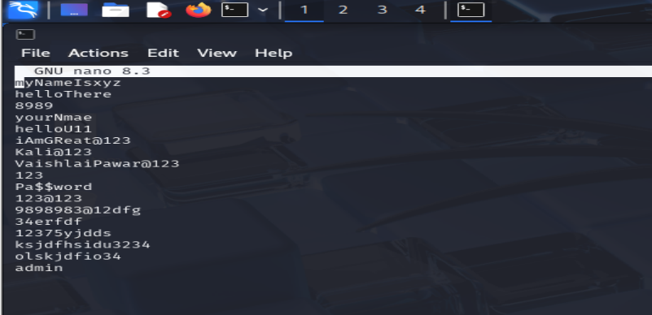

- Verified target systems were accessible via ping and open ports using:
-nmap -sS <target-IP>
Brute-force Attack on Windows (RDP)
Target: Windows Server / Windows 10
Tool Used: Hydra
Command Executed:
- hydra -l Administrator -P rockyou.txt rdp://<target-IP>

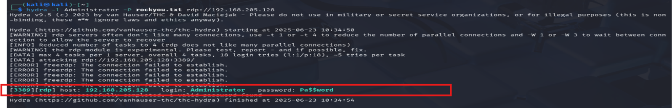

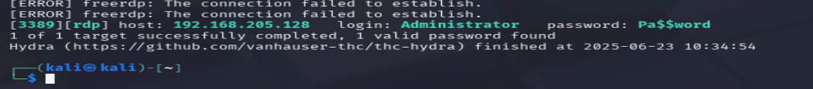
- The attack attempted multiple password combinations for the Administrator account using the provided dictionary.
- On reaching the account lockout threshold (e.g., 5 failed attempts), the system locked the account automatically.
- The lockout event was confirmed by checking Event Viewer on the target:
- Event ID 4625 – Failed login attempts
- Event ID 4740 – Account lockout

Observations
- Repeated failed attempts resulted in automatic account lockout as configured.
- IP addresses of the attacker were visible in both Linux and Windows logs.
- Logs helped identify the brute-force pattern and verify the effectiveness of lockout policy.

5.LOG ANALYSIS

This section provides analysis of the Windows Event Viewer logs and the behavior of the system during and after the brute-force attack executed from Kali Linux using Hydra. The target was a Windows Server/Windows 10 machine running RDP on port 3389, and the attack simulated login attempts to the Administrator account using the rockyou.txt password list.

5.1.1 Event Viewer Navigation
To analyze the results of the brute-force attack on Windows, we used Event Viewer to trace login activity:
- Steps:
- Go to event viewer → press Enter.
- Navigate to:
Windows Logs → Security
- Filter logs using Event IDs to identify relevant events.
- Review timestamps and usernames associated with logon attempts.
- Purpose: To identify failed/successful login attempts, account lockouts, and any privilege escalations during the attack.

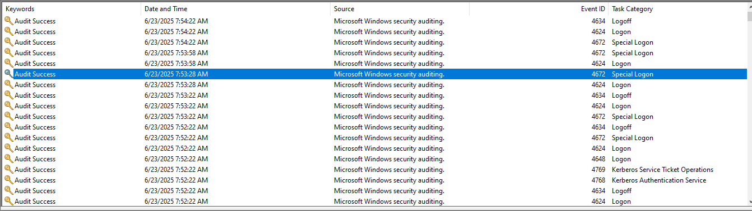

5.1.2 KEY EVENT ID’S

Event ID | Name | Description
4624 | Logon | Successful user login
4625 | Failed Logon | Unsuccessful login attempt (brute-force indicator)
4634 | Logoff | Session ended/logged off
4648 | Logon with Credentials | Login using explicit credentials
4672 | Special Logon | High-privilege logon (e.g., Administrator)
4740 | Account Lockout | Account locked after failed attempts (lockout event)
4768 | Kerberos Auth Request | Login request using Kerberos authentication
4769 | Kerberos Service Ticket | Ticket granted to access a service (e.g., RDP)

5.1.3 PATTERN OBSERVATION

From the brute-force attack simulation using Hydra on port 3389 (RDP):

- Login Activity:
- Repeated Event ID 4625: Brute-force attempts with invalid passwords.
- Followed by Event ID 4624: Successful login using correct credentials.
- Accompanied by 4672: Confirms administrative-level login.
- 4634: Indicates session logoff after testing.
- 4648 and 4768/4769: Show use of credentials and Kerberos-based logon flow.

5.2 ACCOUNT LOCKOUT RESPONSE IMPLEMENTATION

Windows Server:
- Configured via Group Policy:
- Path:
Group Policy Editor → Computer Configuration → Windows Settings → Security Settings → Account Policies → Account Lockout Policy

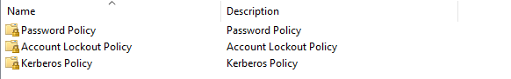

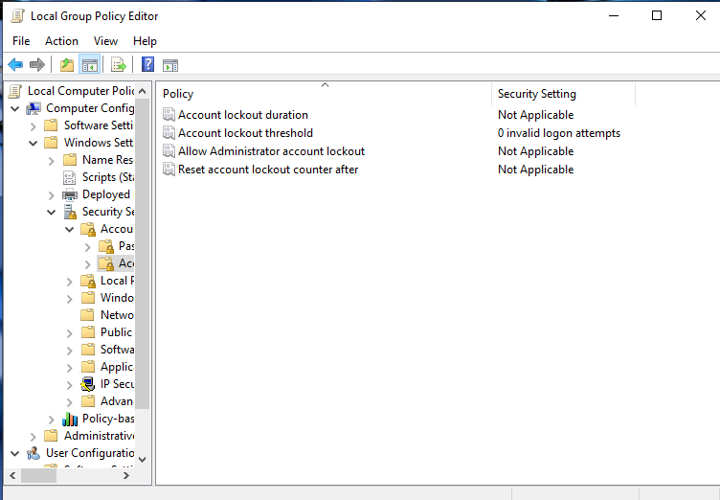

- Settings:
- Account Lockout Threshold: 5 invalid attempts
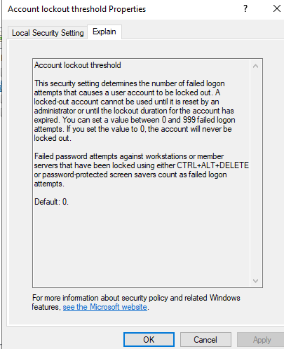
- Lockout Duration: 15 minutes
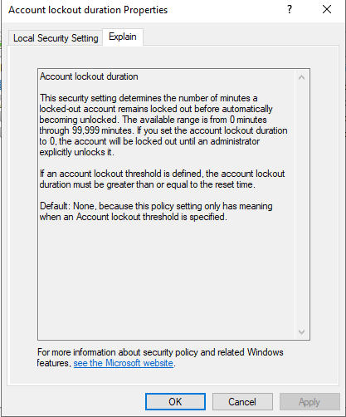

- Reset Counter After: 15 minutes
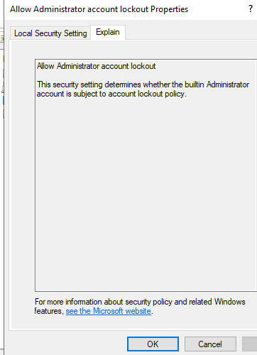

6. INCIDENT RESPONSE PLAN

This section outlines the step-by-step response process followed after detecting brute-force attacks on the Linux and Windows systems. The goal was to detect, contain, eradicate, and recover from the simulated attack, while also improving system resilience.

6.1 Identification
- Log Monitoring:

- Linux: /var/log/auth.log showed repeated SSH login failures.
- Windows: Event Viewer (Security Logs) showed multiple 4625 (Failed Logon) and 4624 (Successful Logon) events.

- Indicators of Compromise (IOCs):
- Multiple failed attempts from the same IP.
- Use of administrator accounts.
- Brute-force pattern detected through time-stamped log entries.

6.2 Containment
- Network Isolation:
- Blocked the attacker's IP on both Linux and Windows firewall using:
- Linux: iptables or ufw
- Windows: Inbound rule to deny IP
- Account Lockout:
- Automatically triggered based on lockout threshold (if configured).
- Manual lockout or disablement applied in case auto-lockout failed.

6.3 Eradication
- Attack Source Shutdown:
- Terminated attack from Kali Linux after identification.
- Account Actions:
- Reset passwords for compromised accounts (e.g., Administrator).
- Audited user accounts to ensure no unauthorized changes occurred.

6.4 Recovery
- System Review:
- Verified integrity of system files and configurations.
- Restored normal access to locked accounts after proper validation.
- Service Restoration:
- RDP services restarted under stricter policy rules.

6.5 Lessons Learned & Improvements
- Enabled/Verified Account Lockout Policies:
- Set lockout threshold and duration for future protection.

- Implemented Stronger Authentication:
- Enforced complex passwords and minimum password age.

- Monitoring Setup:
- Enabled continuous log monitoring and alerting for brute-force patterns.
- Policy Enforcement:
- Drafted and implemented formal password, account lockout, and remote access policies.

7. MITIGATION MEASURES

To strengthen system security and prevent future brute-force attacks, the following mitigation strategies were implemented across both Linux and Windows environments:

7.1 Account Lockout Policy
- Windows:
- Configured via Group Policy:
- Threshold: 5 failed login attempts
- Lockout Duration: 15 minutes
- Reset Counter After: 15 minutes

- Prevents attackers from trying unlimited password combinations.

7.2 Strong Password Policies
- Enforced minimum password complexity:
- Minimum length: 8–12 characters
- Must include uppercase, lowercase, number, and special character
- Restricted use of common or dictionary passwords (e.g., from rockyou.txt)
- Implemented periodic password expiration and history settings

7.3 Network Access Controls
- Firewall Configuration:
- Allowed access only from specific IP ranges
- Blocked suspicious or unused ports (except required services like SSH/RDP)

7.4 Log Monitoring & Alerts
- continuous log monitoring:
Windows: Event Viewer → Security Logs
- Set up alerts for excessive login failures and Event ID 4625/4740 patterns

7.5 Intrusion Detection/Prevention (IDS/IPS)
- Snort/Suricata: to detect brute-force signatures and network anomalies

8. ROOT CAUSE ANALYSIS
This section analyzes the sequence of events, vulnerabilities exploited, system behavior, and the effectiveness of the response during the brute-force attack simulation. The goal is to identify the root causes that allowed the simulated attack to succeed and determine how they can be addressed.

Vulnerabilities Exploited
- Weak/Guessable Passwords:
The Administrator account was secured with a simple password ("Password"), which was found in the rockyou.txt list.

- Lack of Account Lockout (Initial):
Systems initially lacked or had ineffective lockout thresholds, allowing Hydra to attempt numerous password guesses.

- Unrestricted Remote Access:
Remote services like RDP and SSH were exposed without IP-based restrictions or multi-factor authentication.
Log Indicators
- Windows Logs:
- Repeated 4625 entries (failed logons)
- 4624 indicating a successful logon
- 4672 confirming high-privilege access
- Absence of 4740 at first suggested account lockout policy was misconfigured

Failure Points Identified
- Default administrator account was enabled and accessible remotely
- No rate limiting or alerting was in place to detect brute-force attempts early
- Password complexity was not enforced, enabling dictionary attack success
- Systems did not initially trigger lockouts at the appropriate thresholds

Effectiveness of Response
- Attack was successfully simulated and logged on both systems
- Once lockout policies were enforced:
- Password reset and IP block measures were applied effectively
- System access was restored after proper recovery step

- Prevention is better than detection. Strong password policies and account lockout settings must be active by default.

9. SUMMARY OF FINDINGS
- Brute-force attacks on RDP (Windows) were successfully simulated using Hydra.
- Valid credentials (Administrator : Password) were cracked from the rockyou.txt list.
- Event logs (Windows: 4625, 4624, 4672; Linux: /var/log/auth.log) confirmed attack patterns
- Initial lack of account lockout allowed brute-force success; after configuration, lockout policies worked as intended.
- Incident response actions (IP block, password reset, account recovery) were executed effectively.
- Stronger security policies and monitoring were implemented post-attack.

10. RECOMMENDATION & CONCLUSION

- Recommendations
- Enforce Strong Password Policies: Use complex passwords with length and character diversity to resist brute-force attacks.
- Implement Account Lockout Policies: Lock accounts after multiple failed attempts to block automated guessing.
- Continuous Log Monitoring: Regularly review system logs for login anomalies using tools or scripts.
- Enable Alerting: Configure alerts for multiple failed login attempts or unusual login times.
- Use Intrusion Prevention Tools: Tools like Fail2Ban (Linux) or advanced firewalls can block brute-force attempts in real time.

- Conclusion
The project successfully demonstrated how brute-force attacks can compromise weakly secured systems. By simulating attacks on Linux and Windows, analyzing logs, and applying lockout responses, we gained hands-on experience in identifying and mitigating authentication threats. Proper implementation of security policies, account lockout mechanisms, and proactive monitoring are essential to protect systems from unauthorized access.

11. REFERENCES

Hydra Tool – THC Hydra GitHub
https://github.com/vanhauser-thc/thc-hydra

Windows Account Lockout Policy Configuration
https://learn.microsoft.com/en-us/windows/security/threat-protection/security-policy-settings/account-lockout-policy

RockYou Password List Information
https://wiki.skullsecurity.org/RockYou

Remote Desktop Protocol (RDP) Port 3389 Usage
https://learn.microsoft.com/en-us/windows-server/remote/remote-desktop-services/clients/remote-desktop-client-faq

Nmap Port Scanning Tool
https://nmap.org/

VAISHALI PAWAR
28802

