SCREENSHOTS:
ORIGINAL IMAGE:
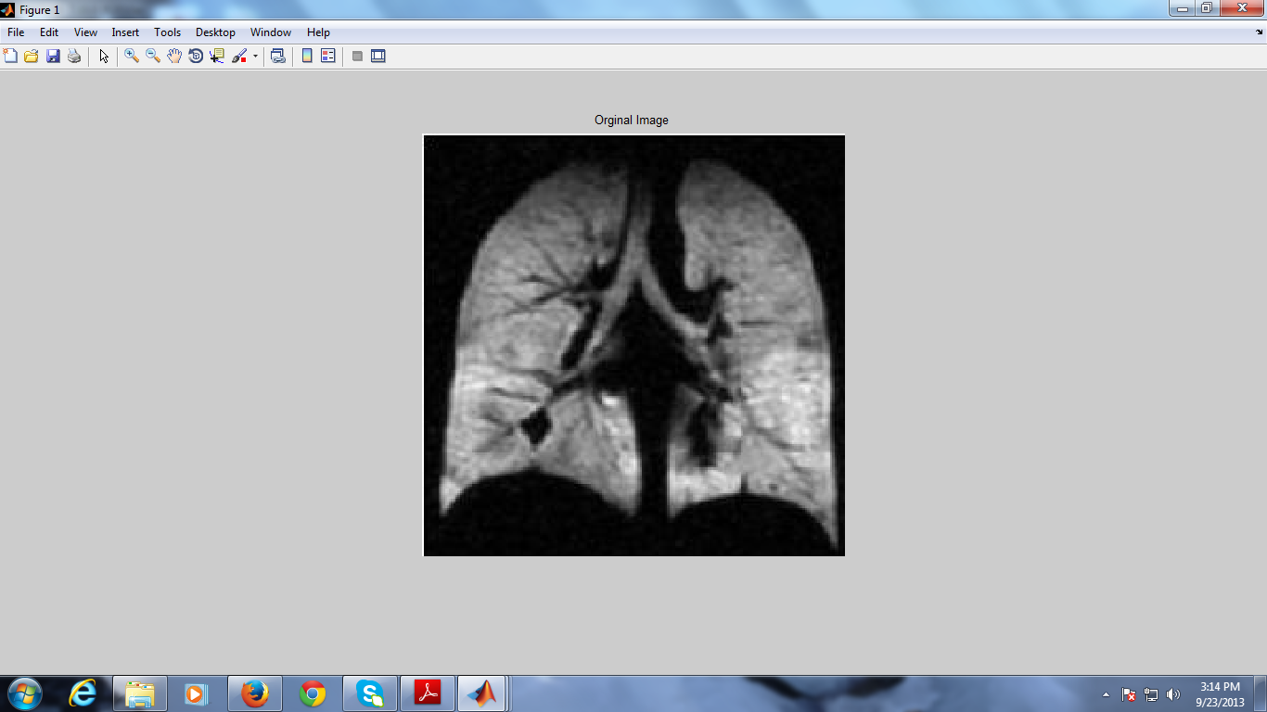
BACKGROUND IMAGE:
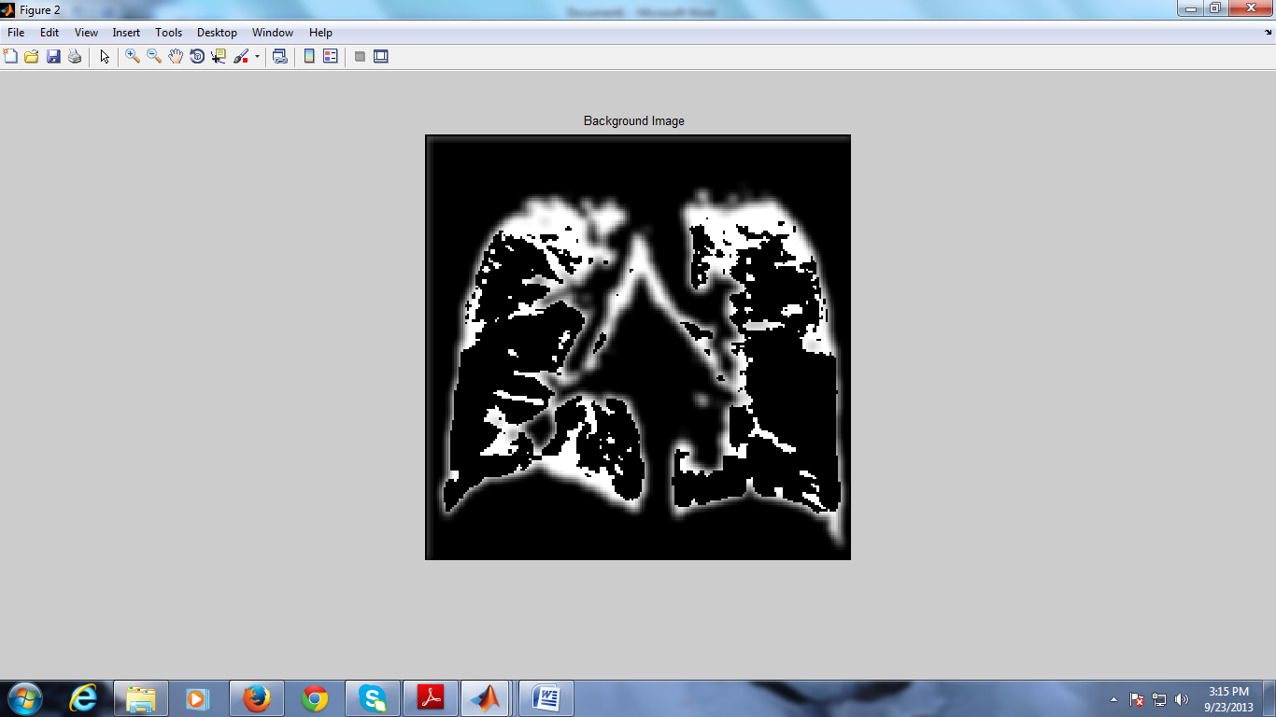

FOREGROUND IMAGE:
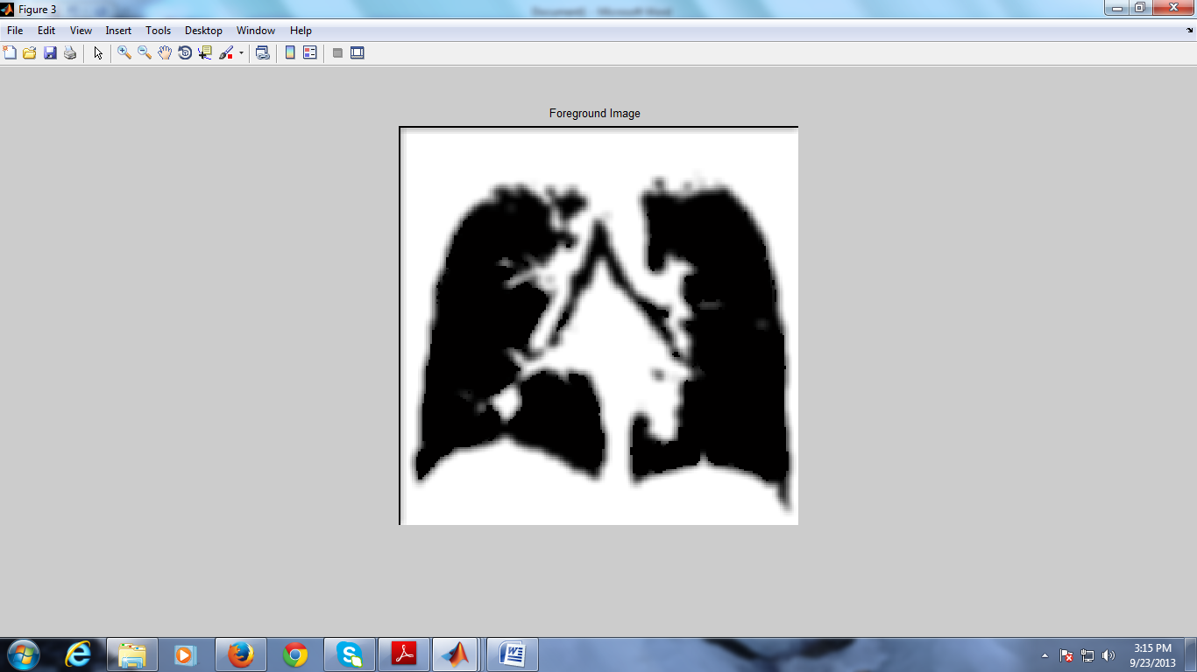
ERODED IMAGE:
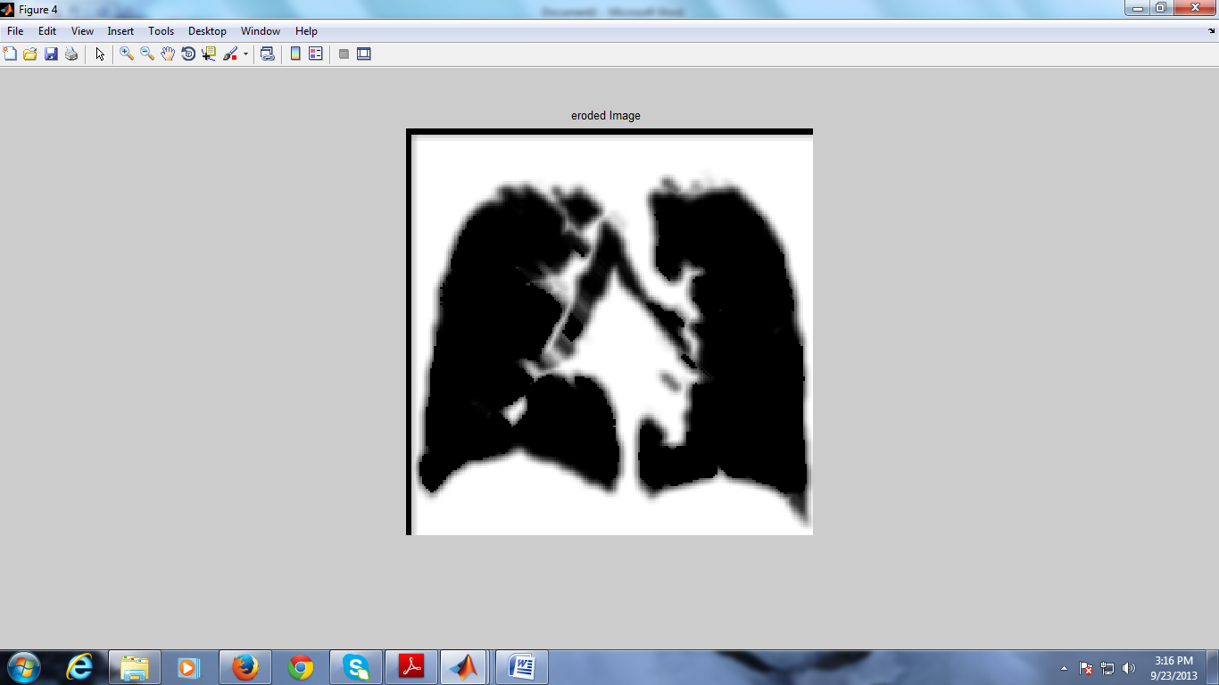

DILATED IMAGE:
