- LITERATURE SERVEY
2.1. History
The earliest forms of information hiding can actually be considered to be highly crude forms of private-key cryptography; the “key” in this case being the knowledge of the method being employed that is referred as security through obscurity. Stegnography books are filled with examples of such methods used throughout history. Greek messengers had messages tattooed into their shave head, concealing the message when their hair finally grew back. Wax tables were scraped down to bare wood were a message was scratched. Once the tablets were re-waxed, the hidden message was secure. Over time these primitive cryptographic techniques improved, increasing speed, capacity and security of the transmitted message.
Images and videos with poor contrast may not reveal all the details in the captured scene, and may have a washed-out and unnatural look. Contrast enhancement targets to eliminate such problems. Obtain a more visually-pleasing or informative image or both. Indirect methods can further be divided into several subgroups:
- Techniques that decompose an image into high and low frequency signals for manipulation, e.g., homomorphic filtering,
- Histogram modification techniques, and
- Transform-based techniques.
Among these second one has most attention since its straightforward and intuitive implementation quality. Also the computing power is less than other one. Contrast enhancement techniques in the second subgroup modify the image through some pixel mapping such that the histogram of the processed image is more spread than that of the original image. Techniques in this subgroup either enhance the contrast globally or locally. If a single mapping derived from the image is used then it is a global method; if the neighborhood of each pixel is used to obtain a local mapping function then
It is a local method. Using a single global mapping cannot enhance the local contrast.
Image Watermarking is the technique of embedding of owner copyright identification with the host image. When and how watermarking is used first is the topic of discussion but it can be used at Bologna, Italy in 1282 at first it is used in paper mills as paper mark of company. Then it is common in practice up to 20th century. After that, watermark also used in the postage stamp and currency notes of any country.
Digital image watermarking is actually derive from stegnography, a process in which digital content is hide with the other content for secure transmission of digital data. In particular conditions stegnography and watermarking are very similar when the data to be secure is hidden in process of transmission over some carrier. The main difference between these two processes is in stegnography the hidden data is on highest priority for sender and receiver but in watermarking both source image and hidden image, signature or data is on highest priority.
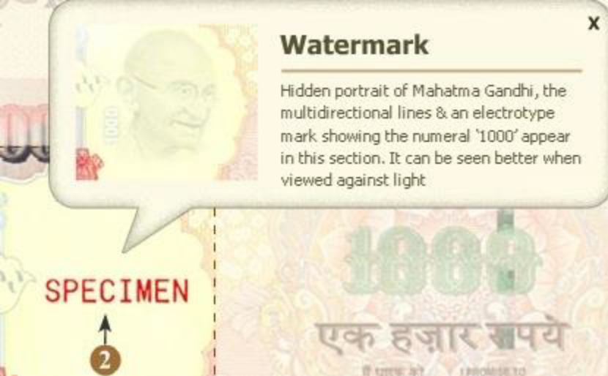

Figure2.1: Example of watermark on Indian currency [3].

Various methods are developed for the reversible data hiding. Step by step methods are as follows:

2.1.1 Regular Singular Method
Early attempts at reversible data hiding used modulo-256 addition to solve both issues to achieve reversibility. Modulo-256, however, causes salt-and-pepper noise, which is not ideal for most of applications. Lossless compression of bit-planes was then used with limited embedding rate. A regular-singular (RS) method was developed and has achieved relatively high embedding rate [4].

2.1.2 Difference Expansion Method
[5]This difference expansion method significantly advanced the performance of reversible data hiding in terms of embedding rate versus visual quality of marked image (PSNR). This method uses a location map to address both collision and overflow issues. In this method, several reversible data hiding schemes using location maps to achieve reversibility with improved performance.

2.1.3 Histogram Shifting
Different methods have been developed using histogram modification. Specifically, one method was developed for addressing overflow using histogram shrinking towards the center [6]. Another method was developed for addressing collision by histogram shifting. This method involves selecting or creating a zero point immediately nearby a peak point in the histogram of a given cover image to embed data reversibly by shifting the whole portion of histogram towards right or left by one unit to avoid collision[7].

2.1.4 Histogram Shrinking
A further advance combined the above two methods, i.e., histogram shrinking to avoid overflow and histogram shifting to avoid collision [8]. Various improved schemes have followed this strategy. Instead of always applying histogram shrinking for various images and providing equal amount of histogram shrinkage at both right and left ends, histogram shrinking becomes adaptive. That is, histogram shrinking is not done unless overflow/underflow is detected. As a result, histogram shrinking does not happen for many images as the embedding rate is not very high, and the amount of shrinkage at the two ends, if happening, may not be the same. Instead of choosing a threshold T, then shifting all the portion of histogram h(x) as |x|>T, a new concept of histogram pair is established. Histogram pair is defined as two horizontally immediately neighboring points in histogram such that [h(x)≠0, h(x+1)=0] for x>0 or [h(x−1)=0,h(x)·0] for x<0. Once a histogram pair is found or created, we can embed data at x. In this way, histogram shifting in data embedding is more flexible. In addition, the embedding points will be within |S|≦|x|≦T (instead of |x|≦T), where S is called as a stop point, and −T≦S≦T. It has been demonstrated that the optimal value of T with respect to the best performance in terms of pure embedding rate versus PSNR of marked image can be searched computationally[9],[10]. Furthermore, the histogram shrinking can now be executed as an inverse process of histogram pair based data embedding process. That is, after the data embedding histogram become more flat, while after histogram shrinking, the histogram becomes steeper.

2.2. Related Work
In the existing system, data hiding is performed on gray level images. Here, data are embedded into bins with the highest two pixel values in the histogram of the image. In order to extract data from the image these two pixel values are required. Therefore for memorizing the positions of highest two bins, last 16 bits of the image are excluded from histogram computing. With this method the amount of data that can be hidden is too small. Hence a new method is proposed for increasing both data hiding rate as well as size of data that can be embedded.
Number of research papers has appeared in this area. Some digital image watermarking techniques for color images are [11]:

2.2.1 Multichannel Digital Watermarking of Color Images using SVD
An invisible Watermark Scheme for color images using Singular Vector Domain. The singular vector domain based watermarking scheme demonstrates that it gives reasonably satisfactory results for color image watermarking without affecting its perceptual quality and robustness of the watermark, by balancing between the two factors robustness and invisibility by using appropriate scaling factor. In this approach, same or different watermarks can be embedded into the three color channels (R, G, B) of the host image in order to increase the robustness of the watermark. The main feature of the scheme is to use all channels of RGB color space to embed watermarks. It has been embedding maximum amount of watermark and also make it more secure. It can be used for a variety of applications since one can perform single channel embedding to multichannel embedding.

2.2.2 Multiple Spatial Watermarking Techniques in Color Images
This technique proposed a novel multiple spatial watermarking techniques in color images based on embedding four identical watermarks into the blue component of host image. The host image is divided into four regions in order to embed multiple watermarks; only one watermark is detected or constructed from the five extracted watermarks according to the highest value of normalized cross correlation (NCC). The proposed scheme is robust for several attacking operations including median filter, JPEG2000, JPEG-loss compression, image cropping, image scaling, rotation, rotation-scaling, rotation cropping.

2.2.3 Digital Watermarking of Color Images in the Singular Domain
The algorithm is based on the well-known matrix factorization technique of the singular vector decomposition. This is achieved by using the fact that a color image can be broken into the RGB channels. These channels are then treated separately as matrices on which the matrix factorization is applied. These matrices are then used to present the embedding and extraction algorithms. This manuscript has appropriately shown that the SVD based watermarking technique presented in it is quite good for rectangular color images of an arbitrary size.

2.2.4 A Digital Watermarking Algorithm for Color Images Based on DCT
A digital watermarking algorithm based on the DCT domain is proposed to embed a true color watermarking image into the host color image for the purpose of protecting the copyrights of digital products. Before embedding the watermarking, the coordinates of R, G, and B components of the watermarking image are scrambled first by using the chaotic sequence, which will bring in good security to the watermarking. Using some characteristics of HVS, watermarking with different strength is embedded into the different regions of a host image, balancing the robustness and imperceptions of watermarking simultaneously.

2.2.5 Digital Watermarking in Singular Vector Domain
An algorithm for digital watermarking using singular value decomposition is resented in the domain of the singular vectors of the image matrices. They have implemented method for gray and color images and shown that the technique is robust against noise, cropping and JPEG compression. The advantage of algorithm, as opposed to other SVD based techniques, lies in the fact that most of the previous methods rely on the singular values of the image matrix; thereby the information content of an n×n image was translated into just n values. In this approach, the scaled singular vectors are used to encode the watermark. The technique also inherently contains a level of security against the hacking of the watermark. The algorithm presented in the manuscript is not closed. `In fact there can be certain modification to the algorithm such that various other aspects can be included.
For example, one can decrease the computational time of embedding and extracting the watermarks by a segmentation of the image. Then the algorithm can be applied to these various segments individually. Apart from this the embedded image can be encrypted thereby enhancing the security of the image content.

2.2.6 Single Channel Watermarking For Video Using Block Based SVD
This technique presents a digital watermarking scheme for color media using block based SVD approach. The proposed algorithm for watermarking handles the problem of false positive detection and can be used for color videos. Watermarking using SVD can be done more efficiently if watermark is embedded in the blue component of the host frame of the video, instead of embedding it in the frame without separating the color component. In this scheme the efficiency of watermarking in terms of MSE and PSNR values and payload is improved by embedding the watermark image in the blue component from the[R,G,B] panel of the video frames. The constraint on size of watermark is removed as bigger watermarks can be embedded in color images using block based approach as compared to the approach of embedding the watermark diagonally in S matrix of the SVD of the host frame. Also more watermark information can be added in the green and red channel of the host image. This algorithm can thus be used for digital watermarking in applications like fingerprinting, copy control, broadcast monitoring, video authentication and copyright protection.

2.2.7 A Reliable SVD based Watermarking Scheme
In this technique singular value based watermarking scheme is used, where they embed the principal components of the watermark in the original image rather than just the singular values. The fact that the principal components have been added to the singular values of original image achieves two useful purposes. Firstly, the information about the entire watermark is not available without a prior knowledge of the original watermark. This is of significance for the security of the watermark. Secondly, the method avoids the pitfall encountered by Liu and Tan, where the watermark was modified only along the diagonals, leading to the extraction of a reference watermark that is being searched using an arbitrary image. Hence, this method utilizes the property of SVD based watermarking algorithms and ensures rightful ownership of the digital watermark image.
Following table shows comparison of different watermarking algorithms [12].

Table 2.1: Comparison of Watermarking Techniques and Their Performances

Year | Author | Title | Methodology | Performance
2010 | Naderahmadian. Y.; Hosseini-Khayat. S | Fast Watermarking Based on QR Decomposition in Wavelet Domain | QR code image by means of wavelet transform | Robustness to Attacks, Visible Copyright Protection and Authentication Tool
2011 | Nan Lin; Jianjing Shen; Xiaofeng Guo; Jun Zhou | A robust image watermarking based on DWT-QR Decomposition | DWT and QR decomposition | Robustness, Invisibility and Higher Embedding Capacity
2012 | Qing Liu,Jun Ying | Grayscale Image Digital watermarking Technology Based on Wavelet Analysis | DWT, Spread Spectrum Technology | Increased Complexity of Method, Extraction Is Not Good Enough
2012 | Zhaoshan Wang, Shanxiang Lv,Yan Shna | A Digital Image Watermarking Algorithm Based on Chaos and Fresnel Transform | Fresnel diffraction plane, Chaotic scrambling | Provide Both Good Robustness and Security
2013 | Jithin V M, K K Gupta | Robust invisible QR code image watermarking in DWT domain | QR Codes, It can be scanned by using the QR code scanner easily | More Robust Than Previous Techniques
2.3. Requirement Analysis
The rapid growth of the Internet facilitates data sharing among people. The Internet provides abundance of data that is necessary to modern life, and accessing the Internet has become part of many people’s daily life. However, the Internet is public, open, and important to many people. Many security problems may occur at any time, and they are becoming more critical than ever. The major problem of publicity and openness is that malicious people can attack or steal personal data easily, even though the victims may put many efforts on privacy protection. It has been reported that hackers’ attacks are becoming more common and fiercer. This phenomenon drives the demands for better data and communication protection mechanisms. Data hiding is one possible way to achieve better data and communication protection by hiding information into a media carrier to form a media file or an unrecognizable code stream. For example, a data-hiding method may create an image with undetectable secret data (a stego-image), or a byte array with embedded secret data (a code stream). Stegnography, watermarking, and cryptography are the major applications in image data hiding. Stegnography and watermarking use cover multimedia to conceal the secret data, while cryptography encrypts the data into cipher text. Although stegnography and watermarking are similar in some aspects, they focus on different application domains—stegnography applications provide secret communication and focus on the issues of undetectability and capacity of the embedded data; watermarking applications provide copyright protection and focus on the issues of robustness of the embedded data.
The huge development of new technologies and the vision of more and more sophisticated open communication system create a new challenge to protect digital content from piracy. Digital watermarking is a research axis and a new technique suggested as a solution to these problems. This technique consists of inserting identification information (watermark) into digital data (audio, video, image, databases...) in an invisible and indelible manner and in such a way not to degrade original medium's quality. Moreover, we must be able to correctly extract the watermark despite the deterioration of the watermarked medium (i.e. attacks).
Traditional watermarking techniques often sacrifice an imperceptible amount of host data for robustness. However, in some applications such as medical imagery, remote sensing, and law enforcement, any permanent distortion introduced by watermarking is not acceptable. The embedded watermark is required to be reversible (i.e., invertible or erasable) so that the original image is able to be losslessly restored. So far, reversible watermarking is mainly proposed for authentication or data integrity verification. In this study, however, we extend its application to visible watermarking. Basically, a reversible watermark is much more than content authentication. It has an additional advantage that, when watermarked content has been detected to be authentic, one can remove the watermark to retrieve the original, unwatermarked content.
Remotely sensed satellite images are an important source of geographical data commonly used as input for various types of classification algorithms. For example, these algorithms are commonly used to classify earth land cover, analyze crop conditions, assess mineral and petroleum deposits, and quantify urban growth. Many vendors of digital images are using or are considering the use of invisible watermarking as a means of protecting their images from theft or unauthorized usage. Indeed, the use of invisible watermarking is routinely considered for use in emerging digital rights management systems that may be deployed to manage and protect the rights associated with satellite imagery, or types of "scientific" imagery (e.g., in the medical field) that routinely have mathematical analyses applied to them. The concern then is how this watermarking impacts subsequent analyses. Specifically, the invisible watermarking process involves making imperceptible modifications to the pixel values of an image. However, even though these changes may be imperceptible to the human observer, they must be of sufficient magnitude to allow for watermark detection.
The possibility of adding several watermarks to the same image would enable many interesting applications such as authentication, confidentiality, data usage monitoring, and multiple property management.
Today, crypto-graphical techniques have reached a level of sophistication such that properly encrypted communications can be assumed secure well beyond the useful life of the information transmitted. In fact, it’s projected that the most powerful algorithms using multi kilobit key lengths could not be comprised through brute force, even if all the computing power worldwide for the next 20 years was focused on the attack. Of course the possibility exists that vulnerabilities could be found, or computing power breakthroughs could occur, but for most users in most applications, current cryptographic techniques are generally sufficient.
Why then pursue the field of information hiding? Several good reasons exist, the first being that “security through obscurity” isn’t necessarily a bad thing, provided that it isn’t the only security mechanism employed. Stegnography for instance allows us to hide encrypted messages in mediums less likely to attract attention. A garble of random characters being transmitted between two users may tip off a watchful 3rd party that sensitive information is being transmitted; whereas baby pictures with some additional noise present may not. The underlying information in the pictures is still encrypted, but attracts far less attention being distributed in the picture then it would otherwise.
This becomes particularly important as the technological disparity between individuals and organizations grows. Governments and businesses typically have access to more powerful systems and better encryption algorithms then individuals. Hence, the chance of individual’s messages being broken increases with each passing year. Reducing the number of messages intercepted by the organizations as suspect will certainly help to improve privacy.
Another advantage is that information hiding can fundamentally change the way that we think about information security. Cryptographic techniques generally rely on the metaphor of a piece of information being placed in a secure “box” and locked with a “key”. The information itself is not disturbed and anyone with the proper key can gain access. Once the box is open, all of the information security is lost. Compare this to information hiding techniques where the key is embedded into the information itself.
This difference can be better illustrated by current DVD encryption methods. The CSS algorithm takes digitally encoded video and wraps it in an encrypted container. When the DVD player provides the proper key, the video is decrypted and played. Once the video has been decrypted even once, it becomes trivial to trans-code the content and distributes it with no mark of the original author present. Compare this approach to that of an ideal watermark, where despite encryption the watermark remains with the video despite various alteration and trans-coding attempts. With this the need for a combination of the two approaches becomes clear.
- SYSTEM DEVELOPMENT
  - Specifications
Front End : MatLab Editor
Language Used : Matlab
Database : Standard test images (color images) of size 512×512 will be taken from USC_SIPI image database (http://sipi.usc.edu/database/).

  - Modules
There will be following modules in the implementation
- User Login
- Preprocessing
- Histogram calculation
- Embedding
- Extraction and Recovery

    - User Login Module
In this module user login form and the interaction to the embedding and extraction module will be there. After successful login only the user will be able to have access to private satellite images.

    - Preprocessing Module
In it preprocessing of the selected images will be done to avoid overflow and underflow as well as the location map of image is created to memorize the modified image pixels.

    - Histogram Calculation Module
In it histogram of color image is calculated on pixel values. 3 channel histogram will be generated and it will be used for the data embedding. Histogram is calculated excluding 16 pixels of last row. These pixels will be used for the extra data storage.

    - Embedding Module
This module actually watermark image using the specified watermark provided by user. Data embedding is performing first on red channel then blue and then green. Embedding process will be done only on the highest bin values pixels. Before message bit location map is embedded then secret message and then the all peak values used sequentially. Data is embedded in the least significant bit of the pixel.

    - Extraction and Recovery Module
In it the image watermark is extracted and the image recovery performed using the equations 3.2 and 3.3. Original image will be output image.

  - Algorithm
    - Pre-processing
Location map is generated to prevent the unnecessary underflow and overflow. Location map generated by taking all the pixels of value 0 and 256 in to another same image of same size and all other pixels are taken as zero. And all the pixels with value 0 in the original image are increased by one and all the pixels with value 255 are decreased by one. And two pixel values which are appeared most of the times are selected for data embedding.

3.3.2 Secret Message Embedding
Embedding is done on only some specific pixels. Highest two bins (highest two pixels which are appeared most of the time) in the histogram are selected for the data embedding. In between this two selected pixel values, highest index having pixel is denoted by I_{L} and second highest index having pixel is denoted by I_{R}.

3.3.3 Embedding algorithm
Now binary data are added and subtracted according to algorithm. First of all red component is used. I_{L} and I_{R} are selected as explained above. All pixels present in the image with value I_{L} and I_{R} are added and subtracted respectively with the corresponding binary values of secrete message. All pixels present in the image with value lower than I_{R} are subtracted by corresponding binary one and all pixels with value greater than I_{L} are added by binary one pixels between I_{L} and I_{R} value are not modified they are kept as it is.
Secret message is embedded only on I_{L} and I_{R}, all other modification applied is for contrast enhancement in watermarked image. Once all the I_{L} and I_{R} present in the red component are embedded, rest of secret message bits will be embed in Green component as per the algorithm explained above and then in blue component. Once the all selected pixels of these three components are embedded new modified histogram generated by red component is used for embedding.
New pair of I_{L} and I_{R} is selected in modified histogram and embedding process is repeated. Similarly new modified histogram of green and blue component is also selected for further embedding. This process is repeated until all the binary bit of secret message is embedded. When all secrete message bits are embedded then binary value then all other pairs of I_{L} and I_{R} except last one are converted in to binary and embedded sequentially in to the image, next to the secrete message. Then lastly selected pair of I_{L} and I_{R} are replaced by the LSB of 16 excluded pixels and these LSBs of excluded pixels are embedded next to the all pairs of I_{L} and I_{R}. Embedding algorithm is shown below in equation:
i-1, for i<I_{s}
I_{s}-b_{k}, for i=I_{s}
i’= i , for I_{s} <i<I_{R} ……. (3.1)
I_{R} +b_{k}, for i=I_{R}
i+1, for i>I_{R}
Where,
i’ - Modified histogram graph.
I_{R} - Smaller pixel value selected from two highest bin in histogram.
I_{L} - Larger pixel value selected from two highest bin in histogram.
b_{K} - k^{th}Binary bit to be embedded.

3.3.4 Extraction and recovery process
For extraction and recovery process, first of all the least significant bits of the excluded 16 pixels are extracted and replaced the LSBs of 16 excluded pixels. From these excluded pixels last embedding Pair of I_{L} and I_{R} are determined.

3.3.5 Secret message extraction
Because of all the information bit embedding has been done only on the I_{L} and I_{R} pixels, they are extracted first. Now secret message extraction algorithm has been applied. Every pixels with value I_{L} and I_{R} are contains binary 0’s and pixels which less than I_{L} or I_{R}, contains binary 1’s. All binary values are extracted and arranged according to the inverse process of random permutation. In this way secret data is constructed accordingly.
1, if i’= I_{s} -1
0, if i’=I_{s}
b_{k}’= 0, if i’=I_{R} ………. (3.2)
1, if i’= I_{R} +1
where b_{k}’ is the k-th binary value extracted from the marked image .

3.3.6 Original image recovery
In this process 16 excluded LSBs and all I_{R} and I_{L} has been removed for form watermarked image For the recovery process inverse algorithm of embedding procedure, shown in equation 3.3 below, is applied. All pixels with value I_{R} or one less than I_{R} are constructed as I_{R}. All pixels with value I_{L} or one more than I_{L} are constructed as I_{L}. All pixels with value one less than I_{R} are added by binary one and pixels with value one more than I_{L} are subtracted by one. In this way all modified pixels are recovered back to their original position.
i’+1, for i’<I_{s} -1
I_{s}, for i’=I_{s} or i’=I_{s} -1
i= I_{R} , for i’=I_{R} or i’=I_{R+1} …………. (3.3)
i’-1, for i’>I_{R} +1
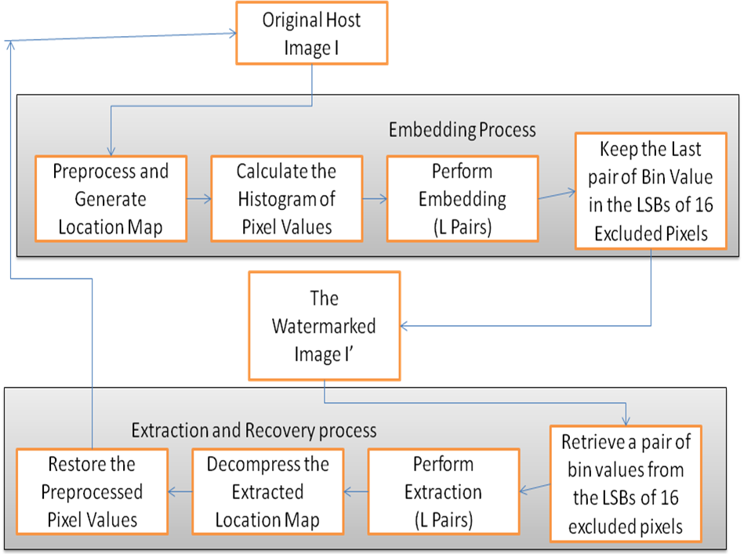
Figure3.1: Procedure of Proposed System

  - Use case diagram

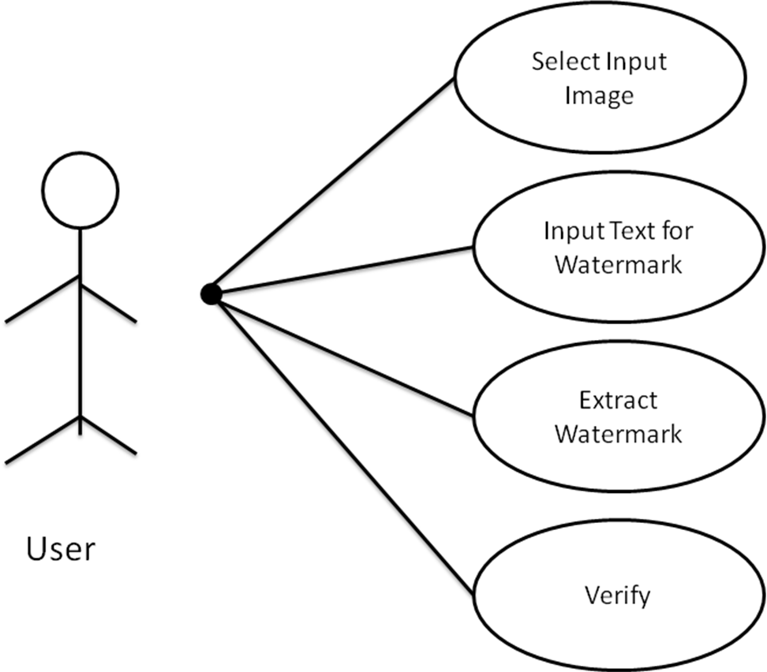
Figure3.2: Use Case Diagram

  - Data Flow Diagram

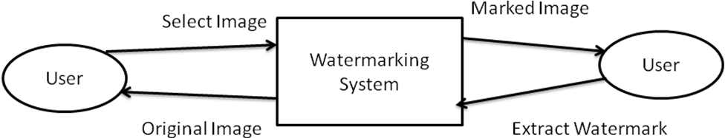
Figure3.3: Data Flow Diagram level 0

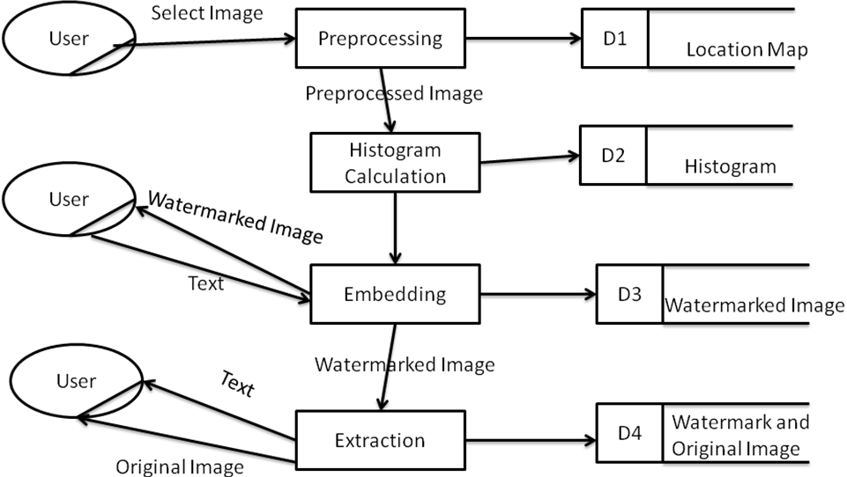

Figure3.4: Data Flow Diagram level 1
  - Architectural Design
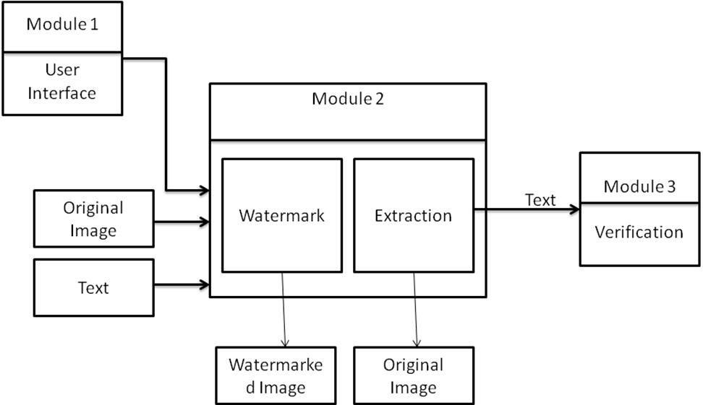
Figure 3.5: Proposed Architecture

  - Sequence Diagram
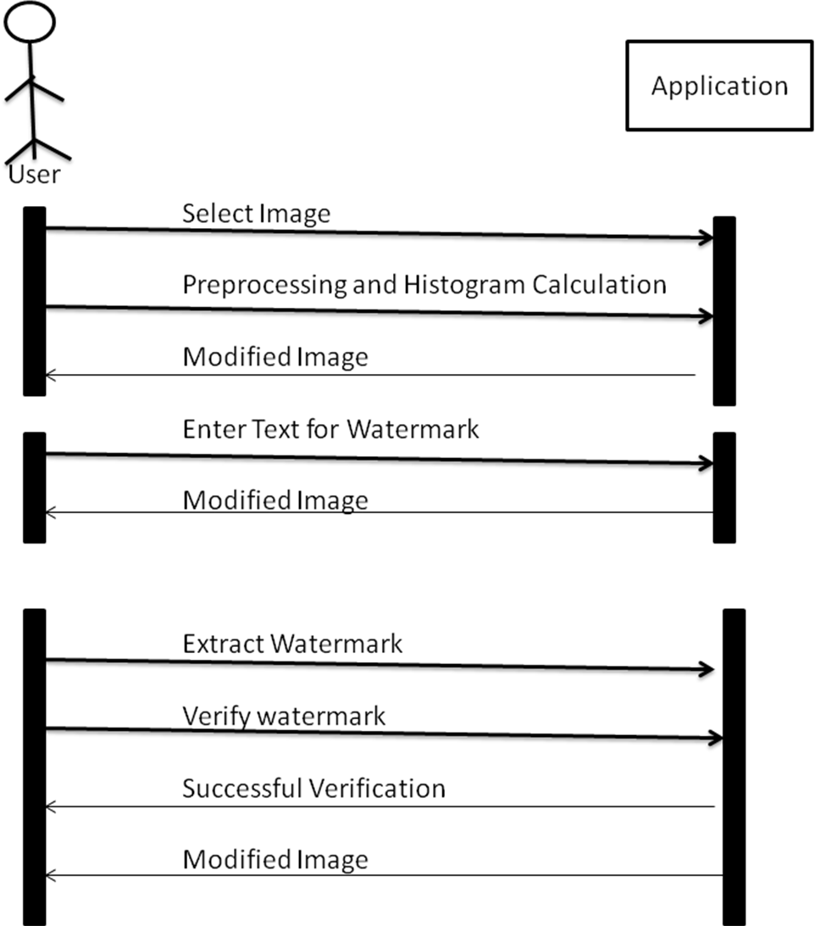
Figure 3.6 Sequence Diagram
  - Activity Diagram
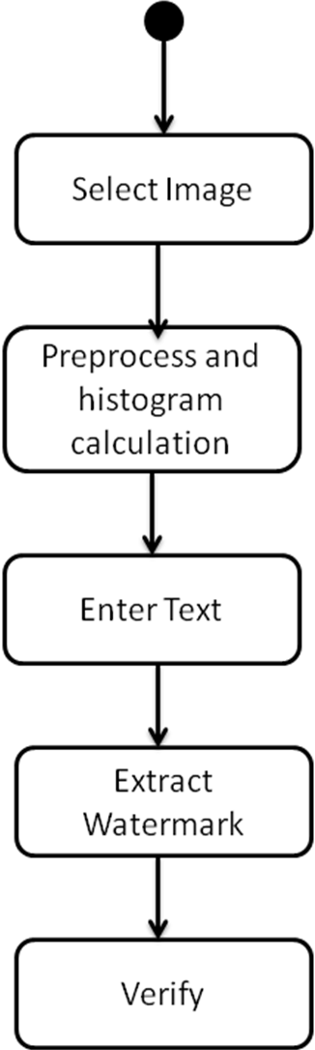

Figure 3.7 Activity Diagram

References

- Yun Q. Shi, “Reversible Data Hiding”, LNCS 3304, pp. 1 – 12, 2005.
- Pranab Kumar Dhar, Mohammad Ibrahim Khan, Sujan Chowdhury, “An Efficient Watermarking system based on error correcting codes in DCT domain”, Department of Computer Science and Engineering, Chittagong University of Engineering and Technology.
- Lalit Kumar Saini, Vishal Shrivastav, “A Survey of Digital Watermarking Techniques and its Applications”, International Journal of Computer Science Trends and Technology (IJCST) – Volume 2 Issue 3, May-Jun 2014.
- Y. Q. Shi, “Reversible data hiding,” International Workshop on Digital Watermarking, Seoul, Korea, October 2004.
- J. Tian, “Reversible data embedding using a difference expansion,” IEEE Transaction on Circuits and Systems for Video Technology, 2003, 13 (8):890-896.
- G. Xuan, J Chen, J Zhu, Y. Q. Shi, Z. Ni, and W. Su, “Distortionless data hiding based on integer wavelet transformation,” IEEE Electronics Letters, vol. 38, No. 25, pp. 1646-1648, December 2002.
- Z. Ni, Y Q. Shi, N. Ansari, and W. Su, “Reversible data hiding,” Proceedings of IEEE International Symposium on Circuits and Systems, vol 2, pp. 912-915, Bangkok, Thailand, May 2003.
- G. Xuan, Y. Q. Shi, C. Yang, Y Zheng, D. Zou, P. Chai, “Lossless data hiding using integer wavelet transform and threshold embedding technique,” IEEE International Conference on Multimedia and Expo (ICME05), Amsterdam, Netherlands, Jul. 6-8, 2005.
- G. Xuan, Y Q. Shi, P. Chai, X Cui, Z. Ni, X Tong, “Optimum histogram pair based image lossless data embedding”, International Workshop on Digital Watermarking (IWDW07), 3-5 Dec. 2007, Guangzhou, China;
- G. Xuan, Y Q. Shi, Z. Ni, P. Chai, X Cui, and X Tong, “Reversible data hiding for JPEG images based on histogram pairs”, International Conference on Image Analysis and Recognition (ICIAR07), Aug. 22-24, 2007, Montreal, Canada.
- Piyush.V.Gattani, Dr.C.S.Warnekar, “Digital watermarking of Color Images” , International Journal of Advanced Research in Computer and Communication Engineering, Vol. 2, Issue 12, December 2013.
- Vinita Gupta, Atul Barve, “A Review on Image Watermarking and its Techniques”, International Journal of Advanced Research in Computer Science and Software Engineering, Volume 4, Issue 1, January 2014

ACKNOWLEDGEMENT
I would like to place on record my deep sense of gratitude to Prof. S. B. Kalyankar, HOD-Dept. of Computer Science and Engineering, Deogiri Institute of Engineering and management Studies Aurangabad, for his generous guidance, help and useful suggestions.
I express my sincere gratitude to Dr. Khan Rahat Afreen , Dept. of Computer Science and Engineering, Deogiri Institute of Engineering and management Studies Aurangabad, for his stimulating guidance, continuous encouragement and supervision throughout the course of present work.
I am extremely thankful to Dr. Ulhas Shiurkar, Director, Deogiri Institute of Engineering and management Studies Aurangabad, for providing me infrastructural facilities to work in, without which this work would not have been possible.

Ashwini G. Deshmane

