Taskflow Task Management and Activity Dashboard
Web Engineering and Frontend Development
Assignment 01 | Section B | CLO1 and CLO2
28 October 2026

Project overview
Taskflow is a React single-page application for organizing tasks and reviewing recent activity. Functional components manage the task workflow, while a class component records operations using lifecycle methods. The application demonstrates reusable components, props, JSX expressions, synthetic events and the required React Hooks.
GitHub repository
https://github.com/vaais251/Os-assignnment
GitHub Pages entry point
https://vaais251.github.io/Os-assignnment/
Published address shown by GitHub Pages
http://vaais.me/Os-assignnment/

Application capabilities
- Create tasks with a title, description, priority, category and optional due date.
- Change status, complete or reopen tasks, and remove tasks.
- Combine text search with status and priority filters.
- View task totals, completion progress, activity history and notifications.
- Switch between light and dark themes and restore data after reloading.

Technology and storage
The implementation uses React, Vite, Lucide React and responsive CSS. Tasks, theme preferences and activity logs are stored in browser localStorage. There is no backend, account system or cross-device synchronization. The first launch includes four demonstration tasks; an empty saved task list remains empty.

Component architecture and lifecycle
App owns the task collection and filter state. It passes data and callbacks to the task components. ThemeProvider supplies a shared theme through context. ActivityLogger owns its separate log and notification state.
Concept | Implementation evidence
TaskForm | Controlled functional component for task input. onAdd sends validated data to App. useRef returns focus to the title field after submission.
TaskList and TaskCard | TaskList renders filtered tasks with map and stable IDs. TaskCard receives a task and callback props for deletion and status updates. React.memo skips unchanged cards.
CardWrapper | A reusable panel that renders props.children. The form, task list and logger compose their content within this shared container.
Header and metrics | Header contains ThemeToggle and the repository link. MetricsSummary derives total, pending, active and completed counts from tasks.
componentDidMount | ActivityLogger reads and validates stored activity entries before restoring them with this.setState.
componentDidUpdate | A new event ID triggers this.setState to prepend the event and show a toast. Changes to logs are persisted to localStorage. A timer hides the toast after 2.8 seconds.
componentWillUnmount | Clears the notification timer so it cannot update the logger after unmounting.

Event flow
A form submission calls App through onAdd. App creates a unique task ID, updates the task collection and emits an activity event. TaskList receives the new filtered collection. ActivityLogger sees the new event prop, updates its local state, persists the entry and displays a notification. Deletion, status changes and filter changes follow the same event path.

Hooks JSX and verification
Concept | Implementation evidence
useState | Stores tasks, form fields, status and priority filters, search text, theme and the latest activity event.
useEffect | Persists tasks and theme; updates document.title with the pending-task count; focuses the task input on mount.
useContext | ThemeToggle consumes ThemeContext to switch the shared light and dark theme without prop drilling.
useRef | Retains the title input reference across renders for mount and post-submit focus.
useMemo | Caches filtering based on tasks, status, priority and search text.
useCallback | Stabilizes add, delete, status and filter handlers, allowing memoized TaskCard components to avoid unnecessary renders.
JSX and events | Braces embed counts and computed values; ternaries render empty states; && displays optional descriptions and high-priority flags. Lists use map and unique keys. Controls handle onClick, onChange and onSubmit.

Verification results
Seven automated tests pass. They cover task creation, completion, reopening and deletion; combined filters; blank-title validation; saved empty lists; theme and task restoration; corrupted or unavailable storage; and activity persistence, toast expiry and timer cleanup. The Vite production build succeeds.
Browser checks confirmed task creation and status changes, restoration after reload, dark mode and priority filtering. A 390-pixel mobile viewport displayed the layout without horizontal overflow. The screenshots on the following pages show the locally verified application.

Run and deployment
Run npm ci, then npm run dev. Use npm test for verification and npm run build to generate dist. GitHub Pages serves the compiled files from the docs directory on the main branch. GitHub reported a successful Pages deployment on 28 October 2026.

Dashboard in light mode
The dashboard below shows five tasks after a new task was added and moved to In progress. Metrics, the completion bar and recent activity reflect the same task state.
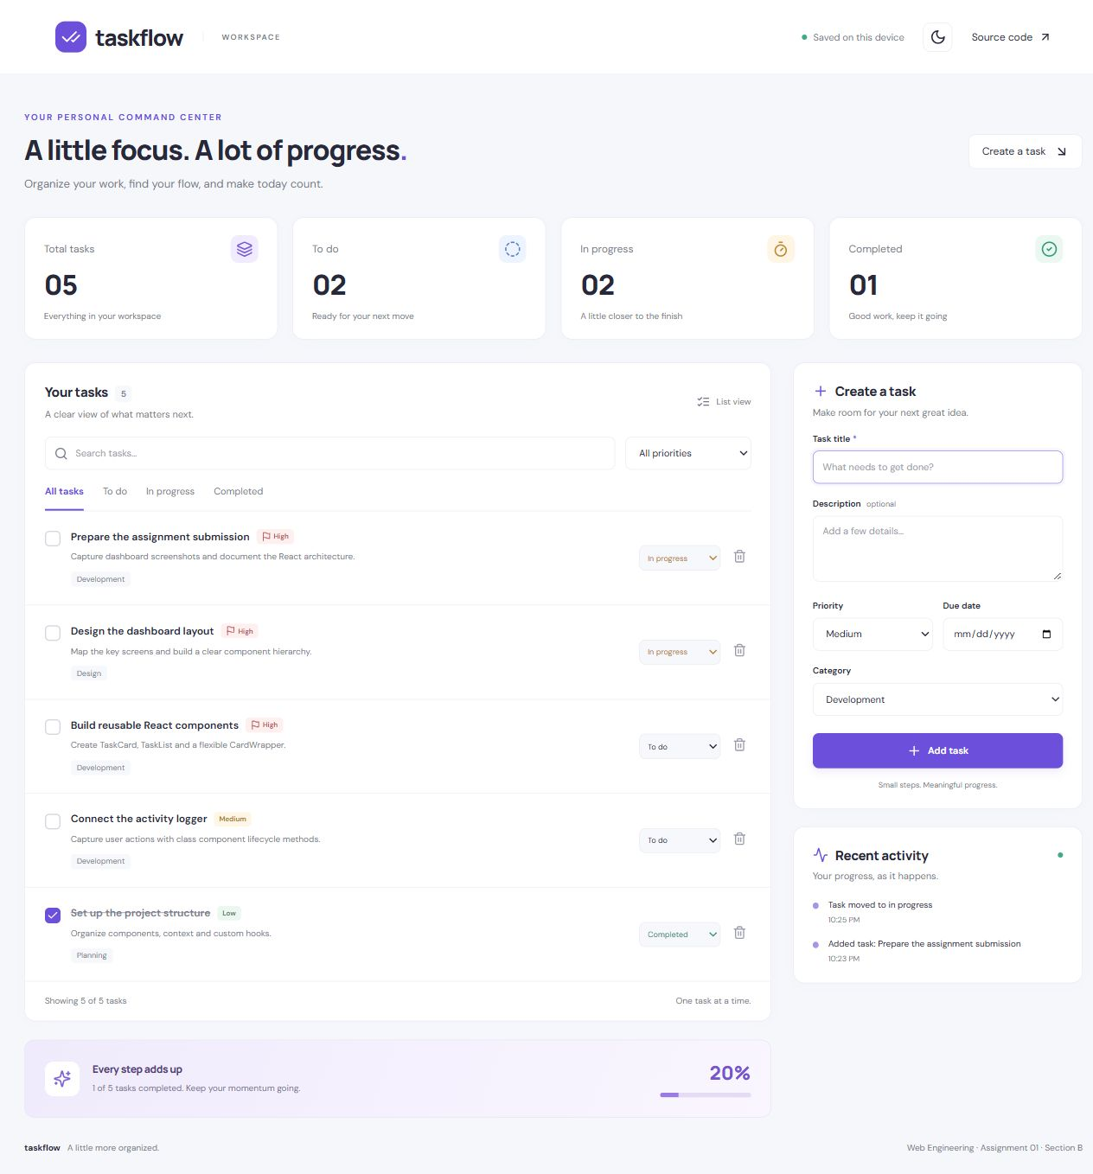
Figure 1. Full dashboard in light mode with the task form and persisted activity log. Local browser capture.

Dark mode and filtered tasks
The High priority filter narrows the list to three tasks. Overall metrics continue to describe the complete workspace. The activity panel records the filter change, and the shared theme applies across the interface.
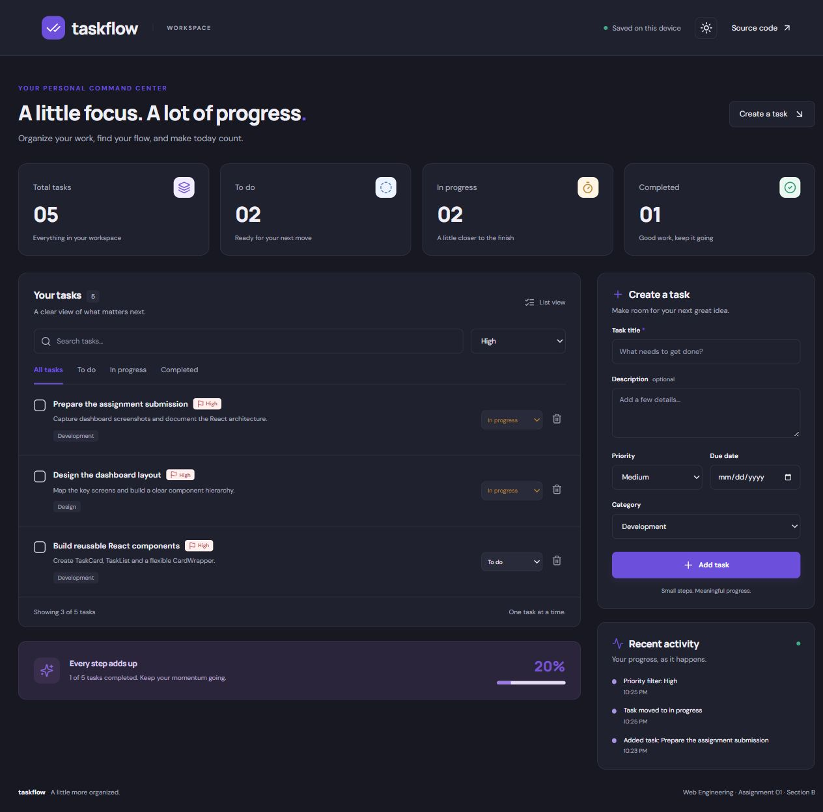
Figure 2. Dark mode with a priority filter applied. Local browser capture.

