Object-Oriented Programming (OOP) Programs
PROGRAM – 1: Password Checker System
#include <iostream>
using namespace std;
class Password {
private:
string pass;
public:
void getPassword() {
cout << "Enter password: ";
cin >> pass;
}

void checkStrength() {
if (pass.length() >= 8)
cout << "Strong Password";
else
cout << "Weak Password";
}
};

int main() {
Password p;
p.getPassword();
p.checkStrength();
return 0;
}

OUTPUT:
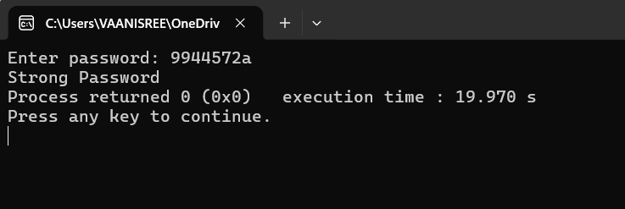

PROGRAM – 2: Shopping Discount System
#include <iostream>
using namespace std;
class Shopping {
private:
float amount, finalAmount;
public:
void getAmount() {
cout << "Enter purchase amount: ";
cin >> amount;
}
void applyDiscount() {
if (amount > 1000)
finalAmount = amount * 0.9;
else
finalAmount = amount;
}
void display() {
cout << "Final Amount: " << finalAmount << endl;
}
};
int main()
{
Shopping s;
s.getAmount();
s.applyDiscount();
s.display();
}

OUTPUT:
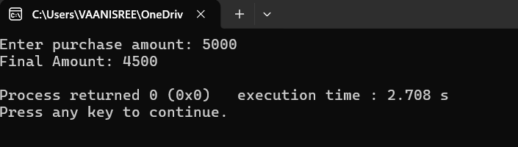

PROGRAM – 3: Count Number of Objects
#include <iostream>
using namespace std;
class Student {
private:
int id;
static int count; // static data member
public:
Student() {
count++;
}
static void showCount() { // static function
cout << "Total objects created: " << count << endl;
}
};

// Definition of static member
int Student::count = 0;

int main() {
Student s1, s2, s3;

Student::showCount(); // calling without object

return 0;
}

OUTPUT:
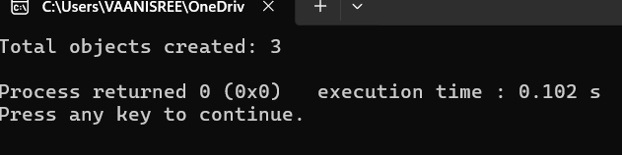

PROGRAM – 4: Bank Interest
#include <iostream>
using namespace std;
class Bank {
private:
int amount;
static float rate; // common for all
public:
void getData() {
cin >> amount;
}
void calculate() {
cout << "Interest: " << amount * rate << endl;
}
static void changeRate(float r) {
rate = r;
}
};
float Bank::rate = 0.05;
int main() {
Bank b1, b2;
Bank::changeRate(0.1);
b1.getData();
b1.calculate();
b2.getData();
b2.calculate();
}

OUTPUT:
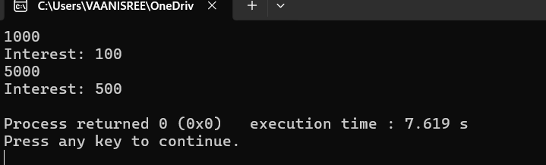

PROGRAM – 5: Palindrome Checker
#include <iostream>
using namespace std;
class Palindrome {
private:
int num, rev = 0, temp;
public:
void getNumber() {
cin >> num;
temp = num;
}
void check() {
while (num > 0) {
rev = rev * 10 + num % 10;
num /= 10;
}
if (temp == rev)
cout << "Palindrome";
else
cout << "Not Palindrome";
}
};
int main() {
Palindrome p;
p.getNumber();
p.check();
}

OUTPUT:
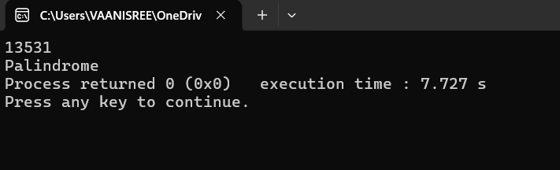
PROGRAM – 6: Temperature Converter
#include <iostream>
using namespace std;
class Temperature {
private:
float celsius;
public:
void getTemp() {
cout << "Enter temperature in Celsius: ";
cin >> celsius;
}
void convert() {
float fahrenheit = (celsius * 9/5) + 32;
cout << "Fahrenheit: " << fahrenheit << endl;
}
};
int main() {
Temperature t;
t.getTemp();
t.convert();
}

OUTPUT:
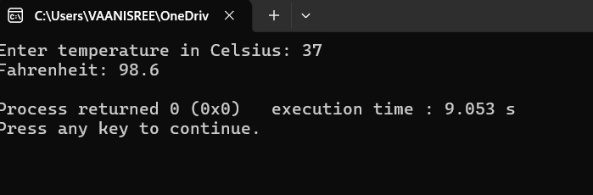

PROGRAM – 7: Employee ID Generator
#include <iostream>
using namespace std;
class Employee {
private:
int id;
static int nextID;
public:
Employee() {
id = nextID++;
}
void display() {
cout << "Employee ID: " << id << endl;
}
};
int Employee::nextID = 100;
int main() {
Employee e1, e2, e3;
e1.display();
e2.display();
e3.display();
}
OUTPUT:
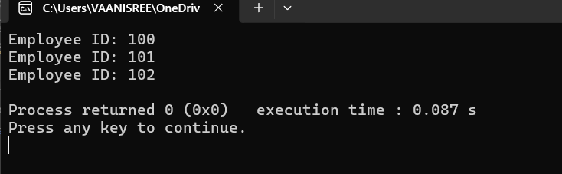

PROGRAM – 8: Returning Object from Function
#include <iostream>
using namespace std;
class Number {
public:
int value;
void getData() {
cin >> value; }
Number add(Number n1, Number n2) {
Number temp;
temp.value = n1.value + n2.value;
return temp; // returning object
}
void display() {
cout << "Sum = " << value;
} };
int main() {
Number n1, n2, result;
cout << "Enter two numbers: ";
n1.getData();
n2.getData();
result = result.add(n1, n2); // object returned
result.display();
return 0;
}
OUTPUT:
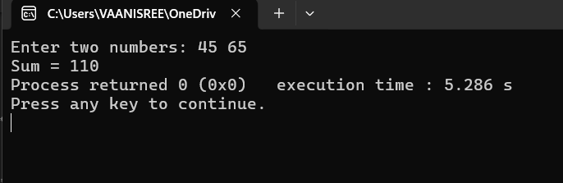
PROGRAM – 9: : Passing Object as Function Argument
#include <iostream>
using namespace std;
class Complex {
public:
int real, imag;
void getData() {
cin >> real >> imag;
}
void add(Complex c1, Complex c2) {
real = c1.real + c2.real;
imag = c1.imag + c2.imag;
}
void display() {
cout << real << " + " << imag << "i";
}
};
int main() {
Complex c1, c2, result;
cout << "Enter first complex number: ";
c1.getData();
cout << "Enter second complex number: ";
c2.getData();
result.add(c1, c2); // passing objects
cout << "Sum = ";
result.display();
return 0;
}
OUTPUT:
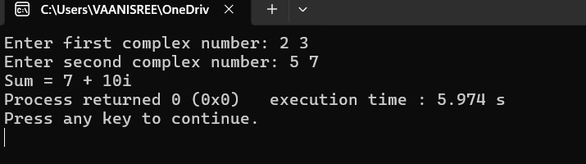
PROGRAM – 10: Constructor Overloading (Box Volume)
#include <iostream>
using namespace std;

class Box {
private:
int length, width, height;
public:
// Default constructor
Box() {
length = width = height = 1;
}
Box(int x) {
length = width = height = x;
}
Box(int l, int w, int h) {
length = l;
width = w;
height = h;
}
void volume() {
cout << "Volume = " << length * width * height << endl;
}
};
int main() {
Box b1; // default
Box b2(5); // cube
Box b3(2, 3, 4); // box
b1.volume();
b2.volume();
b3.volume();
return 0;
}
OUTPUT:
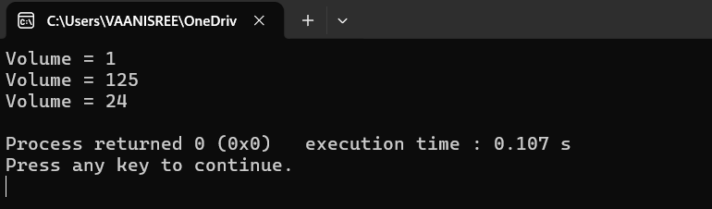
PROGRAM – 11: Constructor Overloading (Time Calculator)
#include <iostream>
using namespace std;
class Time {
private:
int hours, minutes;
public:
// Default constructor
Time() {
hours = 0;
minutes = 0;
}
Time(int m) {
hours = m / 60;
minutes = m % 60;
}
Time(int h, int m) {
hours = h + (m / 60);
minutes = m % 60;
}
void display() {
cout << hours << " hours " << minutes << " minutes" << endl;
}
};
int main() {
Time t1; // default
Time t2(135); // minutes only
Time t3(2, 75); // hours + minutes
t1.display();
t2.display();
t3.display();
return 0;
}
OUTPUT:
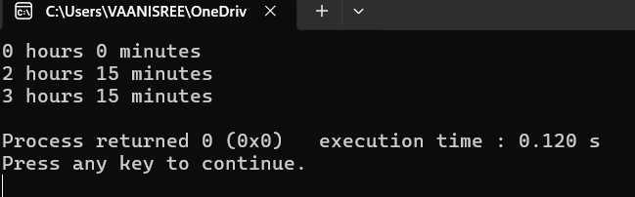
PROGRAM – 12: Function Overriding
#include <iostream>
using namespace std;

class Animal {
public:
void sound() {
cout << "Animal makes sound" << endl;
}
};

class Dog : public Animal {
public:
void sound() {
cout << "Dog barks" << endl;
}
};

int main() {
Dog d;
d.sound(); // calls child class function

return 0;
}

OUTPUT:
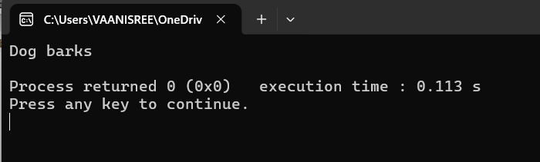
PROGRAM – 13: Function Overloading
#include <iostream>
using namespace std;

class Calculator {
public:
// Function with 2 integers
int add(int a, int b) {
return a + b;
}

// Function with 3 integers
int add(int a, int b, int c) {
return a + b + c;
}

// Function with float values
float add(float a, float b) {
return a + b;
}
};

int main() {
Calculator c;

cout << "Sum (2 ints): " << c.add(2, 3) << endl;
cout << "Sum (3 ints): " << c.add(2, 3, 4) << endl;
cout << "Sum (floats): " << c.add(2.5f, 3.5f) << endl;

return 0;
}

OUTPUT:
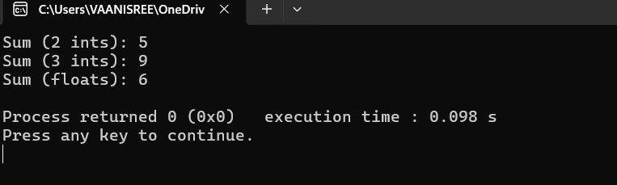

PROGRAM – 14: Operator Overloading (Add Two Complex Numbers)
#include <iostream>
using namespace std;
class Complex {
private:
int real, imag;
public:
void getData() {
cin >> real >> imag;
}
Complex operator + (Complex c) {
Complex temp;
temp.real = real + c.real;
temp.imag = imag + c.imag;
return temp;
}
void display() {
cout << real << " + " << imag << "i" << endl;
}
};
int main() {
Complex c1, c2, result;
cout << "Enter first complex number: ";
c1.getData();
cout << "Enter second complex number: ";
c2.getData();
result = c1 + c2; // overloaded operator
cout << "Sum = ";
result.display();
return 0;
}
OUTPUT:
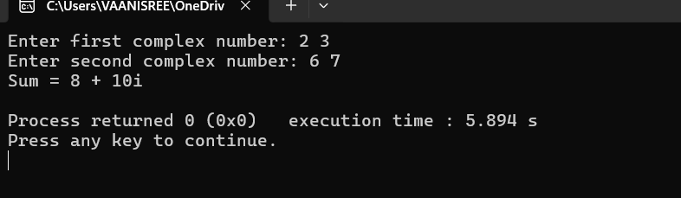
PROGRAM – 15: Operator Overloading (Compare Two Numbers using >)
#include <iostream>
using namespace std;
class Number {
private:
int value;
public:
void getData() {
cin >> value;
}
bool operator > (Number n) {
return value > n.value;
}
void display() {
cout << value << endl;
}
};
int main() {
Number n1, n2;
cout << "Enter first number: ";
n1.getData();
cout << "Enter second number: ";
n2.getData();
if (n1 > n2)
cout << "First number is greater";
else
cout << "Second number is greater or equal";
return 0;
}
OUTPUT:
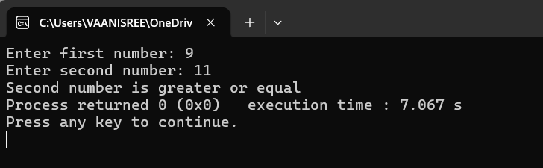
PROGRAM – 16: Student & Marks
#include <iostream>
using namespace std;
class Marks {
public:
int m1, m2;
void getMarks() {
cin >> m1 >> m2;
}
int total() {
return m1 + m2;
}
};
class Student {
private:
string name;
Marks m; // relationship (Student HAS Marks)
public:
void getData() {
cout << "Enter name: ";
cin >> name;
cout << "Enter 2 marks: ";
m.getMarks();
}
void display() {
cout << "Name: " << name << endl;
cout << "Total Marks: " << m.total() << endl;
}
};
int main() {
Student s;
s.getData();
s.display();
}
OUTPUT:
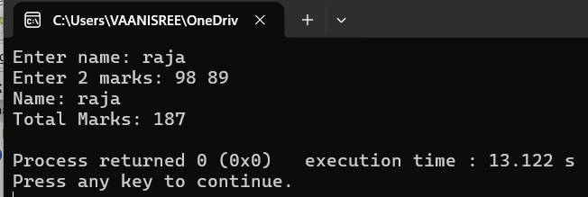
PROGRAM – 17: Employee & Salary
#include <iostream>
using namespace std;
class Salary {
public:
int basic;
void getBasic() {
cin >> basic;
}
int total() {
return basic + 500; // simple allowance
} };
class Employee {
private:
string name;
Salary s; // relationship
public:
void getData() {
cout << "Enter name: ";
cin >> name;

cout << "Enter basic salary: ";
s.getBasic();
}
void display() {
cout << "Name: " << name << endl;
cout << "Total Salary: " << s.total() << endl;
}
};
int main() {
Employee e;
e.getData();
e.display();
}
OUTPUT:
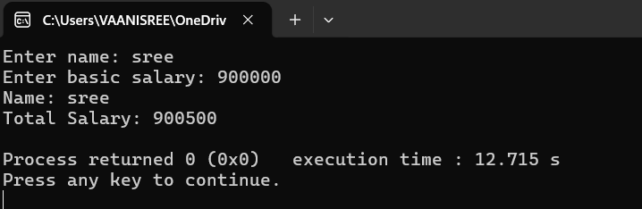
PROGRAM – 18: Friend Function to Add Two Numbers
#include <iostream>
using namespace std;
class Number {
private:
int value;
public:
void getData() {
cin >> value;
}

// declare friend
friend int add(Number n1, Number n2);
};
// friend function
int add(Number n1, Number n2) {
return n1.value + n2.value; // accessing private data
}
int main() {
Number n1, n2;

cout << "Enter two numbers: ";
n1.getData();
n2.getData();

cout << "Sum = " << add(n1, n2);

return 0;
}

OUTPUT:
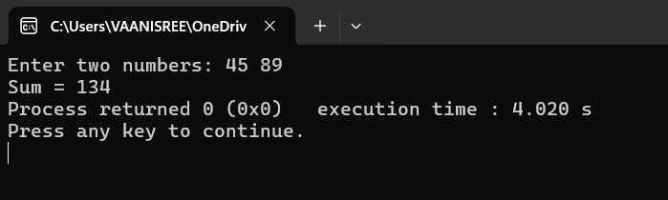
PROGRAM – 19: Friend Function to Compare Two Objects
#include <iostream>
using namespace std;

class Compare {
private:
int num;
public:
void getData() {
cin >> num;
}
// friend function
friend void findMax(Compare c1, Compare c2);
};
void findMax(Compare c1, Compare c2) {
if (c1.num > c2.num)
cout << "First is greater";
else
cout << "Second is greater or equal";
}
int main() {
Compare c1, c2;
cout << "Enter two numbers: ";
c1.getData();
c2.getData();
findMax(c1, c2);
return 0;
}

OUTPUT:
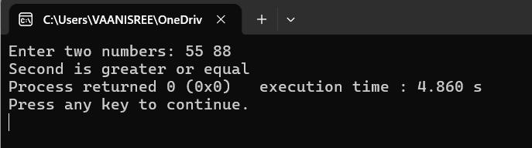
PROGRAM – 20: Friend Function to Swap Two Objects
#include <iostream>
using namespace std;
class Swap {
private:
int a, b;
public:
void getData() {
cin >> a >> b;
}
void display() {
cout << "a = " << a << " b = " << b << endl;
}
friend void swapValues(Swap &s);
};
void swapValues(Swap &s) {
int temp;
temp = s.a;
s.a = s.b;
s.b = temp;
}
int main() {
Swap s;
cout << "Enter two values: ";
s.getData();

cout << "Before swap: ";
s.display();

swapValues(s);

cout << "After swap: ";
s.display();

return 0;
}
OUTPUT:
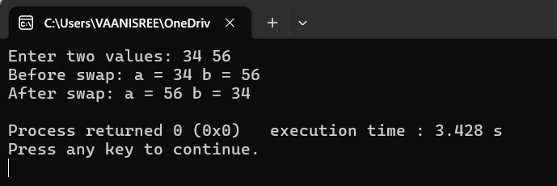
PROGRAM – 21: Friend Function to Calculate Average of Two Objects
#include <iostream>
using namespace std;
class Test {
private:
int marks;
public:
void getData() {
cin >> marks;
}
// friend function
friend float average(Test t1, Test t2);
};

// friend function definition
float average(Test t1, Test t2) {
return (t1.marks + t2.marks) / 2.0;
}
int main() {
Test t1, t2;
cout << "Enter marks of two students: ";
t1.getData();
t2.getData();
cout << "Average = " << average(t1, t2);
return 0;
}
OUTPUT:
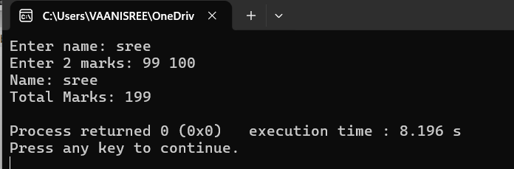
PROGRAM – 22: Abstraction using Abstract Class
#include <iostream>
using namespace std;
class Shape {
public:
virtual void area() = 0;
};
class Rectangle : public Shape {
int length, width;
public:
Rectangle(int l, int w) {
length = l;
width = w;
}
void area() {
cout << "Area of Rectangle = " << length * width << endl;
}
};
class Circle : public Shape {
float radius;
public:
Circle(float r) {
radius = r;
}
void area() {
cout << "Area of Circle = " << 3.14 * radius * radius << endl;
}
};
int main() {
Shape *s;
Rectangle r(5, 4);
Circle c(3);
s = &r;
s->area();
s = &c;
s->area();
return 0;
}
OUTPUT:
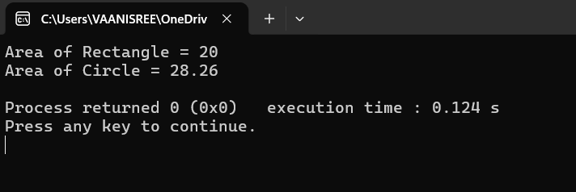

PROGRAM – 23: Virtual Function (Runtime Polymorphism)
#include <iostream>
using namespace std;

class Base {
public:
virtual void show() {
cout << "This is Base class show function" << endl;
}
};

class Derived : public Base {
public:
void show() {
cout << "This is Derived class show function" << endl;
}
};

int main() {
Base *b;
Derived d;

b = &d;
b->show(); // Calls Derived class function

return 0;
}
OUTPUT:
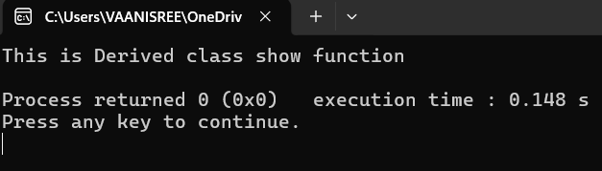
PROGRAM – 24: Divide by Zero Exception
#include <iostream>
using namespace std;

int main() {
int a, b;

cout << "Enter two numbers: ";
cin >> a >> b;

try {
if (b == 0) {
throw "Division by zero error!";
}
cout << "Result = " << a / b << endl;
}
catch (const char* msg) {
cout << "Exception caught: " << msg << endl;
}

cout << "Program continues..." << endl;

return 0;
}
OUTPUT:
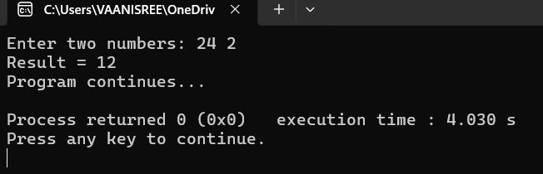

PROGRAM – 25: Multiple Catch Blocks
#include <iostream>
using namespace std;
int main() {
int x;
cout << "Enter a number: ";
cin >> x;
try {
if (x < 0) {
throw x; // integer exception
}
else if (x == 0) {
throw "Zero is not allowed"; // string exception
}
else {
cout << "Valid number: " << x << endl;
}
}
catch (int num) {
cout << "Exception caught: Negative number = " << num << endl;
}
catch (const char* msg) {
cout << "Exception caught: " << msg << endl;
}

cout << "End of program" << endl;
return 0;
}
OUTPUT:
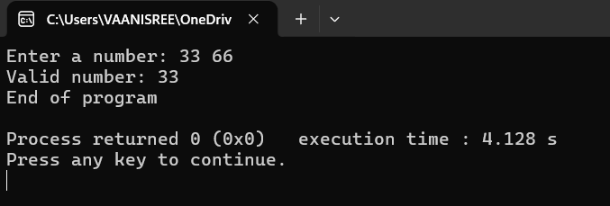

PROGRAM – 26: Function Template
#include <iostream>
using namespace std;

// Template function
template <class T>
T findMax(T a, T b) {
return (a > b) ? a : b;
}

int main() {
cout << "Max (int): " << findMax(10, 20) << endl;
cout << "Max (float): " << findMax(5.5, 2.3) << endl;
cout << "Max (char): " << findMax('A', 'Z') << endl;

return 0;
}
OUTPUT:

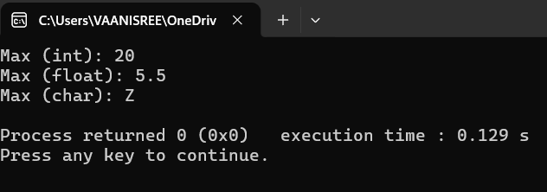
PROGRAM – 27: STL using vector and sort
#include <iostream>
#include <vector>
#include <algorithm>
using namespace std;

int main() {
vector<int> v = {5, 2, 9, 1, 3};

// Sort the vector
sort(v.begin(), v.end());

cout << "Sorted elements: ";
for (int x : v) {
cout << x << " ";
}

return 0;
}
OUTPUT:
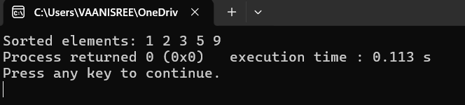
PROGRAM – 28: Write to a File
#include <iostream>
#include <fstream>
using namespace std;
int main() {
ofstream file; // output file stream
file.open("sample.txt");
if (!file) {
cout << "Error opening file!" << endl;
return 1;
}
file << "Hello, this is a file handling program.\n";
file << "Writing data into file using C++.";
file.close();
cout << "Data written successfully." << endl;
return 0;
}

OUTPUT:

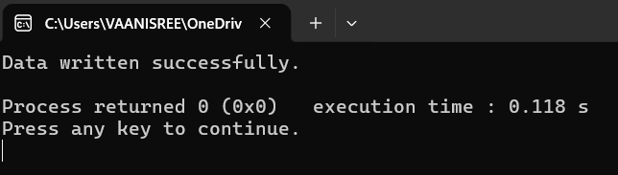
PROGRAM – 29: Read from a File
#include <iostream>
#include <fstream>
using namespace std;
int main() {

ifstream file; // input file stream
string line;
file.open("sample.txt");
if (!file) {
cout << "Error opening file!" << endl;
return 1;
}
cout << "File contents:\n";
while (getline(file, line)) {
cout << line << endl;
}
file.close();
return 0;
}

OUTPUT:
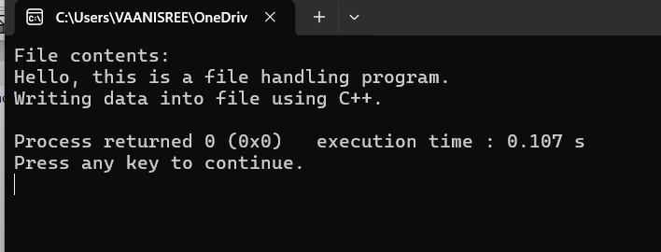

PROGRAM – 30: Pointer to Object using Arrow Operator
#include <iostream>
using namespace std;
class Student {
public:
int id;
string name;

void display() {
cout << "ID: " << id << endl;
cout << "Name: " << name << endl;
}
};

int main() {
Student s1;
Student *ptr;

ptr = &s1; // pointer pointing to object

ptr->id = 101;
ptr->name = "Vaani";

ptr->display(); // using arrow operator

return 0;
}
OUTPUT:
