PROJECT REPORT
REALITY GLITCH DETECTOR
A Java-Based Event Monitoring and Glitch Detection System

Submitted by:
Vaanya Singh

Reg Number
25BAI11544

Course:
Programming in Java
University:
VIT Bhopal University

Academic Year:
2026–27

- Introduction

Reality Glitch Detector is a Java-based console application designed to record events related to different people and identify unusual patterns in those events.
The idea behind the project is to treat unusual or inconsistent event patterns as "reality glitches". For example, events can be recorded with information such as the person involved, event type, location, and time. The application then checks the recorded events using predefined rules and reports any detected inconsistencies.
The project was developed as a practical application of Java programming concepts. It uses multiple classes to divide the different responsibilities of the system, along with collections, exception handling, file handling, and multithreading.
The application provides a simple menu-driven interface through which the user can add people, record events, check for glitches, view the generated report, save the report, and simulate event processing.

2. Problem Statement

When events involving different people are recorded over time, unusual or inconsistent patterns may not always be easy to notice manually. Checking every event individually can also become inconvenient as the number of records increases.
The purpose of Reality Glitch Detector is to provide a simple system that records event information and checks it against predefined rules. The application identifies patterns that may be considered unusual and presents them as detected "glitches".
The project focuses on creating a small, modular Java application that can demonstrate how real-world event monitoring can be implemented using basic and intermediate Java programming concepts.

3. Functional Requirements

The main functional requirements of the Reality Glitch Detector are:
- Person Management – The user can add and view people involved in the recorded events.
- Event Management – The user can add events by entering details such as person, event type, location, and time.
- Input Validation – The system checks for invalid or incomplete information before adding records.
- Glitch Detection – The application checks recorded events using predefined rules to identify unusual patterns.
- Glitch Reporting – Detected glitches can be viewed through the application and saved into a report file.
- Event Processing Simulation – The application uses threads to simulate the processing of events.
- File Handling – The generated report is stored in data/report.txt for later viewing.

4. Non-Functional Requirements

- Usability – The application should be simple to operate through its menu-based console interface.
- Reliability – Invalid inputs should be handled without causing the application to crash.
- Maintainability – Different tasks are divided into separate classes so that the code is easier to understand and modify.
- Portability – The application should run on systems that have a compatible Java JDK installed.
- Readability – The code should follow a clear structure with meaningful class and method names.
- Performance – The application should process the stored events without unnecessary delays.

5. System Architecture

The project follows a simple modular architecture where different classes are responsible for different parts of the application.
The user interacts with the system through Main.java, which handles the menu and user input. The Person and Event classes manage the information entered by the user. EventThread is used to demonstrate event processing using multithreading.
The recorded events are checked by RuleChecker, and GlitchDetector manages the detection of unusual patterns. LocationGlitch and TimeGlitch represent the different types of glitches detected by the system.
The generated results are handled by FileManager, which saves the report in data/report.txt.

System Architecture Diagram

USER / INPUT
Main.java
Menu and User Input
↓
DATA & EVENT MANAGEMENT
Person | Event | EventThread
↓
PROCESSING MODULE
RuleChecker | GlitchDetector
↓
GLITCH TYPES
LocationGlitch | TimeGlitch
↓
REPORTING & STORAGE
Glitch Report | FileManager
↓
OUTPUT
data/report.txt
Component Responsibilities
Component Responsibilities
Component | Responsibility
Main.java | Handles the menu, user input, and overall program flow
Person | Stores information about people
Event | Stores event details
EventThread | Demonstrates event processing using multithreading
RuleChecker | Checks events against predefined rules
GlitchDetector | Detects and manages unusual event patterns
LocationGlitch | Represents location-related glitches
TimeGlitch | Represents time-related glitches
FileManager | Saves the generated report to a text file
data/report.txt | Stores the generated glitch report
This architecture keeps the different responsibilities separated, making the project easier to understand, maintain, and modify.

6. Design Diagrams
This section contains the diagrams used to represent the structure, workflow, interactions, and class relationships of the Reality Glitch Detector project.

6.1 Use Case Diagram
Shows what the user can do with the system.
It will contain:
- User — the actor
- Reality Glitch Detector — the system boundary
- Add Person
- View People
- Add Event
- View Events
- Detect Glitches
- View Glitch Report
- Save Report
- Simulate Event Processing
- Exit

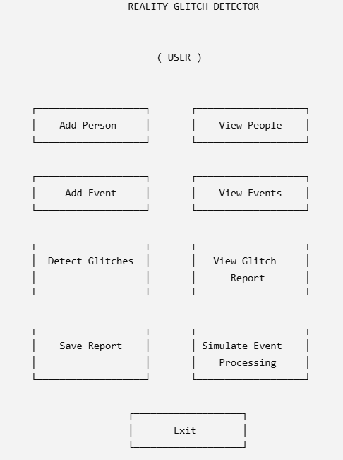

6.2 Workflow Diagram
Shows how the program works from start to finish.
It will show things like:
START → Main Menu → User selects an option → corresponding operation → result → Main Menu / Exit
The main operations are:
- Add Person
- Add Event
- View People
- View Events
- Detect Glitches
- View Report
- Save Report
- Simulate Event Processing
- Exit

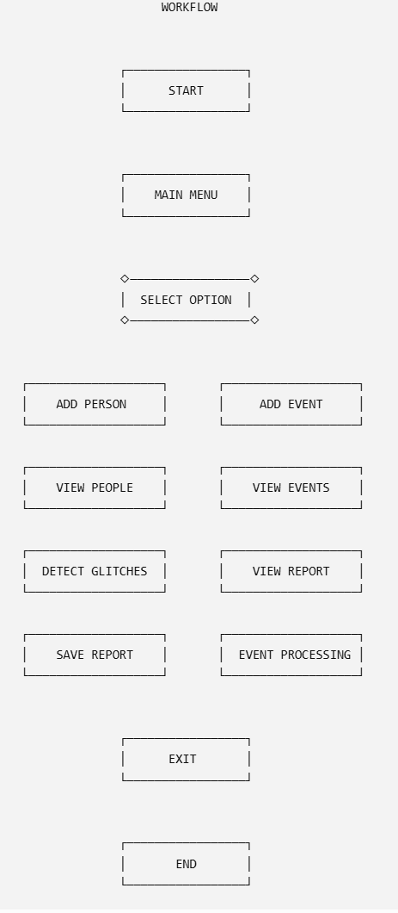

6.3 Sequence Diagram
Shows how different classes interact during one operation.
We'll use the Detect Glitches operation as the example.
The main participants will be:
- User
- Main
- Event
- RuleChecker
- GlitchDetector
- Glitch
It will show the order in which these components communicate while a glitch is being detected.

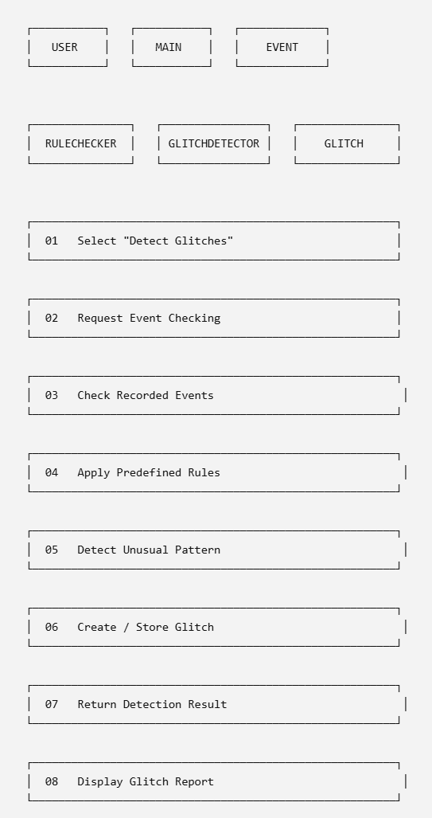

6.4 Class Diagram
Shows the structure of your Java classes and how they are related.
Your diagram will include:
- Person
- Event
- Glitch
- LocationGlitch
- TimeGlitch
- RuleChecker
- GlitchDetector
- EventThread
- FileManager
- Main
Each class will be represented by a rectangle divided into sections for:
- Class name
- Attributes
- Methods

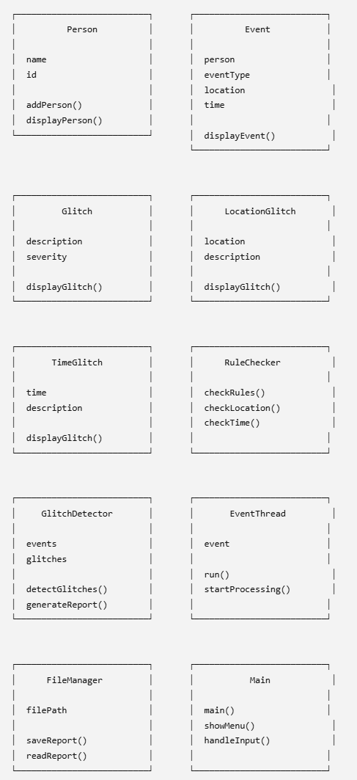

8. Design Decisions & Rationale
8.1 Console-Based Interface
The project uses a console-based interface instead of a graphical interface. This keeps the application simple and allows the main focus to remain on Java programming concepts such as classes, objects, collections, exception handling, file handling, and multithreading.
8.2 Modular Class Structure
Different tasks are divided into separate classes. For example, Person handles person information, Event handles event details, RuleChecker handles rule checking, and FileManager handles report storage. This makes the project easier to understand and maintain.
8.3 Rule-Based Glitch Detection
The application uses predefined rules to identify unusual event patterns. This approach was selected because it is simple to implement using the Java concepts covered in the course while still making the project feel like an actual monitoring system.
8.4 File-Based Report Storage
Instead of using a database, the project stores the generated report in data/report.txt. This avoids external database dependencies and demonstrates Java file handling.
8.5 Multithreading
EventThread is included to demonstrate how Java threads can be used for event processing. It also makes the project more closely connected to the multithreading concepts covered in the syllabus.

9. Implementation Details
The application is implemented using multiple Java classes, with each class having a specific responsibility.
9.1 Main Class
Main.java is the starting point of the application. It displays the menu, accepts user choices, and controls the overall program flow.
9.2 Person Management
The Person class stores information about people added to the system. Users can add people and view the people currently stored in the application.
9.3 Event Management
The Event class stores information about an event, including the person involved, event type, location, and time.
9.4 Glitch Classes
Glitch represents a detected unusual pattern. LocationGlitch and TimeGlitch are used for different types of detected glitches.
9.5 Rule Checking
RuleChecker contains the logic used to check event information against predefined conditions.
9.6 Glitch Detection
GlitchDetector processes the recorded events and identifies glitches based on the rules.
9.7 Multithreading
EventThread demonstrates event processing using Java threads. This is mainly included to demonstrate the use of multithreading in the project.
9.8 File Handling
FileManager is responsible for saving the generated report. The report is stored locally in:
data/report.txt
9.9 Input Validation
The application checks user input before processing it. Invalid menu choices, missing information, unknown people, and invalid event details are handled to prevent the program from terminating unexpectedly.

Screenshots
Screenshot 1 — Main Menu
Shows the main menu displayed when the application starts.

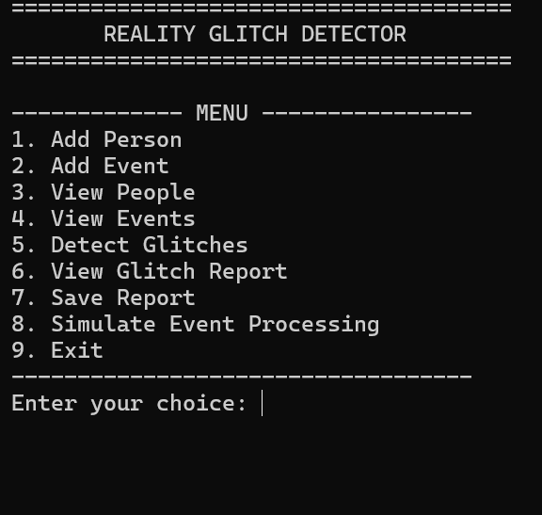

Screenshot 2 — Adding a Person
Shows the process of entering person information.
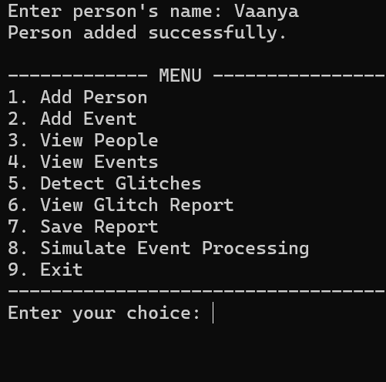
Screenshot 3 — Adding an Event
Shows an event being recorded with its details.
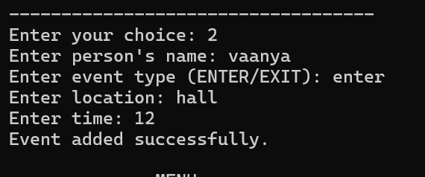

Screenshot 4 — Detecting Glitches
Shows the glitch detection option being executed.
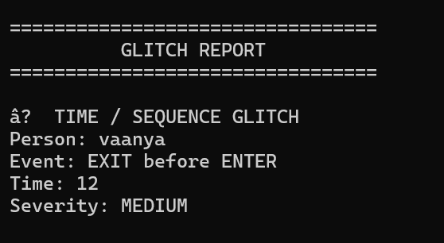

Screenshot 5 — Glitch Report
Shows the generated glitch report.
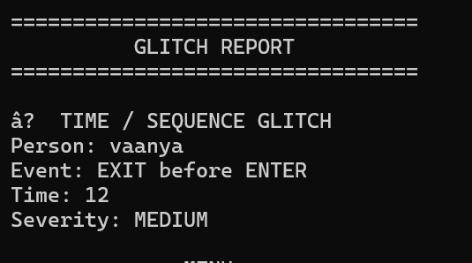

Screenshot 6 — Saved Report
Shows the report being successfully saved to:
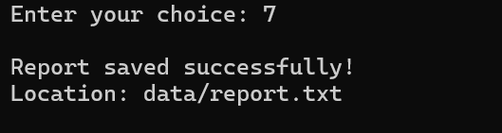

11. Testing Approach
Test Case | Input / Action | Expected Output | Status
1 | Run the program | Main menu should appear | Pass
2 | Add a person | Person should be added | Pass
3 | Add an event | Event should be recorded | Pass
4 | View people | Added people should be displayed | Pass
5 | View events | Recorded events should be displayed | Pass
6 | Detect glitches | Events should be checked for glitches | Pass
7 | View glitch report | Detected glitches should be displayed | Pass
8 | Save report | Report should be saved in data/report.txt | Pass
9 | Simulate event processing | Event processing should run successfully | Pass
10 | Exit | Program should close normally | Pass

12. Challenges Faced

While working on the project, I faced a few challenges:
- Deciding how to divide the project into different classes.
- Handling user input and invalid values.
- Implementing the glitch detection rules.
- Working with file handling to save the report.
- Understanding how to use threads for event processing.
- Testing the different menu options and fixing errors found during testing.
These challenges helped me understand how different Java concepts work together in a single project.

13. Learnings & Key Takeaways

Working on this project helped me understand how different Java concepts can be used together to create a complete application. Instead of using each concept separately, I got to see how they work together in an actual project.
I got practical experience with classes and objects, constructors, methods, collections, exception handling, file handling, and multithreading. I also understood better how inheritance and different classes can be used to organize the code.
Another important thing I learned was how to divide a larger program into smaller classes, where each class has a specific purpose. This made the code easier to understand and manage.
Testing the project also helped me understand the importance of handling incorrect inputs and checking different situations before considering the program complete. I also got experience with compiling and running multiple Java files together and fixing errors during development.
Overall, this project gave me a better understanding of how the concepts from the Java syllabus can be applied to build a working application from scratch.

14. Future Enhancements
The current project works as a console-based application, but it can be improved further by adding more features and making the system more flexible.
Some possible future improvements are:
- Database Integration: Store people, events, and glitch records permanently in a database.
- More Detection Rules: Add more rules to detect different types of unusual event patterns.
- Event Search and Filtering: Allow users to search events by person, location, event type, or time.
- Improved Reports: Generate reports in formats such as CSV or JSON in addition to the current text report.
- Real-Time Processing: Process and check events as soon as they are added.
- Statistics: Add basic statistics such as the total number of events and detected glitches.
- Better User Input: Improve validation and provide clearer messages when incorrect information is entered.

15. References

- Java course material provided as part of the Programming in Java course.
- Oracle Java Documentation – Java language and standard library concepts.
- Java Development Kit (JDK) documentation.
- Git documentation.
- GitHub documentation.

