Python's Slicing, Split, Join

- Slicing
    - Extract some part of an object
    - Applicable on list, tuple, string
    - syantax: object[start: stop: step]
start – included , by default 0
stop – excluded , by default , len of object + 1
step – by default +1
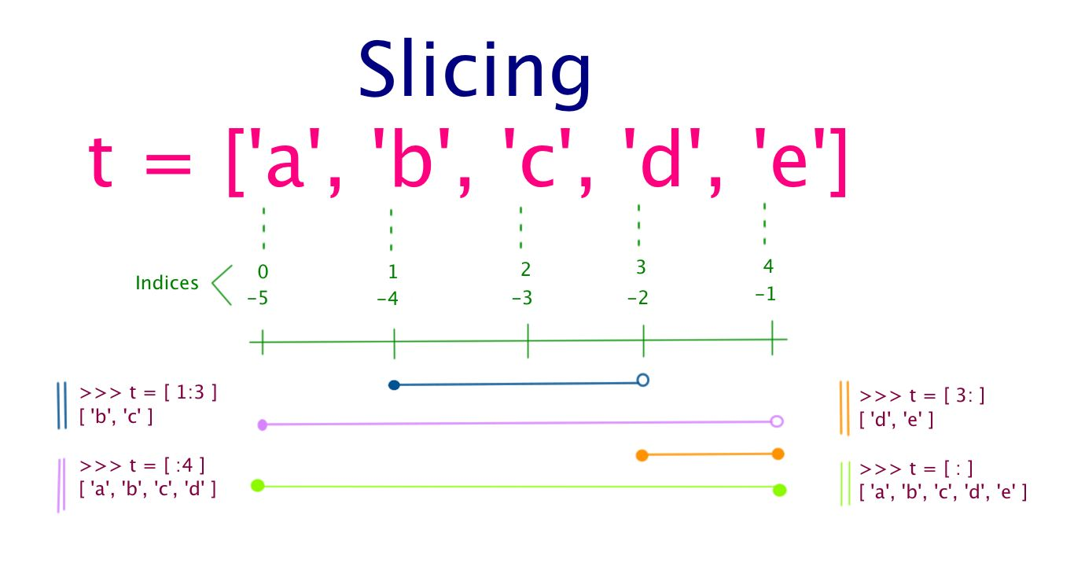

- Split
    - Break a string into list,splited by a spliter
    - syantax: <string>.split(<spliter>)
    - ex: myname = “Good and Great and Awesome and Cool”
    - run: myname.split(“and”)
    - output: [“Good”, “Great”, “Awesome” , “Cool”]
    - how it works:
        - ['Good', 'Great and Awesome and Cool']
        - ['Good', 'Great', 'Awesome and Cool']
        - ['Good', 'Great', 'Awesome', 'Cool']

- Join
    - Join a list into string
    - syantax: <joiner>.split(<list>)
    - ex: mylist = [“Good”, “Great”, “Awesome” , “Cool”]
    - run: “and”.join(mylist)
    - output: Good and Great and Awesome and Cool
    - how it works:
        - Good and Great
        - Good and Great and Awesome
        - Good and Great and Awesome and Cool

Written By:
Vikas Kumar Sharma
vikas.pypy@gmail.com
defpy.com

Feedback, Queries and Suggestions are invited on above mail id.

