GAME-DAY-NOTIFICATION SYS  
SCREENSHOTS

1.ARCHITECTURE:-

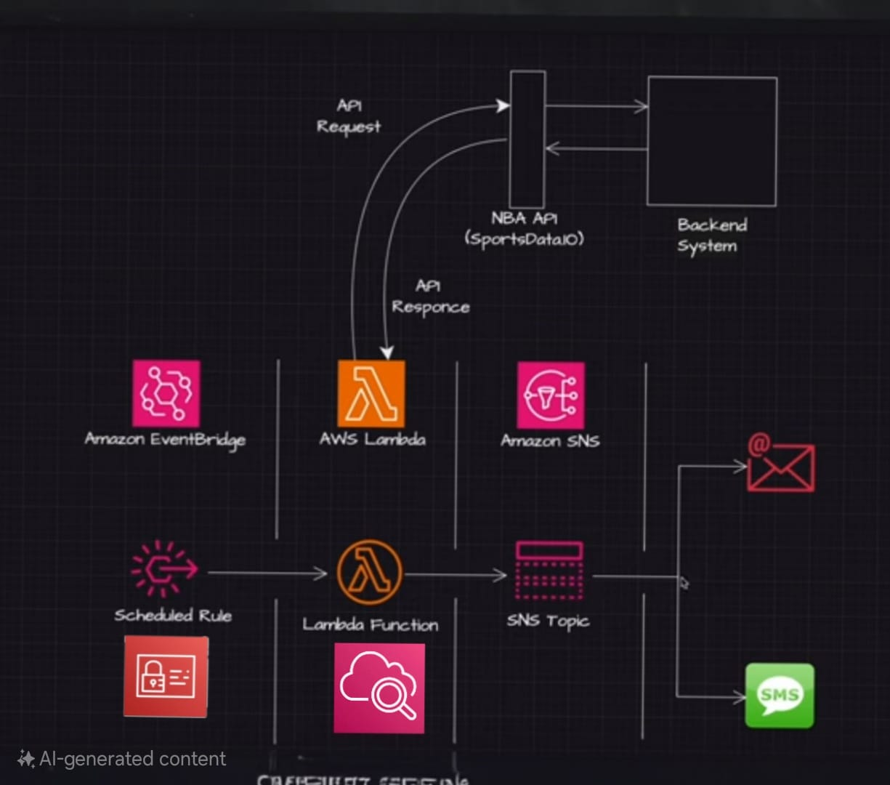

2.EVENTBRIDGE TOPIC:-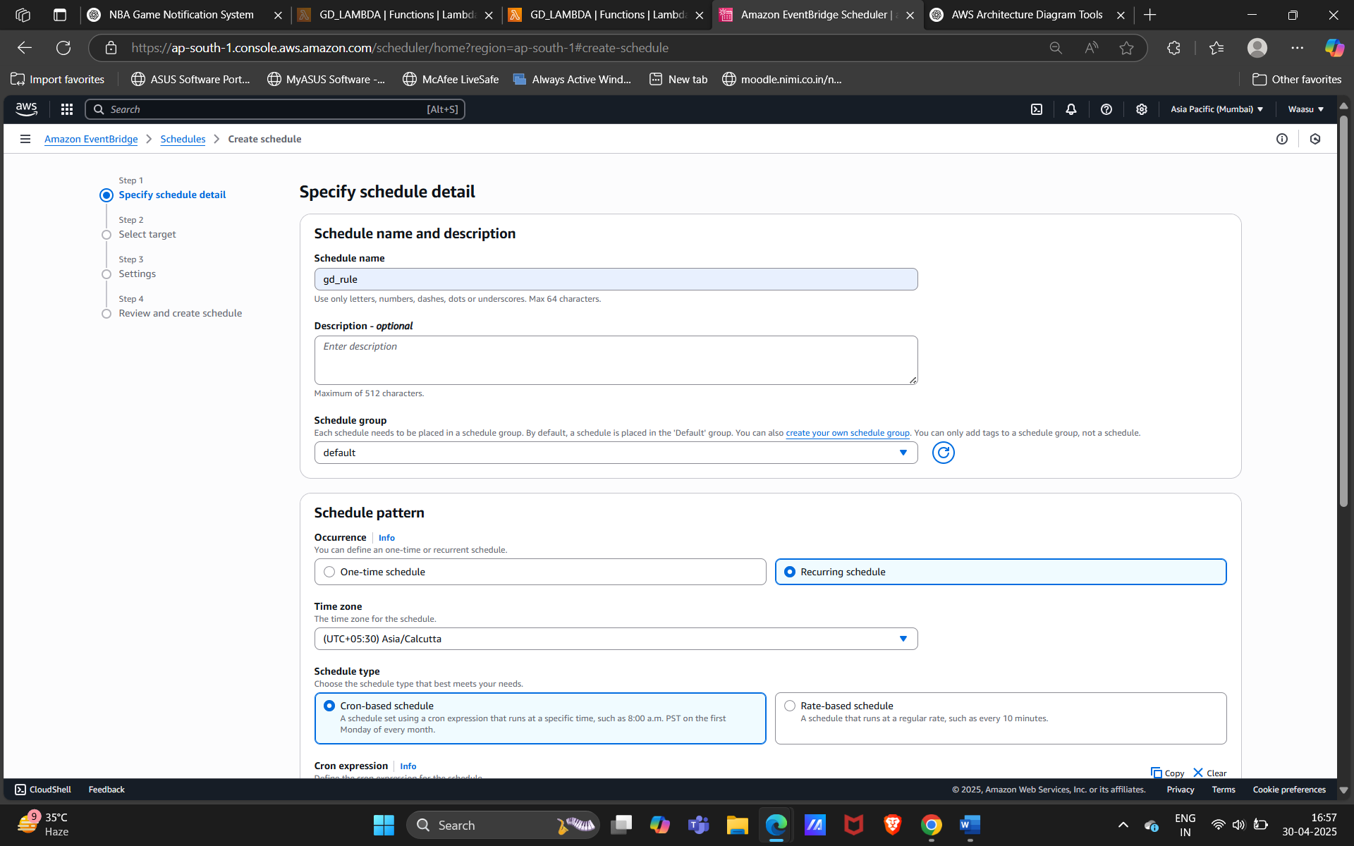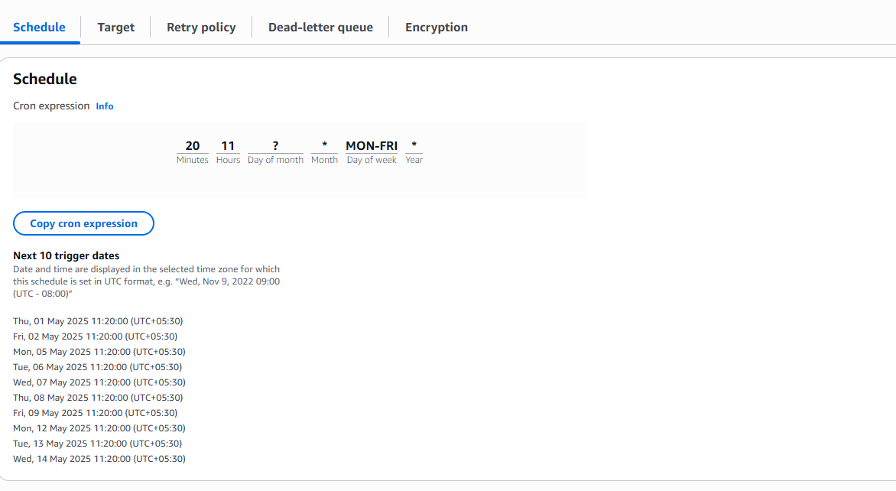

2.LAMBDA LOGIC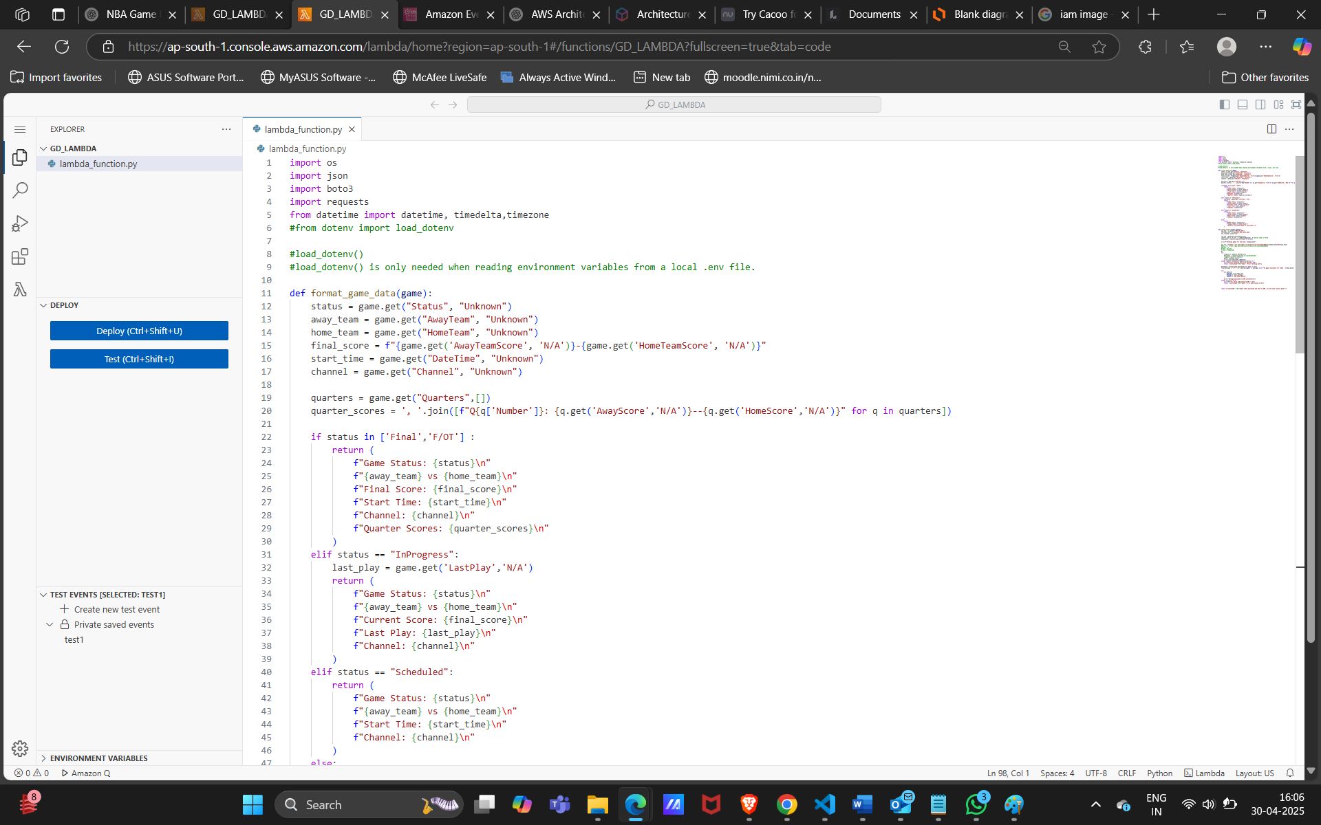

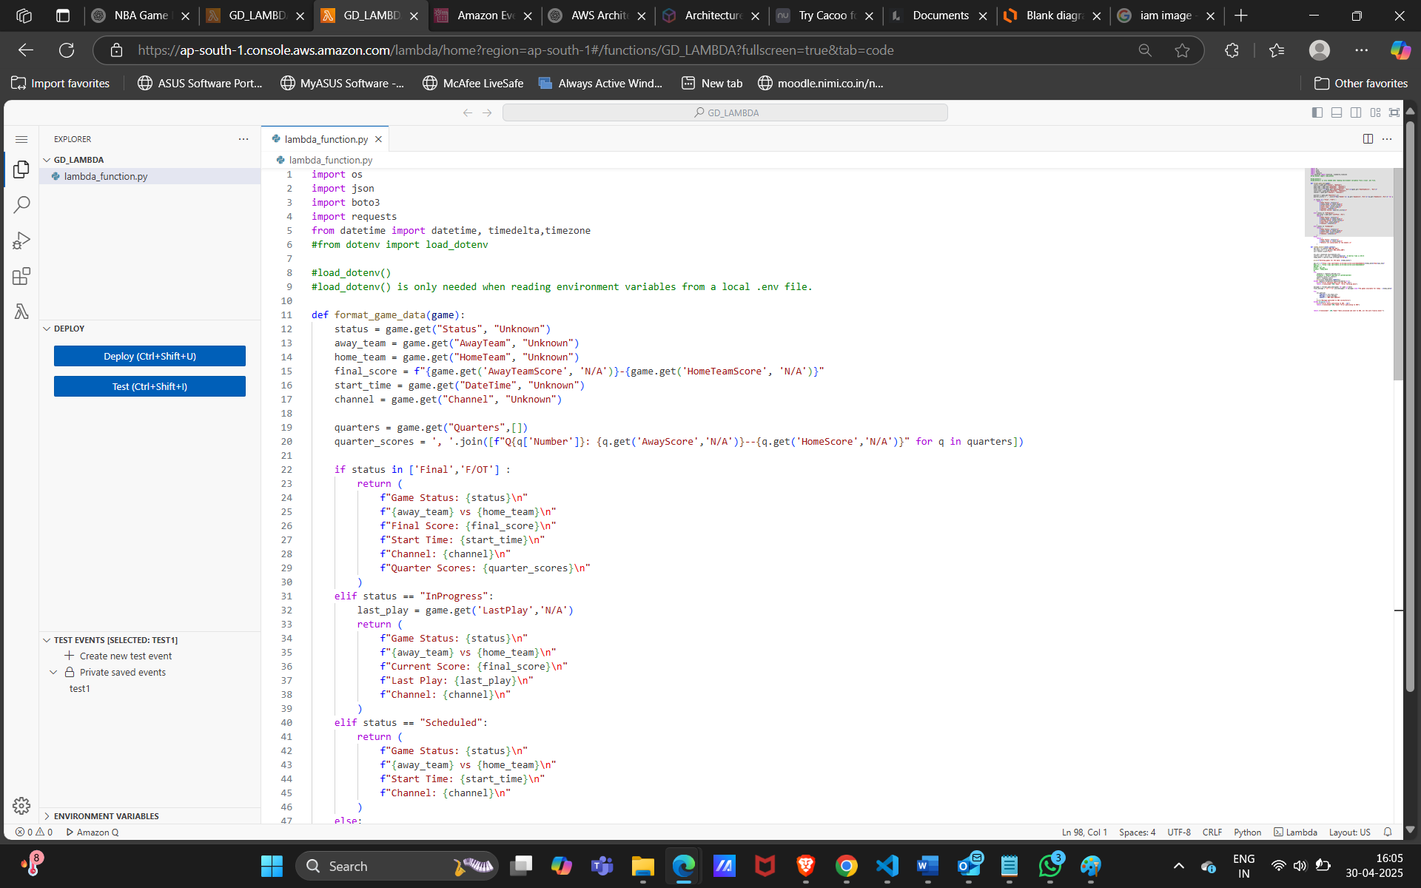

4. SIMPLE NOTIFICATION SERVICE (SNS): -

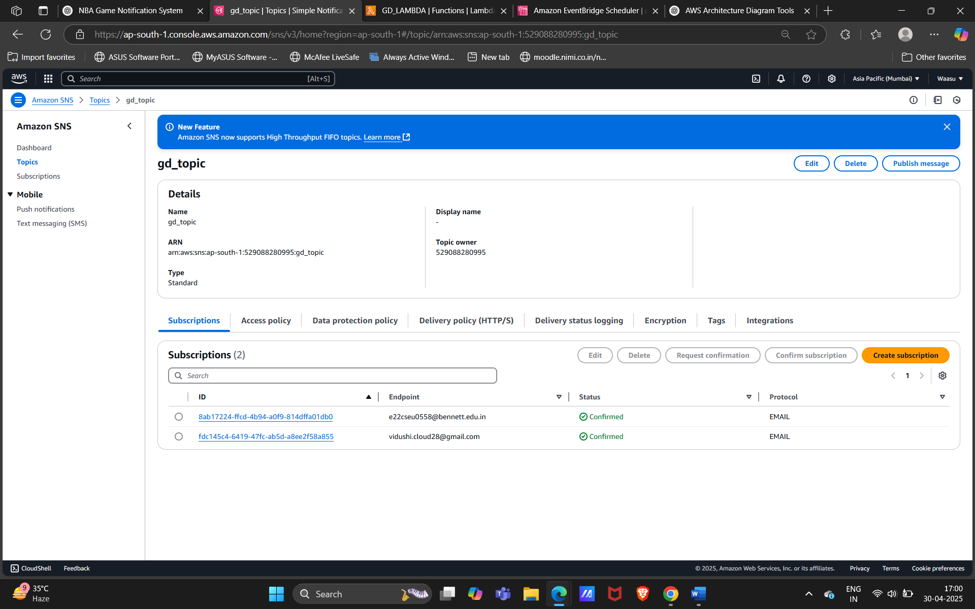



5. IAM POLICY allowing lambda to publish on SNS, whenever its triggered:-

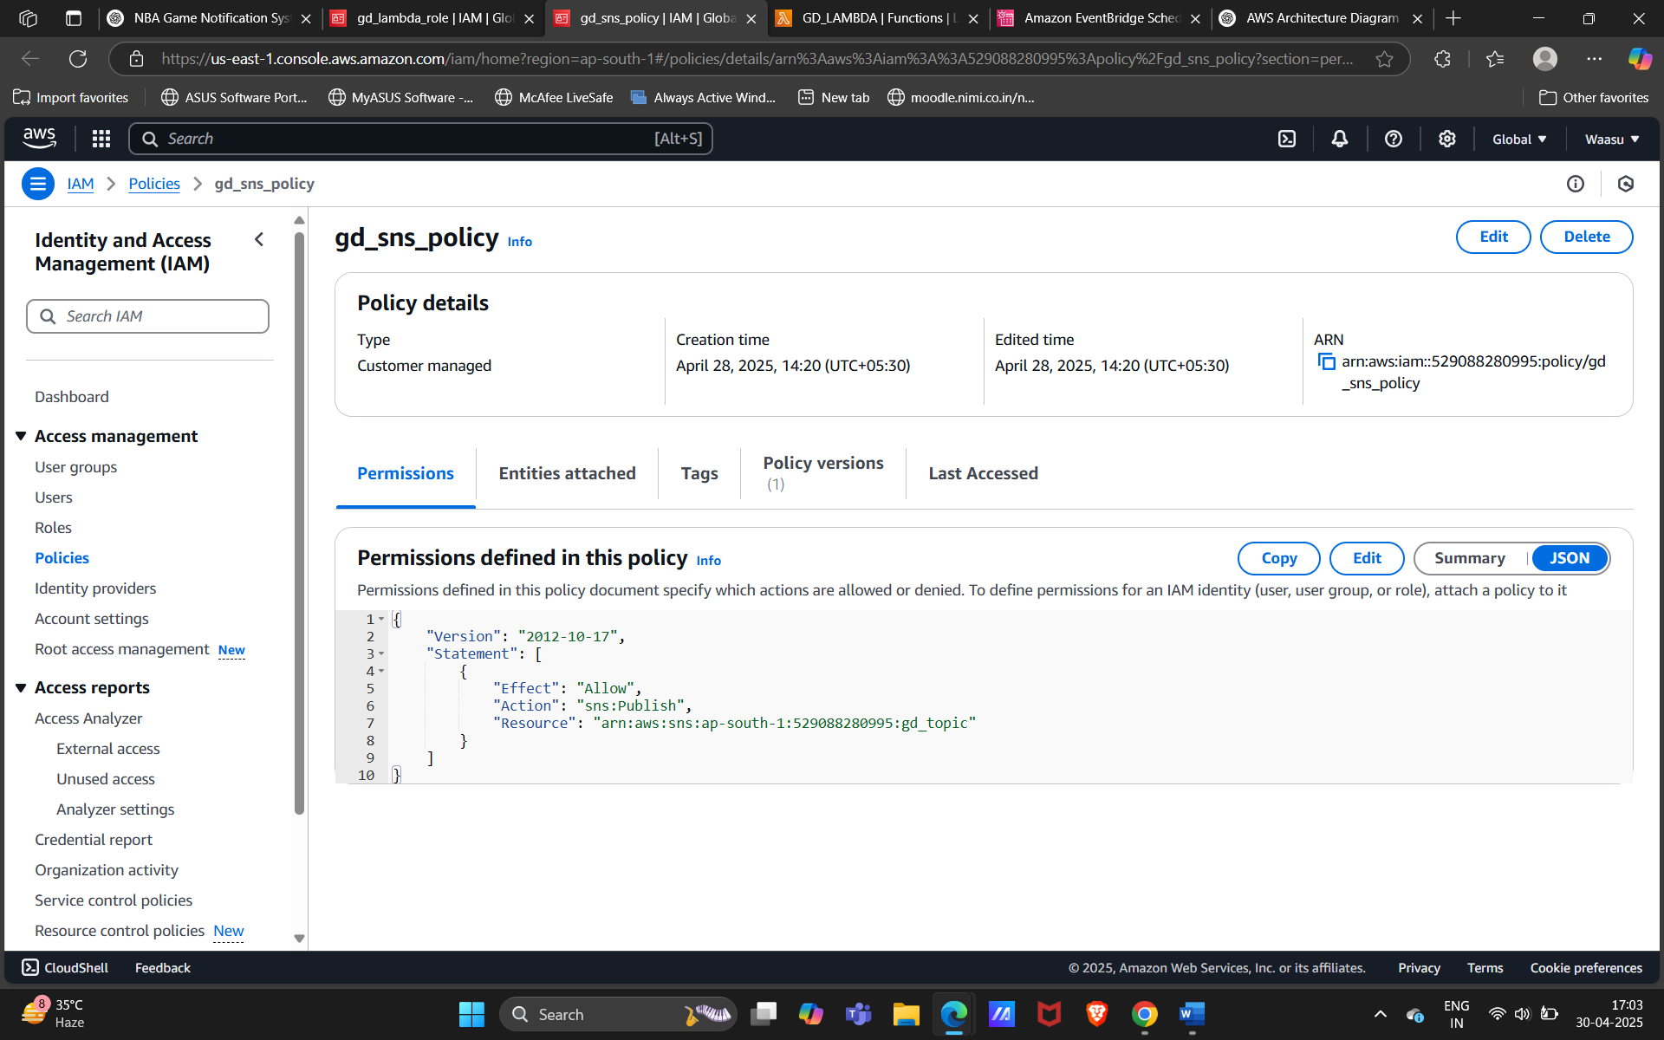



6.CLOUDWATCH metric:-

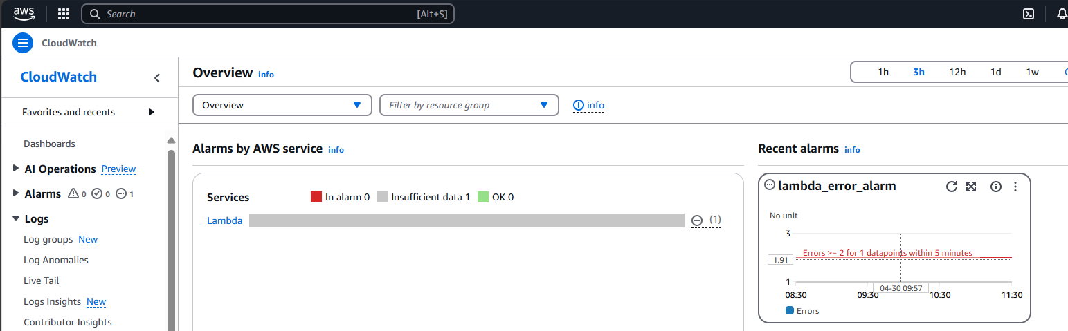

7. OUTPUT as EMAIL:-

