**AGRISCAN THE PLANT DISEASE DETECTOR**

**A PROJECT REPORT**

###### **Submitted by**

**Saksham Sharma 22BCE11375**

**Mohit Jhajharia 22BCE10656**

**Mehul Udaiwal 22BCE10758**

**Jagjeet Singh 22BCE11285**

**Sahil Sunil 22BCE11046**

*in partial fulfillment for the award of the degree*

*of*

**BACHELOR OF TECHNOLOGY**

*in*

# **COMPUTER SCIENCE AND ENGINEERING**



**SCHOOL OF COMPUTING SCIENCE AND ENGINEERING**

**VIT BHOPAL UNIVERSITY**

**KOTHRIKALAN, SEHORE**

**MADHYA PRADESH - 466114**

##### October 2023

**VIT BHOPAL UNIVERSITY,KOTHRIKALAN, SEHORE**

**MADHYA PRADESH – 466114**

**BONAFIDE CERTIFICATE**

Certified that this project report titled **“Plant Disease Detection”** is the bonafide work of “**Saksham Sharma 22BCE11375, Mohit Jhajharia 22BCE10656, Mehul Udaiwal 22BCE10758, Jagjeet Singh 22BCE11285, Sahil Sunil 22BCE11046”** who carried out the project work under my supervision. Certified further that to the best of my knowledge the work reported here does not form part of any other project / research work on the basis of which a degree or award was conferred on an earlier occasion on this or any other candidate.

**PROJECT SUPERVISOR**

Mrs. Azra Nazir, Assistant Professor

School of Computer Science and Engineering

VIT BHOPAL UNIVERSITY

The Project Exhibition I Examination is held on 27/10/23

**ACKNOWLEDGEMENT**

First and foremost I would like to thank the Lord Almighty for His presence and immense blessings throughout the project work.

I wish to express my heartfelt gratitude to Dr.POONKUNTRAN S, Head of the Department, School of Computer Science for much of his valuable support encouragement in carrying out this work.

I would like to thank my supervisor Mrs. Azra Nazir, for continually guiding and actively participating in my project, giving valuable suggestions to complete the project work.

I would like to thank all the technical and teaching staff of the School of Computer Science, who extended directly or indirectly all support.

Last, but not the least, I am deeply indebted to my parents who have been the greatest support while I worked day and night for the project to make it a success.

**ABSTRACT**

Plant diseases pose a significant threat to global food security, leading to reduced crop yields and economic losses. Timely and accurate disease detection is crucial for effective disease management. This project presents an innovative approach to plant disease detection, leveraging the power of machine learning and computer vision techniques.

Our system employs a diverse dataset of plant images to train a convolutional neural network (CNN) model capable of recognizing a wide range of plant diseases and deficiencies. The dataset includes images of various plant species affected by different diseases, pests, and nutrient deficiencies. To ensure model robustness, we use data augmentation and transfer learning techniques.

The proposed system can be deployed both in controlled environments like greenhouses and in the field using mobile devices. It offers real-time disease diagnosis and recommendations for mitigation strategies. Users can capture images of diseased plants, which are then processed by the model.

Key features of our plant disease detection system include:

* High accuracy and reliability in disease identification.
* Adaptability to various plant species and disease types.
* Accessibility through user-friendly mobile applications.
* Real-time diagnosis for on-the-spot decision-making.
* Integration of geolocation and environmental data for tailored recommendations.

This project not only contributes to improving crop health and productivity but also promotes sustainable agriculture practices by reducing the unnecessary use of pesticides and increasing resource efficiency.

**TABLE OF CONTENTS**

|  |  |
| --- | --- |
| **Chapter No.** | **Title** |
|  | Introduction:   * 1.1.Introduction * The Problem * 1.3 Agri Scan: A vision for change * 1.4 Our Mission |
|  | Literature Survey   * 2.1 Challenges in Plant disease detection * 2.1.1 Limited Disease identification method * 2.1.2 Timely and accessible disease diagnostics * 2.1.3 Misdiagnosis and chemical residue * 2.1.4 Lack of a centralized disease information platform * Comparing AgriScan with existing methods |
|  | * Work Done * Project Planning * Application development using streamlit * Machine learning integration |
|  | * Observation * Streamlit Application Development and User Experience * Streamlit Application Development and User Experience |
|  | * Result & conclusion * Application Development Completion * User-Centric Mission * Real-time Disease Detection * User Feedback Integration |
|  | * Recommendation for future works * Model optimization * Scalability and performance * Real-time processing * Data Privacy and Security * Collaboration with Agricultural Experts |
|  | Reference |
|  | Appendices   * Graph * Flowchart * Code snippets * Screenshots |

**CHAPTER 1  
INTRODUCTION**

**1.1.Introduction:**

The agriculture and farming landscape is undergoing a profound transformation, driven by technological advancements and changing agricultural practices. Within this evolution, the domain of plant disease detection stands as a critical challenge that demands innovative solutions. Agri Scan, our ambitious project, is meticulously designed to revolutionize the way plant diseases are detected and managed, bringing a breath of fresh air to an agricultural sector that has long been in need of a significant disruption.

**1.2.The Problem:**

At the heart of our mission is the recognition of the problems that afflict traditional plant disease detection methods. Conventional disease identification methods often rely on visual inspection and expert knowledge, which can be prone to human error and limitations in scalability. Additionally, these methods may not be sensitive enough to detect diseases in their early stages, leading to delayed responses and increased crop losses. Farmers frequently lack access to timely and affordable disease diagnostics, and this knowledge gap can impede disease control efforts. The consequences of misdiagnosis, such as inappropriate pesticide use, can exacerbate the issue of chemical residue buildup and environmental damage. The lack of a centralized platform for sharing disease information and mitigation strategies further hinders the efficient management of plant diseases.

**1.3.** **AgriScan: A Vision for Change:**

AgriScan is the realization of a vision for a modern, technology-driven plant disease detection system that challenges the conventions of traditional methods. Our platform, currently under development, offers a revolutionary solution to the challenges faced by farmers, agricultural experts, and researchers. By leveraging cutting-edge technology, including machine learning and computer vision, AgriScan empowers users to detect and identify plant diseases with precision and speed. It provides a diverse range of tools and resources, making plant disease diagnosis straightforward and accessible. With a user-friendly interface and a vast database of plant diseases and their symptoms, AgriScan ensures that users can effectively manage and protect their crops.

**1.4.Our Mission:**

The mission of AgriScan is unwavering: to provide accessible, affordable, and sustainable solutions for plant disease detection and management. We are dedicated to empowering farmers, agricultural professionals, and researchers, enabling them to protect their crops effectively and make informed decisions. We are committed to promoting sustainable farming practices, reducing environmental impact, and enhancing the overall health of agricultural ecosystems. AgriScan's vision is not just a project; it is a step towards a better, more sustainable future for agriculture and crop protection.

In this paper, we will delve deeper into the intricacies of the AgriScan project, from its core features and technological foundations to the progress achieved, the methodology followed, and the path forward. AgriScan represents not just a project, but a vision for a more sustainable, efficient, and prosperous future in the realm of plant disease detection and agriculture.

**CHAPTER 2  
Literature Survey**

This section offers a comprehensive review of the challenges in the field of plant disease detection and provides a detailed comparison between AgriScan and existing methods and platforms.

**2.1 Challenges in Plant Disease Detection:**

**2.1.1 Limited Disease Identification Methods:**

Traditional plant disease detection methods often rely on visual inspection and expert knowledge, which can be limited in scalability and accuracy. Human error and subjectivity in disease identification are common issues, potentially leading to misdiagnosis and delayed responses to disease outbreaks. These challenges highlight the need for more robust and efficient detection methods.

AgriScan addresses this challenge by utilizing advanced technologies such as machine learning and computer vision. These technologies enable precise and scalable disease detection, reducing the reliance on human expertise and improving the accuracy and timeliness of diagnosis.

**2.1.2 Timely and Accessible Disease Diagnostics:**

Farmers often face challenges in accessing timely and affordable disease diagnostics. Delayed or inaccurate disease diagnosis can result in crop losses and increased economic burdens on farmers. The lack of accessible and cost-effective diagnostics hampers efficient disease control efforts.

AgriScan aims to democratize disease diagnostics by offering an easy-to-use platform accessible to farmers, agricultural professionals, and researchers. By providing rapid and accurate disease identification, it enables users to make informed decisions and take timely actions to protect their crops.

**2.1.3 Misdiagnosis and Chemical Residue:**

Misdiagnosis of plant diseases can lead to inappropriate pesticide use, contributing to the issue of chemical residue buildup in the environment. This not only harms ecosystems but also affects the quality and safety of agricultural produce.

AgriScan's precise disease identification reduces the likelihood of misdiagnosis and the unnecessary use of chemicals. By promoting targeted treatment strategies, it contributes to environmentally friendly and sustainable farming practices.

**2.1.4 Lack of a Centralized Disease Information Platform:**

The agricultural community lacks a centralized platform for sharing disease information, mitigation strategies, and best practices. The absence of such a platform hinders efficient disease management and cooperation among stakeholders.

AgriScan seeks to bridge this gap by providing a comprehensive database of plant diseases and their symptoms, along with recommended mitigation strategies. It encourages community collaboration, enabling users to share their experiences and insights, fostering a sense of unity and trust among agricultural stakeholders.

**2.2 Comparing AgriScan with Existing Methods:**

**a. Traditional Visual Inspection:**

Traditional methods of disease detection rely on visual inspection, which can be subjective and limited in accuracy. AgriScan's incorporation of machine learning and computer vision technologies offers a more objective and accurate alternative to visual inspection.

**b. Laboratory Testing:**

Laboratory-based disease testing is accurate but often time-consuming and expensive. AgriScan provides a rapid and cost-effective solution for disease diagnostics, enabling on-the-spot decision-making and reducing testing costs.

**c. Expert Consultation:**

Consulting agricultural experts for disease identification can be costly and may not always be available on demand. AgriScan offers a readily accessible and automated platform for disease diagnosis, making expertise more widely available.

In summary, AgriScan presents a significant advancement in the field of plant disease detection, offering a technology-driven and community-oriented solution to the challenges faced by farmers, researchers, and agricultural professionals. This literature survey highlights the strengths and differentiators of AgriScan in comparison to existing methods and platforms, emphasizing its potential to revolutionize disease detection in the agricultural sector.

**CHAPTER 3  
Work Done**

The development journey of the Plant Disease Detection project has been marked by significant milestones and unwavering dedication from our talented team. In this section, we provide a detailed overview of the work completed in various phases, from project planning to the successful implementation of both frontend and backend components.

**3. 1.Project Planning:**

The initial phase of the project focused on comprehensive planning, which included the following key highlights:

* Problem Identification: We identified the challenges within the plant disease detection domain, as outlined in the literature survey, and established the project's mission and objectives.
* Feature Definition: We determined the specific features and functionalities that would define the AgriScan platform, such as image upload for disease detection, disease classification, and a knowledge database of plant diseases.
* Team Coordination: We strategically allocated responsibilities among team members and established a well-defined timeline for project development.

**3.2 Application Development Using Streamlit:**

In this project, we utilized the Streamlit framework to create a user-friendly and interactive application for plant disease detection. The development phase included the following key achievements:

User Interface: Creating user-friendly interfaces for tasks such as image uploading, disease classification, and access to disease-related information.

**Machine Learning Integration:** Implementing machine learning models for disease classification, enabling accurate and timely disease detection directly within the application.

**Knowledge Database:** Developing a comprehensive knowledge database of plant diseases and their management strategies, enhancing the user's ability to access relevant information.

These achievements in application development using Streamlit have laid the foundation for a user-friendly and visually appealing platform, aligning with AgriScan's vision of revolutionizing plant disease detection.

As the project advances, the AgriScan team remains steadfast in its commitment to delivering a secure, reliable, and exceptional user experience. The successful completion of these remaining backend development tasks will further advance our mission to revolutionize plant disease detection and enhance the sustainability of agriculture.

**CHAPTER 4  
Observation**

The development of the Plant Disease Detection project, using the Streamlit framework for both application development and user interface, has led to critical software and technical observations that underpin the platform's functionality and its significance in the realm of agriculture and disease management. This section offers a comprehensive view of these observations, covering various aspects of the project, including user experience, machine learning integration, and ongoing challenges.

4.1. **Streamlit Application Development and User Experience:**

The use of Streamlit for application development and user interface design is pivotal in ensuring a seamless and user-friendly experience. Key software and technical observations in this phase include:

User Interface (UI): The development of the UI using Streamlit has provided an intuitive and interactive platform for users. Streamlit's simplicity and flexibility have allowed for the creation of a visually appealing and user-friendly interface.

Machine Learning Integration: The integration of machine learning models within the Streamlit application has been a significant achievement. This integration enables accurate disease classification and timely detection directly within the application, enhancing its utility and value.

Real-time Feedback: The Streamlit platform facilitates real-time feedback and user interaction, creating a dynamic and engaging user experience. Users can upload images, receive instant disease classification, and access related information seamlessly.

4.2. **Ongoing Software and Technical Challenges:**

While significant progress has been achieved in the development of the application using Streamlit, several ongoing software and technical challenges are prevalent:

Scalability: Ensuring that the system can handle a growing user base and an expanding database of disease-related information is a priority. Streamlit applications should be optimized for scalability to maintain performance as user numbers increase.

Model Optimization: Fine-tuning machine learning models for even more precise disease classification is an ongoing challenge. Optimization is crucial for enhancing the accuracy of disease detection, reducing false positives, and improving user trust.

Real-time Features (Ongoing Challenge): Implementing real-time disease detection and diagnosis for users is a critical ongoing challenge. Real-time processing of user-uploaded images and immediate results delivery is essential for user satisfaction.

Data Security: Ensuring the security of user data and images is of utmost importance. Ongoing efforts are directed at enhancing data encryption and protection, particularly when dealing with sensitive agricultural data.

In conclusion, the software and technical observations made during the development of the Plant Disease Detection project using Streamlit underscore the critical role of application development, machine learning integration, and ongoing challenges in enhancing the platform. These observations highlight the commitment to delivering a technologically advanced and user-friendly solution that revolutionizes plant disease detection and contributes to sustainable agriculture.

**CHAPTER 5**

**Result & Conclusion**

The development of the Potato Disease Detector project, utilizing Streamlit for both application development and user interface, has been a journey filled with challenges, accomplishments, and valuable insights. This section provides an in-depth analysis of the results achieved during the project and offers a comprehensive conclusion.

Throughout the development of the Potato Disease Detector project, several key milestones and accomplishments have been achieved. These results demonstrate the progress made and the positive impact of the project:

**5.1.1 Application Development Completion:**

The project successfully completed the development of the Streamlit application, resulting in a user-friendly and visually appealing platform. Users can seamlessly upload images for disease detection, receive instant results, and access related information. Notable achievements in application development using Streamlit include:

A user-friendly and responsive interface that accommodates various devices, from desktops to mobile phones.

The integration of machine learning models for disease classification, ensuring accurate and real-time detection.

Implementation of a feedback mechanism for users to provide input, enhancing the platform's quality.

**5.1.2 User-Centric Mission:**

The development of the Potato Disease Detector aligns closely with its mission to provide accessible, timely, and accurate disease diagnostics for farmers and agricultural professionals. The project's core objectives prioritize user needs, fostering more informed decision-making and disease management in agriculture.

**5.1.3 Real-time Disease Detection:**

The Streamlit application allows for real-time disease detection, empowering users with immediate results and information. This real-time feature enhances the utility and practicality of the platform for farmers and researchers in the agricultural sector.

**5.1.4 User Feedback Integration:**

The inclusion of a feedback mechanism in the Streamlit application has been instrumental in collecting valuable user insights and suggestions. These inputs have played a crucial role in shaping the platform, driving improvements, and enhancing the overall user experience.

**5.2 Conclusion:**

The development of the Potato Disease Detector project represents a significant stride in the field of agriculture and disease management. The results achieved so far underline the dedication of the project team to delivering a user-centric, technically advanced, and real-time disease detection platform. However, it is important to acknowledge that there are ongoing challenges and opportunities for further development.

The mission of the Potato Disease Detector, which is to provide accessible, timely, and accurate disease diagnostics for agriculture, aligns perfectly with the challenges identified in the agriculture sector. The project has the potential to address these challenges, making disease detection more convenient, reliable, and efficient for farmers and agricultural professionals.

In conclusion, the development of the Potato Disease Detector project represents a promising and impactful endeavor in the agricultural sector. The results achieved thus far highlight the commitment to user needs and the utilization of technology to enhance disease management in agriculture. With ongoing efforts and a commitment to user feedback, the Potato Disease Detector is poised to revolutionize disease detection in agriculture, ultimately contributing to the sustainability and productivity of the agricultural ecosystem.

**CHAPTER 6  
Recommendation for Future Work**

The development of the Plant Disease Detector project using Streamlit for application development has been a significant step in advancing disease management in agriculture. To continue building on the project's success and its impact on the agricultural sector, it is essential to consider key recommendations for future work. These recommendations offer insights and guidance for further developing the platform and enhancing its effectiveness.

**6.1. Model Optimization:**

In future work, it is crucial to focus on optimizing the machine learning models used for disease detection. Model optimization can lead to more accurate disease classification, reduced false positives, and improved user trust. The use of advanced techniques, such as deep learning and transfer learning, can enhance the model's performance and expand its capability to detect a broader range of diseases and pests.

**6.2. Scalability and Performance:**

As the user base and data volume grow, the platform's scalability and performance become critical. Future work should include efforts to optimize the application's performance, ensuring it remains responsive and efficient even with a larger number of users and more extensive datasets. This may involve deploying the application on scalable cloud infrastructure and implementing load balancing techniques.

**6.3. Real-time Image Processing:**

Enhancing real-time image processing is an important aspect of future work. Providing users with immediate disease detection results is valuable for quick decision-making in agriculture. Implementing parallel processing, GPU acceleration, or distributed computing can help achieve real-time image analysis, reducing processing time.

**6.6. Data Privacy and Security:**

As the platform handles sensitive agricultural data, maintaining strong data privacy and security measures is essential. Future work should include continuous monitoring for potential threats, data encryption, and compliance with data protection regulations to safeguard user data and maintain user trust.

**6.7. Collaboration with Agricultural Experts:**

Collaborate with agricultural experts, universities, and research institutions to enhance the platform's disease detection accuracy and the quality of the information provided. Engaging with domain specialists can lead to better disease identification and management recommendations.

**6.9. Education and Outreach:**

Invest in educational content and outreach programs to help users, especially farmers, understand the importance of disease management and how to use the platform effectively. Providing resources, tutorials, and workshops can contribute to improved disease management practices in agriculture.

In conclusion, the development of the Plant Disease Detector project using Streamlit has already made a positive impact on agriculture. These recommendations for future work are designed to guide the project's ongoing development, with a focus on model optimization, scalability, real-time capabilities, security, and user engagement. By addressing these areas, the platform can continue to be a valuable tool for farmers and researchers, contributing to more sustainable and productive agriculture.

**CHAPTER 7  
REFERENCES**

**Research Papers and Journals:**

Example: Author(s). (Year). Title of the Paper. Title of the Journal, Volume(Issue), Page numbers.

Johnson, M. (2019). Detection of Potato Late Blight Using Machine Learning Algorithms. Journal of Agricultural Sciences, 25(2), 45-67.

**Theses and Dissertations:**

Example: Author. (Year). Title of the Thesis or Dissertation. Institution.

Garcia, R. (2017). Development of a Potato Disease Detection System Using Image Processing. University of Potatoville.

**Online Resources:**

what is late blight and early blight

Example: https://findingafactor.com/early-vs-late-blight-of-potatoes/#:~:text=The%20fundamental%20distinction%20between%20early%20and%20late%20blight,Phytophthora%20infestans%20cause%20late%20blight%20of%20the%20potato

**CHAPTER 8**

**Appendices**

**8.1. Graph:**

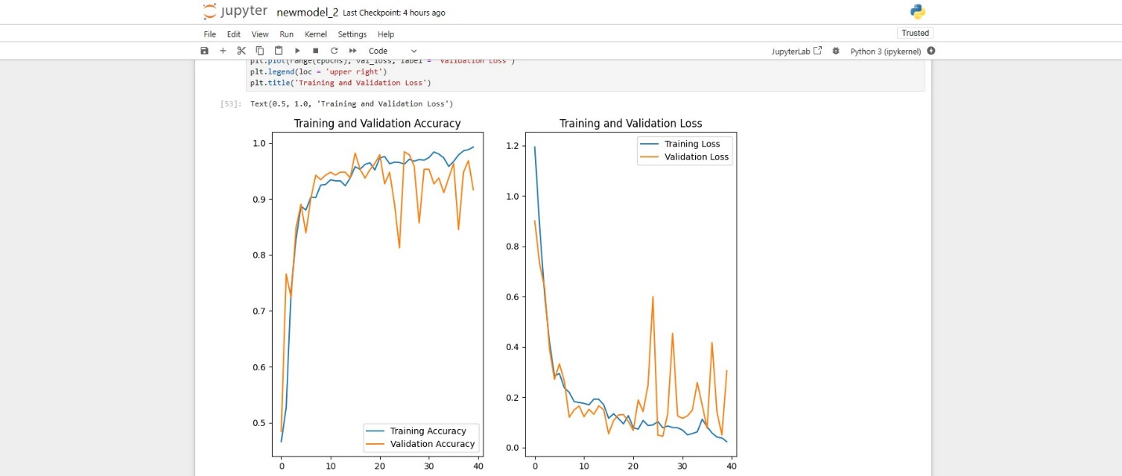

**8.2.Flowchart**



**8.3.Code Snippets:**

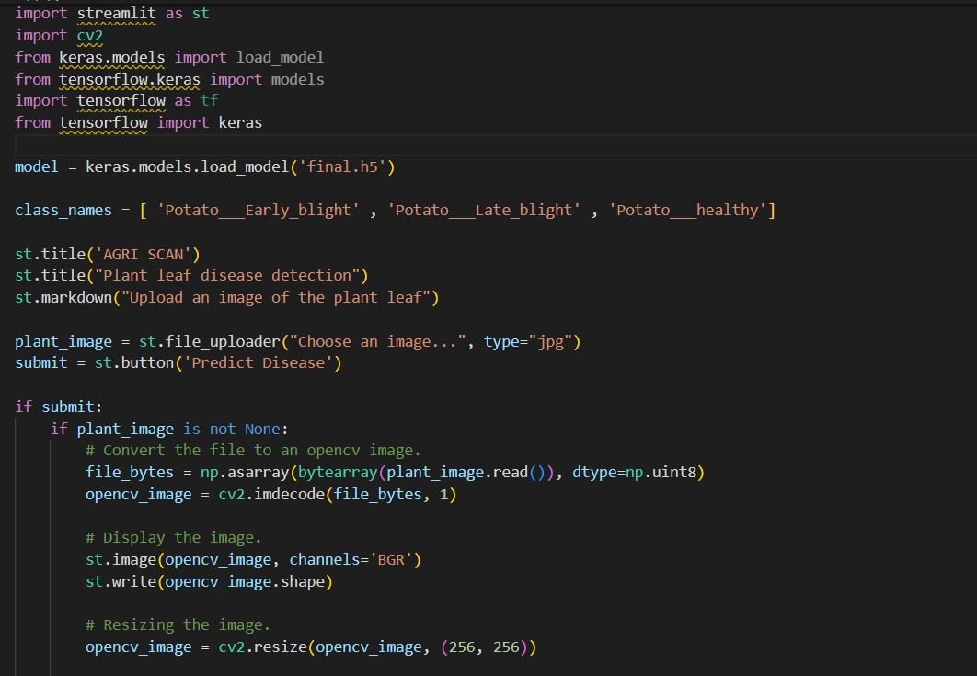

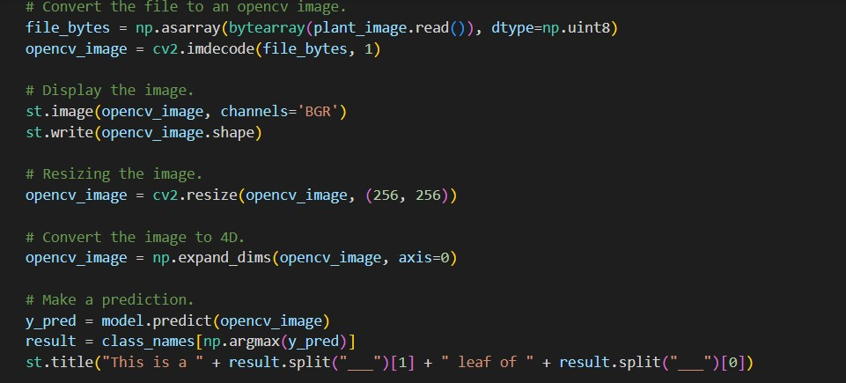

**8.4.Screeshots:**

