# Mastering with Jamin

Okay, you’ve laid all your tracks, mixed them into a good arrangement, adjusted them to their clearest, and now you’re ready to start the process of mastering them.

Perhaps you want to bring out the punch of the drums, the crunch of the rhythm guitar, and the wail of the lead.  Maybe the vocalist’s voice needs to be brought out more, or perhaps you just want to make the whole thing just a bit louder.  Maybe it’s a little too loud, and the recording flirts with the clipping point.

Whatever the task you have in mind, it helps to have the right tools handy for the process. [Jamin](http://jamin.sourceforge.net/) is a collection of filters used in mastering.

These tools work together to get the most out of the sound of a recording, especially in the hands of a skilled mastering engineer.  However, as the skills need to come from somewhere (and I need to learn them myself), here’s a good place to start!

[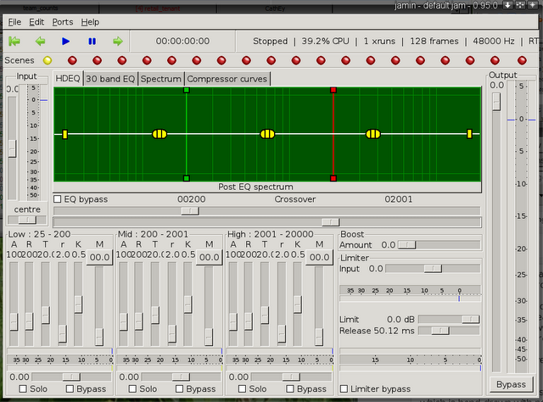](http://www.penguinproducer.com/Blog/wp-content/uploads/2012/02/screenshot27.png)

The Jamin home site has a flowchart showing the various tools that are used in this program, and the order in which they are used.  Since I’m a stubborn punk, I’m going to cover them myself, one at a time.  Of course, if you want to see this flowchart, then [here you go](http://jamin.sourceforge.net/en/routes.html).

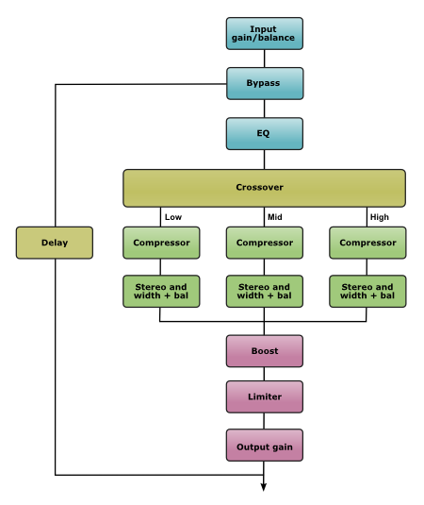

# Input Gain Control

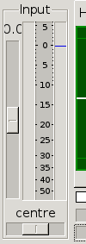

The first item is relatively simple.  If the audio from the recording is too loud or too soft, it can be adjusted prior to processing using the input gain control, found to the left of the equalizer window.

You can use the volume meter to the right of the control to make sure that the gain is appropriate for the range;  You want to make sure that you check the entire mix; at no point in the mix do you want the gain to go over 0dB; as a matter of fact, -2dB to -5dB gain might give good headroom for the mix, especially considering the boosts that will be given as part of the equalization process.

# Total Bypass

[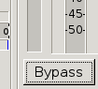](http://www.penguinproducer.com/Blog/wp-content/uploads/2012/02/screenshot5.png)

The next part of the chain is actually at the other corner of the window; the bypass button on the bottom-right allows you to turn off the adjustments; this is useful when you want to compare the processed sound with the raw mix.

When the bypass button is pressed, Jamin will include a delay in order to prevent the output from jumping around; all the processing features in the program will introduce a significant delay compared to the raw mix, and this delay, if bypassed, will distract the ear from comparing processed to raw audio.

# Equalizer

Following the bypass, we begin the first part of the processing, equalization.  Equalization is useful in audio processing, because it can bring out the best parts of a sound, whether it’s the rich depths of a deeper voice, the brighter highs of an opera soprano, the screaming wail of a rock solo, or the smooth hum of the bass line; wherever a voice or instrument lives in the range of frequencies that make up human hearing, equalization will help bring out its defining qualities.

[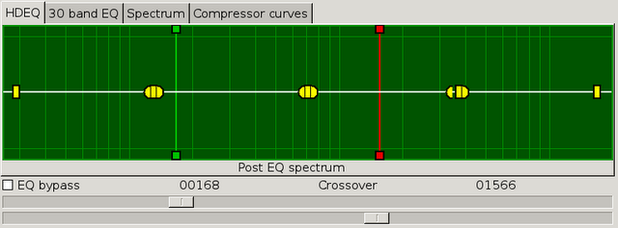](http://www.penguinproducer.com/Blog/wp-content/uploads/2012/02/screenshot613.png)

High-Definition Equalizer - No Gain

Jamin has one equalizer plugin, but there are two ways to control it, depending on the need for details.  By default, the more advanced, 1023-band, hand-drawable, parabolic equalizer with shelves is available.  If you’re not sure what I just said, don’t worry, I’ll explain as we go.

[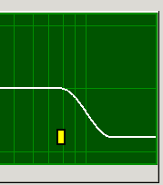](http://www.penguinproducer.com/Blog/wp-content/uploads/2012/02/screenshot7.png)

High Shelf

The tab that controls this equalizer is called “HDEQ”, and the above image includes the controls we’ll use.  The white line going across is the actual equalization level; as you can see, it’s at flat 0dB all across the frequency range.  On both ends, you can see the shelf controls; they determine what final gain is applied to the ends of the spectrum, and at what points.

For example, to the right, you can see the high shelf control.  The gain will start to drop off at the control’s frequency position, and it will stabilize at its amplitude position, all the way to the end of the frequency spectrum.  You can also see that the transition is smooth; the reduction is gradual, as is the leveling off.

[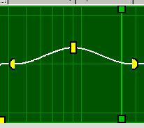](http://www.penguinproducer.com/Blog/wp-content/uploads/2012/02/screenshot82.png)

Parabolic Controls

The three-part yellow objects, consisting of a yellow square and two yellow half-circles, are the parabolic controls.  The two half-circles determine the width of the parabolic (curve) adjustment, while the square determines the hight or depth of the curve.

There are three parabolic controls in Jamin; one for the low frequencies, one for midrange frequencies, and one for the high frequencies.  The curves will only extend as far as both sides have room to; the peak control will always be in the middle, and the ends will stop expanding when one encounters either the frequency where the shelf control begins, or another curve end.

An EQ completely controlled by the parabolic controls and the shelves would look like this, for example:

[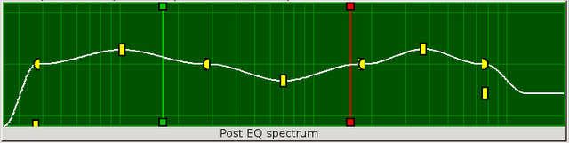](http://www.penguinproducer.com/Blog/wp-content/uploads/2012/02/screenshot916.png)

HDEQ Adjusted with Parabolic and Shelf Controls

Notice how everything smooths out near the edges of the parabolic controls.

If you have a more literal design toward the sound, you can hand-draw the controls to be more to your liking, just drag the mouse across the frequency spectrum, holding the left mouse button down.  Once it’s to your liking, let go and click the mouse again.  The character of the whole line will change pretty drastically:

[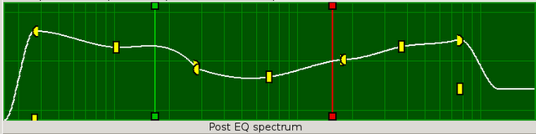](http://www.penguinproducer.com/Blog/wp-content/uploads/2012/02/screenshot1014.png)

HDEQ Adjusted using Hand-Drawn Regions, Parabolic Controls, and Shelving

Notice that while the hand-drawing can change the position of the curve endings, their centers will remain in place, and the shelf ends will continue to exert their influence over the spectrum.  If you were to close the curves altogether and put the shelves back to their respective edges, you will get a very different picture:

[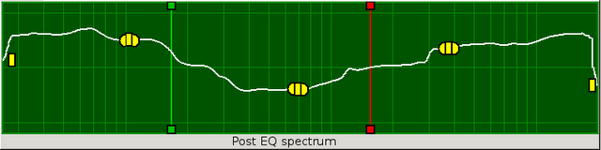](http://www.penguinproducer.com/Blog/wp-content/uploads/2012/02/screenshot1110.png)

HDEQ Adjusted using only Hand-Drawn Regions

Not so tidy, is it?

The red and green bars on the graph do not really apply to the equalizer, they apply to the next filter, the crossover.  The crossover will split the audio into three sections, one lowpass, one midrange, and one highpass.  Each of these ranges will be applied by later filters individually, giving a more detailed control, as well as more character, to the sound.  However, we’re not done with the equalizer yet.

This equalizer window also has a spectrum analyzer as part of it; if you play sound, you will see a line outlining the frequency levels as they play:

[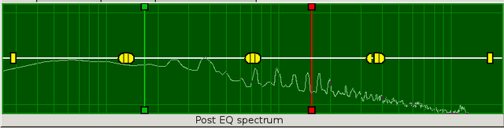](http://www.penguinproducer.com/Blog/wp-content/uploads/2012/02/screenshot127.png)

HDEQ Spectrum Analyzer Displaying Currently-Playing Audio

This can be very useful when adjusting the levels to prevent one part from becoming too overpowering and ruining the mix altogether, and it can also draw your attention to those parts that need some love to bring them out of their quiet little shell.

Don’t forget, I mentioned that there are two ways to control this equalizer.  The above method is much more flexible and immensely more powerful, but sometimes, you just want to adjust the sound in the simplest manner possible.  So there is also a more classical equalizer:

[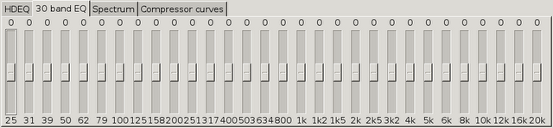](http://www.penguinproducer.com/Blog/wp-content/uploads/2012/02/screenshot1318.png)

30-Band Equalizer

The 30-band equalizer allows you to adjust frequency gain by manipulating a number of slides, rather than with shelves, parabolic curves, or hand-drawn lines; this is especially useful when you just know what to add or remove from a specific set of frequencies.

Unlike the HDEQ, however, the 30-band EQ won’t show the spectrum accordingly.  The smart Jamin developers thought of that, though, and so presented another useful tab in the controls.

[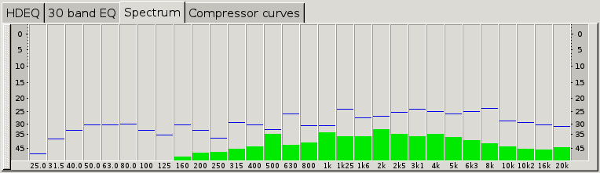](http://www.penguinproducer.com/Blog/wp-content/uploads/2012/02/screenshot146.png)

30-Band Spectrum Analyzer with Peak Markers

The spectrum tab will show a spectrum analysis, complete with a line marking the high point in each frequency band.  This allows you to track any areas where the gain is too much, so you can adjust the input gain accordingly; remember, clipping kills mixes (except for guitars, and they get handled by an entirely different program, and so don’t count).

[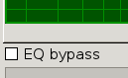](http://www.penguinproducer.com/Blog/wp-content/uploads/2012/02/screenshot1615.png)

Who needs EQ?

Remember, both sets of equalizer controls handle the same equalizer; any changes made to one will be seen by the other.

This means that you can use the 30-band equalizer to make simple adjustments to the curves and shelves of the HDEQ, giving you the benefit of both worlds.  If you don’t want to use the equalizer, there is a little checkbox to bypass the equalizer, turning it off.

# Crossover Controls

In addition to the equalizers, you also have a 3-band compressor and stereo width control.  The actual frequencies handled by the bands are determined by those previously-mentioned crossover controls; the green line controls the cutoff between low and midrange, while the red determines the cutoff between the midrange and high.

[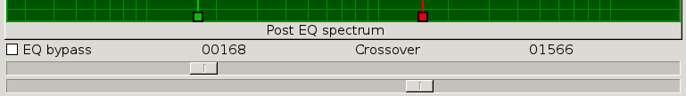](http://www.penguinproducer.com/Blog/wp-content/uploads/2012/02/screenshot1517.png)

Crossover Position Controls

The top slider controls the green line, while the bottom slider determines the position of the red.  The numbers above the sliders are the frequency at which the green and red sliders happen to be at the moment; in this case, the low frequency cutoff is 168Hz, while the high frequency cutoff is 1566Hz.

# 3-Band Compressor

The first tool that handles the regions separated by the crossover controls are the three compressors; one controls the low frequencies, one controls the midrange, and one controls the high frequencies.  Where their controls begin or end are determined by the crossovers.

*Dynamic Range Compression* is a method to increase overall loudness of a mix by compressing the dynamic range (range between the softest sound and the loudest sound) by adjusting the volume increments at the top and increasing the gain to compensate.  The fourth tab, called “Compressor curves,” gives visual representation of the three bands’ compression levels.

[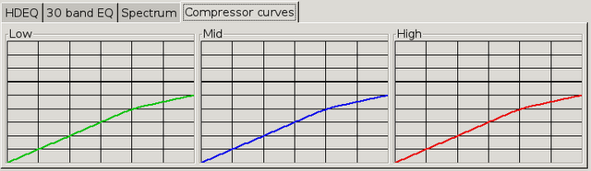](http://www.penguinproducer.com/Blog/wp-content/uploads/2012/02/screenshot17.png)

Low, Midrange, and High Band Compression Graphs

As you can see here, there are three graphs.  The colored line in each is the volume meter.  The horizontal position shows the input volume; the original volume of the mix.  The vertical position indicates the output volume, which, as you see here, starts off with a 1:1 relationship, but then, after the bend, requires more input volume to increase (in this case, a 2:1 ratio, or 2dB input to increase 1dB output).  The heavy line above these colored bars, third from the top of the graph itself, is the clipping point; you never want these bars to pass it.

The controls for these are actually underneath the display:

[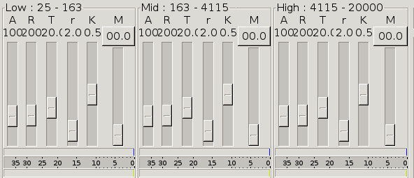](http://www.penguinproducer.com/Blog/wp-content/uploads/2012/02/screenshot1814.png)

Compressor Controls - Separated into Low, Midrange, and High Bands - With Volume Meters

Once again, they are separated in “Low,” “Mid,” and “High” sections.  Hold the mouse over them, and you can see the title will duplicate the color of its own graph.  Each section has several controls that determine the shape of the graphs’ colored lines, or the compressor’s response to them.

The first two values do not affect the line, just the compressor’s response to the current volume.  The other three have very specific effects on the line in the graph.

The first control is *attack*.  Once the volume goes above the bending point, this determines how quickly the compressor will respond to clamp down on further unregulated volume increase.

The second control is *release*.  Once the volume drops below the bending point, this determines how quickly the compressor will switch off, returning volume to normal.  Both attack and release are measured in milliseconds.

The third control is the *threshold*.  This determines at what volume the compressor will begin; it is at this point on the graph where the line will bend.  The threshold ranges from -30dB to 0dB.

The fourth control is *ratio*.  The measurement is self-explanatory; this determines the ratio of output volume to input volume.  In the picture, the ratio is 2:1, meaning that for every 2dB of volume over the threshold, the outgoing volume is increased only by 1dB.

The fifth control is the *knee*.  This determines how gradual the change is; if the knee is hard, then as soon as the volume goes above the threshold (depending on attack value), the ratio is applied in its entirety.  For small ratios, this is fine, but with heavier ratios, the change becomes noticeable, so by softening the knee (by increasing the value), the change will be more gradual, and so less noticeable.

The final control is the makeup gain.  Once you’ve applied the compression, this will increase the volume of the resulting graph so that the low-volume parts become louder.  Since the compression is applied to the high end, this gives you more room to increase the volume without clipping.

The reason the number for the last control is in a button is that this can be automatically handled by Jamin, adjusting the makeup gain based on your compressor controls.  All you’d need to to is press the button to enable the capability, and unpress the button to turn off the adjustment.

# Band Adjustment Controls

[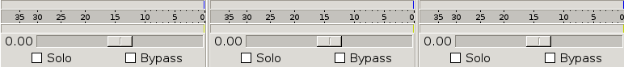](http://www.penguinproducer.com/Blog/wp-content/uploads/2012/02/screenshot203.png)

Stereo Width Controls - With Volume Meters and Solo/Bypass Controls

Underneath the gain controls are the balancing controls  These determine how wide, in the stereo spectrum, that band of sound will seem.  Since different instruments live in different frequencies, this can give the impression that the players are in different locations, thereby increasing the realism provided by stereo.  Moving the slider to the left will narrow the stereo range of sound, while moving it to the right will give it more width.

Also in this area are the “solo” and “bypass” checkboxes.  These will affect all controls for that band; if you bypass one, both the stereo control and the compressor will be bypassed.  Same with solo.

Solo controls will force the associated band to be enabled, and both other bands to be turned off.  When two bands are set to solo, it’s essentially the same as muting the third.

[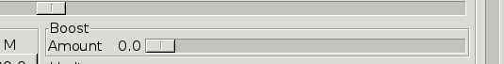](http://www.penguinproducer.com/Blog/wp-content/uploads/2012/02/screenshot2412.png)

Boost Control

The boost control basically adds what the Jamin website labels “a tube-like boost” to the signal.  Tubes were used in older amplifiers and gave their output a warm sound, which may improve your project, depending on the amount you give it.  It’s not necessary, but it’s something to try.

# Limiter

A Limiter is similar in nature to a compressor, in that the filter kicks in when the volume of a signal passes a threshold.  The difference is that, instead of a compression ratio to the sound, it just stops the audio from getting any louder than the limit desired.

[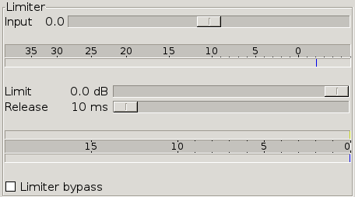](http://www.penguinproducer.com/Blog/wp-content/uploads/2012/02/screenshot267.png)

Limiter Controls - Includes the Limiter Bypass

The input allows you to adjust the volume before the limiter kicks in.  Less limiting means that the dynamics of the sound are preserved as much as possible, and the less work the limiter will have to do to prevent clipping.  This is a good thing, use it in good health.  Once the top volume meter is mostly to your liking (only the really loud parts get past 0), then we can set the limiter.

First, we need to determine where we want the sound cutoff to be.  We don’t want to completely destroy the dynamics of the sound, but going past 0 will cause distortion, and nobody wants that (well… except for those guitar players, and if they don’t like the way I master tracks, it’s too bad for them, so nyah!).  I would probably set this to -5dB.

Once the limit is set, then we set the release.  This filter is referred to as a “lookahead-style” filter, meaning that it will check ahead on the audio, and when it determines that no limiting is needed, or once it’s applied the appropriate limiting, it will release the audio.  The longer this value, the smoother the limit will be applied.

Checking the box on the bottom will bypass this.  The top volume meter will show the volume set by the input to the limiter, while the bottom two will show the amount of reduction, and the final volume out of the limiter.

# Output Gain

[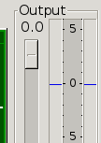](http://www.penguinproducer.com/Blog/wp-content/uploads/2012/02/screenshot2810.png)

Once all the filtering has been applied, we just need to adjust the output volume to make sure it all meets the final requirements; we want the absolute highest peak to the production to be as close to 0 as possible without going over; this will mean that the volume has been maximized, and you can then save and press the audio as needed.

The “high as possible” was applied throughout the rest of the filters, now this final control will soften the final result down just enough that it will not pass the clipping point.  Ever.

# Scenes

Along the top, you’ll notice a series of green and red dots.  These are called “scenes” in Jamin, but I prefer to think of them as “presets.”  When you’ve set all the filters in a specific way that satisfies you, right-click on one of the red dots, and select “set.”  This will store your configuration on that scene.  Keep in mind that if you don’t save the session, the scenes will be lost once you close Jamin.

# Conclusion

And there you have it!  Enough information to make use of this incredible, wonderful tool well enough to actually make your productions into something good!

<http://www.penguinproducer.com/Blog/2011/09/mastering-with-jamin/>